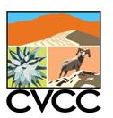
Coachella Valley Multiple Species Habitat Conservation Plan &
Natural Community Conservation Plan
Mecca Hills and Orocopia Mountains
Vegetation Map Report
Report

Coachella Valley Conservation Commission

December 2015
Prepared by the University of California Riverside’s
Center for Conservation Biology

for the Coachella Valley Conservation Commission


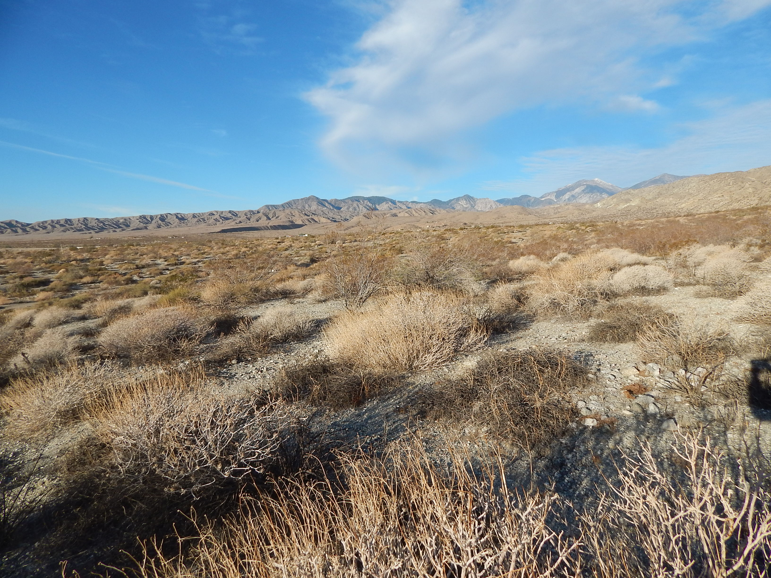
Prepared by the University of California Riverside’s
Center for Conservation Biology
for the
Coachella Valley Conservation Commission

Contents
Executive Summary 3
Introduction 4
Purpose 5
Reconnaissance vegetation assessment 6
Delineation Rules 6
Classification 7
Alliances and Landscape Attributes Identified 8
Associations Identified 8
Mecca Hills-Orocopia Mountains Alliance Map 11
References 12
Appendices 12

Executive Summary
The University of California, Riverside Center for Conservation Biology (CCB) created a fine‐scale vegetation map of the Mecca Hills and Orocopia Mountains Conservation Area in the Coachella Valley of Riverside County, California covers approximately 112,775 acres. This map and report were prepared for the Coachella Valley Multiple Species Habitat Conservation Plan (MSHCP) under contract with the Coachella Valley Conservation Commission (CVCC). The Mecca Hills and Orocopia Mountains final vegetation map, ecological descriptions, classification, and report, were completed in 2015. Initial mapping began with photo-interpretation and field work in 2013 and 2014, with additional work continuing until 2015. One hundred eighty-six reconnaissance vegetation assessment plots were conducted within the study area. Photo-interpretation of 2013 imagery was completed in October 2015 and match the most recent vegetation classification presented in the Manual of California Vegetation Second Edition (Sawyer et al. 2009). Thus, the current version of the map best represents the status of vegetation in 2013.
The vegetation classification follows Federal Geographic Data Committee (FGDC) and National Vegetation Classification Standards (NVCS; Federal Geographic Data Committee 2008). The classification is based on previous survey and classification work done by California Department of Fish and Wildlife's Vegetation Classification and Mapping Program (VegCaMP) and Aerial Information Systems (AIS) for the Desert Renewable Energy Conservation Plan, and by the National Park Service for Joshua Tree National Park. This unit was mapped using the California Department of Fish and Wildlife (CDFW) and California Natural Plant Society Combined (CNPS) Vegetation Classification and Mapping Program protocol (CNPS 2011, 2014). The primary purpose was to develop a dynamic and accurate vegetation map for the Coachella Valley Mecca Hills and Orocopia Mountains Conservation Area, so that it may be applied to future conservation efforts, and assist with management of the 27 species and 27 natural communities listed within the plan. The map was produced by applying heads‐up digitizing techniques using a base of true‐color and color infrared 2013 six-inch imagery from the National Agricultural Imagery Program (NAIP) and local flights provided by the Coachella Valley Conservation Commission. Map polygons were assessed for vegetation type, percent cover, presence of exotics, anthropogenic disturbance, and roadedness.
This, the current version of the vegetation classification for the Mecca Hills and Orocopia Mountains Conservation Area of the Coachella Valley MSHCP includes 1,149 polygons with 24 Alliances and 65 Associations. Alliances were assigned for all polygons, and the additional Association attribute was assigned where field plot data (Vegetation Assessment plot) was available within the polygon boundaries. This unit has two map classes that have less than 2% absolute vegetation cover, including Disturbed/Built-Up, a generic Non-Vegetated Habitat type. The largest amount of land cover is of the Non-Vegetated Habitat type, encompassing 69,600 acres (28,200 ha). Of the alliances within the vegetated areas, the largest amount of vegetation area is classified under the Larrea tridentate-Encelia farinosa Shrubland Alliance. This Alliance covers a total of 12,730 acres (5152 ha), representing 11.3% of the total area within the map. For most alliances occurring in expansive areas, a minimum mapping unit of 2.47 acres (1 ha) was observed. To better focus on conservation of particular habitats, there are several alliances where the minimum mapping unit (MMU) is less than an acre; including Prosopis glandulosa Woodland Alliance, Xylorhiza cognata Provisional Alliance (MMU 0.3 acres and MMU 0.5 acres, respectively), and Washingtonia filifera Shrubland Alliance (MMU 0.34 acres), as well as wetlands and certain wash types which displayed complexity that would necessitate delineation. This report and accompanying data are to be released at the end of 2015. Periodically, a review of the original polygons and fieldwork will be performed to update the map and determine change across the landscape.

Introduction
This vegetation map is a tool to help aid in species monitoring and management in the Mecca Hills and Orocopia Mountains Conservation Area of the Coachella Valley MSHCP and Natural Community Conservation Plan. At the end of the twentieth century, 27 species and 27 vegetation communities in the Coachella Valley were identified as being affected by pressures of land development and conversion of habitats. The most direct threat to the biodiversity of the area is habitat loss. In the 1940s the area south of the Coachella Valley was converted to large scale agricultural operations, utilizing the new water available through the Coachella Canal. Over the next few decades, development began to expand into the Aeolian sand areas. From 1996 to 2008, citizens, scientists, land managers, and federal and state agencies of the Valley developed a conservation plan that offered protection to these species and preserved over 250,000 acres of open space. The plan was approved by federal and state agencies and was implemented in 2008, all cities involved in the collaborative effort. Currently, the Coachella Valley is home to some of the fastest growing cities in the United States, including Palm Desert, Rancho Mirage, and Indio.
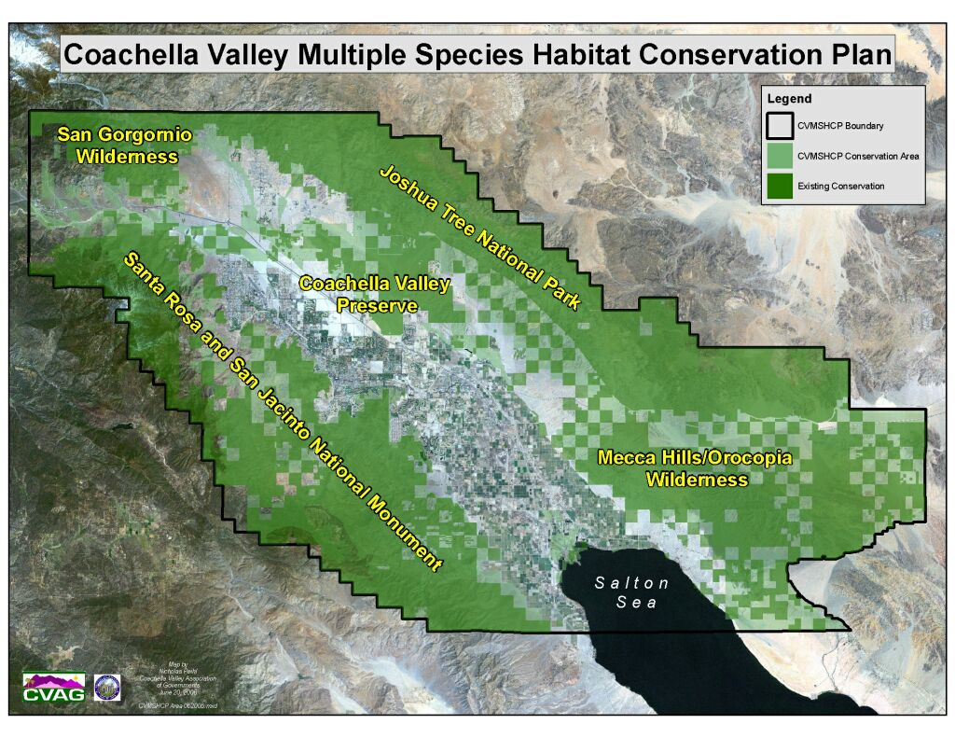
Figure 1: Coachella Valley Multiple Species Habitat Conservation Plan Boundary in relationship to Joshua Tree National Park, the Santa Rosa and San Jacinto National Monument, the Coachella Valley USFWS Preserve, Wilderness areas, and the Salton Sea.

This comprehensive land planning essentially protects the ecological drivers and processes to enhance sustainability of community biodiversity. The plan is science-based and investigates hypotheses related to the persistence of species on conservation lands through adapting monitoring and management. The Coachella Valley is situated in the Colorado Desert which is situated on the northwest portion of the much larger Sonoran Desert, and consists of a variety of habitats. One hundred miles east of Los Angeles, it is bordered on the west by the San Jacinto, San Gorgonio, and Santa Rosa Mountain Ranges. The Valley lies at the northwest boundaries of the Colorado Desert, and to the east of the Valley lies the popular Salton Sea. The Coachella Valley is an extremely arid desert region that is characterized by aeolian sand communities, fan palm oases, creosote shrub, alluvial fan, and salt scrub communities.
Precipitation is the primary driver for vegetation growth in the Coachella Valley, which experiences both summer and winter precipitation events. Rains are highly variable from year to year, but tend to be more frequent at the far west of the Coachella Valley, due to the rain shadow of the San Jacinto, Santa Rosa, and San Bernardino mountain ranges. This causes a gradient of increasing temperature and aridness from west to east, as elevation decreases. During rare monsoonal events in July to September, rare monsoonal events that originate in the Gulf of Mexico, bring heavy but isolated thunderstorms to the Valley. During average years, the vast amount of reliable moisture comes from winter rains, which originate in the northwest and move into the area in October through May, contributing the greatest proportion of the annual rainfall.

Purpose
The Mecca Hills and Orocopia Mountains Conservation Area Vegetation Map was funded by the Coachella Valley Conservation Commission to provide data on characteristics of the vegetation within the Mecca Hills and Orocopia Mountains Conservation Area, and to complement concurrent species and habitat monitoring. The outdated map of the Coachella Valley MSHCP areas, created before 1999, was based on the Holland classification system and was inconsistent with current standards prescribed by CDFW’s Vegetation Classification and Mapping Program (VegCaMP). As part of the CVMSHCP/NCCP monitoring program, a phased work plan to remap all 746,000 acres of Conservation Areas began in 2012. This mapping unit, 112,775 acres, includes wildlife corridors which traverse Interstate 10 to the north and provide a critical corridor between the Peninsular and Transverse mountain ranges. The completion of the Mecca Hills and Orocopia Mountains map updates the CVMSHCP/NCCP natural community map, which was outdated and unrefined beyond the community level. This section of the map provides critical information to assist in monitoring habitat suitability in conservation areas, and quantifies attributes to help researchers understand the effects of environmental variability, including drought and climate change. An updated vegetation map was required to enhance understanding of species and their habitats, and identify management needs to ensure persistence of target species within the Plan area. The updated vegetation map is an essential element of monitoring for other covered species and natural communities and provides a baseline to monitor natural communities and landscape-scale vegetation change. Quantification of biotic habitat variables help document factors that may influence species population fluctuation. These data are key to conservation of biological diversity in the Plan area, especially given the impacts of increasing periods of drought and the effects of climate change. Understanding habitat requirements for species will help to guide the development of land management actions that support recovery and sustainability of healthy populations. Data produced under this effort is publicly available and supports concurrent CVMSHCP/NCCP monitoring.

Reconnaissance Vegetation Assessment

Between February 2013 and February 2015, (with additional surveys in low-confidence areas in November 2015), CCB staff conducted several surveys throughout the mapping area as a reconnaissance of vegetation types. These field visits allowed CCB staff to better match vegetation types detected on aerial imagery to the actual vegetation found on the ground. Photo interpreters identified photo signatures by evaluating ecological characteristics of each vegetation type relation to landscape characteristics such as topographic features. Multiple field trips were completed as training exercises with Joshua Tree National Park vegetation ecologists, so that crews would correlate the vegetation classification descriptions with CNPS and CDFW protocols, to better interpret photo signatures and actual ground conditions in the same manner as mapping classifications completed in the past.

The CNPS California Native Plant Society/Department of Fish and Game Protocol for Combined Vegetation and Rapid Assessment and Relevé Sampling Field Form was used for relevé surveys in the study area (CNPS 2011, 2014). The study area was traversed on foot and by vehicle, and vegetation was assessed at optimal and accessible points, sited according to relevé plot protocol. Because the vegetation map was being built simultaneously to biodiversity surveys, opportunistic reconnaissance points (hereafter “vegetation assessment plots” or “VA plots”) were taken at study sites when monitoring for various species (including Le Conte’s Thrasher, Mecca Hills aster and Orocopia sage). A significant effort was made to access areas where little was known about the vegetation types from previous visits, or where few reconnaissance points existed. At each point, vegetation type and cover were documented, along with the GPS point and other habitat attributes, such as non-native species cover, anthropogenic alteration, and roadedness (Appendix A: VAP Plot Database 2015). In some areas, non-native species are so prevalent that they are the dominant cover within the ecosystem and are recognized as distinctive vegetation types in California, including Bromus rubens / Schismus barbatus Semi-Natural Herbaceous Stands and Tamarix spp. Semi-natural Shrubland Stands (Sawyer et al. 2009) however, none of these were mapped in this study area. In sum, 186 VA plots were collected for this study area, plus an additional 39 plots targeted specifically at identifying Xylorhiza cognata (Mecca aster) populations, enabling delineation of stands of the Xylorhiza cognata Provisional Alliance.

Delineation Rules

Lines were drawn both to distinguish between distinguish between vegetated and non-vegetated areas, and within vegetated areas, alliance and association types to produce the map (Figure 2, Appendix A, B). Photo interpreters drafted boundaries separating vegetation types (Alliances) at 1:1500 scale and attributed other categories using VA plot information and relevant datasets. Absolute cover and relative cover were documented within VA plots to better assist photo interpreters with delineating boundaries. Percent cover was quantified for tree cover, shrubs cover, and as applicable during the drought, for the herbaceous cover. Cover was quantified as non-vegetated habitat (<2%), low (0-2%), medium (2-15%), or high range (15-25%) and those values are included in the VAP geodatabase component. Some coordinates for plots such as those done specifically for Xylorhiza cognata surveys fall outside of the plot boundaries due to the extremely steep vertical habitat of X. cognata. For these surveys, the cover estimates, as they currently stand, apply to the coordinate location of the point, and any associated/adjacent Xylorhiza cognata Provisional Alliance polygon was assigned and delineated separately. To better focus on conservation of particular habitats, there are several alliances where the minimum mapping unit (MMU) is less than an acre; including Prosopis glandulosa Woodland Alliance (MMU = 0.5 acres), Washingtonia filifera Shrubland Alliance (MMU = 0.34 acres), and Xylorhiza cognata Provisional Alliance (no MMU if there is sufficient cover to map the alliance). In contrast to other conservation areas in the CVMSHCP, there were no areas classified as aeolian sand fields, ephemeral sand fields, or stabilized sand fields.
The time period best represented by this map is the year 2013. However, as a living map, in subsequent versions, polygons or divisions that can be refined will be flagged for additional review as part of an ongoing quality control check and/or for a possible field visit during species-specific surveys. A comprehensive quality control effort was conducted by senior GIS staff to finalize polygons, and geodatabase domains (Alliance, Common Name, Association, Group and Macrogroup). Field VA plots and photo interpretation were then published into a database and continuous QC checks will be performed to identify errors or discrepancies as monitoring continues in these areas, and incorporated into the final geodatabase. Polygons will be regularly reviewed, updated, or flagged for further field visits as part of ongoing monitoring within the mapping area, and periodic updates may be published.

Classification

The map classification is based largely on work done in areas for previous and ongoing projects: Vegetation Mapping of Anza-Borrego Desert State Park and Environs (1998), the
Western Riverside County MSHCP Vegetation Map (2004), Vegetation of Joshua Tree National Park (2012), and the Vegetation Map in Support of the Desert Renewable Energy Conservation Plan (2012). Several provisional alliances were identified during this study, based on relevé plot observations and subsequent classification, and these will be proposed to the NVCS, including the Atriplex canescens--Atriplex polycarpa Shrubland Provisional Alliance, the Psorothamnus schottii Provisional Alliance, the Salvia greatae Provisional Alliance (target species) and the Xylorhiza cognata Provisional Alliance (target species). The nested hierarchy, including the Macrogroup and Group, was based on the National Vegetation Classification System (Federal Geographic Data Committee 2008); specifically, the recommendations of Evens (2014) to align the NVCS with the Manual of California Vegetation (Sawyer et al. 2009).

Alliances and Landscape Attributes Identified

Alliance Common Name | % of Study Area | % of Vegetated | Area, acres | Area, ha | # Poly gons
Allscale scrub | 0.05 | 0.1 | 58.3 | 23.6 | 2
Anderson's boxthorn scrub | 0.36 | 1.0 | 410.2 | 166.0 | 20
Blue palo verde - Ironwood woodland | 9.55 | 25.0 | 10770.1 | 4358.5 | 189
California brittle bush scrub | 1.51 | 4.0 | 1705.1 | 690.0 | 41
California fan palm oasis | 0.00 | 0.0 | 0.3 | 0.1 | 1
Catclaw acacia thorn scrub | 0.59 | 1.5 | 665.3 | 269.2 | 74
Cheesebush scrub | 0.40 | 1.1 | 454.6 | 184.0 | 21
Creosote bush - brittle bush scrub | 11.29 | 29.5 | 12730.1 | 5151.7 | 119
Creosote bush - white burr sage scrub | 5.51 | 14.4 | 6209.1 | 2512.7 | 106
Creosote bush scrub | 5.97 | 15.6 | 6729.1 | 2723.2 | 237
Desert Gold -- Spiny Herb Desert Pavement Annual Herbaceous Alliance | 0.01 | 0.0 | 12.5 | 5.0 | 2
Desert lavender scrub | 0.01 | 0.0 | 16.1 | 6.5 | 4
Desert willow woodland | 0.68 | 1.8 | 769.5 | 311.4 | 12
Disturbed/built-up | 0.04 | 0.1 | 41.5 | 16.8 | 2
*Fourwing saltbush - Allscale scrub | 0.01 | 0.0 | 6.4 | 2.6 | 2
Fourwing saltbush scrub | 0.00 | 0.0 | 5.6 | 2.3 | 4
*Mecca aster scrub | 0.01 | 0.0 | 14.5 | 5.9 | 29
Mesquite bosque, mesquite thicket | 0.00 | 0.0 | 1.8 | 0.7 | 3
Mojave yucca scrub | 0.03 | 0.1 | 31.9 | 12.9 | 6
Non-vegetated Habitat (less than 2% absolute cover) | 61.74 | -- | 69628.2 | 28177.6 | 195
*Orocopia sage scrub | 0.00 | 0.0 | 1.7 | 0.7 | 3
*Schott's indigobush scrub | 1.51 | 3.9 | 1700.3 | 688.1 | 42
Smoke tree woodland | 0.46 | 1.2 | 521.2 | 210.9 | 19
White bursage scrub | 0.26 | 0.7 | 292.1 | 118.2 | 16
*Provisional Alliance

Associations Identified
Acacia greggii--Ambrosia salsola Association
Ambrosia dumosa Association
Ambrosia salsola--Psorothamnus schottii Association
Larrea tridentata Association
Larrea tridentata--Ambrosia dumosa Association
Larrea tridentata--Ambrosia dumosa--Encelia farinosa Association
Larrea tridentata--Ambrosia dumosa--Psorothamnus schottii--Encelia farinosa Association
Larrea tridentata--Ambrosia salsola--Psorothamnus schottii Association
Larrea tridentata--Encelia farinosa--Ambrosia dumosa Shrubland Association
Larrea tridentata--Encelia farinosa--Ambrosia salsola--Psorothamnus schottii Association
Larrea tridentata--Encelia farinosa--Psorothamnus schottii--Association
Non-vegetated Habitat / Larrea tridentata Association
Non-vegetated Habitat / Larrea tridentata--Ambrosia dumosa Association
Phragemytes australis / Ambrosia salsola Association
Acacia greggii / Xylorhiza cognata Association
Ambrosia dumosa--Atriplex hymenelytra Association
Ambrosia dumosa--Hyptis emoryi Association
Ambrosia dumosa--Salvia greatae Association
Ambrosia salsola--Larrea tridentata Association
Atriplex canescens--Atriplex polycarpa--Atriplex hymenelytra Association
Atriplex canescens--Xylorhiza cognata Shrubland Alliance
Atriplex polycarpa--Ambrosia salsola Association
Atriplex polycarpa--Larrea tridentata Association
Chilopsis linearis / Ambrosia salsola Association
Chilopsis linearis--Parkinsonia florida Association
Chilopsis linearis--Psorothamnus spinosus Association
Encelia farinosa Association
Encelia farinosa--Atriplex hymelytra Association
Encelia farinosa--Psorothamnus schottii / Paarkinsonia florida Association
Encelia farinosa--Salvia greatae Association
Hyptis emoryii--Encelia farinosa Association
Larrea tridentata - Psorothamnus schottii Association
Larrea tridentata--Ambrosia dumosa--Atriplex spp. Shrubland Alliance
Larrea tridentata--Encelia farinosa Association
Larrea tridentata--Encelia farinosa--Fouquieria splendens Association
Larrea tridentata--Salvia greatae Association
Larrea tridentata--Xylorhiza cognata Association
Non-vegetated habitat / Encelia farinosa Association
Non-vegetated habitat / Larrea tridentata Association--Xylorhiza cognata Association
Non-vegetated habitat / Xylorhiza cognata Association
Olneya tesota / Larrea tridentata--Encelia farinosa Association
Olneya tesota / Psorothamnus schottii Association
Parkinsonia florida / Acacia greggii Association
Parkinsonia florida / Acacia greggii--Hyptis emoryi Association
Parkinsonia florida / Ambrosia salsola Association
Parkinsonia florida / Bebbia juncea Association
Parkinsonia florida / Bebbia juncea--Encelia farinosa--Salvia greatae Association
Parkinsonia florida / Encelia farinosa Association
Parkinsonia florida / Hyptis emoryi Association
Parkinsonia florida / Larrea tridentata--Ambrosia dumosa Association
Parkinsonia florida / Larrea tridentata--Encelia farinosa Association
Parkinsonia florida / Lycium andersonii Association
Parkinsonia florida / Psorothamnus schottii Association
Parkinsonia florida--Chilopsis linearis / Prosopsis glandulosa Association
Parkinsonia florida--Olneya tesota / Acacia greggii Association
Parkinsonia florida--Olneya tesota / Atriplex (canescens & polycarpa) Association
Parkinsonia florida--Olneya tesota / Psorothamnus schottii Association
Parkinsonia florida--Olneya tesota Association
Parkinsonia florida--Olneya tesota--Psorothamnus spinosus Association
Parkinsonia florida--Psorothamnus spinosus / Chilopsis linearis Association
Parkinsonia florida--Psorothamnus spinosus / Hyptis emoryi Association
Parkinsonia florida--Psorothamnus spinosus / Prosopsis glandulosa Association
Psorothamnus schottii--Ambrosia salsola--Salvia greatae Association
Psorothamnus schottii--Larrea tridentata Association
Yucca schidigera--Larrea tridentata--Ambrosia dumosa Association

Mecca Hills-Orocopia Mountains Alliance Map
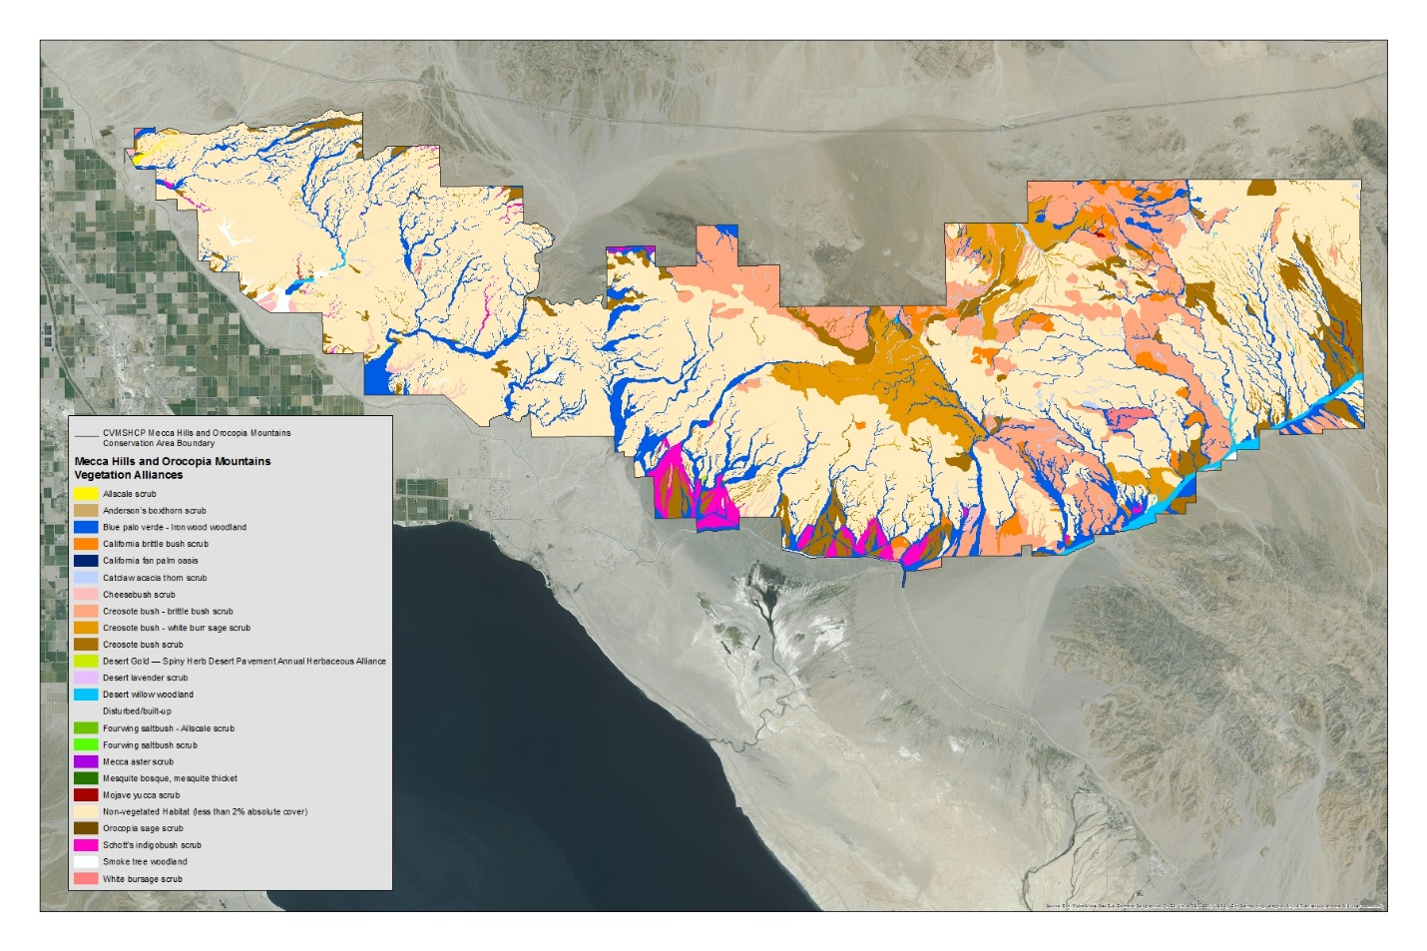
Figure 2: National Vegetation Classification System vegetation Alliances in the Mecca Hills-Orocopia Mountains Conservation Area. See Appendix B for full-size PDF.

References

CNPS. 2011. California Native Plant Society – Vegetation Rapid Assessment Protocol. CNPS Vegetation Committee (Revised). Available online at: http://www.cnps.org/cnps/vegetation/pdf/protocol-rapid_assess.pdf

CNPS. 2014. California Native Plant Society/Department of Fish and Game Protocol for Combined Vegetation and Rapid Assessment and Relevé Sampling Field Form. Available online at: http://www.cnps.org/cnps/vegetation/pdf/protocol-combined-2014.pdf
Evens, Julie M. 2014. Integrating the FGDC National Classification System (NVC) Standard with the CNPS/CDFG Manual of California Vegetation, second edition. Agreement Number G12AC20142 Final Report. Available online at: https://www.fgdc.gov/grants/2012CAP/InterimFinalReports/142-12-5-CA-FinalReport.pdf

Federal Geographic Data Committee. 2008. National Vegetation Classification Standard,
Version 2. Vegetation Subcommittee, FGDC-STD-005-2008. Available at:
http://usnvc.org/wp-content/uploads/2011/02/NVCS_V2_FINAL_2008-02.pdf
Sawyer, John O., Todd Keeler-Wolf, and Julie Evens. 2009. Manual of California Vegetation. California Native Plant Society Press.

Appendices

Appendix A: Orocopia Mountains and Mecca Hills Vegetation Geodatabase 2015
Geodatabase components:
“MecOro_VAP” (VAP database)
“MecOro_VegCover” (Vegetation Alliance Polygons)
File name and type: CVAG_MeccaOrocopiaVegMap_2015.gdb
ArcGIS 10.1 Geodatabase

Appendix B: Orocopia Mountains and Mecca Hills Vegetation Alliance Map
File name and type: UCR_CCB_MeccaOrocopia_Veg_Alliances2015.pdf
PDF

Appendix C: Metadata containing attribute definitions for the MecOro_VegCover component of the geodatabase.
File name and type: Geodatabase metadata Mecca Orocopia Veg Map CVMSHCP 2015.docx

