**Topaz Solar Farm Conservation Lands**

**Habitat Mitigation and Monitoring Plan**

2015 Annual Report

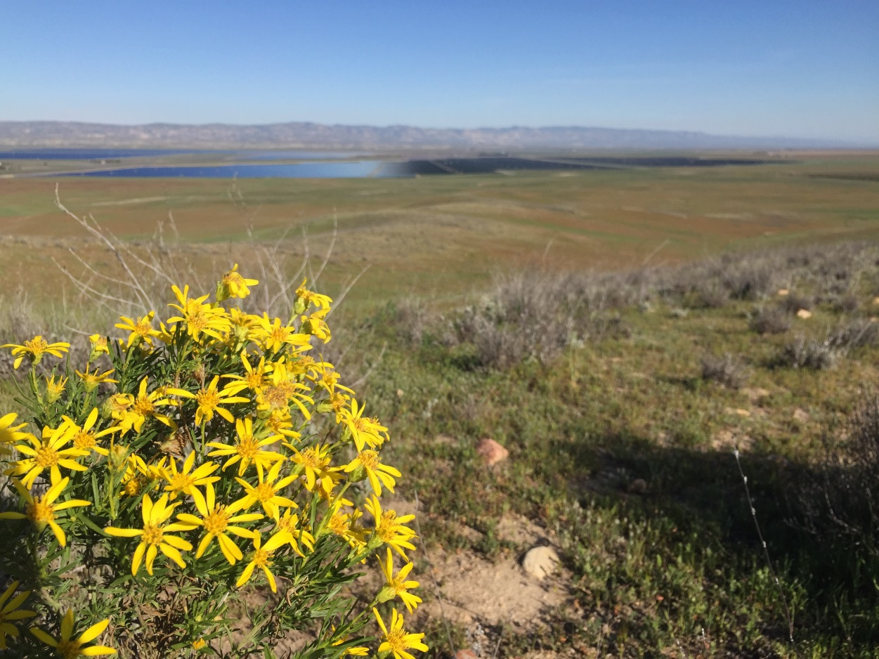

**North Carrizo Ecological Reserve**

California Department of Fish and Wildlife

Region 4

1234 E. Shaw Avenue  
Fresno, CA 93710

Topaz Solar Farm

BHE Renewables

10400 Helios Way

Santa Margarita, CA 93453

**July 8, 2016**

Table of Contents

Introduction 6

Surveys 8

Task Reporting Requirement 8

Task Status 8

Task Check List 10

Management Plan Task Outline with Results (Section 6 of HMMP) 18

6.3 Biological Elements: Goals 18

*6.3.1* *Biological Element: San Joaquin Kit Fox* 18

*6.3.2* *Biological Element: Blunt-nosed Leopard Lizard* 20

*6.3.3* *Biological Element: Giant Kangaroo Rat* 20

*6.3.4* *Biological Element: Listed Fairy Shrimp* 21

*6.3.5* *Biological Element: Nelson’s Antelope Squirrel* 22

*6.3.6* *Biological Element: Mountain Plover* 22

*6.3.7* *Biological Element: Burrowing Owl* 23

*6.3.8* *Biological Element: Other Special Status Birds* 24

*6.3.9* *Biological Element: Special Status Amphibians* 24

6.3.10 Biological Element: Pronghorn and Tule Elk 25

6.3.11 Biological Element: Rare Plants 27

*6.3.12* *Biological Element: Habitat Types* 27

6.4 Management Elements: Goals 30

*6.4.1* *Management Element: Grazing Program* 30

*6.4.2* *Management Element: Habitat Restoration* 31

*6.4.3* *Management Element: Noxious Weed Control* 33

*6.4.4* *Management Element: Fire Management* 34

*6.4.5* *Management Element: Feral Animal Control* 34

*6.4.6* *Management Element: Predatory Animal Control* 34

6.5 Maintenance Elements: Goals 35

*6.5.1* *Maintenance Element: Ranch Roads* 35

*6.5.2* Ranch Roads Task 3a: Review ranch road conditions and locations and develop a ranch road plan. *CDFW staff used GPS receivers to accurately map all the roads. A ranch road plan for the NCER is currently under development and will be finalized in 2015. Maintenance Element: Watering Facilities* 35

*6.5.3* *Maintenance Element: Fences* 37

Monitoring Plan Task Outline with Results (Section 7 of HMMP) 37

7.1 General Implementation Monitoring 37

7.2 Biological Monitoring 38

7.3 Management Activities Monitoring 38

7.4 Rangeland Condition Monitoring 38

Adaptive Management (Section 8 of HMMP) 39

8.1 Preserve Land Management Element: Adaptive Management 39

*8.1.1* *Adaptive management program* 39

*8.1.2* *Performance plan* 39

Table of Figures

Figure 1. Topaz mitigation lands and phasing map. As of July 23 2013, all phases had transferred to CDFW. 6

Figure 2. A San Joaquin kit fox detected by remote camera on the NCER. 18

3. Giant kangaroo rats were detected on cameras in the southeastern portion of the NCER. 19

Figure 4. CDFW lands that were surveyed for GKR precincts in 2015. 20

Figure 5. Flocks of Mountain Plovers were observed on the NCER on December 24, 26, and 29, 2015. 22

Figure 6. Proposed fence construction and retrofitting on the NCER. Green lines indicate fences that were completed by the end of 2014. Diagram courtesy of MidAmerican Solar. 24

Table of Tables

Table 1. Timing of HM Lands Transfer to CDFW 7

Table 2. HMMP Task Check List. A summary of tasks required by the HMMP is provided, including whether it was conducted in 2015, the persons that conducted each task, and the persons responsible to make sure the task was completed. 10

# Introduction

The Topaz Solar Farm Project (Project) is a solar energy development project that involved the installation of photovoltaic (PV) modules and related facilities over an area approximately 3,510 acres in size. The Project was evaluated under the California Environmental Quality Act (CEQA) in an Environmental Impact Report (EIR) entitled “*Topaz Solar Farm Project Conditional Use Permit DRC2008‐00009 (State Clearinghouse No. 2008091026)*” certified by the County of San Luis Obispo (County) on July 12, 2011. Because of Project related impacts to San Joaquin kit fox (*Vulpes macrotis mutica*), a species listed as threatened under the California Endangered Species Act (CESA), the Project also secured incidental take coverage from the California Department of Fish and Wildlife (CDFW) in the form of a State Incidental Take Permit (2081-2011-04-04), executed on September 2, 2011. The Incidental Take Permit (ITP) required, in part, the permanent protection and management of 12,168 acres of Habitat Management (HM) lands, also known as “mitigation lands” or “compensation lands” in associated documents, including this report. The Permittee (FirstSolar initially, then MidAmerican (now BHE Renewables) after the project was sold to the latter entity) had several options in the ITP for “permanent protection” of the compensation lands. They elected to transfer the lands in fee to CDFW after first recording a Conservation Easement with non-merger language in favor of CDFW. The balance of the HM lands was transferred to CDFW in 2013. The total 12,168 acres will collectively be referred to as the North Carrizo Ecological Reserve (NCER) in this report. CDFW will formally designate these lands as the North Carrizo Ecological Reserve at some time in the future and the name will be officially changed at that time. The County and U.S. Fish and Wildlife Service (Biological Opinion 81420-2011-F-0625 issued to the Army Corps of Engineers) also required habitat compensation lands to comply with CEQA, the Clean Water Act, and the Federal Endangered Species Act, respectively. The permanent protection of the 12,168 acres also satisfies a portion of the mitigation obligations set forth by these agencies with permitting authority over the Project.

The ITP allowed the HM lands to be transferred in phases. Specifically, for each of the six construction phases of the Project, prior to initiating ground or vegetation disturbing activities or other Covered Activities for that phase, the Permittee was required to acquire and permanently preserve at least 3.45 acres of HM lands for each acre of Covered Species habitat expected to be permanently impacted during the next construction phase, plus a 15% buffer. As of July 23, 2013, all phases (Phases 1-6) had transferred to CDFW (Figure 1). Table 1 below shows the timing of each land transaction. In 2015, 12,168 acres, or 100% of the total mitigation lands were owned and managed by CDFW.

Table 1. Timing of HM Lands Transfer to CDFW

|  |  |  |
| --- | --- | --- |
| **Phase** | **Date Recorded** | **Mitigation Acres** |
| Phase 1 | December 16, 2011 | 321 |
| Phase 2 | May 2, 2012 | 756 |
| Phase 3 | May 2, 2012 | 3,900 |
| Phase 4 | December 19, 2012 | 3,641.86 |
| Phase 5A | May 16, 2013 | 606.59 |
| Phase 5B | July 23, 2013 | 1,361.22 |
| Phase 6A | July 23, 2013 | 1,505.65 |
| Phase 6B | July 23, 2013 | 76.09 |
| Total |  | 12,168.41 |

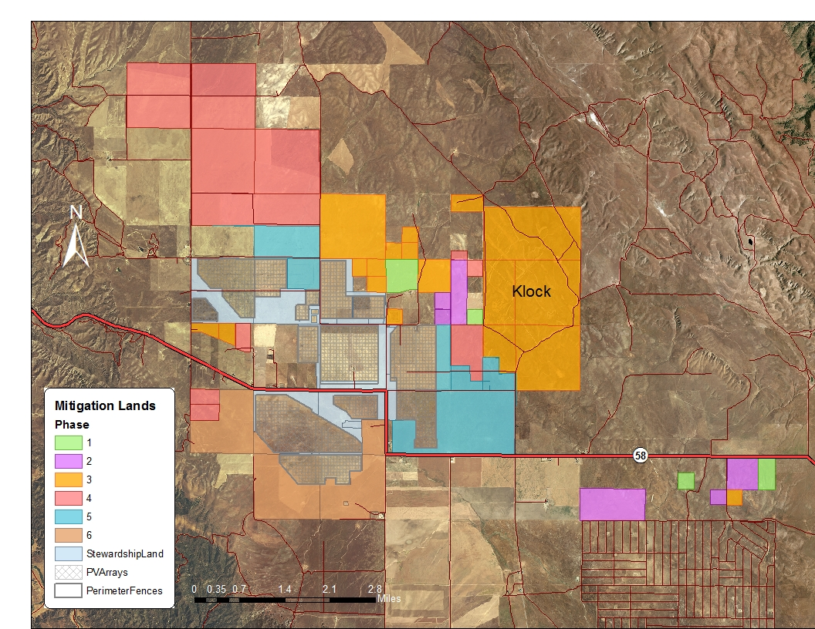

Figure . Topaz mitigation lands and phasing map. As of July 23 2013, all phases had transferred to CDFW.

This Annual Report provides information of annual activities and habitat conditions for lands owned and administered by CDFW in 2015. Drought conditions in the northern Carrizo Plain delayed several management activities including weed surveys and shrub restoration plantings. The rainfall totals for the 2014-2015 rain year (July1 –June 30) were 3.75 inches on the Carrizo Plain National Monument and 5.12 at the La Panza weather stations. These values are well below the rainfall averages for these areas and represent the third rain year in a row of below average rainfall.

As of January 1, 2013, the California Department of Fish and Game (DFG or CDFG) became the California Department of Fish and Wildlife (CDFW). Please note that references to CDFG or DFG in previously referenced documents (including but not limited to the HMMP) are references to CDFW.

## Surveys

Biologists from CDFW visited the NCER lands frequently in 2015 to conduct surveys for wildlife and to assess range condition. CDFW biologists conducted biological surveys throughout the year. In August and November, spotlighting surveys for San Joaquin kit fox were conducted on the property, as well as bird and wildlife surveys.

## Task Reporting Requirement

The Topaz Solar Farm’s Habitat Mitigation and Monitoring Plan (HMMP) prescribes management goals and tasks for the Preserve lands. One of these tasks is production of this HMMP annual report, as stated in Section 6.1. GM Task 2a, which also prescribes the content of this report:

**General Monitoring Task 2a**: The Annual Report for the NCER lands shall be written by the CDFW Land Manager and presented to CDFW, USFWS, and the Conservation Groups. All monitoring results from Tasks specified in this HMP shall be supplied to the CDFW Land Manager to be incorporated into the Annual Report. The report shall be prepared to professional standards and sent as a printed document or electronic documents to CDFW, USFWS, and the Conservation Groups by February 1st of the year following reporting period. Information in the report shall include a discussion of NCER land condition, status of special status species, a residue pattern map showing range condition, results from tasks that require reporting, and a checklist showing completion or status of Task Checklist.

## Task Status

Tasks are defined in the Management Plan as follows: “Tasks are the individual projects or work elements which implement the goal and are useful in planning operation and maintenance budgets.” (Section 6.2 (7)).

This annual report includes information regarding management tasks. The following task checklist (Table 2) presents each task and whether it was addressed during the reporting period. Following the task checklist, the management plan sections that outline the tasks are provided, abbreviated for convenience. This outline includes results, information, and notes regarding the status of each task. The results, information, and notes are in ***boldface italics*** within the outline.

## Task Check List

Table 2. HMMP Task Check List.  A summary of tasks required by the HMMP is provided, including whether it was conducted in 2015, the persons that conducted each task, and the persons responsible to make sure the task was completed.

| **Task** | **Plan reference** | **Source element** | **Task**  **conducted by** | **Responsible**  **Party** | **Frequency** | **Conducted in 2014** |
| --- | --- | --- | --- | --- | --- | --- |
| **Biological Elements** | | | | | | |
| **SJKF Task 1a**  **Maintain kit fox habitat** | 6.3.1 | San Joaquin kit fox | Manager  Grazing operator | Preserve Manager | Ongoing | Yes |
| **SJKF Task 2a**  **Coordinate depredation** | 6.3.1 | San Joaquin kit fox | Preserve Manager | Preserve Manager | As needed | N/A |
| **SJKF Task 3a**  **Inspect escape dens** | 6.3.1 | San Joaquin kit fox | Qualified biologist | Preserve Manager | Three years | N/A |
| **SJKF Task 3b**  **Repair escape dens** | 6.3.1 | San Joaquin kit fox | Qualified biologist | Preserve Manager | Three years | N/A |
| **SJKF Task 4a**  **Monitor kit fox** | 6.3.1 | San Joaquin kit fox | Qualified biologist | Preserve Manager | Annual | Yes |
| **SKJF Task 5a**  **Evaluate kit fox status** | 6.3.1 | San Joaquin kit fox | Qualified biologist | Preserve Manager | Annual | Yes |
| **BNLL Task 1a**  **Reptile survey** | 6.3.2 | Blunt-nosed leopard lizard | Qualified biologist | Preserve Manager | Five years | N/A1 |
| **GKR Task 1a**  **Look for GKR** | 6.3.3 | Giant kangaroo rat | Qualified biologist | Preserve Manager | Annual | Yes |
| **GKR Task 1b**  **Map GKR** | 6.3.3 | Giant kangaroo rat | Qualified biologist | Preserve Manager | Annual | Yes |
| **GKR Task 2a**  **Discuss in annual report** | 6.3.3 | Giant kangaroo rat | Qualified biologist | Preserve Manager | Annual | Yes |
| **GKR Task 3a**  **Manage grassland** | 6.3.3 | Giant kangaroo rat | Grazing operator | Preserve Manager | Annual | Yes1 |
| **FS Task 1a**  **Protect fairy shrimp pools** | 6.3.4 | Fairy shrimp | Grazing operator | Preserve Manager | Annual | N/A3 |
| **AS Task 1a**  **Look for antelope squirrel** | 6.3.5 | Antelope squirrel | Qualified biologist | Preserve Manager | Five years | Yes |
| **MP Task 1a**  **Look for mountain plover** | 6.3.6 | Mountain plover | Qualified biologist | Preserve Manager | Five years | Yes |
| **BUOW Task 1a**  **Maintain burrowing owl habitat** | 6.3.7 | Burrowing owl | Grazing operator | Preserve Manager | Annual | Yes1 |
| **BUOW Task 2a**  **Look for burrowing owls** | 6.3.7 | Burrowing owl | Qualified biologist | Preserve Manager | Five years | Yes |
| **SSB Task 1a**  **Look for and report special status birds** | 6.3.8 | Special status birds | Qualified biologist | Preserve Manager | Five years | Yes |
| **SSA Task 1a**  **Protect toad pools** | 6.3.9 | Special status amphibian | Preserve Manger/  grazing operator | Preserve Manager | Ongoing | N/A3 |
| **SSA Task 2a**  **Look for amphibians** | 6.3.9 | Special status amphibian | Qualified biologist | Preserve Manager | Five years | N/A3 |
| **Pronghorn and Tule Elk Task 1a**  **Fence enhancement and removal** | 6.3.10 | Pronghorn and Tule Elk | Fence contractor | Preserve Manager | Complete in three years | Yes |
| **Pronghorn and Tule Elk Task 1b**  **Seed salt bush** | 6.3.10 | Pronghorn and Tule Elk | Seeding contractor | Preserve Manager | Once | No1 |
| **Pronghorn and Tule Elk Task 1c**  **Maintain shrub cover** | 6.3.10 | Pronghorn and Tule Elk | Grazing operator | Preserve Manager | Ongoing | Yes |
| **Pronghorn and Tule Elk Task 1d**  **Allow supplemental feed** | 6.3.10 | Pronghorn and Tule Elk | Pronghorn advocates | Preserve manager | As needed | Yes |
| **Rare Plants Task 1a**  **Identify rare plant populations** | 6.3.11 | Rare plants | Qualified biologist | Preserve Manager | Five years | No1 |
| **Grassland Task 1a**  **Graze grassland per standards** | 6.3.12 | Annual grassland | Grazing operator | Preserve Manager | Annual | N/A2 |
| **Grassland Task 2a**  **Protect rare plants** | 6.3.12 | Annual grassland | Preserve Manager | Preserve Manager | Ongoing | N/A2 |
| **Grassland Task 3a**  **Control noxious weeds** | 6.3.12 | Annual grassland | Herbicide applicator | Preserve Manager | Ongoing | N/A |
| **Grassland Task 5a**  **Monitor grassland habitat** | 6.3.12 | Annual grassland | Preserve Manager | Preserve Manager | Annual | N/A |
| **Buckwheat Scrub Task 1a**  **Manage grazing to maintain buckwheat scrub habitat** | 6.3.12 | Buckwheat scrub | Grazing operator | Preserve Manager | Annual | N/A2 |
| **Buckwheat Scrub Task 2a**  **Adjust grazing duration and intensity** | 6.3.12 | Buckwheat scrub | Grazing operator | Preserve Manager | Annual | N/A2 |
| **Vernal Pool Task 1a**  **Time grazing to protect pools** | 6.3.12 | Vernal pool | Grazing operator | Preserve Manager | Annual | N/A2 |
| **Vernal Pool Task 1b.**  **Remove exotic aquatic animals** | 6.3.12 | Vernal pool | Qualified biologist | Preserve Manager | Ongoing | N/A3 |
| **Vernal Pool Task 1c**  **Avoid pesticides** | 6.3.12 | Vernal pool | Preserve Manager | Preserve Manager | Ongoing | N/A3 |
| **Bunchgrass Task 1a**  **Manage vegetation** | 6.3.12 | Bunchgrass grassland | Grazing operator | Preserve Manager | Annual | No2 |
| **Management Elements** | | | | | | |
| **Grazing Task 1a.**  **Meet RDM targets** | 6.4.1 | Grazing | Grazing operator | Preserve Manager | Annual | Yes |
| **Grazing Task 1b**  **Predict range condition, adjust stocking rate** | 6.4.1 | Grazing | Grazing operator | Preserve Manager | Annual | Yes2 |
| **Grazing Task 2a**  **Move salt licks** | 6.4.1 | Grazing | Grazing operator | Preserve manager | Annual | N/A2 |
| **Grazing Task 3a**  **Fire management** | 6.4.1 | Grazing | Grazing operator | Preserve Manager | Ongoing | Yes |
| **Grazing Task 4a**  **Prevent erosion** | 6.4.1 | Grazing | Grazing operator | Preserve Manager | Annual | Yes |
| **Grazing Task 5a**  **Promote soil stability** | 6.4.1 | Grazing | Grazing operator | Preserve Manager | Annual | Yes |
| **Grazing Task 6a**  **Manage restoration areas** | 6.4.1 | Grazing | Grazing operator | Preserve Manager | Annual | No* |
| **Grazing Task 7a**  **Fence construction** | 6.4.1 | Grazing | Contractor | Preserve Manager | As needed | Yes |
| **Grazing Task 8a**  **Corral construction** | 6.4.1 | Grazing | Contractor | Preserve Manager | As needed | N/A |
| **Habitat Restoration Task 1a**  **End farming** | 6.4.2 | Habitat restoration | Preserve Manager | Preserve Manager | Ongoing | Yes |
| **Habitat Restoration Task 1b**  **Increase native species** | 6.4.2 | Habitat restoration | Grazing operator | Preserve Manager | Annual | N/A |
| **Habitat Restoration Task 2a**  **Seed salt bush** | 6.4.2 | Habitat restoration | Seeding contractor | Preserve Manager | Once | No1 |
| **Habitat Restoration Task 2b**  **Maintain shrub cover** | 6.4.2 | Habitat restoration | Grazing operator | Preserve Manager | Annual | Yes |
| **Habitat Restoration Task 2c**  **Measure salt bush density, remediate if necessary** | 6.4.2 | Habitat restoration | Qualified biologist | Preserve Manager | Five years | N/A |
| **Habitat Restoration Task 3a**  **Conduct vegetation sampling in restoration areas** | 6.4.2 | Habitat restoration | Rangeland manager | Preserve Manager | Annual | No |
| **Habitat Restoration Task 4a**  **Remove fences** | 6.4.2 | Habitat restoration | Contractor | Preserve Manager | Complete within three years | Yes |
| **Habitat Restoration Task 5a**  **Enhance fences** | 6.4.2 | Habitat restoration | Contractor | Preserve Manager | Complete within three years | Yes |
| **Habitat Restoration Task 6a**  **Allow appropriate research** | 6.4.2 | Habitat restoration | Biologist | Preserve Manager | Ongoing | Yes |
| **Habitat Restoration Task 7a**  **Remove abandoned compounds** | 6.4.2 | Habitat restoration | Contractor | Preserve Manager | Once | Yes |
| **Habitat Restoration Task 8a No trespassing signs** | 6.4.2 | Habitat restoration | Preserve Manager or contractor | Preserve Manager | Ten years | Yes |
| **Habitat Restoration Task 8b Interpretative sign** | 6.4.2 | Habitat restoration | Contractor | Preserve Manager | Fifteen years | No |
| **Weed Task 1a**  **Weed surveys** | 6.4.3 | Weeds | Qualified biologist | Preserve Manager | Two years | No |
| **Weed Task 1b**  **Control infestations** | 6.4.3 | Weeds | Herbicide applicator | Preserve Manager | As needed | No |
| **Weed Task 1b**  **Mow weeds** | 6.4.3 | Weeds | Contractor |  | Annual | No |
| **Weed Task 1c**  **Prevent introductions** | 6.4.3 | Weeds | Preserve Manager | Preserve Manager | Ongoing | Yes |
| **Fire Task 1a**  **Graze to manage fuels** | 6.4.4 | Fire Management | Preserve Manager | Preserve Manager | Annual | N/A |
| **Fire Task 1b**  **Mow firebreaks** | 6.4.4 | Fire Management | Preserve Manager | Preserve Manager | Annual | N/A |
| **Feral animal control Task 1a**  **Consult with CDFW** | 6.4.5 | Feral animal control | DFG/  Federal trapper | Preserve Manager | As needed | N/A |
| **Predatory Animal Task 1a**  **Consult with CDFW** | 6.4.5 | Predatory animal control | Preserve Manager | Preserve Manager | As needed | N/A |
| **Maintenance Elements** | | | | | | |
| **Ranch Roads Task 1a**  **Maintain roads** | 6.5.1 | Ranch roads | Contractor | Preserve Manager | As needed | N/A |
| **Ranch Roads Task 2a**  **Survey for special status animals** | 6.5.1 | Ranch roads | Qualified biologist | Preserve Manager | As needed | N/A |
| **Ranch Roads Task 2b**  **Protect special status animals** | 6.5.1 | Ranch roads | Contractor | Preserve Manager | As needed | N/A |
| **Ranch roads Task 3a**  **Ranch Road Plan** | 6.5.5 | Ranch roads | Preserve Manager | Preserve Manager | Once | Yes |
| **Water Facilities Task 1a**  **Regular maintenance** | 6.5.2 | Watering facilities | Contractor | Preserve Manager | As needed | Yes |
| **Water Facilities Task 2a**  **Install watering sites** | 6.5.2 | Watering facilities | Contractor | Preserve Manager | As feasible | Yes |
| **Water Facilities Task 3a**  **Pronghorn waterers** | 6.5.2 | Watering facilities | Contractor | Preserve Manager | At least one per year for ten years | Yes |
| **Fence Task 1a**  **Maintain fences** | 6.5.3 | Fences | Contractor | Preserve Manager | Annual | Yes |
| **Monitoring Plan** | | | | | | |
| **General Monitoring Task 1a**  **Complete annual checklist** | 7.1 | General monitoring | Preserve Manager | Preserve Manager | Annual | Yes |
| **General Monitoring Task 2a**  **Annual Report** | 7.1 | General monitoring | Preserve Manager | Preserve Manager | Annual | Yes |
| **General Monitoring Task 2b**  **Annual meeting** | 7.1 | General monitoring | Preserve Manager | Preserve Manager | Annual | No |
| **Rangeland Monitoring Task 1a**  **Rangeland inspection** | 7.4 | Rangeland monitoring | Certified Range Manager | Conservation Easement Holder | Annual | Yes |
| **Rangeland Monitoring Task 1b**  **Assess rangeland condition** | 7.4 | Rangeland monitoring | Certified Range Manager | Preserve Manager | Annual | Yes |
| **Adaptive Management** | | | | | | |
| **Adaptive Management Task 1a**  **Assimilate and report** | 8.1.1 | Adaptive management | Qualified biologist/ Preserve Manager | Preserve Manager/  Conservation Easement Holder | Annual | Yes |
| **Adaptive Management Task 1b**  **Implement approved changes** | 8.1.1 | Adaptive management | Preserve Manager | Preserve Manager | Annual | Yes |
| **Adaptive Management Task 1c** | 8.1.1 | Adaptive management | Preserve Manager | Preserve Manager | Annual | Yes |

**1** Drought conditions made it not necessary/possible to conduct this task

**2** Livestock grazing was not necessary to maintain habitat due to the ongoing

**3** Drought conditions resulted in no development of vernal pools

# Management Plan Task Outline with Results (Section 6 of HMMP)

## Biological Elements: Goals

### *6.3.1 Biological Element: San Joaquin Kit Fox*

**SJKF Goal 1:** Maintain and enhance habitat.

SJKF Task 1a:Implement grazing and vegetation management

***Grazing of annual grasses by cattle did not occur on the NCER. Residual dry matter (RDM) levels were within the specified parameters, therefore grazing was not needed to maintain or enhance kit fox habitat on the NCER lands.***

**SJKF Goal 2:** Manage the NCER to reduce the impact of predators on San Joaquin kit fox.

SJKF Task 2a: Coordinate appropriate depredation activities when predation of SJKF is shown to need intervention.

***No depredation activities were necessary.***

**SJKF Goal 3:** Maintain artificial escape dens installed as part of the Topaz Solar Farm applicant proposed measures on the NCER.

SJKF Task 3a: Inspect condition of each escape den pipe, soil cover, and entrance once every three years

***This goal does not apply to CDFW as no artificial escape dens were installed on the NCER. Escape dens were installed on the Topaz project and stewardship land in 2013.***

Task 3b: If escape dens are not functioning to allow kit fox entrance and exclude larger canids, repair escape den.

***This goal does not apply to CDFW as no artificial escape dens were installed on the NCER. Escape dens were installed on Topaz project and stewardship land in 2013.***

**SJKF Goal 4:** Monitor the population of San Joaquin kit fox on the NCER.

SJKF Task 4a: Conduct annual monitoring surveys on the NCER to examine presence, population trends, and behavior of San Joaquin kit fox.

***Spotlighting surveys were conducted in August and November 2015 on the NCER. Five San Joaquin kit foxes and two badgers were detected during spotlighting surveys.***

***In May-June and November-December 2015, the Endangered Species Recovery Program (ESRP) staff live-trapped and fitted GPS or VHF collars on 5 kit foxes on the NCER as part of a project investigating kit fox use of the solar facility and adjacent reference sites. Seven foxes were captured on the solar site itself. New GPS collars were deployed on 5 of the foxes. This additional information on foxes using Topaz project and stewardship lands (lands between the solar arrays that are owned and managed by the solar company) will be very beneficial in understanding kit fox use of the California Valley area on a population-level scale.***

**SJKF Goal 5:** Evaluate data collected and discuss in relation to SJKF and the management of its habitat.

SJKF Task 5a**:** Annual Report to include San Joaquin kit fox data collected and discussion.

***Although only a total of 5 San Joaquin kit foxes were sighted during spotlighting surveys, it was noted that these*** ***sightings were proportionally higher than those from standardized kit fox spotlighting surveys on the Carrizo and Elkhorn Plains. Additionally, the average number of kit foxes observed during spotlighting on the NCER has remained consistent at between 2 and 2.5 foxes per route. Kit fox numbers in general have decreased dramatically due to the extended drought in the region. However, in the northern Carrizo where kit foxes are not dependent on giant kangaroo rats, kit fox numbers appear to be stable.***

***So far the number of foxes detected during spotlighting has not been a good indication of the number of foxes using the property, as evidenced by the live trapping that has occurred within the same years. Standardized camera trapping was initiated in late 2015 to supplement spotlighting data. Kit foxes were readily detected on remote cameras across the NCER (Fig. 2).***

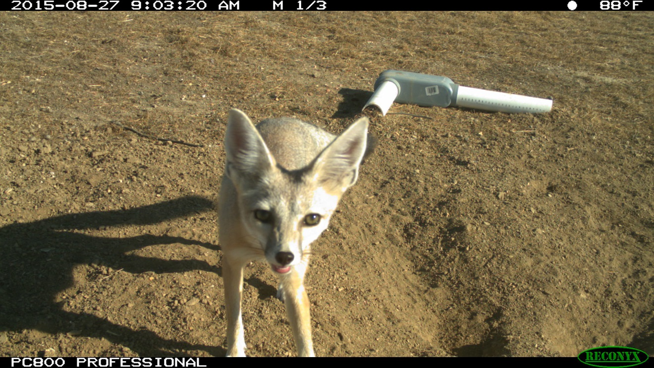

Figure . A San Joaquin kit fox detected by remote camera on the NCER.

### *6.3.2 Biological Element: Blunt-nosed Leopard Lizard*

**BNLL Goal 1:** Survey for reptiles on NCER once every five years to inform management decisions.

BNLL Task 1a:Conduct visual inspections on the NCER for reptiles once every five years.

***BNLL surveys were not required to be conducted in 2015. Standardized BNLL surveys will be conducted Reserve-wide in 2016.***

### *Biological Element: Giant Kangaroo Rat*

**GKR Goal 1:** Preserve and protect giant kangaroo rat populations on the NCER.

GKR Task 1a:Monitor distribution and density of precincts of GKR populations on the NCER annually.

***Giant kangaroo rat precincts as well as individuals were observed on the NCER in 2015. Due in part to the extreme drought, GKR sign was not extensive and was not individually mapped. Individuals were also detected using remote cameras (Fig. 3). The area surveyed is circled in yellow in Figure 2 below. Standardized surveys will be conducted in 2016 for GKR precincts. Active precincts will be marked and recorded using a GPS. Additionally, trapping may be used to confirm GKR distribution and activity.***

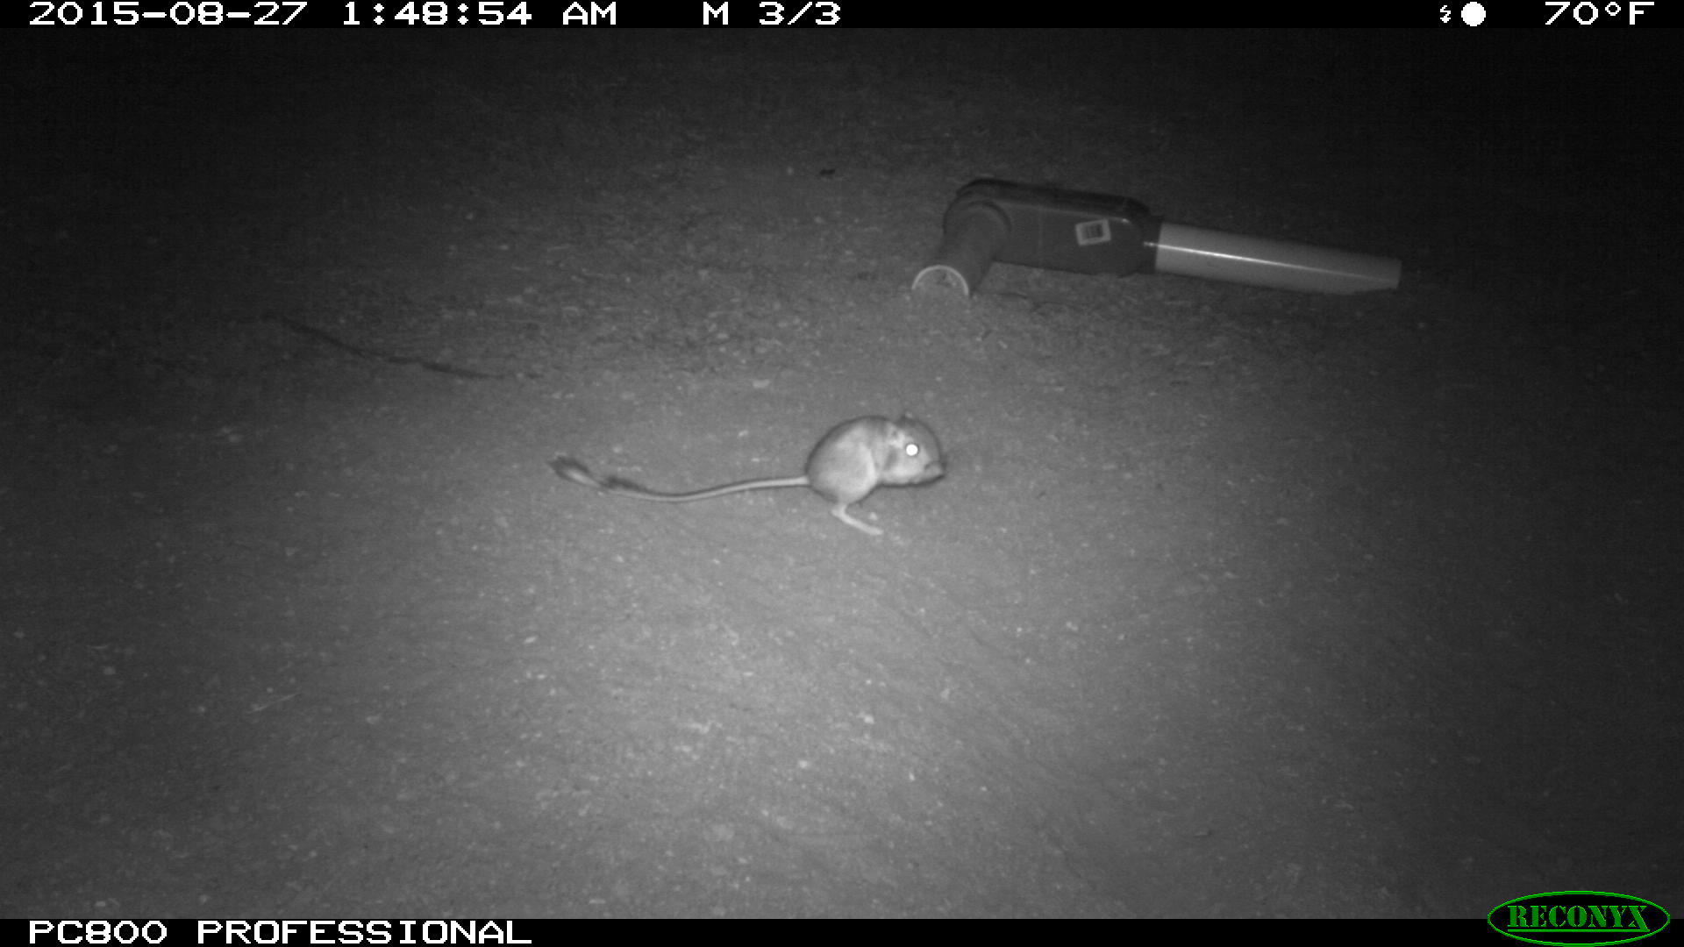

3. Giant kangaroo rats were detected on cameras in the southeastern portion of the NCER.

GKR Task 1b: Prepare a map of all known localities of listed GKR on the NCER.

***A general map of known GKR localities was prepared in 2015 (Fig. 4).*** 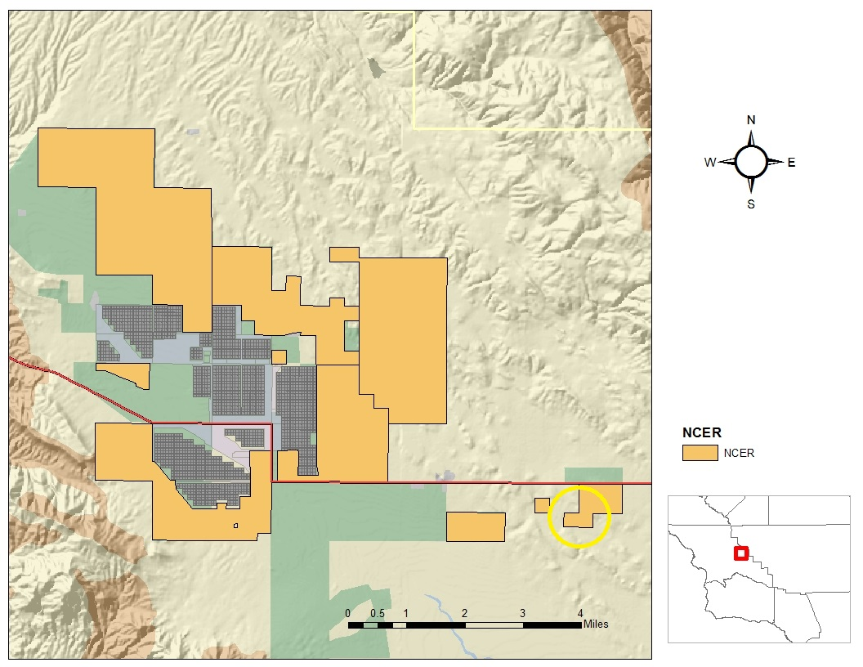

Figure . CDFW lands that were surveyed for GKR precincts in 2015.

**GKR Goal 2:**  Evaluate data collected and discuss in relation to GKR and the management of its habitat.

GKR Task 2a: Annual Report.

***Several of the precincts observed appeared to be active. Further surveys and exploratory small mammal trapping will be conducted in 2016 in order to resolve current GKR distribution on these parcels.***

**GKR Goal 3:** Maintain habitat on the NCER in condition appropriate for use by GKR.

GKR Task 3a:Manage vegetation to promote habitat conditions preferred by GKR and other rare grassland species.

***No grazing of annual grasses by cattle occurred on the NCER. The range conditions were well below target parameters for GKR on the NCER.***

### *Biological Element: Listed Fairy Shrimp*

**Fairy Shrimp Goal 1:** Preserve and protect fairy shrimp habitat on the NCER.

FS Task 1a: Control access by livestock to fairy shrimp habitat during wet conditions when standing water is present or soil is saturated.

***The vernal pool fairy shrimp (Branchinecta lynchi) is known from numerous vernal pools occurring in the Phase 6 parcels of the NCER (See Figure 1). However, rainfall totals were too low in 2015 to create the favorable ponding conditions needed by these branchiopods. Due to low precipitation and a corresponding lack of vegetative growth, no livestock grazing occurred on the NCER in 2015.***

### *Biological Element: Nelson’s Antelope Squirrel*

**Antelope Squirrel Goal 1:** Monitor the NCER once every five years for the presence of Nelson’s antelope squirrel (*Ammospermophilus nelsoni*) colonies.

AS Task 1a:Conduct visual inspections throughout the NCER for Nelson’s antelope squirrel colonies.

***Standardized Nelson’s antelope squirrel surveys were not conducted on parcels owned by CDFW in 2015. Opportunistic surveys were conducted on most of the property but no antelope squirrels were detected. Standardized antelope squirrel surveys will be conducted on the NCER in 2016.***

### *Biological Element: Mountain Plover*

**Mountain Plover Goal 1:**  Monitor the mountain plover wintering population on the NCER.

Mountain Plover Task 1a: Conduct monitoring surveys on the NCER once every five years for mountain plover presence.

***Both CDFW staff and staff from Althouse and Meade, Inc. biological consultants detected Mountain Plovers on NCER on December 24, 26, and 29, 2015 and observed over 160 birds total (Fig. 5).***

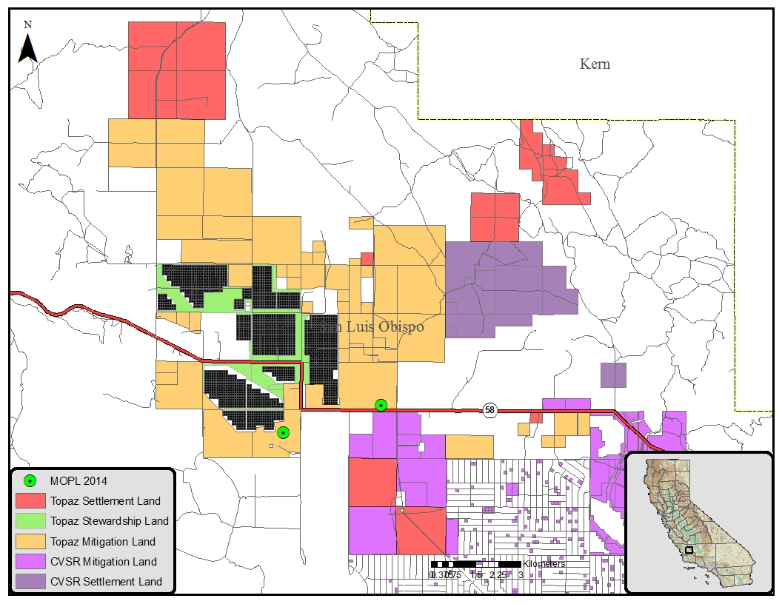

Figure 5. Flocks of Mountain Plovers were observed on the NCER on December 24, 26, and 29, 2015.

### *Biological Element: Burrowing Owl*

**Burrowing Owl Goal 1:** Maintain upland grassland habitat in appropriate condition for use by burrowing owl.

BUOW Task 1a:Manage vegetation to promote habitat conditions preferred by burrowing owl and other rare species.

***Grazing of annual grasses by cattle did not occur on the NCER. Grazing occurred prior to fee title transfer to CDFW. Low precipitation in 2015 resulted in low primary production making vegetation management by cattle grazing unnecessary to maintain appropriate burrowing owl habitat conditions over most of the property.***

**Burrowing Owl Goal 2:** Monitor the burrowing owl population on the NCER.

BUOW Task 2a:Conduct surveys of the NCER at five year intervals to determine burrowing owl nesting locations.

***Opportunistic burrowing owl surveys were conducted in 2015. Large numbers of wintering burrowing owls were encountered during spotlighting in November 2015. Though nesting activity was documented in 2015, no successful reproduction was documented on the NCER.***

### *Biological Element: Other Special Status Birds*

**Special Status Birds Goal 1:** Monitor use of the NCER by special status birds.

SSB Task 1a: Conduct bird surveys once every five years on the NCER in a manner suitable to detect special status bird species.

***Opportunistic special status bird surveys were conducted in 2015. Aside from Burrowing Owls and Mountain Plovers, we observed Golden Eagles, Short-eared Owls, and Loggerhead Shrikes on the property. Standardized bird surveys will be initiated in 2016.***

### *Biological Element: Special Status Amphibians*

**Special Status Amphibians Goal 1:** Maintain breeding ponds and upland grassland habitat.

SSA Task 1a: Control access by livestock to amphibian breeding ponds during wet conditions when standing water is present or soil is saturated.

***Rainfall totals were too low in 2015 to create the favorable ponding conditions needed by special status amphibians. Due to low precipitation and a corresponding lack of vegetative growth, no livestock grazing occurred on the NCER in 2015.***

**Special Status Amphibians Goal 2:** Monitor special status amphibian populations on the NCER.

SSA Task 2a:Survey suitable ephemeral aquatic habitat for presence of Western spadefoot toad or other special status amphibians once every five years, or during years with average or above-average rainfall.

***Visual and dip-net surveys for special status amphibians were not conducted in 2015 because rainfall totals were too low to create the favorable ponding conditions needed by special status amphibians.***

* + 1. Biological Element: Pronghorn and Tule Elk

**Pronghorn and Tule Elk Goal 1:** Maintain and enhance habitat for pronghorn and elk on the NCER.

PT Task 1a: Implement fence enhancement and/or removal on the NCER to increase permeability across the landscape.

***Approximately 39 miles of fence has been removed from the NCER and approximately 39 miles of fence has been enhanced or installed since the fence work was initiated in 2012. Removed fence included old fence materials and hogwire or field fence. Much of the fence removed was cross fence from the interior portions of the NCER. Enhanced fence included fence that was salvageable and needed maintenance but did not need full replacement. The majority of this occurred along Bitterwater Road, State Route 58, and in Sections 23 and 26 to the east of Topaz Solar Farms (Fig. 6). A 4-strand, wildlife friendly fence specification was chosen for all new and enhanced fence construction (Fig. 7). All fence work was monitored by Althouse and Meade, Inc. biologists.***

***A total of 45 pronghorn (9 bucks, 30 does, and 6 fawns) were observed in the North Carrizo herd in 2015. A total of 173 tule elk (34 males, 117 females, and 22 calves) were observed in the North Carrizo herd in 2015.***

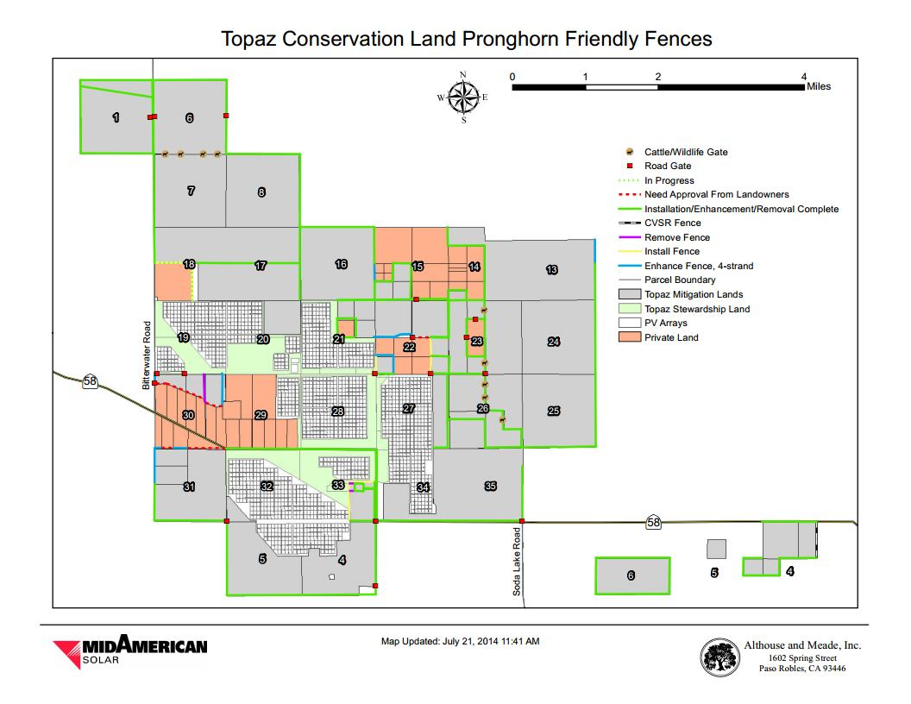

Figure 6. Proposed fence construction and retrofitting on the NCER. Green lines indicate fences that were completed by the end of 2014. Diagram courtesy of MidAmerican Solar.



Figure 7. Wildlife friendly 4-strand fence specifications. From the handbook “A Landowner’s Guide to Wildlife Friendly Fences” by the Montana Department of Fish, Wildlife and Parks (2012).

PT Task 1b: Seed as per producer’s recommendation in patches to produce approximate cover of 5-30 percent within patches.

***No seeding activities were performed by CDFW. In 2013, CDFW staff identified priority shrub restoration sites on the property. Shrub seeds were purchased in 2013 but conditions were so dry on the property in 2014 and 2015 that any seeding activities will be postponed until more favorable conditions exist. Seeding is planned for 2016.***

PT Task 1c: Maintain shrub cover in perpetuity at approximately 5 to 30% within patches utilizing grazing management, and restoration activities including reseeding if necessary due to fire, drought or other circumstance.

***Existing shrub cover was maintained at current levels. No new shrub areas have been established yet on the NCER.***

PT Task 1d: If pronghorn are at risk of starvation due to drought or other natural cause, allow supplementary feed to be placed on the NCER.

***Supplemental feeding of pronghorn (Anitlocapra americana) was performed on a limited basis in Spring/Summer 2014. Extreme drought conditions during 2014 coupled with large scale retirement of dryland agricultural lands in the area resulted in low amounts of forb availability for pronghorn. Alfalfa was placed in feeding troughs for pronghorn in areas of the NCER that were close to water sources. Pronghorn did utilize the provided feed. The pronghorn seemed to sustain themselves mostly on low quantities of late season forbs in 2015.***

* + 1. Biological Element: Rare Plants

**Rare Plant Goal 1:** Investigate the distribution and abundance of rare plants on the NCER.

RP Task 1a: A qualified botanist shall conduct seasonally appropriate surveys for rare plants on the NCER once every five years, or during years with average or above-average rainfall.

***Botanical surveys were conducted on the NCER by the CDFW Vegetation Community Mapping Program (VegCAMP) crew in 2013 and 2014. Precipitation levels were very low in 2013 and 2014 and plant germination was correspondingly low. More extensive botanical surveys were performed on the NCER in 2015.***

### *Biological Element: Habitat Types*

1. **California Annual Grassland**

**Grassland Goal 1:**  Maintain and enhance grassland habitat in condition appropriate for use by San Joaquin kit fox and other arid grassland species.

Grassland Task 1a:Manage vegetation to promote habitat conditions preferred by San Joaquin kit fox and other arid grassland species.

***Due to low precipitation and a corresponding lack of vegetative growth, the standards were met and no active vegetation management was needed this year.***

**Grassland Goal 2:** Protect rare plant populations on the NCER.

Grassland Task 2a: Install protective fencing, or adjust vegetation management regime as guided by routine monitoring surveys.

***Protective fencing and vegetation management adjustments were not necessary because precipitation levels were very low in 2015 and plant germination was correspondingly low. Due to low precipitation and a corresponding lack of vegetative growth, no livestock grazing occurred on the NCER in 2015. A rare plant survey will be performed during a year of average or better rainfall in order to maximize the chances of detecting rare plant species and protective fencing will be installed around sensitive populations as needed.***

**Grassland Goal 3:** Minimize presence of noxious weeds on the NCER.

Grassland Task 3a: Implement management strategies to minimize or eliminate populations of noxious weeds on the NCER.

***Weed management activities were not necessary in 2015. Precipitation levels were very low in 2015 and plant germination was correspondingly low. An invasive weed survey will be performed during a year of average or better rainfall in order to maximize the chances of accurately detecting and mapping weed populations on the NCER.***

**Grassland Goal 4:** Monitor grassland habitat annually throughout the NCER during fall months to ensure RDM targets are met (see Section 7.4).

***Due to extremely low rainfall totals for rain year 2014/2015 (and correspondingly low primary production), RDM targets were visually assessed and determined to be well below target values.***

**Grassland Goal 5**: Monitor grassland habitat throughout the NCER.

Grassland Task 5a:Conduct vegetation sampling once every five years in grassland areas throughout the NCER.

***During the spring of 2015, vegetation sampling and mapping were not performed. These activities are planned for 2016 but may be postponed until a year of average or better rainfall in order to accurately map the vegetation communities***

1. **Buckwheat Scrub**

**Buckwheat Scrub Goal 1:** Maintain buckwheat scrub in locations where it is naturally occurring.

Buckwheat Scrub Task 1a: Manage grazing to maintain buckwheat scrub habitat.

***Some of the mitigation parcels acquired by CDFW in 2013 contained buckwheat scrub habitat. However, low precipitation in 2014 and 2015 resulted in low primary production making vegetation management by cattle grazing unnecessary in areas with buckwheat habitat.***

Buckwheat Scrub Task 1b: Adjust grazing duration and intensity to allow recovery of buckwheat scrub. Use residue pattern map in Annual Report to compare aerial extent.

***No grazing occurred on the NCER in 2015, including lands that contained buckwheat scrub habitat.***

1. **Vernal Pools**

**Vernal Pool Goal 1:** Protect and enhance vernal pool and sag pond habitat for use by rare species and wildlife.

Vernal Pool Task 1a:Restrict grazing impacts on vernal pools during winter and spring breeding seasons for aquatic organisms.

***Rainfall totals were too low in 2015 to create the favorable grazing conditions. No grazing occurred on the NCER in 2015.***

Vernal Pool Task 1b: Coordinate exotic aquatic species eradication.

***Rainfall totals were too low in 2015 to create vernal pools. Therefore, there was no need for aquatic species eradication.***

Vernal Pool Task 1c: Protect aquatic habitats by avoiding the use of pesticides on the NCER.

***Rainfall totals were too low in 2015 to create vernal pools. Pesticides were not used on the NCER in 2015.***

1. **Bunchgrass Grassland**

**Bunchgrass Goal 1:** Increase the distribution and abundance of perennial native bunchgrass.

Bunchgrass Task 1a: Use vegetation management practices that consider the timing of flower and seed production of bunch grasses to avoid damage to the adult plants, maximize reproductive output, and facilitate germination and establishment of new plants.

***Perennial native bunchgrass management and restoration was not performed on the NCER in 2015. Precipitation levels were very low in 2015 and plant germination was correspondingly low. Therefore, conditions for native plant growth and restoration were inappropriate. Completion of plant surveys and vegetation mapping will help identify populations of bunchgrasses which will be the focus of management and restoration efforts in future years. The VegCAMP crew conducted vegetation surveys for all of the NCER in the spring of 2013and 2014 and will produced a vegetation map for the property in early 2015.***

## Management Elements: Goals

### *6.4.1 Management Element: Grazing Program*

**Grazing Goal 1:** Enhance habitat for endangered, rare, and common species, including pronghorn and tule elk.

Grazing Task 1a: The NCER land manager shall direct the rangeland program to meet RDM targets of 3-8 inch high grassland vegetation for San Joaquin kit fox, and shorter vegetation for giant kangaroo rat and blunt-nosed leopard lizard.

***Grazing was not necessary on the NCER in 2015. RDM levels were within the specified parameters.***

Grazing Task 1b: Assess grassland condition based on rainfall amounts in the winter and spring.

***RDM was visually estimated using methods from the Wildlands Solutions handbook (2008). RDM targets were estimated to be below the minimum target values of 500 pounds per acre due to extreme drought.***

**Grazing Goal 2:** Prevent overgrazing at salt licks

Grazing Task 2a: If grazing is occurring, routinely randomize placement of nutrient supplements (salt licks).

***Grazing did not occur on the NCER in 2015.***

**Grazing Goal 3:** Manage fuel load to minimize risk of fire.

Grazing Task 3a: The NCER land manager shall direct the Grazing Management program to meet fire management goals.

***Low precipitation for 2012, 2013, 2014, and 2015 as well as prior livestock grazing, resulted in low fire fuel levels on the Preserve lands. Therefore, fire management goals were met.***

**Grazing Goal 4:** Provide adequate ground cover to prevent wind and water erosion of soils.

Grazing Task 4a: If RDM monitoring data collected annually in the fall determines any area is less than the RDM target, the NCER manager shall direct the grazing program such that adequate ground cover is maintained to prevent wind and water erosion of soils.

***Grazing did not occur on the NCER in 2015 and RDM levels were estimated to be below 500 pounds per acre. However, it was determined that adequate ground cover was present on the NCER to prevent wind and water erosion of soils.***

**Grazing Goal 5:** Promote improved soil aggregate stability through increased soil organic matter, roots, and fungal associations.

Grazing Task 5a: This goal is met if minimum RDM targets are met annually. No specific monitoring shall be required for this goal.

***The minimum RDM targets were met.***

**Grazing Goal 6:** **Provide adequate cover to stabilize former croplands.**

Grazing Task 6a: Restoration of croplands will require managed grazing that may include no grazing for the first one or two years after cessation of plowing. The NCER land manager shall ensure appropriate grazing intensity is provided on restoration lands

***Grazing did not occur from 2013 to 2015 on the NCER or on retired croplands, therefore, adequate cover was provided to stabilize former croplands.***

**Grazing Goal 7:** Fence to protect NCER lands and manage grazing.

Grazing Task 7a: If necessary, fence with wildlife friendly fence, only those areas where fence control is necessary to protect NCER lands or manage vegetation.

***Though grazing did not occur from 2013 to 2015, wildlife friendly fence installation was initiated on the NCER in 2013 and continued through 2014 All fencing was completed in 2015. See Section 6.3.10.***

**Grazing** **Goal 8:** Corralling structures as needed to manage livestock on the NCER.

Grazing Task 8a: To facilitate gathering and transportation of livestock, construct the minimum number of corralling structures in appropriate locations near main roads and not near sensitive habitat areas.

***Grazing did not occur on the NCER in 2015. Therefore, corrals were not needed.***

### *Management Element: Habitat Restoration*

**Habitat Restoration Goal 1:** Implement habitat restoration measures designed to convert existing croplands to annual grassland habitat suitable for rare, endangered, and common wildlife and plants of the Carrizo region.

Habitat Restoration Task 1a: End farming on all mitigation lands. Allow natural recovery of grassland habitat.

***Farming ceased on the NCER in 2012. No subsequent grazing on those lands has occurred following the cessation of farming.***

Habitat Restoration Task 1b: Utilize managed grazing in concert with fencing as needed to promote native plant species growth and inhibit introduced plant species. Conduct grazing as needed to reach RDM targets for restored croplands.

***Grazing did not occur on the NCER in 2015. Low precipitation 2012-2015 resulted in little plant production of any kind on the retired croplands and little to no recruitment of introduced plant species. In 2015, RDM values were estimated to be at or below target levels on retired croplands and grazing was not necessary. Grazing will be utilized in the future, if needed, to maintain appropriate RDM levels on restored croplands.***

**Habitat Restoration Goal 2:** Create natural vegetation communities that include shrubs suitable as browse and cover for pronghorn.

Habitat Restoration Task 2a: Apply *Atriplex polycarpa,* *A. spinosa, A. spinifera, A. canescens, Baccharis pilularis, Ericameria linearifolia, and Isocoma menziesii* seed in patches covering 15 to 20 percent of 50 percent of the NCER as per producer’s recommendation.

***Shrub seeding did not occur on the NCER. Below average precipitation levels from 2012-2015 contributed to adverse conditions for shrub seeding, making it likely that any seeding efforts would result be unsuccessful.***

Habitat Restoration Task 2b: Maintain shrub cover at approximately 5 to 30 percent of total cover within shrub patches utilizing grazing management.

***Visual estimates indicate that there is currently very little shrub cover on the NCER (perhaps less than 5%). Shrub cover was maintained at those levels in 2015. Though shrub cover was not quantified in 2015, no livestock grazing occurred on the NCER and no net loss of shrub cover was documented. VegCAMP mapped all vegetation types on the NCER in 2013-14, including shrubs.***  ***From that survey, a determination of shrub cover density will be made.***

Habitat Restoration Task 2c: Every five years, conduct a survey of shrub habitat to determine density of shrub cover*.*

***A survey of shrub habitat did not occur in 2015. VegCAMP mapped all vegetation types on the NCER in 2013-14, including shrubs. From that survey, a determination of shrub cover density will be made.***

**Habitat Restoration Goal 3:** Monitor grassland habitat throughout the NCER.

Habitat Restoration Task 3a:Conduct vegetation sampling annually in restoration areas throughout the NCER.

***No restoration areas were established in 2015. Below average precipitation from 2012-2015 created inadequate conditions for restoration efforts. Therefore, vegetation sampling was not conducted on the NCER in 2015.***

**Habitat Restoration Goal 4:**  Remove fences that are not necessary for grazing management.

Habitat Restoration Task 4a: Identify all internal fences on the NCER and determine which fences are essential for vegetation management. Remove non-essential fences within 3 years of the establishment of each Phase.

***All internal fences were identified and evaluated to be retained, removed or enhanced. In total, approximately 8 miles of fence was removed. See Section 6.3.10.***

**Habitat Restoration Goal 5:** Enhance fences for wildlife movement at perimeter and any remaining internal fences on the NCER.

Habitat Restoration Task 5a:Enhance fences within three years.

***In total, approximately 11 miles of fence was enhanced or installed in 2014. Just gates and small sections of fencing were installed in 2015. Fence enhancement involved removal of old material and hogwire fencing and construction of new wildlife friendly fence. See Section 6.3.10 and Figure 6 of this report.***

**Habitat Restoration Goal 6:** Research Opportunities

Habitat Restoration Task 6a: Allow appropriate research authorized by CDFW and the USFWS to be conducted on the natural community present on the NCER.

***Research on San Joaquin kit fox by ESRP and MidAmerican was begun in December 2014 and continued through 2015.***

**Habitat Restoration Goal 7:** Removal of abandoned structures

Habitat Restoration Task 7a: Remove and dispose of abandoned structures, compounds, and debris consistent with County demolition permits and standards.

***Removal of abandoned structures began on the NCER in 2012 and was completed in 2013.***

**Habitat Restoration Goal 8:** Signage

Habitat Restoration Task 8a: Place signage on perimeter fencing at noticing frequency required to designate the NCER as restricted property (as applicable) with no trespassing allowed.

***Signage was ordered and placed on the NCER in 2013 and 2014.***

Habitat Restoration Task 8b: If determined appropriate by CDFW, and with approval of the County of San Luis Obispo and the USFWS, place an interpretative sign on the NCER.

***An interpretive sign was not placed on the NCER in 2015.***

### *Management Element: Noxious Weed Control*

**Weed Goal 1:** Monitor and control weeds on CDFG List A, CDFG List B, CDFA List C, and Cal-IPC Moderate and Limited rated species from the NCER.

Weed Task 1a: Conduct weed surveys over the entire NCER once every two years, when possible concurrent with botanical surveys conducted per Rare Plant Task 1a.

***No standardized weed surveys or management activities occurred on the NCER Preserve. However, one infestation of Russian knapweed was detected during routine activities. Precipitation levels were very low in 2015 and plant germination was correspondingly low. An invasive weed survey will be performed during a year of average or better rainfall in order to maximize the chances of detecting and mapping weed populations on the NCER.***

Weed Task 1b: The Preserve Manager shall implement approved management techniques to control infestations of noxious weeds identified in the Annual Report or otherwise observed on the NCER.

***One infestation of Russian knapweed was identified in 2013.***

Weed Task 1c: Prevent introduction of new weedy species as practicable

***Due to very low precipitation levels in 2015 as well as the recent cessation of dryland farming activities, the introduction of new weedy species was prevented/minimized in 2015.***

### *Management Element: Fire Management*

**Fire Goal 1:** Use grazing to manage fuels and reduce fire hazard potential.

Fire Task 1a: Manage vegetation to promote habitat conditions preferred by San Joaquin kit fox and other arid grassland species, and to reduce fuel load.

***Grazing was not necessary on the NCER. RDM targets were estimated to be below 500 pounds per acre, which does not pose an extreme fire hazard.***

**Fire Goal 2:** Mow firebreaks to prevent wildfires on the NCER.

Fire Task 2a: As determined necessary by the Preserve Manager, mow firebreaks along public roads or other areas of potential wildfire ignition to prevent wildfires on the NCER.

***Firebreaks were not mowed on the NCER. Additionally, firebreaks were not necessary due to the drought and lack of vegetative productivity.***

### *Management Element: Feral Animal Control*

**Feral Animal Control Goal 1:**  Minimize populations of feral animals, such as wild pigs or cats that could result in adverse effects on native wildlife species and habitat.

Feral Animal Control Task 1: If feral animal populations are deemed problematic to proper Preserve land function, the Preserve Manager shall work with CDFW to design and implement a feral animal control program.

***Feral animal control was not needed on the NCER.***

### *Management Element: Predatory Animal Control*

**Predatory Animal Control Goal 1:** Minimize populations of predatory animals on the NCER that are deemed a threat to the continued existence of rare and endangered species such as the SJKF.

Predatory Animal Control Task 1a: If predation of rare and endangered species is determined to be a threat to their continued existence and recovery, the NCER land manager shall work with CDFW to design and implement a predatory animal control program.

***Predatory animal control was not needed on the NCER. Data from the previous San Joaquin kit fox collaring study indicated that predation of kit foxes by bobcats occurred but not to an excessive degree. Therefore, predatory animal control is necessary in the area at this time.***

## Maintenance Elements: Goals

### *Maintenance Element: Ranch Roads*

**Ranch Roads Goal 1:** Maintain roads as necessary for management access.

Ranch Roads Task 1a: Use a road grader or other implement to maintain existing ranch roads in good working condition.

***Road maintenance actions did not occur on the NCER. Lack of substantial rainfall combined with low usage made road maintenance unnecessary.***

**Ranch Roads Goal 2**: Protect special status animal species from road maintenance operations.

Ranch Roads Task 2a: If road grading operations will consistently disturb more than six inches of ranch road bed depth, a qualified biologist familiar with all of the special status animal species in the NCER land shall survey the roadway work area immediately prior to maintenance using heavy equipment.

***Surveys were not necessary as the lack of substantial rainfall combined with low usage made road maintenance unnecessary.***

Ranch Roads Task 2b**:** If special status animal species are found in or near the work area, or are suspected to have the potential to enter the work area and be at risk, work will be postponed or suspended until such time as the work will have no potential to affect rare species.

***No work suspension was necessary as the lack of substantial rainfall combined with low usage made road maintenance unnecessary.***

**Ranch Roads Goal 3:** Develop ranch road plan

### Ranch Roads Task 3a: Review ranch road conditions and locations and develop a ranch road plan. *CDFW staff used GPS receivers to accurately map all the roads. A ranch road plan for the NCER is currently under development and will be finalized in 2015. Maintenance Element: Watering Facilities*

**Watering Facilities Goal 1:** Maintain watering facilities by regular inspections of equipment, pipes, and troughs, and repair as needed.

Watering Facilities Task 1a: NCER land manager will conduct regular inspections and repairs to watering facilities, as needed, as part of the on-going managed grazing operation.

***Watering facilities on the NCER were inspected regularly in 2015. The expansion of watering infrastructure is expected to occur prior to the commencement of livestock grazing on the NCER.***

**Watering Facilities Goal 2:** Installation of watering sites.

Watering Facilities Task 2a: Where allowed and appropriate develop new wells and water sources and install watering facilities usable by livestock, elk, and antelope. Proposed density is one per square mile.

***A total of 10 watering sites were installed across the NCER in 2013 primarily to provide water for pronghorn. All of the troughs were built as shallow, ground water troughs which make water available to all wildlife species. These troughs were maintained as needed during 2015. Location for permanent water sources were identified in 2015 with installation of watering facilities planned for 2016.***

**Watering Facilities Goal 3:** Improve watering sites for pronghorn antelope.

Watering Facilities Task 3a: Where practical, and on flat ground, install ground level water troughs near existing troughs using piping that provides water to ground level troughs when livestock troughs are turned off.

***A total of 10 pronghorn troughs were installed across the NCER in 2013 and maintained throughout 2015. Water for the tanks which supplied the troughs has been provided by MidAmerican. Species seen or known to have used the troughs include tule elk, pronghorn, black-tailed jackrabbit, and numerous bird species.***

Figure 8. One of 10 pronghorn watering troughs installed on the NCER in 2013.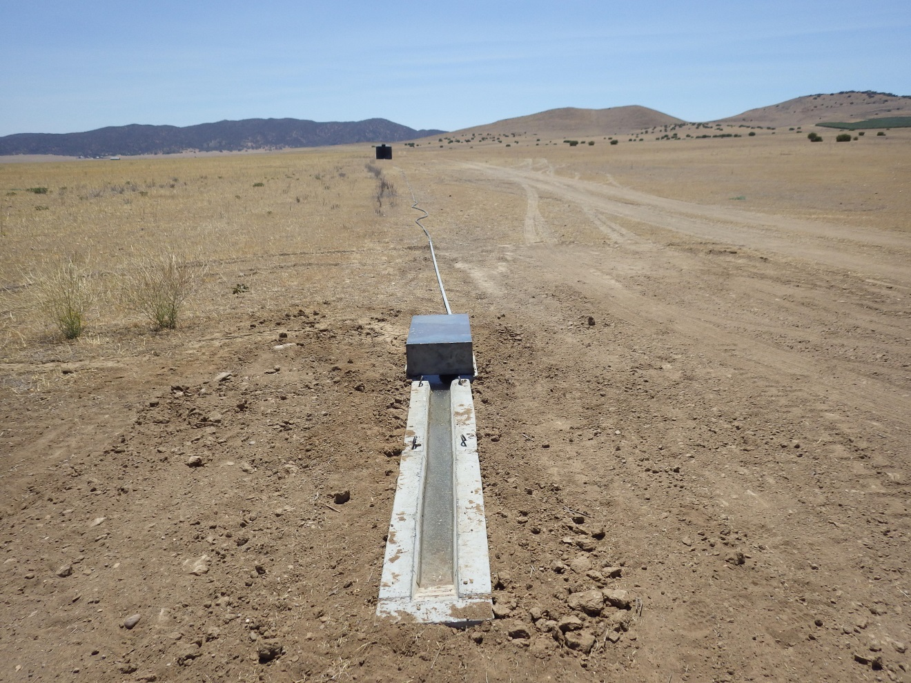

### *Maintenance Element: Fences*

**Fence Goal 1:** Maintain perimeter fencing of the NCER.

Fence Task 1a: Inspect and repair annually to maintain fences on the NCER land identified as essential for conservation management.

***See Section 6.3.10 of this report.***

# Monitoring Plan Task Outline with Results (Section 7 of HMMP)

## General Implementation Monitoring

**General Monitoring Goal 1:** Conduct annual monitoring of the NCER.

General Monitoring Task 1:Utilize the Management Plan Task List for annual inspections to determine if required tasks have been completed. Review task list and note status of all tasks for the year. Include completed checklist in Annual Report.

***Inspection of the Management Plan Task List occurred in 2015. The updated task list is included in this report as Table 1.***

**General Monitoring Goal 2:** Produce an Annual Report for the NCER.

General Monitoring Task 2a: Write Annual Report for the NCER.

***This report is the annual reporting of all activities conducted through December 2015 on the NCER. This report will be provided to the Permittee, Army Corps of Engineers, U.S. Fish and Wildlife Service, and San Luis Obispo County as well as any other interested parties. The Annual Report will also be available to the public on the CDFW website.***

General Monitoring Task 2b: Conduct an annual meeting at the NCER that includes representatives from USFWS to review Annual Report and status of the NCER.

***This is the third Annual Report for this property. A meeting will be scheduled with the appropriate parties for 2016.***

## Biological Monitoring

Biological resource monitoring tasks are described above in the Biological Elements section of this report. Biological monitoring tasks shall be accomplished as described in each Task, and results shall be included in the Annual Report.

## Management Activities Monitoring

Monitoring will be conducted as specified in those tasks: ranch roads, watering facilities, and fences. No additional tasks are required.

## Rangeland Condition Monitoring

**Rangeland Monitoring Goal 1:** Provide rangeland condition information for evaluation of grazing activity.

Rangeland Monitoring Task 1a: A qualified biologist shall conduct annual site inspections over the entire NCER to assess habitat condition.

***Rangeland condition was assessed qualitatively using visual estimation of RDM as described in the Wildlands Solutions handbook (2008). In the event that larger amounts of precipitation and primary productivity occur in 2016, RDM will be assessed both quantitatively and qualitatively.***

Rangeland Monitoring Task 1b: Assess NCER habitat condition based on rainfall amounts in the winter and spring, and habitat biomass in the spring. Adjust stocking rates as appropriate to meet fall RDM goals.

***Habitat condition was assessed in 2015. Rainfall amounts were extremely low leading to low levels of biomass on the NCER. At the writing of this report, the vegetation is still below RDM targets therefore grazing may not be needed in Spring 2016.***

# Adaptive Management (Section 8 of HMMP)

## 8.1 Preserve Land Management Element: Adaptive Management

### *8.1.1 Adaptive management program*

The purpose of an adaptive management program is to integrate management and monitoring to facilitate progress toward the biological goals and objectives of the NCER. Adaptive management provides flexibility to managers so that unforeseen or unusual events, conditions, or circumstances can be quickly addressed and the goals of protecting and promoting species that are the reason for the NCER are fulfilled.

### *8.1.2 Performance plan*

**Adaptive Management Goal 1:** Utilize information generated on the NCER and the best scientific information to adjust NCER land management to the benefit of rare native species.

Adaptive Management Task 1a: Preserve Manager and the Conservation Easement Holder shall review available information from monitoring tasks and studies conducted on the NCER and in the Carrizo Plain, along with pertinent scientific information regarding species and habitats on the NCER. Make recommendations in the Annual Plan for review by CDFW, the USFWS, and the County of San Luis Obispo, if modifications to Management Plan would improve management for rare species on the NCER. Conservation Easement Holder to provide information from monitoring tasks, and to review adaptive management recommendations.

***Continued kit fox habitat use data obtained from current and future studies will provide a feedback loop that will ideally allow CDFW biologists to fine tune the grazing of NCER to suit listed species such as kit fox and burrowing owl. Another component of adaptive management that will be invaluable will be the thorough mapping of vegetation communities on NCER by VegCAMP. Additionally, CDFW placed GPS collars on Tule elk in 2015 in order to help guide adaptive management. Plans are moving forward to place GPS collars on pronghorn in 2017.***

Adaptive Management Task 1b: If concurrence from all reviewing agencies is obtained for recommended changes in management on the NCER, implement changes.

***Analyses of data collected from GPS collars on Tule elk from 2005 to 2007 indicated that the elk preferentially used the former Klock property CRP lands. CRP lands are generally rangelands that are left ungrazed for a prescribed length of time. The results of the above studies were used to inform the decision to honor the existing CRP contract with the USDA on the former Klock property for the remaining 7 years of the contract. CDFW placed GPS collars on Tule elk in 2015 in order to help guide adaptive management. Data from this current project has also shown heavy elk use of the NCER, including the Klock unit (Fig. 10).***

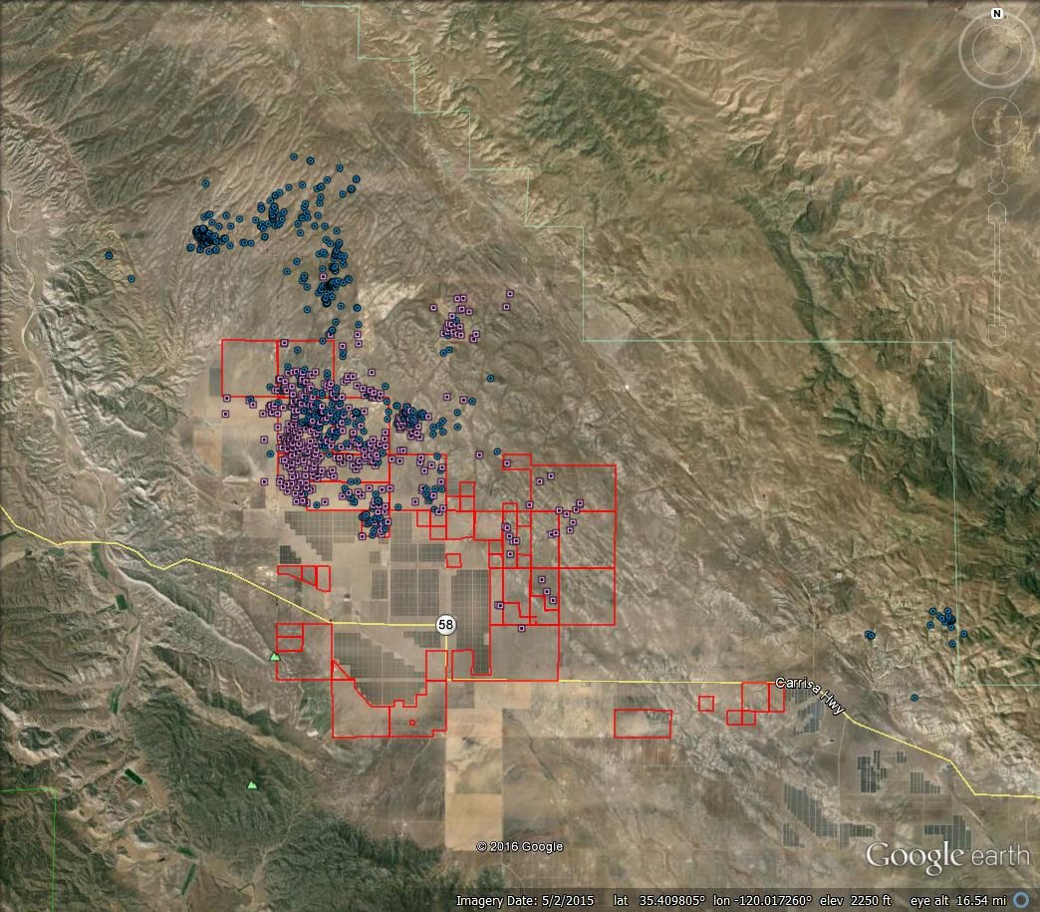

Figure 9. Collared elk location on the NCER from 4/1/2015 to 12/31/2105. Pink squares are for cow elk 9090 and blue circles are for bull elk 9440.

Adaptive Management Task 1c: If new information or conditions arise that require additional tasks, or changes in tasks, or if additional goals are developed through the adaptive management process, revise the Management Plan, and submit to County of San Luis Obispo, USFWS, and CDFW for review and approval of changes.

***While kit fox are the primary focus for management actions, the County’s EIR prepared for this project also identified the need to mitigate impacts for several other species, including tule elk and pronghorn, both of which prefer taller vegetative structure. As per the approved HMMP, longer term mitigation for these species includes revegetating the NCER with native shrubs, which will not become established for several years. For these reasons, CDFW requested the amendment of the HMMP to allow the Klock CRP contract to be honored for its specified duration which ends on September 30, 2017. During that time, CDFW will continue to monitor kit fox use of the parcel. CDFW placed GPS collars on Tule elk in 2015 in order to help guide adaptive management.***