CDFW Proposition 1 & Proposition 68 Grant Programs
Technical Review Guidance
Contents
Introduction 3
WebGrants Reviews 3
Printing an Application 3
Application Annotations 4
Completing a Review 4
Submitting a Review 5
Conflict of Interest & Confidentiality 5
Scoring Instructions 5
Standard Scoring Criteria 6

Introduction
CDFW WebGrants is the application and grant tracking system used by WRGB. All Reviewers must have a WebGrants account to review proposal applications. If you do not have a WebGrants account or need technical assistance, please contact the WebGrants Help Desk at Prop1Webgrants@wildlife.ca.gov.
If you have questions about technical review criteria or a submitted review needs to be unlocked and modified, contact Daniel Burmester at (916) 445-0086 or Daniel.Burmester@wildlife.ca.gov.

WebGrants Reviews
Access your reviews through the following steps:
- Log onto WebGrants
- Select “My Reviews” to see your Review Assignments
  - “Applications to be Reviewed” are applications that have not been completed or submitted and can still be edited by the reviewer
  - “Recently Reviewed Applications” are applications that have been submitted and are locked to editing by the reviewer
  - “Archived Reviews” are reviews from past PSNs that have been archived
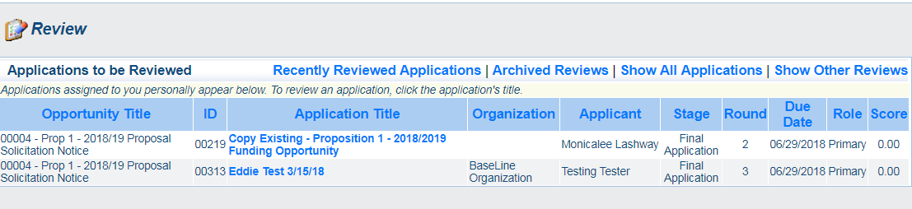
a
b
c
- Select the Application Title to open an application
  - “Review” opens the Review forms
  - “Funding Opportunity” opens the Funding Opportunity information
  - “Annotations” opens internal notes visible to all reviewers
a
b
c

Printing an Application
If you want to print an application, DO NOT USE THE “PRINT TO PDF” BUTTON. This option will print all pdf and other image file attachments with the application and is in a less desirable format.
Instead, use the “Print” button in the top menu (shown below in green). This option will open the browser’s print window, where you can choose to print as a pdf or hardcopy.
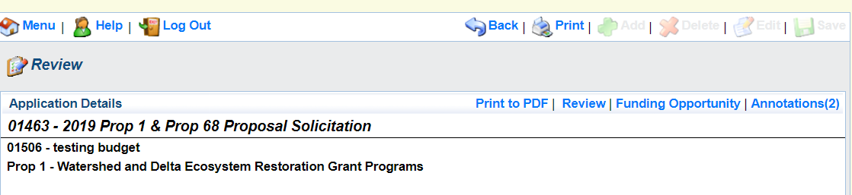

Application Annotations
Annotations are what Admin Reviewers may use to note red flags on an application. They can be viewed by other Reviewers and are only visible internally. Please note: Annotations cannot be edited or deleted, and Technical Reviewers should not create annotations. Technical Review red flag comments must be captured in the Overall Evaluation.

The image below shows the “Annotations” button. The number in the parentheses displays how many Annotations have been made. When reviewing, check the Annotations for red flags from Admin Review by selecting “Annotations.”

Completing a Review
We recommend that you save all your scores and comments in the Excel spreadsheet provided to avoid loss of data in the event of WebGrants system malfunction.
- To start a review, click on the Application title. The Application will open, with attachments available as clickable links.
- Click “Review”. The Review Form screen will pop up as a second window so that you can view it side by side with the Application.
- Click on the Review form name to view review form fields.
- To enter your data into form fields, select “Edit”.
- Use the “Back” button to exit the review without saving.
- To save your progress and leave Edit Mode, select “Save.”
- To close the review, select “Close”.
- When you have completed the entire form, be sure to “Mark as Complete.”
- To return to the list of review forms, select “Back to Submit”.

Submitting a Review
IMPORTANT: ALL FIELDS MARKED WITH A RED ASTERISK (*) MUST BE COMPLETED BEFORE SUBMITTING APPLICATION.
- If you are completing multiple reviews, we recommend that you complete several reviews and revisit the first ones to re-calibrate your scoring before submitting.
- Once you are confident with your scores and confirmed that you have completed all fields, you are ready to submit.
- To submit, select “Back to Submit” to get to the “Review Forms” screen and select “Submit Review”.
- After submitting the review, it will be locked against further editing. If you need to have it unlocked to make changes, please contact the review coordinator.

Conflict of Interest & Confidentiality
If any potential conflicts of interest arise after reading the proposal, please contact your review coordinator as soon as possible. Potential conflicts could include: close connections to the applicant, contributions to the development of the proposal, anticipated participation in implementing the project should it be funded, or participation in the inception or development of the overall project or prior phases (even if you did not participate in writing the proposal). Knowing applicants does not necessarily disqualify you, but we would like to know in advance of you completing your review.
Please review the entire proposal independently. The review process is confidential, and we ask that you do not share proposals or your reviews with individuals other than your review administrator.
Reviews will be shared with the Selection Panel without the identity of the reviewers. Following the Panel’s award decisions, reviews will be made available to the public, again without attribution to specific reviewers. We expect to list the names of all individual reviewers, but will not identify the authors of specific reviews.

Scoring Instructions
See the Technical Review Excel scoresheet template for specific required scoring criteria; the WebGrants review sheet has a link to this template, which you have the option to use to develop your scores and comments offline. You must then transfer the data to WebGrants.
The proposal must be scored based on the information provided, and if critical information is missing, the reviewer must evaluate the proposal without that information. However, expert knowledge can and should be used to evaluate the project's feasibility and relevancy based on the information provided.
Planning Projects - Where applicable, the evaluation of planning proposals will take into consideration the future on-the-ground project(s) that the pre-project activities are intended to support.
Reviewers are responsible for reviewing the entire application and assigning scores to the criteria based on the information presented therein.
All fields are required. Enter a score in all required score fields. There are two fields associated with each scored criterion:
- In the Score field, assign the criterion a point value between zero and five (0.5 point increments are acceptable), in accordance with the applicable scoring standards. Most questions use the Standard Scoring Criteria below; some use specific scoring criteria; see the Excel scoresheet template. The scores will have a weighting factor applied to them after you have completed your review. The maximum total score is 100 points.
- In the Comments field, enter your written explanation for the assigned point value. Comments should be clear, concise, and tone neutral. Critical comments in this field should be repeated in the "Overall Evaluation" fields: Strengths, Weaknesses and Red Flags. Comments are expected for scores less than 5.

Standard Scoring Criteria
5 points: the criterion is fully addressed and supported by thorough and well-presented documentation and logical rationale.
4 points: the criterion is fully addressed but is supported by less thorough documentation or less sufficient rationale.
3 points: the criterion is less than fully addressed and is supported by less thorough documentation or less sufficient rationale.
2 points: the criterion is marginally addressed or the documentation or rationale is incomplete or insufficient.
1 point: the criterion is minimally addressed or no documentation or rationale is presented.
0 points: the criterion is not addressed.

