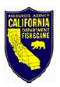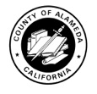

Media Advisory: Dubai Oil Spill FAQ Updated
NEWS RELEASE
ALAMEDA, Calif. – The Joint Information Center for the Dubai Star oil spill has posted an up-to-date frequently asked questions section on the response website – www.jointinformation.com.
The FAQ section contains information about the personnel involved in the response and clean-up effort, status of impacted wildlife and information about areas affected by the spill.
The Joint Information Center will continue to field media calls via phone at 510-437-3808 and issue press releases to distribute new and pertinent information regarding the spill and clean up to members of the media.
-end-
For more information contact:
Lt. JG Pichette
(510) 437-3189
beacon@uscg.mil

