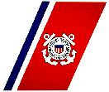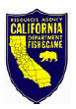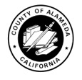

Unified command continues cleanup operations in the San Francisco Bay after fuel oil spilled into the water while the tanker vessel Dubai Star was refueling.
The U.S. Coast Guard, the Department of Fish and Game’s (DFG) Office of Spill Prevention and Response and the vessel owner, South Harmony Shipping, have established a unified command and are jointly managing cleanup operations. Local government agencies are also engaged in the operations.
Command emphases for the current operational period are:
- Safety of responders
- Safety of the environment and sensitive areas
- Economic health of the Port and minimization of financial impact
- Ensure media needs are met
- Ensure stakeholder information needs are met
- Maintain unified response efforts
A claims number has been established: (800) 421-0863
DFG has activated the Oiled Wildlife Care Network to conduct wildlife search and reconnaissance operations. The public is asked to not attempt to rescue oiled wildlife as this may cause injury to both the individual and the animal. Instead the public should report sightings of oiled wildlife to 1-877-823-6926.
Individuals can submit inquiries regarding response efforts by selecting 'Questions/Comments' from the menu bar above.

