Memorandum
Date: May 7, 2025
To: Nicolas (Nick) Bauer
Senior Environmental Scientist, Supervisory
California Department of Fish and Wildlife, North Central Region

From: Hideaki Shig Kubo
Environmental Scientist
California Department of Fish and Wildlife, North Central Region

Subject: Adult Chinook Salmon stranding downstream of the Cache Creek Settling Basin Outlet

On Tuesday, April 29, 2025, Dennis Finger with the Department of Water Resources (DWR) notified CDFW staff about several live adult Chinook Salmon stranded in a pool downstream of a culvert that drains water from the Cache Creek Settling Basin into the Yolo Bypass (Bypass). This stranding area is located approximately 0.32 miles north of the I-5 causeway, on the inside of the western levee of the Bypass (Figure 1).
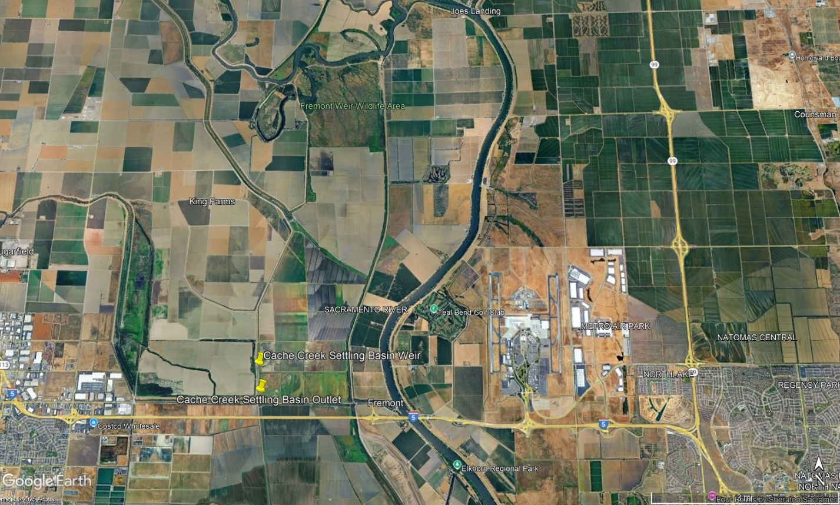
Figure 1. Map showing the location of the Cache Creek overflow weir and outlet culvert.

A site visit was made later that afternoon to evaluate the level of stranding. Several live adult Chinook Salmon were observed swimming near the surface of the pool, along with multiple carcasses washed up along the banks of the pool (Figure 2).
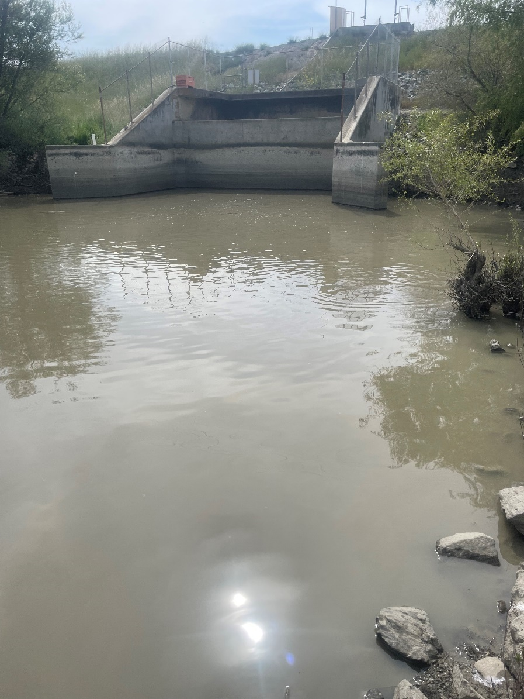
Figure 2. View of the Cache Creek Settling Basin Outlet culvert from downstream in the stranding pool looking up.
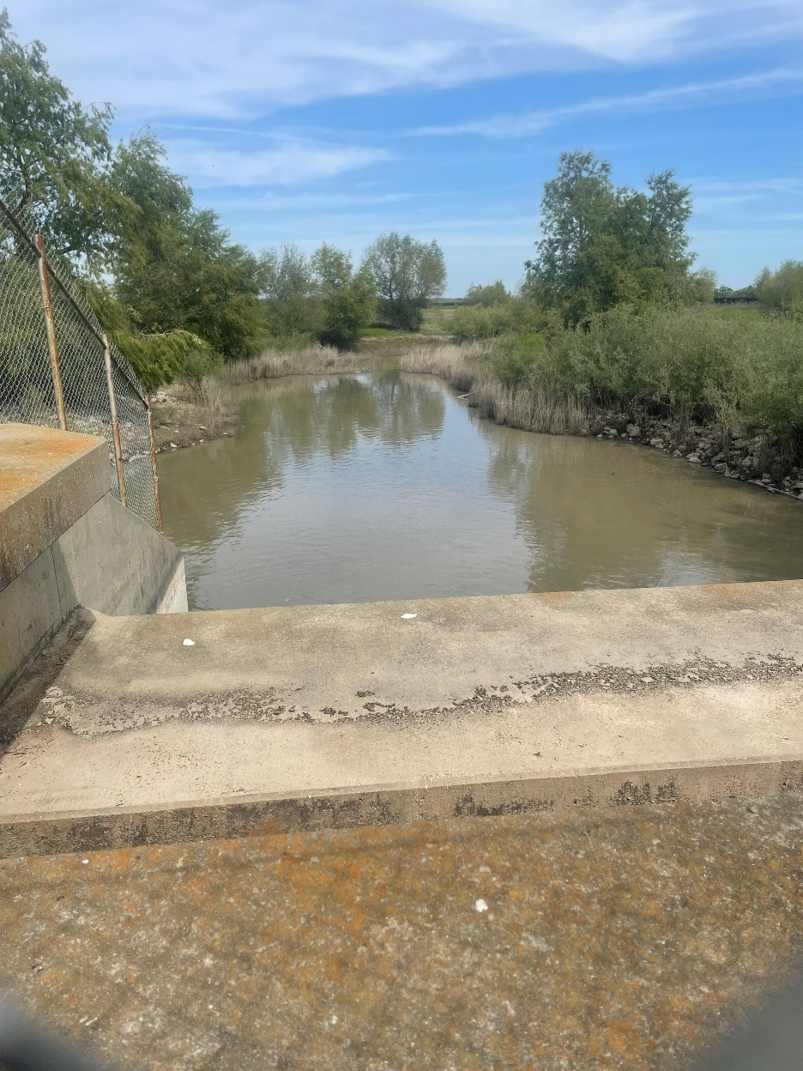
Figure 3. Looking downstream from the top of the Cache Creek Settling Basin Outlet culvert into the stranding pool.

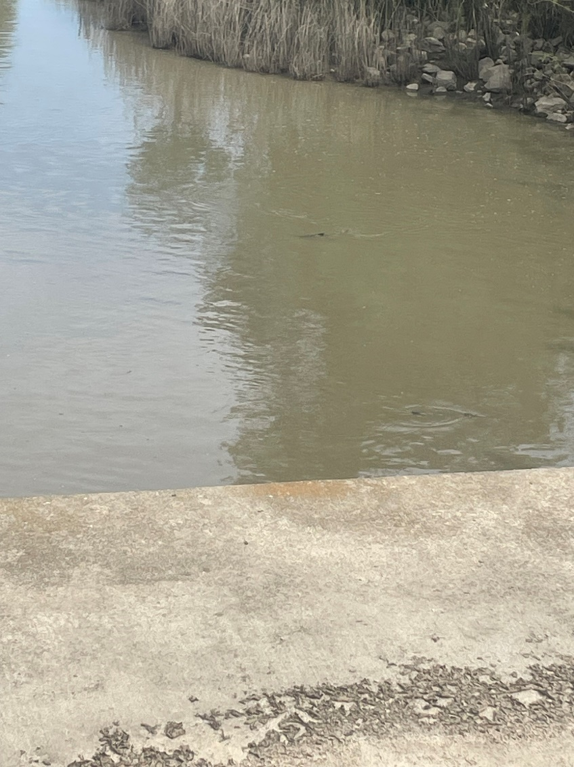
Figure 4. An adult Chinook Salmon swimming near the water’s surface in the pool downstream of the Cache Creek Settling Basin Outlet culvert.
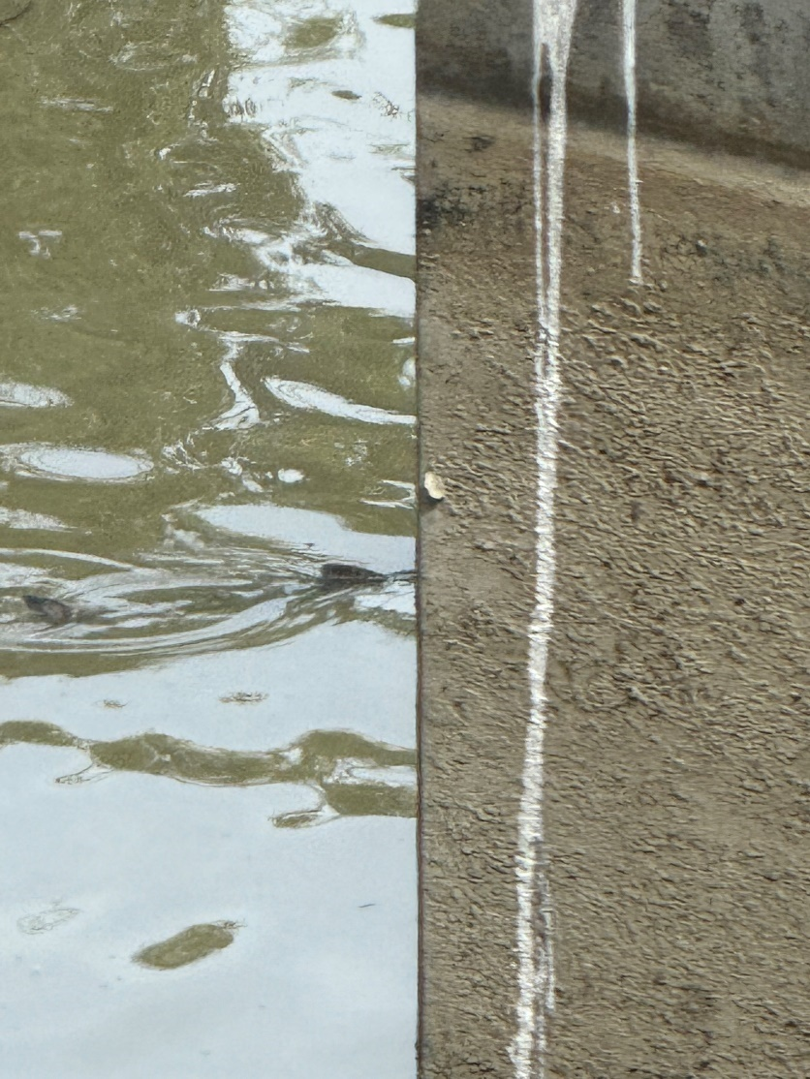
Figure 5. Adult Chinook Salmon in the pool near the culvert.
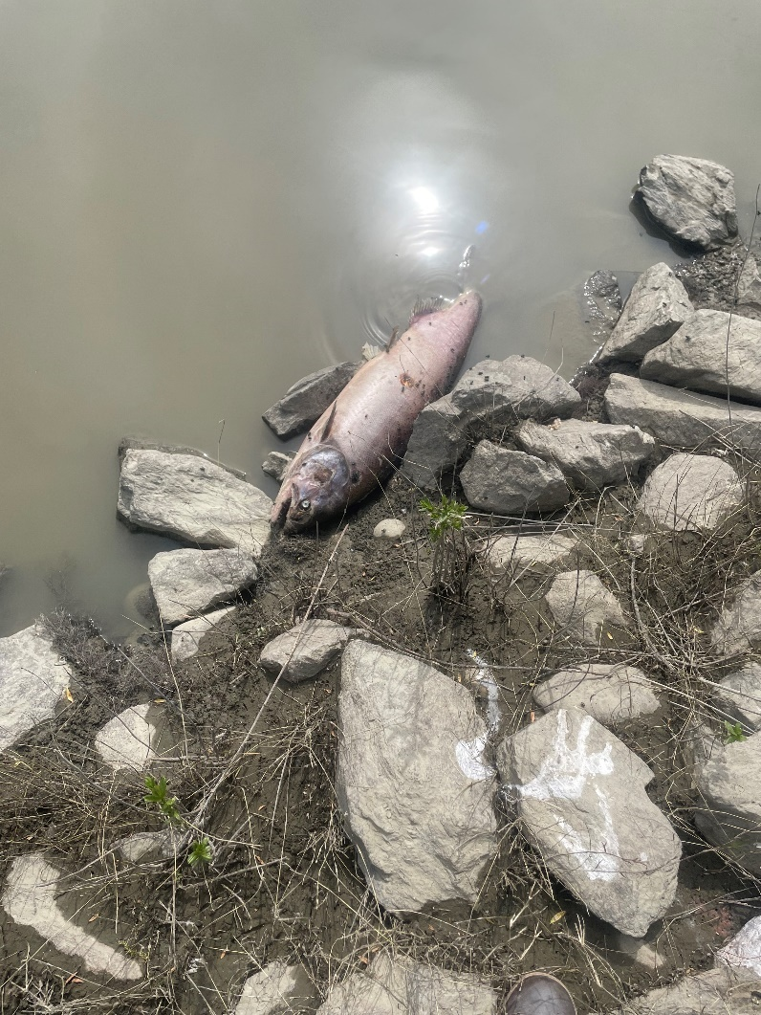
Figure 6. Chinook Salmon carcass observed in the pool just downstream of the culvert.
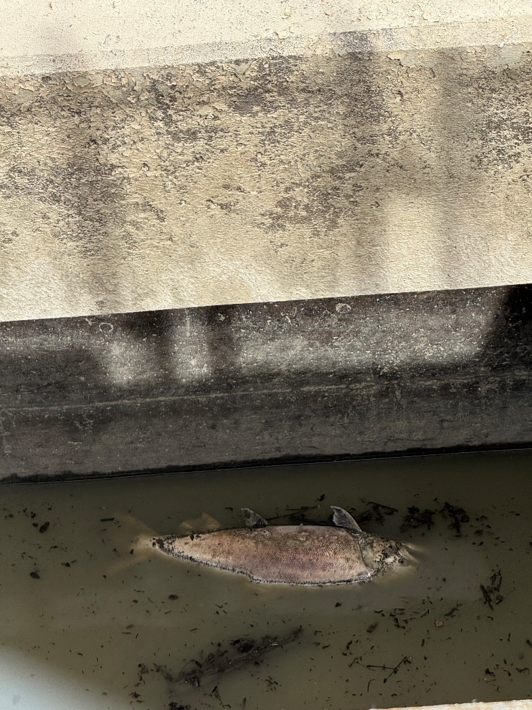
Figure 7. Chinook Salmon carcass observed floating inside of the culvert.
There were additional reports of two live Chinook Salmon below the splash basin of the nearby overflow weir for the settling basin. The pool below the culvert drained into a channel on its eastern edge where several more live and dead Chinook Salmon were observed for approximately half a mile downstream. After the area was surveyed, Dennis Finger was contacted regarding the operation of the culvert. It was later learned that the DWR West Sacramento Levee Maintenance crew maintains this culvert and was later asked to close any gates within the culvert to prevent more attraction flow from the structure and drain the pool to a workable level.

CDFW Region 2 Anadromous Fisheries staff coordinated with West Sacramento DWR staff and UC Davis lab staff to plan a rescue effort on the morning of May 1, 2025. Water temperature in the pool was measured at the beginning of the day using a YSI Pro 20. Water temperature at 0955 was 18.5 degrees Celsius. A 25’ wide seine net was used to move fish into the pool from the channel downstream and block off the downstream end of the pool to keep fish from escaping. A larger 50’ wide seine net was used to crowd fish from the front of the culvert down to the block net. Once fish were crowded between the two seines, field staff used dip nets to catch individual fish. Two trailer mounted 400 gallon tanks were used to transport fish from the rescue site to the release site at Elkhorn Boat Launch on the Sacramento River. Both tanks were filled with approximately 350 gallons of water from on site and nearby Wallace Weir Fish Collection Facility (Facility). Ice from the American River Fish Hatchery was mixed into the transport water to help stabilize temperatures. Once tanks were filled and iced down, fish were loaded in one at a time and processed in a limited manner to reduce handling stress. Each fish was evaluated for sex, adipose fin clip status, and a fin clip from the upper caudal lobe was taken for genetic analysis. No tags were applied, nor were fork length measurements taken. A maximum of 12 fish were loaded into each tank. Upon arrival at the release site, water temperatures were measured between the tank and river. If the difference between the two temperatures exceeded 2 degrees Celsius, tank temperatures were acclimated to the river by bucketing river water into the tank. A total of 72 adult Chinook salmon (six tank loads) were released alive from the rescue site. Six of these rescued fish were adipose intact. There were 43 females, 28 males and one of unknown sex. All fish appeared darker in color, likely due to stress from prolonged exposure to poor water quality (high water temperatures, low dissolved oxygen).

After the rescue effort, the site was surveyed for carcasses. Field staff walked in the channel below the pool approximately 400 feet downstream and worked upstream towards the pool. Each carcass was measured to fork length, evaluated for sex, adipose fin clip status, sampled for genetics from the most viable fin (excluding adipose fin) or operculum, and a head taken from adipose fin clipped fish for later coded wire tag (CWT) extraction. A total of 37 Chinook Salmon carcasses were recovered on April 30, 34 of which were adipose fin clipped and sampled for CWTs, two adipose intact and one that was too decayed to determine adipose fin status. Carcass recovery continued the following day on May 1, with an additional 35 carcasses recovered, four of which were adipose intact. Due to a lack of storage space, only 10 of the 35 carcasses from the second day were sampled for CWTs. Out of all the heads taken, 36 CWTs were extracted and read, all of which were confirmed to be Livingston Stone National Fish Hatchery (NFH) winter-run, mostly from brood year 2022, with one from 2023 (Table 1). Fork lengths for all carcasses ranged from 48 to 108 cm, with an average of 80.6 cm.

Table 1. Tag codes and associated data found from carcasses found in the Cache Creek settling basin outlet
CWT code | Number found | Hatchery of origin | Run | Brood year | Release Year | Release location
056501 | 1 | Livingston Stone NFH | Winter | 2023 | 2024 | Sac. R. @John F. Reginato River Access
056521 | 6 | Livingston Stone NFH | Winter | 2022 | 2023 | Sac. R. @John F. Reginato River Access
056522 | 5 | Livingston Stone NFH | Winter | 2022 | 2023 | Sac. R. @John F. Reginato River Access
056523 | 5 | Livingston Stone NFH | Winter | 2022 | 2023 | Sac. R. @John F. Reginato River Access
056585 | 4 | Livingston Stone NFH | Winter | 2022 | 2023 | Sac. R. @John F. Reginato River Access
056586 | 2 | Livingston Stone NFH | Winter | 2022 | 2023 | Sac. R. @John F. Reginato River Access
056587 | 10 | Livingston Stone NFH | Winter | 2022 | 2023 | Sac. R. @John F. Reginato River Access
056588 | 3 | Livingston Stone NFH | Winter | 2022 | 2023 | Sac. R. @John F. Reginato River Access

Though this is the first rescue effort at this location for CDFW Region 2 staff, this has likely been an ongoing issue. CDFW district biologist Skyler Burson received information and photos in 2024 about salmon carcasses that were found in Cache Creek upstream of where it spills into the Bypass, indicating that fish were able to get into Cache Creek during last year’s high flow events. This year’s stranding event likely occurred after this winter and early spring’s storms that increased flows in Central Valley tributaries, including the Sacramento River and Cache Creek.
As Cache Creek floods, the settling basin just west of the Yolo Bypass western levee fills and holds water, spilling over a weir and through the culvert once flows are high enough. Flows from both the weir and culvert travel east through the bypass and drain into the eastern Toe Drain (Figure 8), which is likely the entry point for these fish to have accessed the stranding area below the culvert.
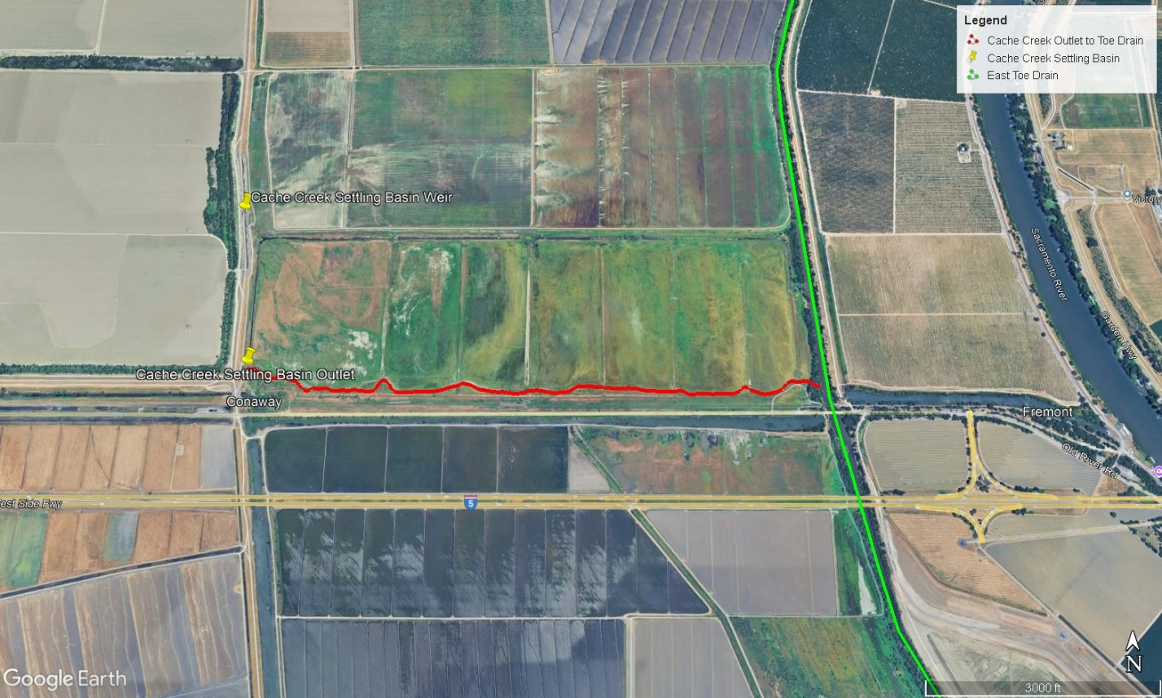
Figure 8. Map showing the route taken (highlighted in red) for adult Chinook Salmon to get from the east Toe Drain of the Yolo Bypass (highlighted in green) to the Cache Creek Settling Basin Outlet stranding pool.

Flood flows over Fremont Weir earlier in the year likely caused the initial pulse of attraction flow into the bypass for adult Chinook salmon. Once Fremont Weir overtopping stopped on February 22 (Figure 9), the residual high flows from the Knights Landing Ridge Cut Slough continued to attract more salmon to the bypass as the Wallace Weir Fish Collection Facility captured more salmon into May.
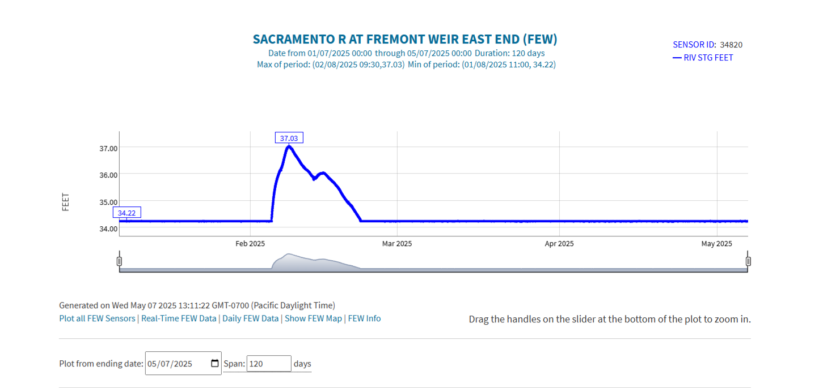
Figure 9. Hydrograph showing the stage height from January to May 2025 at the Fremont Weir East End gage. Data downloaded from the California Data Exchange Center FRE gage website on 5/7/2025.

During this time, flows continued to come out of the Cache Creek Settling Basin via the Cache Creek Settling Basin Weir and the nearby culvert. Online USGS gage data for the weir associated with the settling basin shows the weir had spilled four times between November 2024 and April 2025, with the last spill event being extensive, going from February 5 to April 15 and peak discharge reaching over 11,000 cubic feet per second (cfs) (Figure 10). A USGS gage associated with the culvert shows flow passing through the structure from November 23, 2024 until April 30, 2025 (Figure 11) when DWR was asked to shut off flow for the rescue effort. Flows through the culvert reached a peak discharge of 720 cfs.
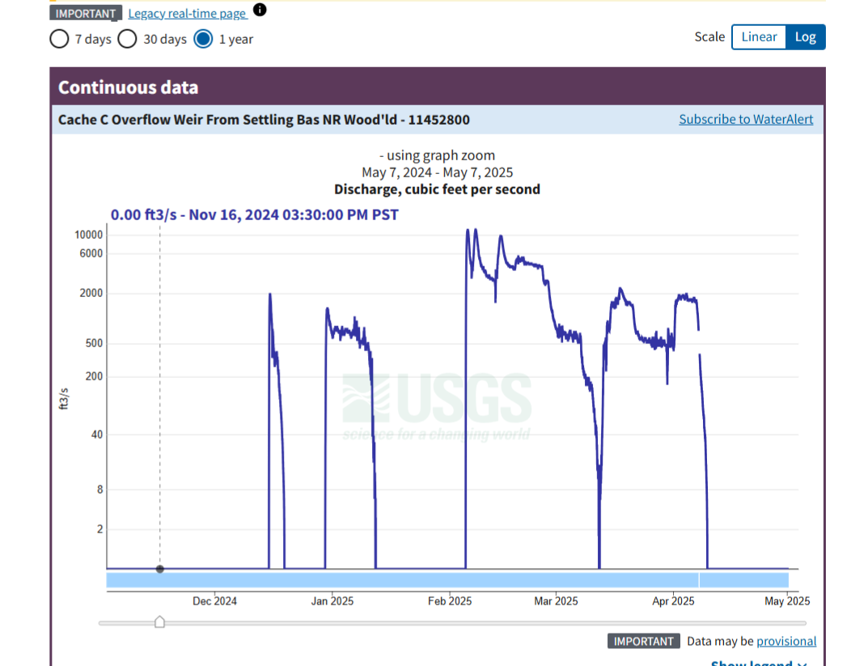
Figure 10. Hydrograph showing discharge through the Cache Creek Settling Basin overflow weir from October 2024 to May 2025. Data downloaded from the USGS monitoring station website for the Cache Creek Weir from Settling Basin NR Woodland - 11452800 gage on 5/7/2025.

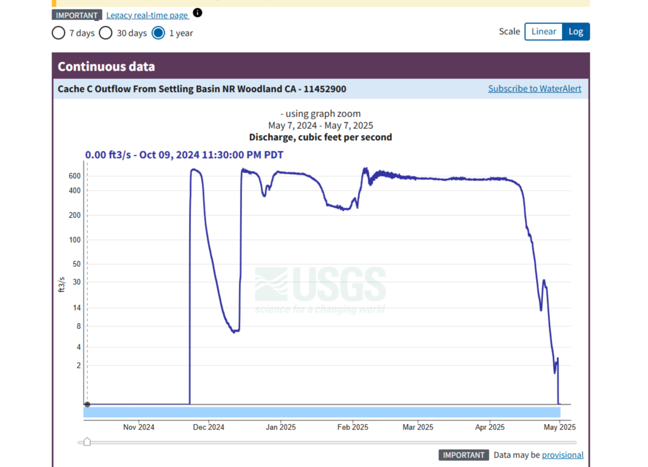
Figure 11. Hydrograph showing discharge through the Cache Creek Settling Basin Outlet Culvert from October 2024 to May 2025. Data downloaded from the USGS monitoring station website for the Cache Creek Outflow from Settling Basin NR Woodland CA – 11452900 gage on 5/7/2025.

Based on the CDEC and USGS data showing the timing of the spill event over Fremont weir and the Cache Creek Weir, and the high flows through the culvert, it seems possible the stranded fish and carcasses could have arrived as early as February or March. Genetic analysis of fin clips taken from all fish from this site showed there were 76 winter-run, 3 spring-run and 65 that yielded no results. Results of the CWT readings showed that 27 of the 65 fish that were not identified to run were Livingston Stone Hatchery winter-run, making a total of 103 winter-run observed in this stranding event. These fish appeared darker in color and more advanced in their physical development than one would expect a newly arrived adult winter or spring-run Chinook Salmon to look. Based on the same USGS culvert gage, there were several days between March and June where water temperatures exceeded 20 degrees Celsius (Figure 12). Prolonged exposure to these temperatures would be detrimental to the health of any adult Chinook salmon and may be the cause of the darker color and more advanced development.

Table 2. The number of each run observed in the Cache Creek Settling Basin Outlet, based on genetic analysis. No results were due to insufficient amounts of viable genetic material to analyze samples.
Run ID | Number of fish
Winter-run | 76
Spring-run | 3
No Results | 65

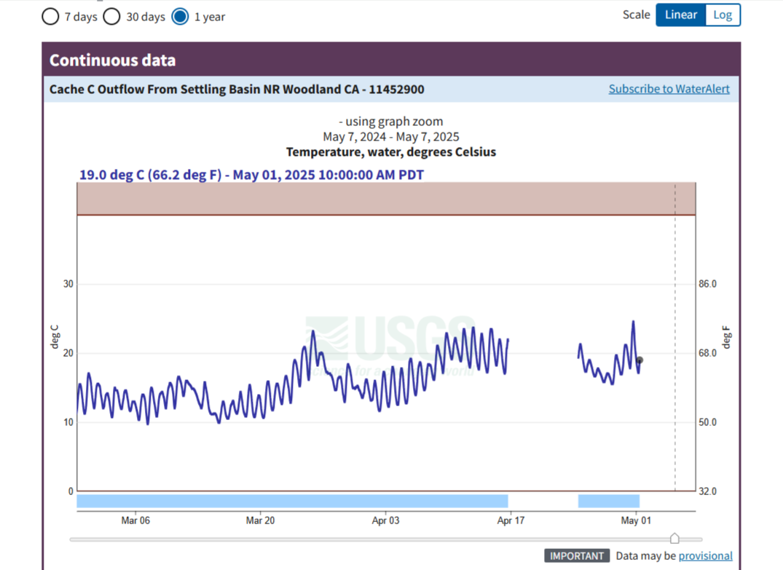
Figure 12. USGS gage showing water temperature from February to May, 2025. Data downloaded from the USGS monitoring station website for the Cache Creek Outflow Settling Basin NR Woodland CA – 11452900 gage on 5/7/2025.

Despite the 72 live fish rescued and 72 carcasses recovered from the stranding area, it is likely that there were many more that perished before the initial sighting and rescue effort. There were no obvious signs of poaching or large-scale predation in the area. Future coordination will be needed to develop solutions to this infrastructure such that it does not strand or attract fish after flooding and high flow events. The operation of the Big Notch Project may also help to reduce the number of fish stranded in this area as they would have been able to continue migrating upstream in the Toe Drain.

Acknowledgements
We would like to extend our gratitude to those that helped with coordinating and carrying out the rescue efforts and carcass recovery, including Aster Rasnick, Ryan Dooley, Kai Honda-Scully, Dennis Finger, Brandy Smith, Luke Olson, Kevin Anfinson, Carson Jefferies and his UC Davis lab staff. Thank you.

References

California Department of Water Resources Data Exchange Center, Sacramento River at Fremont Weir East End (FEW). 2025. https://cdec.water.ca.gov/cdecplotter/JspPlotServlet?sensor_id=34820&end=2025-05-07&geom=SMALL&interval=120&cookies=.

Richter, A., and S.A. Kolmes, 2005. Maximum Temperature Limits for Chinook, Coho, and Chum Salmon, and Steelhead Trout in the Pacific Northwest. Reviews in Fisheries Science 13:23-49.

United States Geological Survey Water Data, Cache Creek Outflow From Settling Basin NR Woodland CA – 11452900. 2025. https://waterdata.usgs.gov/monitoring-location/11452900/#dataTypeId=continuous-00060-0&period=P365D.

United States Geological Survey Water Data, Cache Creek Outflow Weir From Settling Basin NR Woodland – 11452800. 2025. https://waterdata.usgs.gov/monitoring-location/11452800/#dataTypeId=continuous-00065-0&period=P7D.

Yoshiyama, R.M., Fisher F.W., and Moyle, P.B. 1998. Historical abundance and decline of Chinook salmon in the Central Valley region of California. North American Journal of Fish Management 18: 487-521.

