State of California
Natural Resources Agency
Department of Fish and Wildlife
Wildlife Branch

April 2025 Meeting Notes for
Multi-Agency Monarch and Pollinator Collaborative

Wildlife Diversity Program, 2026-02

Monarch Multi-Agency Collaborative, Management Oversight Group (MOG)
April 22, 2025, 9 – 10:30 am
Attendees: Scott Gardner (CDFW), Jon Gustafson (NRCS), Rebecca Fris (CCC), Patricia Bohls (CDFA), Pete Figura (CDFA), Patricia Kruger (USFS), Dan Applebee (CDFW), Darrin Thome (USGS), Melissa Burns (USFWS), Dena Spatz (State Parks), Rachel Pausch (CCC), Matt Nicholson (NPS), Luz Quinnell (CalTrans), Michelle Selmon (CDFW), Shannon Shea (Navy), Patty Krueger (USFS), Adam Johnson (USFWS), Shannon Shea (Navy)

Facilitators: Scott Gardner (CDFW), Hillary Sardiñas (CDFW)
Notetaker: Julea Shaw (CDFW)

Announcements
- Patricia Kruger - Diana Craig is retiring from USFS- so Pati will be covering MOG and TAC; Chris Feutrier will de deputy regional forester. New acting regional forester Jason Kuiken (usually Stanislaus forest supervisor).
- Melissa Burns- Adam is currently acting Regional Director for R8 through May (Paul Sousa is serving as acting director of USFWS).

Collaborative logo (Meredith Fleener, CDFW graphic designer)
Received feedback from group on options
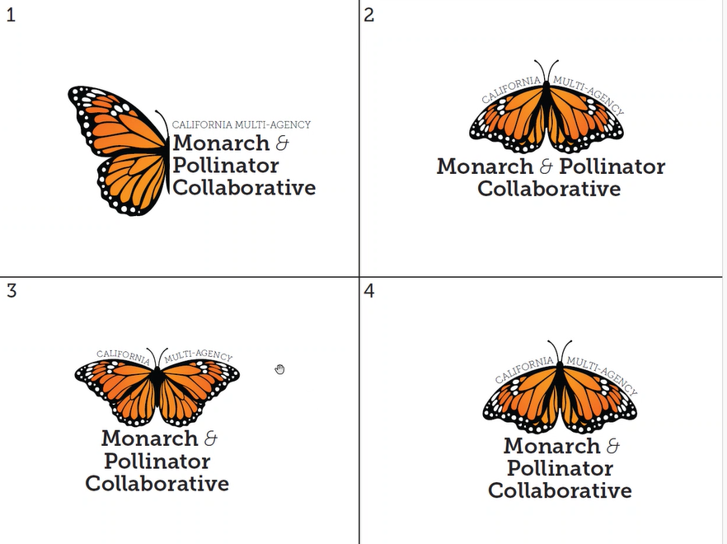
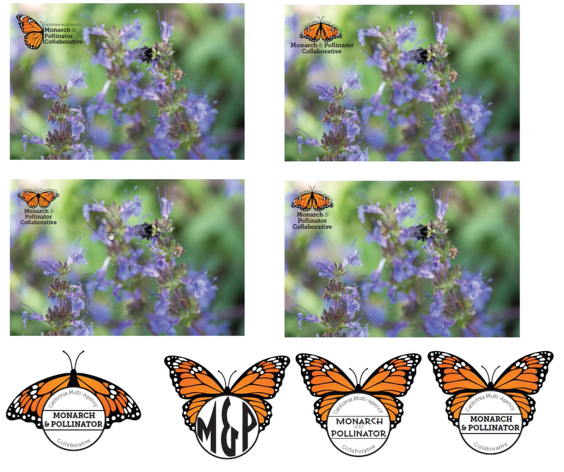
- Will update logos based on feedback
- Hillary will send out a poll for logo section before next meeting

MOU
- Still waiting on signatures from some agencies
- Decided not to post MOU on website until all agencies have signed

Review report draft
- Julea and Melissa put together template; TAC members signed up to filling it in based on notes from past year of meetings.
- Still need some agencies to complete their Case study.
- Discussion about authorship versus contributors- each agency will make determination; if not an author, will be listed in acknowledgements.

Artificial Intelligence agency policies
- The exec summary and conclusion were, in part, generated using AI (government ChatGPT). The TAC, however, wrote the report and AI mainly summarized our work.
- Do federal agencies have policies? Here is the state agency policy as of now: DGS policy
- Discussion about use of AI to generate Exec Summary and Conclusion: Several people expressed concerns with energy consumption and the optics of using AI but determined did not want to re-do work and noted that we heavily edited sections it provided first draft of.
- Homework: Check with your agencies on AI policies so we can develop appropriate wording in report to capture how we used AI while stressing that the report was a long process developed by partners.

Plan Updates
- How often do we want to commit to updating the plan (e.g., 2 years? 5 years? Periodically?)
- Decision: 5 years; two is too short and won’t give time to do the work; not giving a timeframe doesn’t make sense.

Timeline for review by partner agencies
Decided on this review and approval timeline:
  - Initial MOG review sent around May 15, due by July 7 (2 weeks before the MOG meeting so TAC can review and respond to comments)
    - Please use Google Drive shared doc if possible, otherwise emailed Word doc.
  - Discuss changes and completion timeline at July 22 MOG meeting
  - TAC incorporates changes
  - Draft for final review/approval by each agency (August- Sept)
  - Goal = adopt at October meeting

Tackling priorities from report
- Habitat definition- Melissa: Xerces and WSU, supported by USFWS- breeding/migratory habitat science meeting in July.
- Hillary will present work Collaborative is doing there
- Decision: TAC will come up with a plan for how to move forward on the priorities and ask MOG for approval at next meeting.

