State of California
Natural Resources Agency
Department of Fish and Wildlife
Wildlife Branch

July 2025 Meeting Notes for
Multi-Agency Monarch and Pollinator Collaborative

Wildlife Diversity Program, 2026-03

Monarch Multi-Agency Collaborative, Management Oversight Group (MOG)
July 22, 2025, 9 – 10:30 am
Attendees: Dan Applebee (CDFW), Brigitte Tafarella (CDPR), Patricia Bohls, Ryan Bourbour (CDFW), Hillary Sardiñas (CDFW), Julea Shaw (CDFW), Scott Gardner (CDFW), Hayley Pechner (WBC), Alicia Torregrosa (USGS), Kimiora Ward (CDFW), Ron Melcer (State Parks), Pete Figura (CDFW), Krista Hoffman (CDFW), Rebecca Fris (WCB), Luz Quinnell (Caltrans), Jill Townzen (CDPR), Colleen Grant (USFWS), Melissa Burns (USFWS), Katariina Tuovinen (NPS), Rachel Pausch (CCC), Darrin Thome (USGS)

Facilitators: Scott Gardner (CDFW), Hillary Sardiñas (CDFW)
Notetaker: Julea Shaw (CDFW)

Announcements
- Adam Johnson: Changes to USFWS Science Applications program led to staff moving to other programs within agency. Also in process of determining whether the National Pollinator Center will continue to function. Despite pollinators remain a priority for Region 8 and USFWS is moving ahead with CBA with ag producers in CA.
- USGS just published their Pollinator Research Priority Report: https://www.usgs.gov/publications/us-geological-survey-pollinator-science-strategy-2025-35-a-review-and-look-forward

Logo selection and next steps
11/13 votes total for this design (winner):
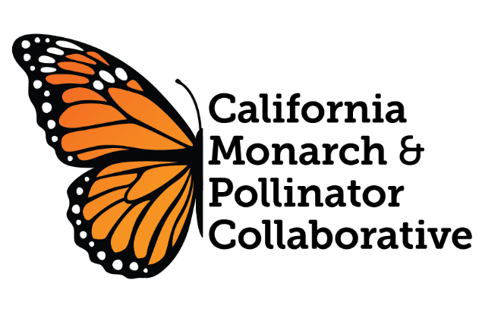
The circle below will be the alternate logo for stickers, presentations, etc.
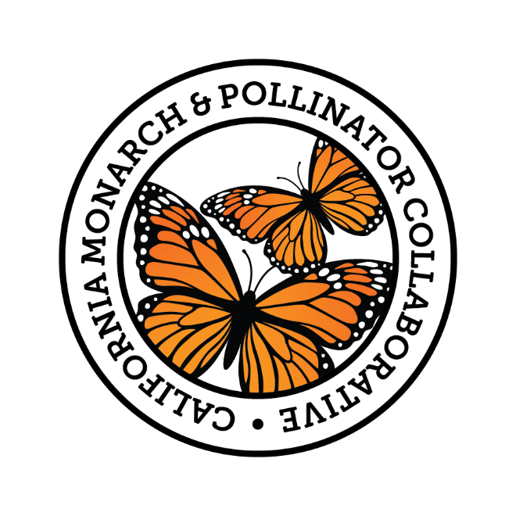

TAC format going forward
- Instead of separate working groups, TAC elected to rotate the focus of regular meetings amongst identified near-term priorities.
- Will begin rotating facilitators and notetakers each meeting. The note-taker at the previous meeting will be the facilitator at the next.

Meeting Minutes
- Realized we forgot to provide meeting minutes for approval from past few meetings. Will cover backlog from last few meetings at next MOG meeting and make it a standing meeting agenda item for MOG.

Report- Review Comments and Next Steps
- Reviewed all comments provided by MOG and TAC members provided comments on draft report and made determinations.
- Set deadline for final edits: Friday, August 18th; MOG members will aim for approval from their agencies by Oct 28th MOG meeting.
- CDFW OCEO staff will do all formatting, including cover and conceptual model.
- TAC unanimously decided to keep actions related to other pollinators in via vote. We added justification language in section and intro to make a stronger case for these non-monarch actions.
- Ideal timeline for publication: Final approval of formatted report at January 27th MOG meeting so it can be disseminated in February, after monarch overwintering count numbers are published.

Rescheduling December Meeting
- Would have fallen Dec 23rd – rescheduled to January 27th

