General Information
Project Title: |  |  | Application Number:
Applicant: Full legal title of organization requesting funding |  |  | Organization Type:
Mailing Address: | Primary Contact: |  | Phone:
 | Primary Contact Title: |  | Email:
Amount Requested: Total CDFW Requested Amount | Total Project Cost: Estimated Cost for this Project Phase (CDFW + cost share) |  | Project Duration: Estimated Start (no sooner than June 1, 2020) and End Dates (no later than January 1, 2025 for UC/CSUs or March 15, 2025 for all other applicants)
Project Type: Select one  Coastal Wetlands  Delta  Mountain Meadows  Seasonal Inland Wetlands |  | Project Category: Select one  Implementation only  Planning and Implementation
Project Latitude Coordinates (Project Centroid, decimal degrees, NAD83): |  | Project Longitude Coordinates (Project Centroid, decimal degrees, NAD83):
Landowner(s): Applicant, federal, State, local, NGO, private |  | County(ies): Which counties is the project in?

Project Summary

Project Description
Briefly describe the project. Identify the problem or need and how the proposed project will provide a solution. Describe the project objectives (e.g., the project will restore or enhance habitats or ecosystem function, result in improved land management for wildlife). Identify the existing habitat shortcomings, specific methods used to restore or enhance habitats, greenhouse gas (GHG) benefits, and describe all resulting habitat(s), including acreage by habitat type and, where appropriate, the length and width (in feet) of the resulting restored or enhanced habitat. Identify current and past major land uses. Describe long-term management and maintenance activities of the project site and identify who will be responsible for those activities.

Conceptual Model
- Attach conceptual model figure(s) in “Pre-Application Attachments.”
- Describe conceptual model(s) as it relates to your project and how the proposed restoration activities result in net GHG benefits. Include a discussion of the period of time, minimum of 50 years, over which the project will yield GHG benefits.

Timeline
Provide the proposed project timeline that outlines the key project milestones and their estimated dates chronologically in the table below. Examples of project milestones are included in the table.
Key Project Milestones | Estimated Dates
Project Start | Start date cannot be sooner than June 1, 2020
Final engineering designs complete
CEQA compliance complete and all permits in-hand
Baseline/Pre-Construction Monitoring
Construction Start
Construction End
Revegetation and habitat enhancement
Post-Project Monitoring
Final Report
Project End | End date cannot be later than January 1, 2025 for UC/CSUs or March 15, 2025 for all other applicants

Estimated GHG Benefit
The Wetlands Calculator Tool and its supporting Quantification Methodology (QM) can be found at http://www.arb.ca.gov/cci-resources under the “Natural Resources and Waste Diversion” header and California Department of Fish and Wildlife Wetland Restoration (see Figure 1 below).
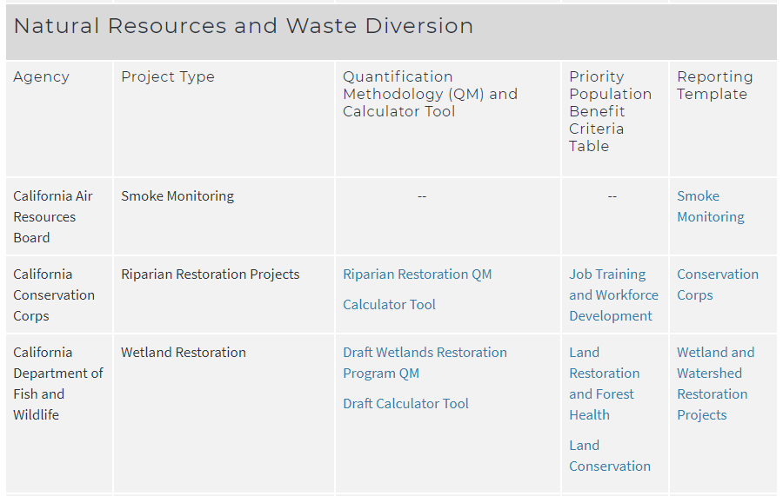
Figure 1. The Wetlands Restoration Program QM and Calculator Tool are available on the CARB website in the CCI Quantification, Benefits, and Reporting Materials table
- Attach completed Wetlands Restoration Calculator Tool in “Pre-Application Attachments”
- In addition to providing results from the CARB approved quantification methodologies, applicants may provide additional site-specific data and alternative calculation methods to estimate GHG benefits. Attach any additional quantification methodology to “Pre-Application Attachments.” This attachment is optional.
- Provide the estimated GHG benefit over the project life (at least 50 years after construction is complete) as calculated in the Quantification Methodology for CDFW Wetlands Restoration for Greenhouse Gas Reduction Grant Program.

Land Tenure
- Please describe the status and expected conclusion of landowner negotiations, including estimated date by which negotiations will result in a conservation easement or an equivalently enforceable conservation agreement to manage and maintain restoration project benefits for at least 50 years (AB 109, Budget Act of 2017, Section 14, Provision 1 and SB 856, Budget Act of 2018, Section 21, Provision 1).
- Attach Land Tenure Documents in “Pre-Application Attachments.”
  - If applicant is not the landowner, please attach a document affirming the landowner will enter into a conservation easement or an equivalently enforceable conservation agreement for at least 50 years after construction activitie are complete or an existing conservation easement/agreement.
  - If the applicant is the landowner, please attach proof of ownership.

Project Location Map
Clearly identify the project’s location in relation to prominent area features in a Project Location Map. The map should provide sufficient detail to allow a person unfamiliar with the area to locate the project. Attach the Project Location Map in “Pre-Application Attachments.”

Project Shapefiles
Upload a shapefile or kmz in “Pre-Application Attachments” under “Project Shapefile.” Note: If your Project is selected for funding, you may be required to submit more detailed shape files or kmz files.
- Attach a polygon boundary of the proposed project using one of the formats below:
  - Shapefile (shs): zipped
  - Keyhole Markup Language: zipped (kmz)
- Project sites separated by more than 0.5 miles should be included as separate polygons. Include the following in the file to be uploaded:
  - Application Number: (found near the top left of the page in your application).
  - Applicant Name
  - Project Title
  - Site Name

