# Guidelines for Creating a Vegetation Report

**What Is This Document?**

This is an informational document for creating vegetation classification and mapping reports that meet Survey of California Vegetation (SCV) standards while maintaining Americans with Disabilities Act (ADA) compliance. For more information on SCV standards, please refer to the [Survey of California Mapping and Classification Standards](https://nrm.dfg.ca.gov/FileHandler.ashx?DocumentID=102342).

Below, the document is broken up into headings based on an outline of required [SCV deliverables](https://nrm.dfg.ca.gov/FileHandler.ashx?DocumentID=102346&inline). In general, this document supplies a structure for reports that addresses the heading titles and desired content. A [blank template](https://nrm.dfg.ca.gov/FileHandler.ashx?DocumentID=206210) is available alongside this instructional document containing the preset headings and structure with no added information.

Specific guides for maintaining ADA compliance as it relates to vegetation reports are included in the appendices of this document. In general, use size 12 or larger Arial font and be sure all non-text objects have descriptive text associated with them, either in the form of detailed captions or alt text. For detailed information about ADA formatting, please visit the [World Wide Web Consortium’s Web Content Accessibility Guidelines](https://www.w3.org/WAI/WCAG21/quickref/?currentsidebar=%23col_overview&levels=aaa&showtechniques=131%2C132%2C24%2C246) website.

Some reports may cover only portions of a complete mapping project (for instance, an Accuracy Assessment Report), so only the applicable sections shown in this document would be included.

Information listed in each section of the body includes all the information typically generated for a report. Some of these items should be presented as an appendix rather than in the body of the report. See Appendix A for a list of usual appendices.

For examples of different report organizational structures, please refer to following reports in the [VegCAMP document library](https://wildlife.ca.gov/Data/VegCAMP/Reports-and-Maps). Note: these examples may not be ADA compliant.

* [California Desert Vegetation Map and Accuracy Assessment in Support of the Desert Renewable Energy Conservation Plan 2013](https://nrm.dfg.ca.gov/FileHandler.ashx?DocumentID=62825)
* [Classification and Mapping of Mendocino Cypress (*Hesperocyparis pygmaea*) Woodland and Related Vegetation on Oligotrophic Soils, Mendocino and Sonoma Counties, California 2019](https://nrm.dfg.ca.gov/FileHandler.ashx?DocumentID=161736&inline)
* [Fine-Scale Vegetation Map of a Portion of Modoc and Lassen Counties, California, for the Bureau of Land Management (Applegate Field Office) 2021](https://nrm.dfg.ca.gov/FileHandler.ashx?DocumentID=191774&inline)

Title Page

Example of a title page photo (note the use of alt text: right click to View AltText):

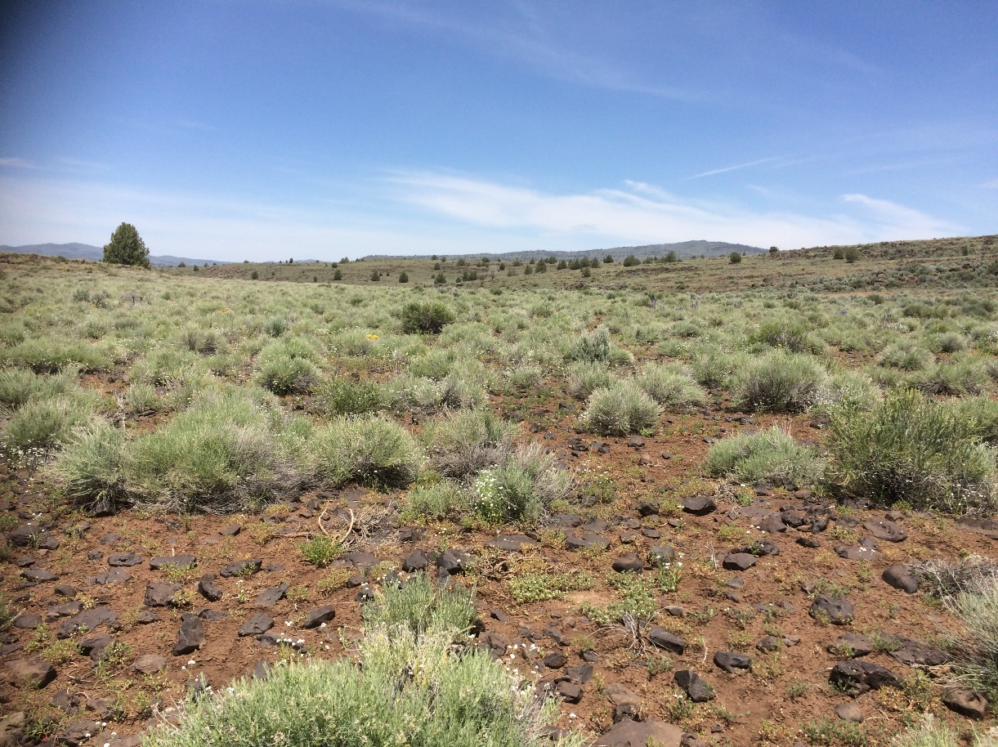

**The following information should be included on the title page*:**

* + Date
  + Preparer(s)
  + Agency for which the report was prepared
  + Contract number, if applicable

*VegCAMP information is shown below as an example.

**California Department of Fish and Wildlife**

**Biogeographic Data Branch**

**Vegetation Classification and Mapping Program**

**2021**

**CDFW Shield Logo** 

# Contents

* Insert a table of contents for the main body of the report, tables of figures, charts, etc. and a table of appendices.
* Appropriate use of headings throughout the report will make these tables easier to generate.

Guidelines for Creating a Vegetation Report i

Contents ii

Table of Appendices iii

Abstract iv

Acknowledgements iv

Introduction 1

Methods 2

Field Sampling 2

Sample Allocation 2

Data Collection 2

Digital Data Entry Methods and Field Survey Database Description 2

Classification 2

Mapping 3

Mapping Materials 3

Map Classification 3

Mapping Reconnaissance 3

Mapping Methods and Criteria 3

Accuracy Assessment 3

Sample Allocation 3

Field Sampling 3

Results 4

Sampling 4

Floristics 4

Sample Collection 4

Analysis 4

Classification 4

Mapping 5

Summary Statistics 5

Accuracy Assessment (AA) 5

Sample Allocation Results 5

Summary Statistics 5

Literature Cited 7

Figures

Tables

# Appendices

Appendix A: Typical Information Included in Appendices

Appendix B: ADA Table Examples

Appendix C: ADA Figure Examples

Appendix D: Vegetation Type Descriptions Example

Appendix E: Instructions for Generating Mail Merge Vegetation Type Descriptions

Appendix F: Map Class Descriptions Example

Appendix G: Glossary of Terms

# 

# Abstract

The abstract should briefly but concisely identify the objectives, methods, principal results, and major conclusions. The purpose is to allow readers to determine whether the information is useful to them. The recommended length is up to 3% of the total length of the report, with a maximum length of 250 words.

# Acknowledgements

In this section, acknowledge:

* + Funder(s)
  + Landowner access contacts
  + Data contributors
  + Staff

# Introduction

* Use a subheading for each of the following sections used in the introduction:
  + Purpose, scope, study area, context, etc.
* Map delineating the study area. Follow formatting example in Appendix C.

# Methods

## Field Sampling

### Sample Allocation

* Details about the sample allocation process

### Data Collection

* (Reconnaissance, Rapid Assessment (RA)/Relevé)
* Map of study area showing the surveyed data points
  + Follow map formatting guidelines in Appendix C.
* Taxonomy standard
  + e.g., Jepson E-Flora for identification of plants, USDA NRCS PLANTS codes incorporated into standard databases where possible

## Digital Data Entry Methods and Field Survey Database Description

* Database quality control

## Classification

* + Description of analysis, software used, and steps performed
    - Cover class categories used for analysis
    - Identification of plots and species removed (if any) as outliers and the criteria for their removal
    - For hierarchical clustering, report distance measure and linkage method used
  + Description of approach to developing classification
  + General approach to developing the key
  + Description of the field test of the key
  + Approach to summarizing environmental data for each vegetation type
  + Approach to summarizing species data for each vegetation type
  + Definitions of terms used in descriptions and keys (should be included in the intro text to the key and included as an appendix)

## Mapping

### Mapping Materials

* Computer software/hardware
* Imagery and data layers used

### Map Classification

* Adapting the vegetation classification to the map classification
* USNVC hierarchy level at which vegetation types were mapped
* Vegetation types that were not mappable
* Use of field data assisting photo-interpretation or modeling
* Ancillary data (geology, topography, hydrology, etc.), and base and ancillary imagery used for the map

### Mapping Reconnaissance

* Field survey dates, with area surveyed

### Mapping Methods and Criteria

* Delineation and attribution methods
* Minimum mapping units (MMUs) for vegetation type changes and cover breaks
* Minimum width of linear polygons
* Full descriptions of each map attribute (may be listed here or in an appendix)
* Description of mapping geodatabase and quality control methods

## Accuracy Assessment

### Sample Allocation

* Details about the AA sample allocation process

### Field Sampling

* Map depicting locations of surveyed AA points
* Measures to ensure the independence of field samplers, AA scorers, and mappers
* Scoring method and goodness-of-fit scoring rules
* Process for providing feedback to mappers and correcting the map

# Results

## Sampling

### Floristics

* Total number of species encountered in project
* List of species used in the analysis, with codes (may be listed here or in an appendix). Follow table template guidelines provided in Appendix A.
* List of rare species, their rarity ranking, and the vegetation types in which they were found. Follow table template guidelines provided in Appendix A.
* Location of and number of voucher specimens collected (list any rare species documented with vouchers)

### Sample Collection

* Number and type (RA, Relevé, Reconnaissance) of samples collected for each vegetation type
* Accuracy of field survey database, if tested

## Analysis

* Table with all plant taxa and corresponding survey ID’s and cover categories imported into analysis software. Follow formatting instructions for tables in Appendix A.
* For indicator species analysis, report cluster groupings with relatively low p-values and high numbers of indicator species
* Table identifying final cluster groupings and all survey IDs included in each group. Follow formatting instructions for tables in Appendix A.

## Classification

* Table showing relationship of final vegetation types in the classification to USNVC hierarchy standards, with sample sizes for each type sampled at the finest hierarchical level (e.g., at Alliance, Association level). Follow formatting instructions for tables in Appendix A.
* Table showing final classification names for each field survey (some may be unclassifiable), and number and ranges of classes. Follow table formatting guidelines in Appendix A.
* Vegetation key: describe here and include as an appendix
* Vegetation type descriptions: describe here and include as an appendix. See formatting guidelines in Appendix D.
  + Summary
  + Distribution in project area and global distribution
  + Environmental description
  + Comments
  + Total number of samples of this type in the project area, and list of field survey database IDs for all samples
  + Rarity status
  + Stand tables: table summarizing constancy and abundance values for taxa in each vegetation type (for abundance, include minimum, maximum and average values for each taxon). Optional categories can include indicator, exotic, or special status species notation. Follow formatting instructions for tables in Appendix A.
* Crosswalk to other vegetation classifications: describe here and include as an appendix. If utilizing a table for crosswalk, be sure to follow formatting instructions for tables in Appendix A.

## Mapping

### **Summary Statistics**

* Total number of polygons, average polygon size
* Number of polygons and acreage mapped for each vegetation type
* Common and uncommon vegetation types
* Detailed description of all map classes and their identification, with examples over imagery. Follow formatting guidelines for images in Appendix B. An example of a map class description can be found in Appendix D.

## Accuracy Assessment (AA)

### Sample Allocation Results

* Number of AA surveys of each vegetation type mapped

### Summary Statistics

* Contingency table (confusion matrix): describe here and include as an appendix. Follow formatting guidelines for the Confusion Matrix Table in Appendix A.
* Table of results showing vegetation type, and users’ and producers’ accuracy. Follow formatting guidelines for table in Appendix A.
* Discussion of types that did not achieve 80% accuracy
  + - Potential reasons for confusion
    - Possible remedies to improve accuracy
    - Actions taken to correct the map

# Literature Cited

Citation examples:

CNPS. 2020. A Manual of California Vegetation, Online Edition. <http://www.cnps.org/cnps/vegetation/>. California Native Plant Society, Sacramento, CA.

Jepson Flora Project (eds.) 2015. Jepson eFlora, <http://ucjeps.berkeley.edu/eflora/> accessed various dates in March 2015.

Sawyer, J. O., T. Keeler-Wolf, and J. Evens. 2009. A manual of California vegetation. Second edition. California Native Plant Society, Sacramento CA. 1300 pp.

USDA NRCS. 2015. The PLANTS Database (http://plants.usda.gov, 4 June 2015). National Plant Data Team, US Department of Agriculture, Natural Resources Conservation Service, Greensboro, NC 27401-4901 USA.

Appendix A: Typical Information Included in Appendices

The appendices in this instructional template document show examples and instructions to aid in report creation and are not intended to be included in actual reports. Any appendices here that are representative of actual report appendices may be organized differently.

Below is a list of items that would typically be included as appendices rather than in the body of a report:

* Final Vegetation Classification and Hierarchy
* Vegetation Key
* Field Forms and Protocols
* Initials used on Field Survey Forms
* Plant Taxa List
* Cluster Analysis Dendrogram
* Noteworthy Taxa
* Classification Crosswalk
* Accuracy Assessment Tables
* Vegetation Type Descriptions
  + Usually included in a classification report
* Map Class Descriptions
  + Usually included in a mapping report
* Glossary of Terms

Appendix B: ADA Table Examples

* Rules for formatting tables for ADA compliance:
  + [Tabs, Tables, Columns in Word](http://blogs.wright.edu/learn/accessibility/word/tabs-tables-and-columns-in-microsoft-word/)
  + Tables should be simple and easy to navigate, with headings repeated across pages.
  + Tables wider than 63 columns (example: contingency tables) do not fit in word. In this case, the table should be stored externally and shown as a linked image in the report.

Table : Example of a simple table: Accuracy assessment. users’ and Producers’ accuracy by type.

| Map Class | | Users' Accuracy | Users' Count | Producers' Accuracy | Producers' Count |
| --- | --- | --- | --- | --- | --- |
| Abies concolor – Pinus ponderosa / Cercocarpus ledifolius Association | | 93.3 | 9 | 82.2 | 9 |
| Populus tremuloides / Symphoricarpos rotundifolius Association | | 100.0 | 15 | 100.0 | 16 |
| Juniperus occidentalis – Pinus jeffreyi / (Purshia tridentata, Prunus virginiana) Association | | 62.5 | 8 | 97.5 | 8 |
| Juniperus occidentalis / Artemisia arbuscula / Poa secunda Association | | 91.1 | 18 | 96.9 | 13 |
| Juniperus occidentalis / Artemisia tridentata – Purshia tridentata Association | | 97.0 | 27 | 98.8 | 17 |
| Juniperus occidentalis / Cercocarpus ledifolius Association | | 84.0 | 5 | 100.0 | 7 |
| Cercocarpus ledifolius – Artemisia tridentata ssp. vaseyana Association | | 100.0 | 9 | 100.0 | 6 |
| Cercocarpus ledifolius – Prunus virginiana – Symphoricarpos rotundifolius Scrub Association | | 97.5 | 8 | 90.0 | 12 |
| Bromus tectorum Ruderal Grassland Association | | 74.0 | 10 | 84.2 | 19 |
| Ericameria nauseosa Shrubland Association | | 96.7 | 6 | 78.3 | 12 |
| Ericameria nauseosa / Bromus tectorum Ruderal Shrubland Association | | 75.0 | 12 | 78.0 | 10 |
| Artemisia arbuscula / Poa secunda Association | | 73.3 | 24 | 92.9 | 17 |
| Artemisia arbuscula / Bromus tectorum Ruderal Shrubland Association | | 77.5 | 16 | 93.3 | 6 |
| Artemisia nova / Poa secunda Association | | 84.0 | 5 | 88.0 | 5 |
| Eriogonum sphaerocephalum / Poa secunda Dwarf-shrub Grassland Association | | 86.0 | 10 | 100.0 | 7 |
| Artemisia tridentata – Ephedra spp. Shrubland Association | | 92.9 | 14 | 94.5 | 11 |
| Artemisia tridentata Shrubland Association | | 93.3 | 9 | 95.0 | 12 |
| Artemisia tridentata – (Ericameria nauseosa) / Bromus tectorum Ruderal Shrubland Association | | 82.7 | 15 | 85.7 | 7 |
| Artemisia tridentata ssp. vaseyana – Symphoricarpos oreophilus / Bromus carinatus Shrubland Association | | 84.0 | 10 | 100.0 | 8 |
| Artemisia tridentata ssp. vaseyana / Festuca idahoensis Shrub Grassland Association | | 97.1 | 7 | 97.1 | 7 |
| Purshia tridentata – Artemisia tridentata Association | | 78.8 | 16 | 90.9 | 11 |
| Purshia tridentata – Artemisia tridentata – Tetradymia canescens Association | | 90.0 | 8 | 89.1 | 11 |
| Tetradymia canescens Provisional Association | | 84.7 | 17 | 90.9 | 11 |
| Ceanothus velutinus Shrubland Association | | 87.8 | 18 | 97.5 | 16 |
| Prunus emarginata Sierran Chaparral Shrubland Association | | 62.9 | 7 | 52.9 | 14 |
| Salix lasiolepis – Rosa woodsii / Mixed Herbs Wet Shrubland Association | | 93.3 | 6 | 90.0 | 6 |
| Artemisia cana (ssp. bolanderi, ssp. viscidula) / Poa secunda Wet Shrubland Association | | 80.0 | 14 | 81.5 | 13 |
| Prunus virginiana / Leymus cinereus Shrubland Association | | 84.4 | 9 | 71.4 | 14 |
| Vancouverian – Rocky Mountain Montane Wet Meadow & Marsh Group | | 100.0 | 6 | 80.0 | 8 |
| Juncus balticus Wet Meadow Association | | 95.0 | 16 | 86.3 | 19 |
| Taraxia tanacetifolia – Iva axillaris Provisional Association | | 95.0 | 8 | 100.0 | 9 |
| Sarcobatus vermiculatus – Artemisia tridentata Wet Shrubland Association | | 90.0 | 20 | 84.8 | 21 |
| Elymus cinereus Bottomland Wet Meadow Association | | 65.5 | 11 | 49.3 | 15 |
| Columbia Plateau cliff, scree and rock mapping unit | | 100.0 | 7 | 86.7 | 9 |
|  | Overall Score | 86.7 |  | 88.4 |  |

Table 2: Example of a linked contingency table

An image of the table can be inserted in the report here with a link to an excel version will be posted on the CDFW document library. Please provide a Table.xlsx version of the contingency table separately. Be sure to make it clear that the image contains a link to an external copy of the contingency table. Also note that alt text should be included if there is not a caption.

[Accuracy assessment contingency table showing field assessed alliances across the top and their corresponding mapped alliances along the left side. Numbers in the boxes in the middle represent how many times a mapped alliance was assessed as the same alliance or a different alliance in the field.
Please click the image for a link to an excel file containing the contingency table.](https://nrm.dfg.ca.gov/FileHandler.ashx?DocumentID=192229)

Appendix C: ADA Figure Examples

* Rules for formatting figures for ADA compliance:
  + [Alternative Text](https://webaim.org/techniques/alttext/)
  + Figures, photos, etc. must have some form of alternative text, this may take the form of a caption or alt text, the two images below show an example of each of these options using the same image.
  + Figures (and objects in general) should be in line with text. Text boxes and wrapping should be avoided.

Example of an image with a caption, no alt text necessary:

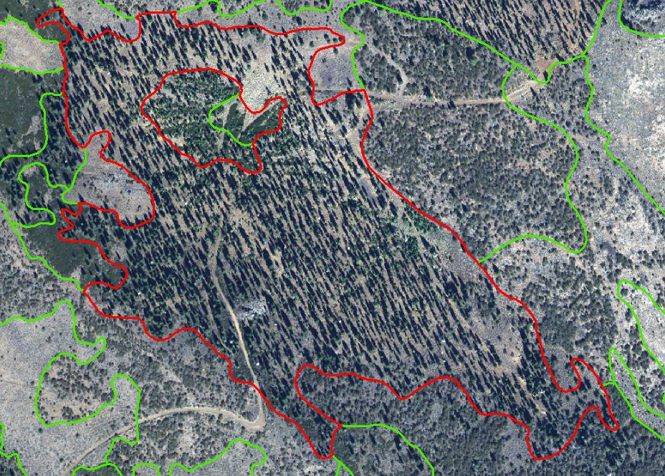

The aerial view shows an open previously logged stand of *Abies concolor*. The understory is shrubby with *Prunus, Ceanothus*, and regenerating pines.

Example of an image with no caption, alt text is necessary in this case:



Below is an example of a map of survey points. All the survey points used for analysis should be included in the data analysis/recon effort. The points should be overlain on pertinent boundaries and data layers like project area(s), ecoregions, and orienting landmarks (water bodies, major cities, topography, etc.). Figure should include a clear description and legend. If appropriate, a secondary data frame indicating the extent rectangle for the project can also be included.

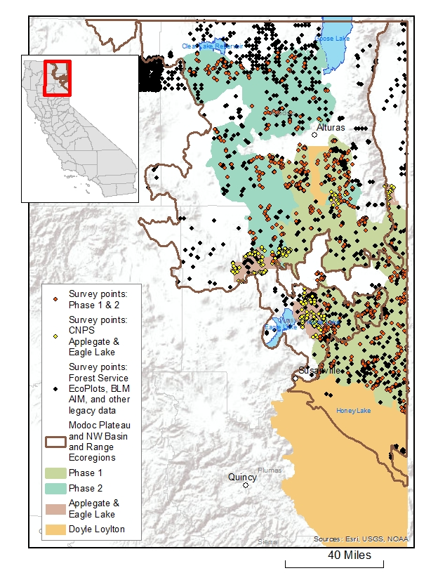

Figure 1: Field Survey Locations. Locations of the 2,059 surveys included in the final vegetation classification data analysis for the Modoc and Lassen vegetation mapping project. Orange points are the 627 samples collected specifically for the project by GIC and VegCAMP in 2016, 2017, and 2018. Yellow points are the 230 points collected in 2018 and 2019 by CNPS for a separate project. Black points are the 1,193 legacy surveys collected between 1985 and 2018 by BLM, the Forest Service, Lava Beds National Monument, and CDFW (Pine Creek and Fitzhugh Creek Wildlife Areas sampled by VegCAMP in 2006).

Appendix D: Vegetation Type Descriptions Example

* The purpose of this appendix is to show an example of how to organize type descriptions so they are easy to navigate – formatting may differ
* Headings for community type, alliance, and association are different from the headings used in the main body of the report to ease creation of a separate table of contents

**Contents**

[Tree Overstory Communities D2](#_Toc69896728)

[Abies concolor Alliance D2](#_Toc69896728)

[Abies concolor – Pinus ponderosa / Amelanchier alnifolia Association D6](#_Toc69896728)

Tree Overstory Communities

Abies concolor Alliance

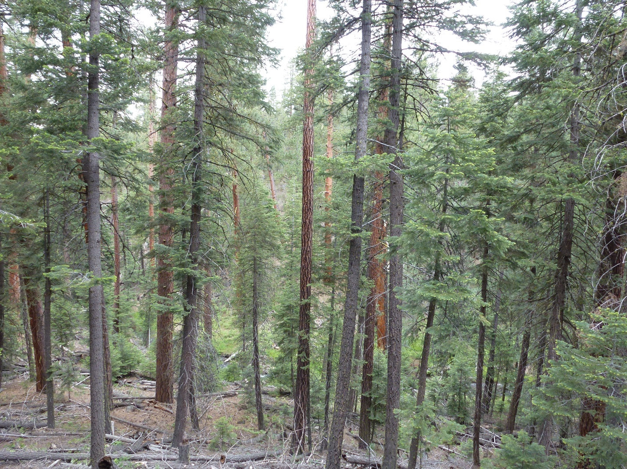

**Common Name:** White fir forest Alliance

**NVC Alliance Code:** A3420. *Abies concolor* Dry Forest & Woodland Alliance

**Alliance Concept**

The *Abies concolor* Alliance forms an open to continuous tree canopy with a sparse to intermittent shrub understory. It is found primarily on north-facing slopes. Soils are derived from a variety of substrates but primarily andesite, volcanics, and basalt, and soil texture is loamy. Elevation range is approximately 1554 – 2344 meters. The dominant tree is *Abies concolor* and *Symphoricarpos rotundifolius* is often present in the shrub layer*.*

**Diagnostic Criteria:** This alliance is characterized by an open to continuous tree canopy of *Abies concolor,* which ranges from 6 to 93 percent cover. The overall tree cover ranges from 10 to 93 percent.

**Local Alliance Distribution**

**Modoc Plateau:** Adin Mountains and Valleys (M261Gl), Crowder Flat (M261Gc), Eagle Lake - Observation Peak (M261Gm), Horsehead Mountain (M261Gk), Likely Mountain (M261Gi), Likely Tableland (M261Gh), Warner Mountains (M261Gf)

**Northwestern Basin and Range:** Medicine Lake Lava Flows (M261Dh)

**Southern Cascades:** Medicine Lake Lava Flows (M261Dh)

**Associations**

*Abies concolor – Pinus ponderosa* / *Cercocarpus ledifolius* Association

**Environmental Description**

**Plot/Sample Data Environmental Summary:**

Elevation: Mean 1924 m, Range 1554 – 2344 m

Aspect: NE (14), NW (12), SE (4), SW (2)

Slope: Mean 16.0 degrees, Range 2 – 30 degrees

Macro Topography: Upper 1/3 of slope (9), Middle 1/3 of slope (6), Middle to Upper 1/3 of slope (5), Lower 1/3 of slope (3), Lower to Upper 1/3 of slope (2), Ridge summit, crest (2), Bottom (1), Upper 1/3 of slope to Ridgetop (1), Midslope (1), Lower to Middle 1/3 of slope (1), Draw, intermittent stream bottom (1)

Tree Cover: Mean 18.7%, Range 10 – 93%

Shrub Cover: Mean 5.1%, Range 0 – 40%

Herb Cover: Mean 13.3%, Range 0.2 – 61%

Large Rock: Mean 3.8%, Range 0 – 12%

Small Rock: Mean 8%, Range 0 – 39%

Fines Cover: Mean 8.4%, Range 0 – 43%

Litter Cover: Mean 74.5%, Range 15 – 98%

Soil Texture (field assessed): Medium to very fine, sandy loam (3), Coarse, loamy sand (2), Medium loam (2), Moderately coarse, sandy loam (2), Moderately fine sandy clay loam (2), Medium silt loam (1), Moderately fine clay loam (1), Sandy Loam (1)

Geology (map data): Andesite (11), General volcanic extrusives (7), Basalt (5)

**Environment:** Stands of *Abies concolor* within the Modoc Plateau and NW Basin and Range ecoregions are restricted to the highest elevations where the summer-time temperatures are more moderate and precipitation is higher than at the lower elevation ranges.

**Vegetation Description**

**Vegetation Structure:** The alliance forms an open to continuous tree layer with a sparse to intermittent shrub layer and sparse to intermittent herbaceous understory.

**Vegetation Floristics:** The dominant tree is *Abies concolor* in the overstory*. Symphoricarpos rotundifolius* is often present in the shrub layer*.*

**Dynamics:** *Abies concolor* is a large, long-lived conifer that tends to increase in areas that have not burned recently.The ecological amplitude of *Abies concolor* is broader than for other firs in California. It is the only member of the genus within the study area.

**Species of Interest:** *Hackelia cusickii* and *Silene oregana*

**Classification Confidence:** High

**Conservation Status Rank**

**Global:**G4 **State:**S5

**References**

None

**Total Sample Size Used for Description**: N=32

**Alliance Stand Table**

***Abies concolor* Alliance**

**n =** **32**

**Lifeform** **Botanical Name** **Con** **Avg** **Min** **Max**

**Tree**

*Abies concolor* 100 26.88 6 93

*Pinus ponderosa* 50 12.86 1 48

*Juniperus occidentalis* 19 1.65 0.2 3.5

*Pinus jeffreyi* 19 14.03 0.2 35

**Sapling**

*Abies concolor* 78 3.48 0.2 12

*Pinus jeffreyi* 13 3.3 0.2 7

**Seedling**

*Abies concolor* 81 2.08 0.2 11

*Pinus ponderosa* 13 0.6 0.2 1

**Shrub**

*Symphoricarpos rotundifolius* 53 2.75 0.2 25

*Amelanchier utahensis* 31 0.98 0.2 3

*Ribes velutinum* 28 0.89 0.2 3

*Cercocarpus ledifolius* 25 1.23 0.2 4

*Ribes cereum* 25 0.6 0.2 1

**Alliance Stand Table continued**

***Abies concolor* Alliance**

**n =** **32**

**Lifeform** **Botanical Name** **Con** **Avg** **Min** **Max**

**Herb**

*Prunus virginiana* 19 3.57 0.2 18

*Mahonia aquifolium* 19 0.73 0.2 1

*Ceanothus velutinus* 16 2.64 0.2 5

*Ribes viscosissimum* 16 8.8 1 40

*Artemisia tridentata* ssp. *vaseyana* 13 1.35 0.2 4

*Prunus emarginata* 13 1.3 0.2 2

*Ribes* 13 1 1 1

*Artemisia tridentata* 13 0.2 0.2 0.2

*Arctostaphylos patula* 13 2.23 0.2 7.5

**Herb**

*Collinsia parviflora* 41 1.82 0.2 15

*Elymus elymoides* 34 0.35 0.2 1

*Arnica cordifolia* 34 8.75 0.2 30

*Pseudostellaria jamesiana* 31 8.32 0.2 30

*Maianthemum racemosum* 22 1.74 0.2 7

*Osmorhiza chilensis* 22 1.03 0.2 2

*Viola purpurea* 22 0.69 0.2 2

*Wyethia mollis* 19 0.97 0.2 4

*Carex rossii* 19 1.87 0.2 6

*Collomia grandiflora* 19 0.2 0.2 0.2

*Poa secunda* 19 1.1 0.2 3

*Poa wheeleri* 16 0.84 0.2 1

*Maianthemum stellatum* 16 0.52 0.2 1

*Hieracium horridum* 16 0.88 0.2 2

*Galium aparine* 16 0.52 0.2 1

*Elymus glaucus* 16 1.84 0.2 5

*Cryptantha* 16 0.52 0.2 1

*Aquilegia formosa* 16 0.68 0.2 1

*Bromus carinatus* 16 1.48 0.2 3

*Phacelia humilis* 13 0.68 0.2 2

*Hieracium scouleri* 13 0.6 0.2 1

*Pyrola picta* 13 0.8 0.2 1

*Hydrophyllum capitatum* 13 0.8 0.2 1

*Bromus orcuttianus* 13 1 1 1

*Osmorhiza occidentalis* 13 1.05 0.2 2

Abies concolor – Pinus ponderosa / Amelanchier alnifolia Association

**Common Name:** White Fir - Ponderosa Pine / Serviceberry

**NVC Association Code:**  CEGL000014, *Abies lowiana - Pinus ponderosa* / *Amelanchier alnifolia* Forest

**Alliance:** *Abies concolor* Alliance

**Association Concept**

The *Abies concolor – Pinus ponderosa* / *Amelanchier alnifolia* Association forms an open to continuous tree canopy with a sparse to open shrub understory. It is found primarily on slopes, ridges, and draws with intermittent streams at all aspects. Soils are derived from a variety of substrates but primarily andesite, general volcanic extrusives, or basalt and textures vary widely. Elevations range from approximately 1554 to 2344 meters. The dominant tree is *Abies concolor,* and *Pinus ponderosa* is often present.

**Diagnostic Criteria:** This association is characterized by an open to continuous tree canopy of *Abies concolor* which ranges from 6 to 93 percent cover. The overall tree cover ranges from 10 to 93 percent.

**Environmental Description**

**Plot/Sample Data Environmental Summary:**

Elevation: Mean 1895 m, Range 1554 – 2344 m

Aspect: NE (12), NW (10), SE (4), SW (2)

Slope: Mean 15.4 degrees, Range 2 – 30 degrees

Macro Topography: Middle 1/3 of slope (6), Upper 1/3 of slope (5), Middle to Upper 1/3 of slope (5), Lower 1/3 of slope (3), Ridge summit, crest (2), Lower to Upper 1/3 of slope (2), Lower to Middle 1/3 of slope (1), Midslope (1), Draw, intermittent stream bottom (1), Bottom (1), Upper 1/3 of slope to Ridgetop (1)

Tree Cover: Mean 17%, Range 10 – 93%

Shrub Cover: Mean 3.3%, Range 0.2 – 11%

Herb Cover: Mean 10.4%, Range 0.2 – 61%

Large Rock: Mean 3.8%, Range 0 – 12%

Small Rock: Mean 8%, Range 0 – 39%

Fines Cover: Mean 9.3%, Range 0 – 43%

Litter Cover: Mean 73.8%, Range 15 – 98%

Soil Texture (field assessed): Not recorded (6), Medium to very fine, sandy loam (3), Coarse, loamy sand (2), Medium loam (2), Moderately coarse, sandy loam (2), Moderately fine sandy clay loam (2), Sandy Loam (1), Medium silt loam (1), Moderately fine clay loam (1)

Geology (map data): Andesite (7), General volcanic extrusives (7), Basalt (5)

**Vegetation Description**

**Vegetation Structure:** The association forms an open to continuous tree layer with a sparse to open shrub layer and sparse or intermittent herbaceous understory.

**Vegetation Floristics:** The dominant tree is *Abies concolor* in the overstory*,* and *Pinus ponderosa* is often present.

**Dynamics:** *Abies concolor* is dominant to co-dominant in the tree layer with *Pinus ponderosa* or *Pinus* jeffreyi. *Juniperus occidentalis* may be present but insignificant. Higher elevation, cold-tolerant shrubs are present and may include *Amelanchier utahensis, Cercocarpus ledifolius,* *Ribes* spp., *Symphoricarpos rotundifolius, Artemisia tridentata* ssp. *vaseyana,* and *Prunus* spp.

**Species of Interest:** *Hackelia cusickii, Silene oregana*

**Classification Comments**

None.

**Classification Confidence:** High

**Conservation Status Rank**

**Global:**GNR **State:**N

**References**

None.

**Total Sample Size Used for Description**:N=28

**Association Stand Table**

***Abies concolor – Pinus ponderosa / Amelanchier alnifolia* Association**

**n =** **28**

**Lifeform** **Botanical Name** **Con** **Avg** **Min** **Max**

**Tree**

*Abies concolor* 100 22.93 6 93

*Pinus ponderosa* 57 12.86 1 48

*Juniperus occidentalis* 21 1.65 0.2 3.5

*Pinus jeffreyi* 21 14.03 0.2 35

**Sapling**

*Abies concolor* 75 3.2 0.2 12

*Pinus jeffreyi* 14 3.3 0.2 7

**Association Stand Table continued**

***Abies concolor – Pinus ponderosa* / *Amelanchier alnifolia* Association**

**n =** **28**

**Lifeform** **Botanical Name** **Con** **Avg** **Min** **Max**

**Seedling**

*Juniperus occidentalis* 11 0.63 0.2 1.5

*Abies concolor* 79 2.28 0.2 11

*Pinus ponderosa* 14 0.6 0.2 1

*Juniperus occidentalis* 11 0.2 0.2 0.2

*Pinus jeffreyi* 11 2.67 2 3

**Shrub**

*Symphoricarpos rotundifolius* 46 1.45 0.2 7

*Amelanchier utahensis* 36 0.98 0.2 3

*Ribes velutinum* 32 0.89 0.2 3

*Cercocarpus ledifolius* 29 1.23 0.2 4

*Ribes cereum* 29 0.6 0.2 1

*Mahonia aquifolium* 21 0.73 0.2 1

*Prunus virginiana* 21 3.57 0.2 18

*Ceanothus velutinus* 18 2.64 0.2 5

*Prunus emarginata* 14 1.3 0.2 2

*Artemisia tridentata* ssp. *vaseyana* 14 1.35 0.2 4

*Artemisia tridentata* 14 0.2 0.2 0.2

*Arctostaphylos patula* 14 2.23 0.2 7.5

*Ribes* 14 1 1 1

*Ceanothus prostratus* 11 0.73 0.2 1

*Ericameria nauseosa* 11 0.47 0.2 1

*Symphoricarpos* 11 0.73 0.2 1

*Collinsia parviflora* 43 0.72 0.2 3

*Elymus elymoides* 39 0.35 0.2 1

*Arnica cordifolia* 25 9.89 0.2 30

*Poa secunda* 21 1.1 0.2 3

*Wyethia mollis* 21 0.97 0.2 4

*Pseudostellaria jamesiana* 21 6.87 0.2 30

*Collomia grandiflora* 21 0.2 0.2 0.2

*Carex rossii* 21 1.87 0.2 6

*Viola purpurea* 21 0.63 0.2 2

*Bromus carinatus* 18 1.48 0.2 3

*Cryptantha* 18 0.52 0.2 1

**Association Stand Table continued**

***Abies concolor – Pinus ponderosa* / *Amelanchier alnifolia* Association**

**n =** **28**

**Lifeform** **Botanical Name** **Con** **Avg** **Min** **Max**

**Shrub**

*Galium aparine* 18 0.52 0.2 1

*Maianthemum racemosum* 18 2.04 0.2 7

*Maianthemum stellatum* 18 0.52 0.2 1

*Poa wheeleri* 18 0.84 0.2 1

*Elymus glaucus* 14 1.05 0.2 2

*Osmorhiza chilensis* 14 1.05 0.2 2

*Phacelia humilis* 14 0.68 0.2 2

*Hieracium scouleri* 14 0.6 0.2 1

*Hieracium horridum* 14 0.85 0.2 2

*Lupinus* 14 0.6 0.2 1

*Melica bulbosa* 11 0.2 0.2 0.2

*Stellaria longipes* 11 0.47 0.2 1

*Silene* 11 0.47 0.2 1

*Senecio aronicoides* 11 1.33 1 2

*Phacelia hastata* 11 0.2 0.2 0.2

*Osmorhiza occidentalis* 11 1.07 0.2 2

*Lupinus arbustus* 11 1.07 0.2 2

*Kelloggia galioides* 11 1 1 1

*Hydrophyllum capitatum* 11 0.73 0.2 1

*Festuca idahoensis* 11 0.2 0.2 0.2

*Claytonia rubra* 11 0.2 0.2 0.2

*Bromus tectorum* 11 1.07 0.2 2

*Penstemon* 11 0.8 0.2 2

Appendix E: Instructions for Generating Mail Merge Vegetation Type Descriptions

## Mail Merge Instructions

Basic instructions for generating mail merge vegetation type descriptions based on the approach used for the Modoc – Lassen Classification Report:

1. Make a copy of a vegetation database for mail merge editing.
2. Create mail merge tables in your database, these are tables containing the name of the vegetation type with relevant attributes. The mail merge template will be populated using information from these fields.
   1. Consider which attributes you will need for your description. Examples: minimum and maximum elevation, aspect, slope, long text fields for listing the names of dominant or characteristic species
   2. Create separate tables for each level of classification needing descriptions (likely just alliances and associations).
   3. These tables are populated using summarized information from vegetation surveys. Using a maketable query to create an initial table with basic information such as elevation, slope, aspect, and ground cover is a simple approach that will minimize the amount of work needed to fill out the table.
3. Summarize important plant species for each type based on dominance
   1. This step may not be necessary if this information is not desired in your vegetation type description. Stand tables present this information in another format but listing the plant species that define the type in the description can make for an easier-to-read summary.
   2. Species dominance and related data are determined using relative cover and constancy. Suggested definitions for these terms and more are included in the glossary at the end of this appendix. Constancy and average relative cover should be included in stand tables for querying.
   3. Species constancy represents the percentage of plots of a vegetation type in which a species is present. For example, if *Abies concolor* is in one plot out of four it has a constancy of 0.25 or 25%.
   4. Average relative cover represents the cover of a species relative to other species in the same plot.
   5. Using the constancy and relative cover values, follow the rules laid out in the glossary to determine which species are dominant, characteristic, often present, etc. for each vegetation type. Create a table listing all of the species in each vegetation type, separated by stratum, with fields that track whether they are dominant, characteristic, often present, etc.
      1. The dominant, characteristic, often present, etc. species can then be placed into a concatenated list field for each vegetation type
4. Concatenated list fields
   1. Text values like references, topography, substrate, etc. can be put into lists which must be contained in long text (memo) fields if they exceed 255 characters. There are multiple methods to achieve this result. Instructions for the method used in the MOLA classification report are included below this outline.
5. Create mail merge document templates
   1. Link your mail merge document to the database containing your tables
      1. In the Mailings tab of Word, click Select Recipients, then Use an Existing List, navigate to your database and open it. You’ll be asked to link the correct table from the database, this will be the mail merge table for the classification level for which you’re generating descriptions.
   2. Create an outline with the basic desired look of the vegetation description and insert merge fields (use the Mailings tab) as necessary. It may be useful to work from an existing template for this step.
      1. There will often be further details to add at the end of the process, mail merging is used to place quantifiable data in a structure that can be edited later for clarity.
      2. The number of decimal places displayed by a numeric field can be changed by right clicking a merge field, clicking “Toggle Field Codes” and adding “\#0.x” where x is a number of zeroes representing how many numbers will come after the decimal. For example: {MERGEFIELD "MinOfConif_cover” \#0.0} would display the number from the MinOfConif_cover field to one decimal place.
   3. In the Mailings tab, click Finish & Merge, then edit individual documents. Save the resulting document as a draft and edit as needed.

VBA Concatenator Instructions

This code is designed to avoid the issue of truncation in long concatenated fields which happens when populating with a series of values that exceeds a lower limit. Other methods may be more efficient in certain circumstances, especially if concatenating fields with less than 255 characters.

Copy and paste the code below into a new module in your access database (Ctrl + G will open the VBA window).

'*************************************************************************

Public Function Report_Concat( _

strOutTable As String, _

Optional strWhere As String, _

Optional strOrderBy As String, _

Optional strSeparator = ", ")

' This function takes a 2-column input table and concatenates the second column

' depending on breaks in the first

' You must supply the input and the output table names

' Declare the local variables

Dim tmpDb As DAO.Database

Dim tmpInRec As DAO.Recordset

Dim tmpOutRec As DAO.Recordset

Dim strConcat As String

Dim strInTable As String

Dim strOldVegType As String

Dim strVegType As String

Dim tmpSQL As String

Set tmpDb = CurrentDb

' First get the name of the input table

strInTable = InputBox("Please enter the name of the input table")

If Len(strInTable) = 0 Then

MsgBox "exiting - input table name cannot be blank"

GoTo Exit_Report_Concat

End If

' Clear the output table

tmpSQL = "DELETE * from " & strOutTable

'DoCmd.SetWarnings False

DoCmd.RunSQL tmpSQL

DoCmd.SetWarnings True

' Get the first input record

tmpSQL = "Select * from " & strInTable

Set tmpInRec = tmpDb.OpenRecordset(tmpSQL)

' If we don't find one, put up a message and exit

If tmpInRec.EOF Then

MsgBox strInTable & "is empty"

GoTo Exit_Report_Concat

End If

' Set up the first record before we start the loop

strOldVegType = tmpInRec(0).Value

strConcat = tmpInRec![expr1]

tmpInRec.MoveNext

' Note: this code should be used in a macro.

' Open the output table so that we can write to it

Set tmpOutRec = tmpDb.OpenRecordset(strOutTable)

' Loop through the input table, starting with the second record

Do While Not tmpInRec.EOF

strVegType = tmpInRec(0).Value

If strVegType = strOldVegType Then

strConcat = strConcat & strSeparator & tmpInRec![expr1]

Else

'write the record

tmpOutRec.AddNew

tmpOutRec![VegType] = strOldVegType

tmpOutRec![Concat_out] = strConcat

tmpOutRec.Update

'reset the vegtype and start the concat

strOldVegType = strVegType

strConcat = tmpInRec![expr1]

End If

tmpInRec.MoveNext

Loop

'write the final record

tmpOutRec.AddNew

tmpOutRec![VegType] = strOldVegType

tmpOutRec![Concat_out] = strConcat

tmpOutRec.Update

Exit_Report_Concat:

' Clear the variables

strConcat = ""

strOldVegType = ""

strVegType = ""

tmpSQL = ""

Set tmpInRec = Nothing

Set tmpOutRec = Nothing

Exit Function

Err_Report_Concat:

MsgBox Err.Description

Resume Exit_Report_Concat

End Function

'***********************************************************************

The next step is to create a macro that looks like this:

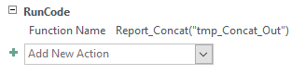

Where “tmp_Concat_Out” is an empty table in your database with 2 long text (aka memo) fields:



What this code does is take a 2-column table (or select query) and concatenate the values from the second column into a long text field based on the values in the first column. Your source table/query should have a one-to-many relationship between the first and second columns. As a default, the second column in your originating table will need to be titled “Expr1” but you can change this within the code by changing the name at the 3 locations highlighted in yellow above. You can additionally change what goes between the concatenated values by changing the red highlighted variable at the top of the code. For example, to insert a carriage return between values, remove “ ,” and replace it with vbCrLf (note the lack of quotation marks.)

If you want to use the generated table to populate a field in another table via an update query, you will have to change the data type of the column you are using for a join. If changing to short text, ensure that you set the field size appropriately for the length of your data – the maximum for short text is 255. Given that this process is designed to produce a concatenated long text field in the second column, you will want to rely on the data in the first column for joins.

Appendix F: Map Class Descriptions Example

Abies concolor Alliance (11110)

White fir forest Alliance



The aerial view shows an open previously logged stand of *Abies concolor*. The understory is shrubby with *Prunus, Ceanothus*, and regenerating pines.

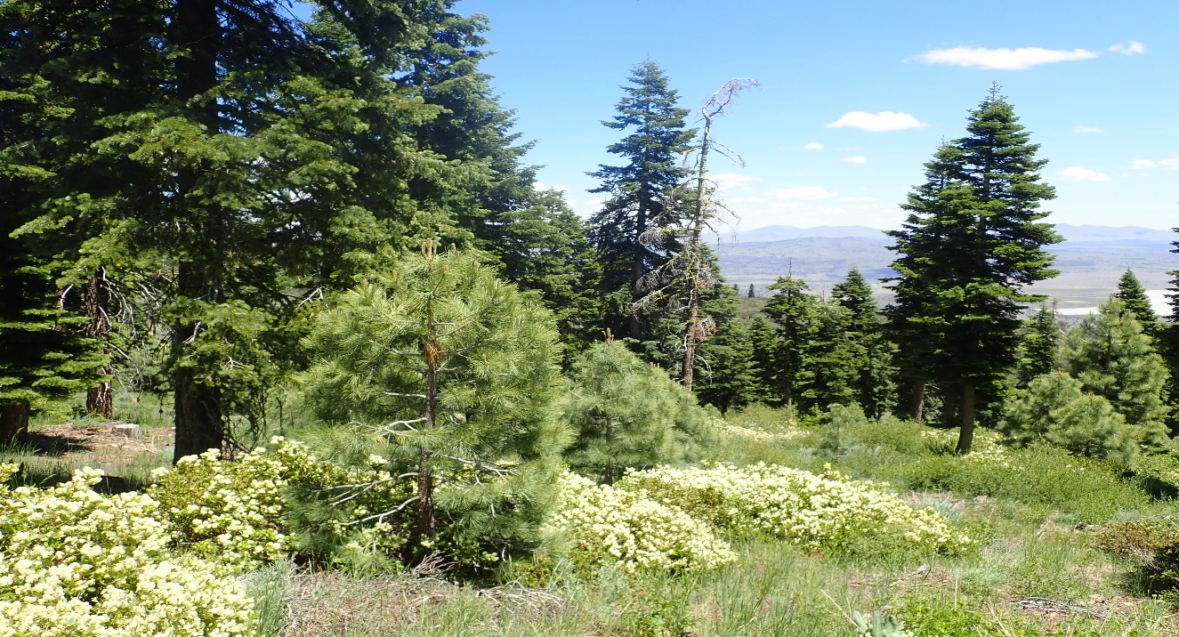

This is an open stand with an overstory of *Abies concolor*, and an understory of regenerating *Pinus ponderosa*.

***Abies concolor* Alliance (11110)**

**DESCRIPTION:** *Abies concolor* is dominant to co-dominant in the tree layer. *Pinus ponderosa* or *Pinus jeffreyi* are co-dominant to absent. *Juniperus occidentalis* may be present, but at very low cover.

**PHOTOINTERPRETATION SIGNATURE:** *Abies concolor* has a narrower more conical shape than other conifers; especially pines. Colors trend more blue-green than pine. Cover is generally higher than either juniper or pine woodlands stands. Limited at lower elevations in riparian and north-trending slopes where it often interfaces with *Pinus ponderosa* or *P. jeffreyi.* *Pinus ponderosa* and *P. jeffreyi* both have a medium to large, rounded dense crown with branching extending broadly to the mid-crown.

**TYPES WITH SIMILAR PHOTOINTERPRETATION SIGNATURES:**

* Types dominated by *Pinus ponderosa* and *Pinus jeffreyi* are found adjacent at lower elevations and generally have a larger more rounded crown, however *P. jeffreyi* can overlap with *Abies* in elevation. Pines in general usually have a yellow-green color. Crowns tend to be more open.

***Abies concolor* Alliance (11110)**

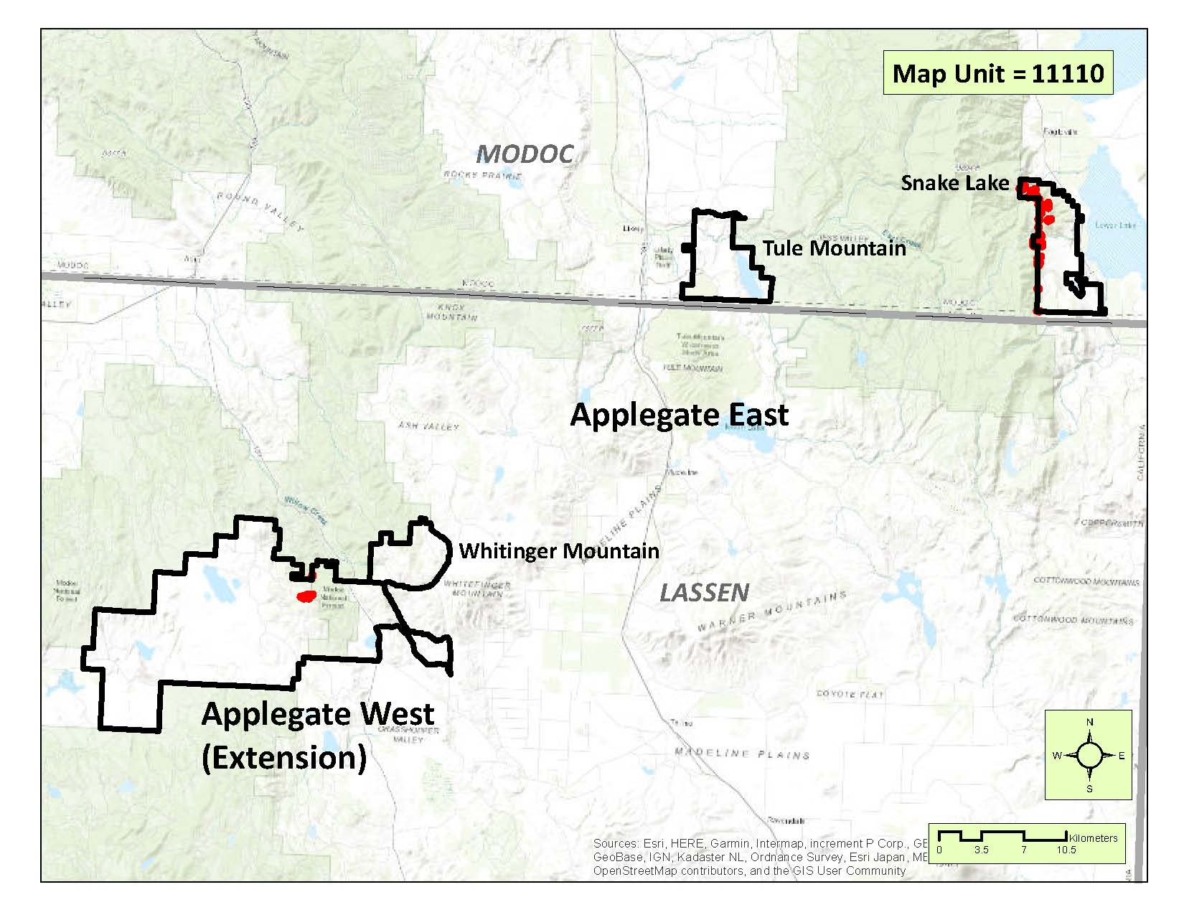

**DISTRIBUTION:** *Abies concolor* is mapped at the Alliance level primarily on the east slopes of the Warner Mountains in the Snake Lake subunit. A small stand is identified east of Silva Flat Reservoir on a north slope near Four-Pine spring in the Applegate Extension subunit.

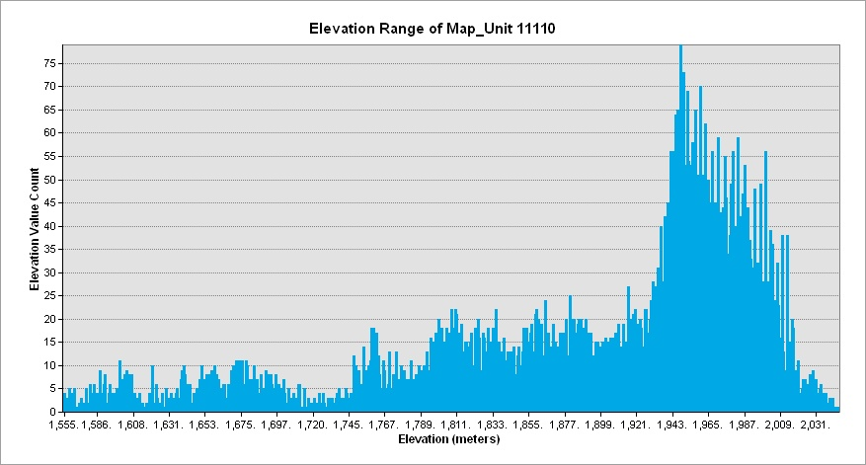

Abies concolor – Pinus ponderosa / Amelanchier alnifolia Association (11111)

White fir – Ponderosa pine / Serviceberry Association

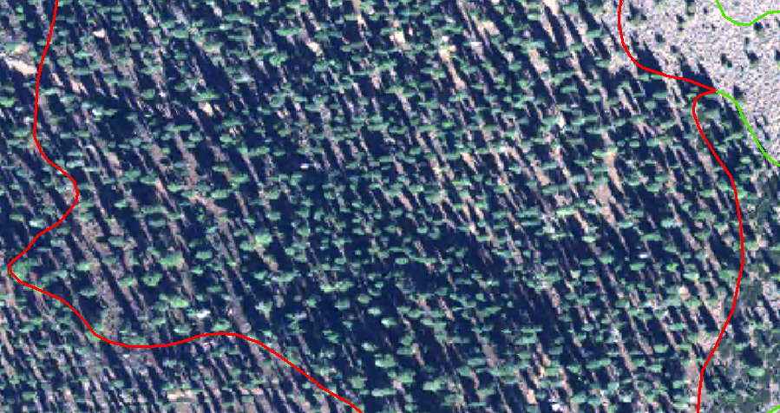

The aerial view depicts a dense, previously logged stand of *Abies concolor*. The stand trends north to northwest averaging about 7200 feet.

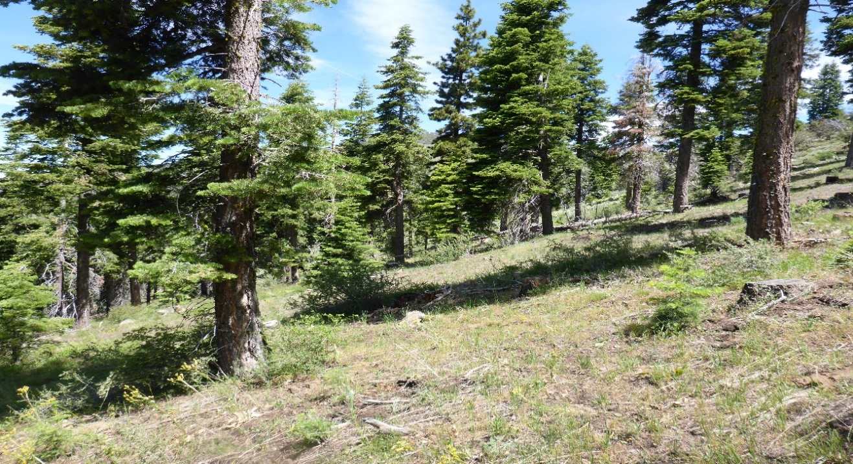

This ground photo shows open margins of the stand depicting an open grassy understory with minimal shrub cover.

***Abies concolor – Pinus ponderosa / Amelanchier alnifolia* Association (11111)**

**DESCRIPTION:** *Abies concolor* is dominant to co-dominant in the tree layer. *Pinus ponderosa* or *Pinus jeffreyi* is co-dominant to absent. *Juniperus occidentalis* may be present but insignificant. Higher elevation, cold-tolerant shrubs are present and may include *Amelanchier utahensis, Cercocarpus ledifolius, Ribes* spp., *Symphoricarpos rotundifolius, Artemisia tridentata* ssp*. vaseyana, and Prunus* spp*.* The shrub and herb layers are characteristically sparse (less than 10% absolute cover) and are low in species diversity.

**PHOTOINTERPRETATION SIGNATURE:** *Abies concolor* has a narrower more conical shape than other conifers; especially pines. Colors trend more blue-green than pine. Cover is generally higher than either juniper or pine woodlands stands. Limited at lower elevations in riparian and north-trending slopes where it often interfaces with *Pinus ponderosa* or *P. jeffreyi.*

**TYPES WITH SIMILAR PHOTOINTERPRETATION SIGNATURES:**

* Types dominated by *Pinus ponderosa* and *Pinus jeffreyi* are found adjacent at lower elevations and generally have a larger more rounded crown, however *P. jeffreyi* can overlap with *Abies* in elevation. Pines in general usually have a yellow-green color. Crowns tend to be more open.

***Abies concolor – Pinus ponderosa / Amelanchier alnifolia* Association (11111)**

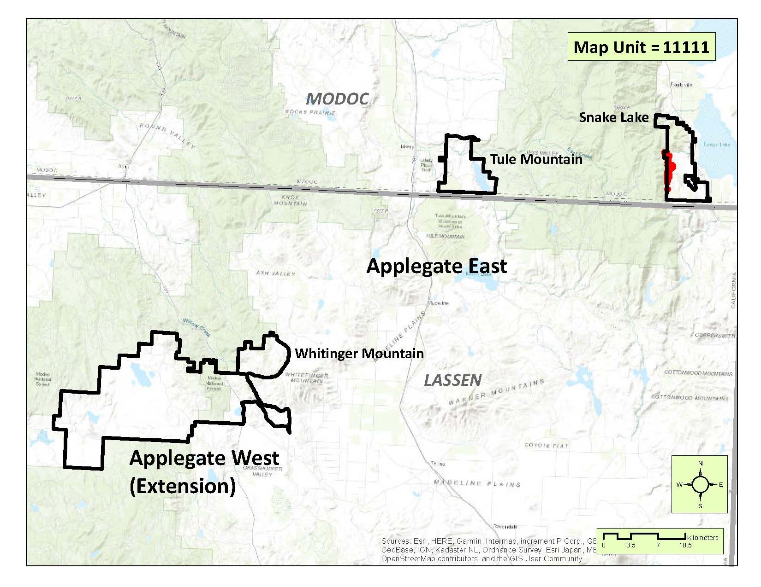

**DISTRIBUTION:** This Association is found on steep east-trending slopes in elevations as low as 6200 feet along the eastern side of the Warner Mountains in the Snake Lake subunit. It is not mapped in the other subunits.

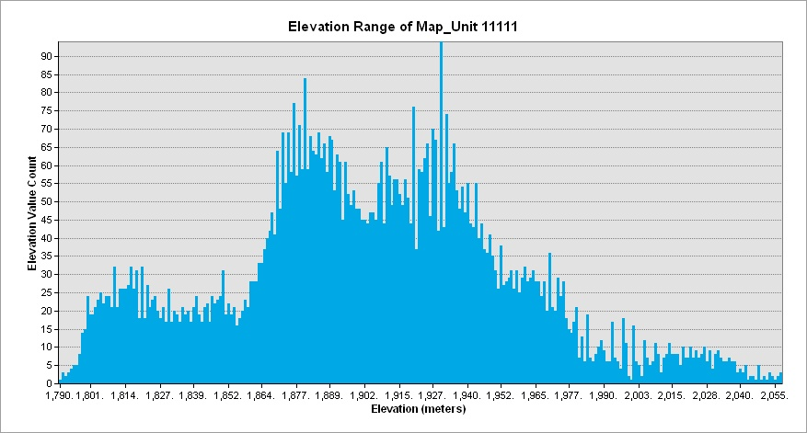

Appendix G: Glossary of Terms

Taken from the National Park Service 2018 Channel Islands Classification Report

* **Absolute cover** – Refers to the actual percentage of the ground (surface of the plot or stand) that is covered by a species or group of species. Absolute cover of all species or groups if added in a stand or plot may total greater or less than 100% because it is not a proportional number.
* **Characteristic** – Present in at least 75% of the samples for that vegetation type, with no restriction on cover.
* **Co-dominant** – Two or more abundant species with high cover in relation to other species in the layer with the highest canopy cover. We typically define co-dominant species as those with at least 30% relative cover.
* **Cover** – The primary metric used to quantify the abundance of a particular species or a particular vegetation layer within a plot. It was measured by estimating the aerial extent of the living plants, or the “bird’s-eye view” looking from above for each category.
* **Dense/Continuous cover** – Used to describe individual layers of vegetation (tree, shrub, herb, or subdivisions of them) where there is greater than 66 percent absolute cover.
* **Dominant** – An abundant species with high cover in relation to other species in the layer with highest canopy cover. We typically define dominant species as those with at least 50% relative cover within a particular layer.
* **Emergent** – A plant (or vegetation layer) is considered emergent if it includes plants that rises above a predominant vegetation layer, but that are sparse in cover. It is considered as a member of the next tallest layer, but typically has an absolute cover < 10%.
* **Herb** – Is any vascular plant species that has no main woody stem-development, and includes grasses, forbs, and perennial species that die-back seasonally.
* **Open** – Used to describe individual layers of vegetation (tree, shrub, herb, or subdivisions of them) where the cover is less than 33 percent absolute cover.
* **Relative cover** – Refers to the amount of the surface of the plot or stand sampled that is covered by one species (or physiognomic group) as compared to (relative to) the amount of surface of the plot or stand covered by all species (in that group). Thus, 50% relative cover means that half of the total cover of all species or physiognomic groups is composed of the single species or group in question. Standardized layers of herb, shrub, and tree are used to determine relative cover. Relative cover values are proportional numbers and, if added, total 100% for each stand (sample).
* **Semi-natural vegetation** – Stands characterized by naturalized non-native species. Note that NVC vegetation types use “ruderal” to describe these plant communities.
* **Shrub** – Is normally a multi-stemmed woody plant that generally has several erect, spreading, or prostrate stems and that is usually between 0.2 meters and 5 meters tall, giving it a bushy appearance. Definitions are blurred at the low and the high ends of the height scales. At the tall end, shrubs may approach trees in size (*Heteromeles arbutifolia,* often appears tree-sized on Santa Rosa Island. At the low end, woody perennial herbs or sub-shrubs of various species are often difficult to categorize into a single life-form; usually sub-shrubs (per USDA-NRCS 2014) were categorized in the “shrub” category.
* **Sometimes** – Present in 25 to 50% of the samples with no restriction on cover.
* **Sparse** – Used to describe individual layers of vegetation (tree, shrub, herb, or subdivisions of them) where the *average* cover value is <2% absolute cover (though the range in cover could be <1-9% cover).
* **Stand** – The basic physical unit of vegetation in a landscape. It has no set size. Some vegetation stands are very small such as wetland seeps, and some may be several square kilometers in size such as desert or forest types. A stand is defined by two main unifying characteristics:
  + It has *compositional* integrity. Throughout the site, the combination of species is similar. The stand is differentiated from adjacent stands by a discernable boundary that may be abrupt or gradual.
  + It has *structural* integrity. It has a similar history or environmental setting, affording relatively similar horizontal and vertical spacing of plant species. For example, a hillside forest formerly dominated by the same species, but that has burned on the upper part of the slope and not the lower is divided into two stands. Likewise, a sparse woodland occupying a slope with shallow rocky soils is considered a different stand from an adjacent slope of a denser woodland/forest with deep moister soil and the same species.
* **Sub-dominant –** Used to describe an important species in the stand that is less than 30% relative cover.
* **Tree** – Is a one-stemmed woody plant that normally grows to be greater than 5 meters tall. In some cases trees may be multiple-stemmed (ramifying) after fire or other disturbance, but size of mature plants is typically greater than 5 m and undisturbed individuals of these species are usually single stemmed.
* **Usually/Often** – Present in 50 to 75% of the samples, with no restriction on cover.