**State of California  
Department of Fish and Wildlife**

M e m o r a n d u m

**Date:** May 28, 2025

**To:**Nick Bauer

Senior Environmental Scientist; Supervisor

Department of Fish and Wildlife

North Central Region

1701 Nimbus Road, Suite A

Rancho Cordova, CA 95670

**Cc:** CDFW North Central Region Fish Files

**From:** Marc Beccio; Environmental Scientist

Department of Fish and Wildlife

1701 Nimbus Road, Suite A

Rancho Cordova, CA 95670

**Su****bject:** **2024 Yuba River Sturgeon Spawning Study**

# Purpose

This report documents findings of the fifth year of a California Department of Fish and Wildlife (CDFW) study to determine spawning occurrences of southern Distinct Population Segment (sDPS) green sturgeon (*Acipenser medirostris*) and white sturgeon (*Acipenser transmontanus*) in the Yuba River and the temporal, spatial, and habitat requirements associated with sturgeon spawning events.

# Background

Southern DPS green sturgeon and white sturgeon populations have been severely reduced because of dams, diversions, habitat degradation, and both legal and illegal harvest. The Sacramento River system is the only river system supporting spawning of the federal threatened sDPS green sturgeon and is the primary river system supporting spawning of white sturgeon. Green sturgeon spawning has been documented in a 93 km section of the Sacramento River from Hamilton City (river kilometer [rkm] 332.5) upstream to Cottonwood (rkm 426) (Poytress et al. 2013) and in the Feather River in the vicinity of the Thermalito Bay Outlet in mid-June 2011 (Seesholtz et al. 2015). The majority of white sturgeon are thought to spawn in the middle Sacramento River between Knights Landing (rkm 142) and Colusa (rkm 237) (CDFW 2021, 2022, 2023, and Schaffter 1997). Because green sturgeon are federally listed as threatened, it is crucial to identify and support additional spawning populations. One of the Demographic Recovery Criteria points in the *Recovery Plan for Southern Distinct Population Segment of the North American Green Sturgeon* *(Acipenser medirostris)* is that “SDPS green sturgeon spawn successfully within at least two rivers in their historical range on an annual basis...”

Both green sturgeon and white sturgeon have been observed in the Yuba River. Southern DPS green sturgeon were observed in the Yuba River in 2011; and from 2016 through 2020 in the pool immediately downstream of Daguerre Point Dam (DPD pool). In early May 2011, CDFW staff observed at least one green sturgeon in the DPD pool (personal communication with C. McKibbin). Cramer Fish Sciences conducted underwater video surveys 24-26 May 2011 and determined that there were at least four green sturgeon holding in the DPD pool (Cramer Fish Sciences 2011). In July of 2016, CDFW divers conducted a visual survey of the DPD pool and observed at least eight adult SDPS green sturgeon holding in the pool (personal communication with M. Healy). CDFW conducted the initial sturgeon spawning survey in the Yuba River in 2017 but did not collect any sturgeon eggs, although staff observed green sturgeon in the DPD pool during egg mat deployment and retrieval site visits (CDFW 2017). In 2018, CDFW documented spawning of green sturgeon for the first time in the Yuba River by collecting approximately 270 sturgeon eggs from an egg mat deployed in the DPD pool. Of these, 33 eggs were vouchered for species verification and developmental staging to determine a spawning date (CDFW 2018). CDFW documented a green sturgeon spawning event in the Yuba River in 2019 by the capture of one late-stage larva or early-stage juvenile (approximately 40 mm) 200 m downstream of Daguerre Point Dam on 19 August 2019. Although spawning events were not documented by the collection of eggs or larvae in 2020, CDFW staff observed between two and six adult sDPS green sturgeon in the DPD pool during most site visits (CDFW 2020).

Pacific States Marine Fisheries Commission (PSMFC) staff tagged six adult green sturgeon with acoustic transmitters in the summer of 2020, and telemetry data suggest that some or all of the adult green sturgeon observed in the DPD pool in 2020 did not initiate their post-spawn downstream migration until the atmospheric river event in late October 2021 resulted in Yuba River flow increases from around 500 cubic feet per second (cfs) on 23 October to over 11,000 cfs on 25 October. It did not appear that any adult green sturgeon migrated up the Yuba River in the critically dry water year of 2021, as Yuba River flows during the spring migration period of mid-March through mid-May ranged from 825 cfs on 15 March to 1,278 cfs on 16 April and were likely of insufficient magnitude and duration to attract green sturgeon. Additionally, although four or five adult green sturgeon were observed in the DPD pool during late spring and early summer 2021, CDFW staff recorded detections in the DPD pool for five tag codes for green sturgeon tagged by PSMFC with acoustic transmitters in 2020. As green sturgeon spawn once every two to five years, any green sturgeon which remained in the DPD pool from the 2020 spawning migration would not spawn again in 2021. No green sturgeon eggs were collected during the 2021 Yuba River spawning survey. CDFW conducted visual surveys in the DPD pool in May and June of 2022 but did not observe any sturgeon. Once again, Yuba River flows were likely of insufficient magnitude and duration to attract green sturgeon, therefore; CDFW staff did not conduct a sturgeon spawning survey in the Yuba River in 2022. CDFW staff observed adult green sturgeon holding in the pool immediately downstream of DPD in May of 2023 and initiated egg mat sampling on 16 June. Sampling ended on 14 July 2023. No sturgeon eggs were collected during the 2023 sampling season (CDFW 2023).

Suitable sturgeon spawning habitat typically consists of pools or deep runs with depths ranging from 1.8 to 11.2 meters and flow velocities of ≥ 1.0 meter per second with substrates consisting of gravel, cobble, and boulder (Poytress 2013, Schaffter 1997). Although DPD blocks upstream passage, the DPD pool appears to be suitable sturgeon spawning habitat based on the combination of depth, flow, turbulence, and substrate composition. Coupled with visual observations of sDPS green sturgeon in the DPD pool in 2011, 2016, and 2017, the collection of green sturgeon eggs in 2018, the collection of a single green sturgeon late-stage larva in 2019, and visual observations of adult green sturgeon in the pool below DPD again in 2020, CDFW staff focused sturgeon egg mat sampling in this habitat unit (**Figure 1**).

# Methods

**Egg mat sampling.** Egg mats were constructed by securing a furnace filter insert to a 76×107×5-cm rectangular steel frame rigged with a 9.5 mm diameter braided polypropylene rope attachment bridle. A 9.5 mm diameter buoy line of sufficient length (depending on depth) and crab pot buoy were used to mark the egg mat location from the surface and facilitate retrieval. Factors considered for mat deployment sites included presence of sDPS green sturgeon as determined by visual observation from the surface and during snorkeling surveys; site depth, flow, and substrate composition requirements for green sturgeon spawning habitat as reported in the literature. Once a suitable sampling site was selected, the mat was deployed by gradually lowering it to the river bottom from the bow of the boat while holding the boat stationary in the current. When the egg mat reached the river bottom, the buoy was deployed and observed for several minutes to ensure the egg mat remained in place. Egg mats were retrieved by slowly hauling in the buoy line to avoid dislodging adhered sturgeon eggs and gently lifting the mat into the boat for inspection. Two to three CDFW staff conducted a thorough visual inspection of both surfaces of each egg mat to check for sturgeon eggs prior to re-deployment.

Egg mat sampling to document spawning by sDPS green sturgeon was conducted in the Yuba River in the pool immediately downstream of DPD in 2024 (**Figure 1.**) Sampling was initiated on 31 May 2024 and terminated on 24 July for a sampling period of 54 days. Site visits were conducted 31 May; 3, 7, 10, 14, 19, 24, and 28; and 3, 8, 12, 15 and 24 July. In total, eight egg mats were deployed during 2023 survey, however, one mat went missing after the initial deployment as it appeared the buoy line was cur. Water temperature, mat deployment depth, and Yuba River flow at Marysville were recorded for each site visit. Water temperature was measured with a multiprobe water quality meter or a hand-held thermometer, water depth was measured using a hand-held sonar device or estimated, and Yuba River flow data was obtained from the United States Geological Survey gage near Marysville (CDEC 2024). During several of the site visits, CDFW staff conducted monitoring for the presence of adult green sturgeon tagged with acoustic transmitters by deploying a VEMCO® VR100 receiver in the DPD pool prior to egg mat retrieval. Data sheets for the 2024 Yuba River sturgeon spawning survey are provided in **Attachment 1**.

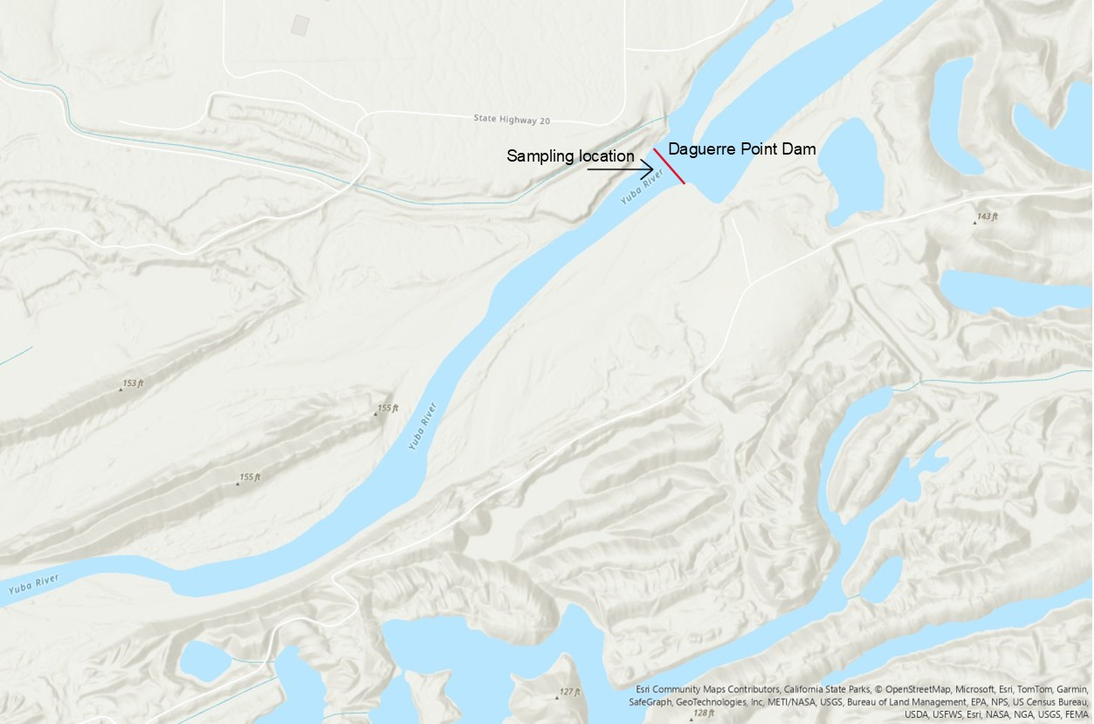

**Figure 1.** 2024 Yuba River sturgeon spawning survey – Daguerre Point Dam sampling location.

# Results

No green sturgeon eggs were collected during the 2024 sampling season, although CDFW staff made visual observations of between two and five adult green sturgeon holding in the DPD pool during most site visits. Other fish species observed during site visits included adult Central Valley spring-run Chinook salmon (*Oncorhynchus tshawytscha*), adult steelhead or rainbow trout (*O. mykiss*), Sacramento sucker (*Catostomus occidentalis*), Sacramento pikeminnow, (*Ptychocheilus grandis*), prickly sculpin (*Cottus asper*), riffle sculpin (*Cottus gulosus*), American shad (*Alosa sapidissima*), and striped bass (*Morone saxatilis*). Benthic macroinvertebrates such as stonefly nymphs (*Hesperoperla pacifica*), and Ephemeroptera larvae (Baetidae, Heptageniidae) were commonly observed on the egg mats. Yuba River flows during the sampling period ranged from a high of 3,741 cfs on 5 June to a low of 1,173 cfs on 22 July. Water temperatures over the duration of the study ranged from a low of 15.3° C on 3 June to a high of 16.1° C on 24 July (**Figure 2**)**.** Water depth and substrate composition in the DPD pool sampling site were within ranges reported in the literature for green sturgeon spawning habitat. Although flow velocity measurements were not taken, estimated surface velocities where egg mats where deployed were about 0.5 m/s meter per second.

**Figure 2.** Water temperature (° C) at DPD and flow at Marysville (cfs), 2024 Yuba River sturgeon spawning survey.

**Table 1.** Deployment and retrieval dates, metadata, and number of sturgeon eggs sampled, 2024 Yuba River Sturgeon Spawning Study.

| **Deployment date - time** | **Retrieval date - time** | **Water temp.**  **(° C)** | **Deployment depth range (ft)** | **Flow (cfs)** | **Sturgeon eggs (n)** |
| --- | --- | --- | --- | --- | --- |
| 5/31 - 10:22 | 6/3 – 10:40 | 15.3 | 10-12 | 3,583 | 0 |
| 6/3 – 10:45 | 6/7 – 10:24 | 15.3 | 10-12 | 3,723 | 0 |
| 6/7 – 10:28 | 6/10 – 10:18 | 15.8 | 8-12 | 3,048 | 0 |
| 6/10 – 10:24 | 6/14 – 10:15 | 15.6 | 8-10 | 2,922 | 0 |
| 6/14 - 10:25 | 6/19 - 9:54 | 15.3 | 8-12 | 2,590 | 0 |
| 6/19 – 9:59 | 6/24 – 10:40 | 15.3 | 10-14 | 1,992 | 0 |
| 6/24 – 10:50 | 6/28 – 9:48 | 15.0 | 10-14 | 1,836 | 0 |
| 6/28 – 10:10 | 7/3 – 10:15 | 15.5 | 9-15 | 1,681 | 0 |
| 7/3 – 10:20 | 7/8 – 10:15 | 15.5 | 10-15 | 1,611 | 0 |
| 7/8 – 10:15 | 7/12 – 10:16 | 15.5 | 10-15 | 1,588 | 0 |
| 7/12 – 10:20 | 7/15 – 11:50 | 15.8 | 10-15 | 1,606 | 0 |
| 7/15 – 12:02 | 7/24 – 10:47 | 16.1 | 10-15 | 1,221 | 0 |

# Discussion

The most likely explanation why no green sturgeon eggs were collected during the 2024 sampling season is that although spawning may have occurred, no eggs were deposited on the mats. As in previous years, an abundance of fish species known to prey on fish eggs or larvae were observed in the DPD pool. These species included steelhead/rainbow trout, Sacramento sucker, Sacramento pikeminnow, riffle sculpin, prickly sculpin, striped bass, and smallmouth bass.Although American shad (*Alosa sapidissima*) have not been documented to feed on fish eggs or larvae, the Yuba River supports a considerable spawning run of this species, with hundreds to thousands of individuals typically present in the DPD pool during the sDPS green sturgeon spawning season. Stomach content analysis through direct observation of consumed eggs or environmental-DNA analysis would provide evidence of green sturgeon egg or larval predation by American shad.

In summary, CDFW has conducted seven years of sturgeon spawning surveys in the Yuba River DPD pool since 2017 and has documented spawning in two years, 2018 and 2019. Adult sDPS green sturgeon were observed in the DPD pool in all survey years but in 2022. Green sturgeon are broadcast spawners, and their eggs are negatively buoyant. Water velocities and hydraulic characteristics in spawning locations likely play major roles in egg deposition that results in patchiness of distribution (Caroffino et. al. 2010). Coupled with the relatively small sampling area of the total available spawning habitat in the DPD pool, it is challenging to document spawning through egg collection.

The Yuba River DPD pool appears to support spawning of sDPS green sturgeon, at least in years when Feather and Yuba River flows are sufficient to attract them during their spawning migration. Removal of the Daguerre Point Dam would provide access to additional upstream habitat in the lower Yuba River for sDPS green sturgeon and would also likely decrease predator densities during spawning events and the subsequent larval growth period when early life stages are most susceptible to predation.

# References

Brown, K. 2007. Evidence of Spawning by Green Sturgeon, *Acipenser medirostris*, in the Upper Sacramento River, California. Environmental Biology of Fishes 79(3-4):297-303.

Caroffino D. C., T. M. Sutton, R. F. Elliott, and M. C. Donofrio. 2010. Early life stage mortality rates of lake sturgeon in the Peshtigo river, Wisconsin. N Am J Fish Management 30:295–304.

CDEC. 2021. Yuba River mean daily flow at Marysville. Available at: <http://cdec.water.ca.gov/dynamicapp/QueryDaily?s=MRY&d=now>. Accessed January 2022.

California Department of Fish and Wildlife. 202*3.* Sacramento River sturgeon spawning survey. CDFW Document Library: https://nrm.cfg.ca.gov/documents/ContextDocs.aspx?cat=R2-Fish

California Department of Fish and Wildlife. 2022*.* Sacramento River sturgeon spawning survey. CDFW Document Library: https://nrm.cfg.ca.gov/documents/ContextDocs.aspx?cat=R2-Fish

California Department of Fish and Wildlife. 2021*.* Sacramento River sturgeon spawning survey. CDFW Document Library: https://nrm.cfg.ca.gov/documents/ContextDocs.aspx?cat=R2-Fish

California Department of Fish and Wildlife. 2021 Yuba River sturgeon spawning survey report. CDFW Document Library: https://nrm.cfg.ca.gov/documents/ContextDocs.aspx?cat=R2-Fish

California Department of Fish and Wildlife. 2020 Yuba River sturgeon spawning survey report. CDFW Document Library: https://nrm.cfg.ca.gov/documents/ContextDocs.aspx?cat=R2-Fish

California Department of Fish and Wildlife. 2019 Yuba River sturgeon spawning survey report. CDFW Document Library: https://nrm.cfg.ca.gov/documents/ContextDocs.aspx?cat=R2-Fish

California Department of Fish and Wildlife. 2018 Yuba River sturgeon spawning survey report. CDFW Document Library: https://nrm.cfg.ca.gov/documents/ContextDocs.aspx?cat=R2-Fish

California Department of Fish and Wildlife. 2017 Yuba River sturgeon spawning survey report. CDFW Document Library: https://nrm.cfg.ca.gov/documents/ContextDocs.aspx?cat=R2-Fish

Cramer Fish Sciences. 2011. Memo: Green Sturgeon Observations at Daguerre Point Dam, Yuba River, CA.

Deng X., Van Eenennaam J.P., Doroshov S. I. 2002. Comparison of early life stages and growth of Green and White Sturgeon. In: Van Winkle W et al., editors. 2002. Biology, management, and protection of North American sturgeon. American Fisheries Society, Symposium 28, Bethesda, Maryland. p. 237-248.

Heublein, J. C., J. T. Kelly, C. E. Crocker, A. P. Klimley, S. T. Lindley. 2009. Migration of green sturgeon (*Acipenser medirostris*), in the Sacramento River. Env. Biol. Fish. 84: 245-258.

Kynard, B., E. Parker, and T. Parker. 2005. Behavior of early life intervals of Klamath River green sturgeon (*Acipenser medirostris*) with a note on body color. Env. Biol. Fish. 72:85-97.

Klimley, A. P., E. D. Chapman, J. J. Cech, D. E. Cocherell, N. A. Fangue, M. Gingras, Z. Jackson, E. A. Miller, E. A. Mora, J. B. Polleto. 2015. Sturgeon in the Sacramento-San Joaquin watershed: new insights to support conservation and management. San Francisco Estuary and Watershed Science 13(4).

National Marine Fisheries Service. 2015. 5-Year Summary and Evaluation: Southern Distinct Population Segment of the North American Green Sturgeon. U.S. Department of Commerce, pp. 42.

Poytress, W. R., J. J. Gruber, and J. P. Van Eenennaam. 2012. 2011 Upper Sacramento River Green Sturgeon Spawning Habitat and Larval Migration Surveys U.S. Fish and Wildlife Service and University of California Davis, pp. 1-46.

Poytress, W. R., Gruber, J. J., Van Eenennaam, J. P. 2015. Spatial and temporal distribution of spawning events for Sacramento River green sturgeon. Trans. Am. Fish. Soc. 144(6): 1129-1142.

Seesholtz, A.M., Manuel, M. J., Van Eenennaam, J. P. 2014. First documented spawning and associated habitat conditions for green sturgeon in the Feather River, California. Environ. Biol. Fishes 98(3): 905-912.

Shaffter, R. G. 1997. White sturgeon spawning migrations and locations of spawning habitats in the Sacramento River, California. California Fish and Game: 83: 1-20.