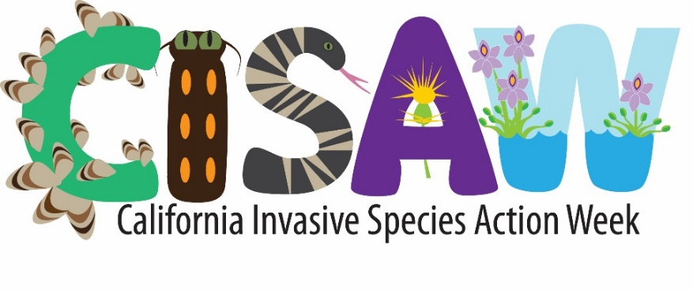

# 2025 Events

## All week or ongoing

Don’t see an event near you this week? Many State Parks, County Parks, and local organizations hold volunteer events all year to remove invasive species and restore habitat for wildlife.

| **County** | **Organization** | **Time** | **Location** | **Details** | **Registration required?** |
| --- | --- | --- | --- | --- | --- |
| Statewide | CA State parks Foundation | Varies | Varies | Through our volunteer program, we plan over 100 volunteer projects throughout the year to benefit more than 30 parks across California. | Yes. [Register here.](https://volunteer.calparks.org/calendar) |
| Statewide | CA Native Plant Society | Varies | Varies | Local CNPS chapters host habitat restoration days that include removing invasive plants. | [Chapter Map](https://www.cnps.org/chapters/map) |
| Statewide | [[California Department of Fish and Wildlife](https://wildlife.ca.gov/Conservation/Invasives/Citizen-Science)](https://wildlife.ca.gov/Conservation/Invasives/Citizen-Science) | Any time | Anywhere | Use the California Department of Fish and Wildlife (CDFW)’s Invasive Species App (through EDDMaps) to record invasive species in your local park or natural area. | Yes. On the app.  [EDDMapS](https://www.eddmaps.org/) |

## Saturday, June 7

| **County** | **Organization** | **Time** | **Location** | **Details** | **Registration required?** |
| --- | --- | --- | --- | --- | --- |
| Los Angeles | Friends of Ballona Wetlands | 10am - noon | Ballona Discovery Park | Join the Friends of Ballona Wetlands on a tour of the Ballona Freshwater Marsh! We we will learn about invasive and native species, history of the marsh and the surrounding areas, and more! We can’t wait to see you out at the wetlands! | Yes. Register here:  [**https://www.ballonafriends.org/calendar/2025/6/7-fwm-tour**](https://www.ballonafriends.org/calendar/2025/6/7-fwm-tour) |
| Sacramento | Cosumnes River Preserve | 8am-2:30pm | Cosumnes River Preserve – the Barn | Join the Habitat Restoration Team at the Cosumnes River Preserve on June 7th for California Invasive Species Action Week. The Cosumnes River Preserve is a Partnership made up of 10 partners that collaboratively protects, restores, and manages land and water to conserve Central Valley native plant and animal species. Through your volunteer efforts we will be removing a variety of invasive plants that hinder the growth of our native California Vegetation, while also providing the opportunity to learn and experience this special landscape in areas that are closed to the public. Join us for a day of fun at the Cosumnes River Preserve and be a part of your local California community. | Yes. Register here:  [**info@cosumnes.org**](mailto:info@cosumnes.org) |
| Santa Barbara | Carpinteria Weed Warriors | 10am - noon | Carpinteria Salt Marsh Nature Park | Help remove non-native plants and plant natives to create a healthier habitat for our wildlife. Bring gloves and tools if you have them, or we have some loaners. Wear closed toed shoes, bring water, and sun protection.  More info: <https://www.noozhawk.com/location/carpinteria-salt-marsh-nature-park-entrance-opposite-the-corner-of-sandyland-and-ash-avenues/> | No |

## Sunday, June 8

| **County** | **Organization** | **Time** | **Location** | **Details** | **Registration required?** |
| --- | --- | --- | --- | --- | --- |
| Ventura | WHIP – Ventura Land Trust | 8am – 10am | Harmon Canyon  7511 Foothill Rd.,Ventura | WHIP (wildlife habitat improvement program) brings nature into balance by removing noxious and invasive weeds from our beloved Harmon Canyon in Ventura. Our efforts rely entirely on volunteers who are eager to make HC a beautiful native landscape. Wear closed shoes long pants and sleeves. Bring gloves, eye protection/sunglasses, hats, sunscreen….. In the 5-years of operation, we have restored several acres along the extensive hiking and biking trails to a haven for native plants, pollinators and other wildlife—please join us and make a difference**!** | Yes. Register here:  [**https://www.venturalandtrust.org/whip**](https://www.venturalandtrust.org/whip) |

## Monday, June 9

| **County** | **Organization** | **Time** | **Location** | **Details** | **Registration required?** |
| --- | --- | --- | --- | --- | --- |
| Statewide | UC Cooperative Extention | 12pm -1pm | Online | Lunchtime Talks: Formosan Subterranean Termites: Will Your House Be Teir Next Meal? | Yes.  [Register here](https://ucanr.edu/sites/invasivelunch/2025/). |

## Tuesday, June 10

| **County** | **Organization** | **Time** | **Location** | **Details** | **Registration required?** |
| --- | --- | --- | --- | --- | --- |
| Statewide | UC Cooperative Extension | 12pm -1pm | Online | Lunchtime Talks: Anticipating the Next Invasive Treat to California | Yes.  [Register here](https://ucanr.edu/sites/invasivelunch/2025/). |

## Wednesday, June 11

| **County** | **Organization** | **Time** | **Location** | **Details** | **Registration required?** |
| --- | --- | --- | --- | --- | --- |
| Statewide | UC Cooperative Extension | 12pm -1pm | Online | Lunchtime Talks: Don’t Move a (Golden) Mussel | Yes.  [Register here](httpshttps://ucanr.edu/sites/invasivelunch/2025/). |
| El Dorado | League to Save Lake Tahoe | 10am - noon | Tahoe Keys Marina  (2435 Venice Dr. E, South Lake Tahoe) | Do you love to kayak, paddleboard, and walk on the shoreline at Lake Tahoe? Then join us for a free Eyes on the Lake training! This training is open to the public, all ages welcome.  Learn how to identify Tahoe’s various native and invasive aquatic plants, and how to report observations that allow the League and our partners to control new populations of aquatic invaders before they do lasting damage to Lake Tahoe. We want to be sure that Lake Tahoe remains clear and blue! | Yes.  Register here:  **[keeptahoeblue.org/eyes-on-the-lake-training-jun-11-2025](https://www.keeptahoeblue.org/events-activities-lessons/eyes-on-the-lake-training-jun-11-2025/)** |
| Yolo/Solano | Putah Creek Council | 3:30pm – 5:30pm | Register for address | California Invasive Species Action Week is June 7-15, 2025! In recognition, Putah Creek Council will be hosting an Invasive Species Workshop on Wednesday, June 11th from 3:30PM-5:00PM.  This workshop will cover: what makes a species invasive, common invasive species in the Putah Creek region, best removal methods, and native plant alternatives for your garden. The workshop will be led by Maddie Galal, PCC Stewardship Coordinator.  The event will be held in-person at Putah Creek Council HQ in Davis. Please fill out the sign-up form to receive the address. Registration is required due to limited venue space. Attendees must be ages 14 or older.  All volunteers must sign a waiver, and those under the age of 18 will need a guardians’ signature. You can print our liability and photo release waiver here. A physical copy is required. | Yes.  Register here:  [**https://tally.so/r/mOrW0k**](https://tally.so/r/mOrW0k) |

## Thursday, June 12

| **County** | **Organization** | **Time** | **Location** | **Details** | **Registration required?** |
| --- | --- | --- | --- | --- | --- |
| Statewide | UC Cooperative Extension | 12pm -1pm | Online | Lunchtime Talks: The Fast and the Furriest Rats, Traps, and Winning the Race | Yes.  [Register here](https://ucanr.edu/sites/invasivelunch/2025/). |

## Friday, June 13

| **County** | **Organization** | **Time** | **Location** | **Details** | **Registration required?** |
| --- | --- | --- | --- | --- | --- |
| Statewide | UC Cooperative Extension | 12pm -1pm | Online | Lunchtime Talks: Palms and Eucalyptus Under Threat in the Golden State | Yes.  [Register here](https://ucanr.edu/sites/invasivelunch/2025/). |

## Saturday, June 14

|  |  |  |  |  |  |
| --- | --- | --- | --- | --- | --- |
| **County** | **Organization** | **Time** | **Location** | **Details** | **Registration required?** |
| **Santa Clara** | **Keep Coyote Creek Beautiful** | **9am – 11:30 am** | **Alum Rock Park** | A BioBlitz is an event that focuses on finding and identifying as many species as possible in a specific area over a short period of time. At a BioBlitz, scientists, families, students, teachers, and other community members work together to get an overall count of the plants, animals, fungi, and other organisms that live in a place.  Located in the heart of San Jose, the park we will be at is a safe haven for many species of plants and animals right along Coyote Creek. Join Keep Coyote Creek Beautiful and partners in cataloging and documenting all of the wildlife that reside there. We will have experts in various fields to help guide participants through all the cool plants and wildlife.  The best part? All you need to participate is a smart phone with the iNaturalist app! So bring your family and prepare for an in-depth tour of this great park.  Community service hours available  Hosted by Keep Coyote Creek Beautiful, BioBlitz Club, Santa Clara Valley Bird Alliance, and Peninsula Open Space Trust | **Yes. Register here:**  [**https://250614-bioblitz.eventbrite.com/?aff=cafw**](https://250614-bioblitz.eventbrite.com/?aff=cafw) |

## Sunday, June 15

| **County** | **Organization** | **Time** | **Location** | **Details** | **Registration required?** |
| --- | --- | --- | --- | --- | --- |
|  |  |  |  | Events coming soon! |  |