**State of California  
Department of Fish and Wildlife**

M e m o r a n d u m

**Date:** May 5, 2025

**To:**Nick Bauer

Senior Environmental Scientist; Supervisor

Department of Fish and Wildlife

North Central Region

1701 Nimbus Road, Suite A

Rancho Cordova, CA 95670

**Cc:** CDFW North Central Region Fish Files

**From:** Marc Beccio; Environmental Scientist

Department of Fish and Wildlife

1701 Nimbus Road, Suite A

Rancho Cordova, CA 95670

**Su****bject:** **Yolo Bypass Wildlife Area White Sturgeon Rescue**

# Purpose

This report documents rescue efforts conducted by CDFW Region 2 staff to relocate an adult White Sturgeon (*Acipenser transmontanus*) that was stranded in a shallow pool in the Yolo Bypass Wildlife Area.

# Background

The approximately 59,000-acre Yolo Bypass was designed to convey floodwaters from the Sacramento River and west side streams and drains around the populated regions of the Sacramento Valley **(Figure 1)**. Inundation of the Yolo Bypass occurs when Sacramento River flows overtop the Fremont Weir at river kilometer 32.3 when and flows reach approximately 1,622 cubic meters per second (57,290 cfs) (DWR 2016) Inundation of the Yolo Bypass is augmented by flows from west side tributaries including Cache Creek, Willow Slough, Willow Slough Bypass, Putah Creek, and South Fork Putah Creek. Up to 80 percent of the Sacramento River’s floodwaters are conveyed for a distance of approximately 50 km (31 miles) through the Yolo Bypass and returned to the Sacramento River via the Cache Slough Complex approximately two miles upstream of the town of Rio Vista. The Yolo Bypass capacity is 9,713 cubic meters per second (343,000 cfs) (DWR 2010).

The Yolo Bypass serves as a migration corridor for adult and juvenile anadromous fish during overtopping events as well as rearing habitat for juvenile salmonids and other freshwater fish species. Federal and State anadromous listed species including Sacramento River winter-run Chinook salmon (*Oncorhynchus tshawytscha*;federal and State endangered), Central Valley spring-run Chinook salmon (*O. tshawytscha*; federal and State threatened), Central Valley steelhead (*O. mykiss*; federal threatened), and the southern Distinct Population Segment (DPS) Green Sturgeon (*Acipenser medirostris*; federal threatened), and White Sturgeon (*A. transmontanus*; candidate for State threatened listing status) are also known to utilize the Yolo Bypass as a migration corridor. Flows within the Yolo Bypass can be much greater than flows within the Sacramento River during weir overtopping events, attracting anadromous fish migrating up the Sacramento River into the Yolo Bypass at the Cache Slough complex. When the Sacramento River stage height drops below 32 feet mean sea level, flows over the Fremont Weir cease, resulting in fish stranding within the Fremont Weir stilling basin and various ponded areas within the Yolo Bypass.

# Methods

CDFW Rancho Cordova staff received phone calls from Yolo Bypass Wildlife staff regarding the presence of a large white sturgeon stranded in a shallow pool in the southeast section of the approximately 19,000 acre Yolo Bypass Wildlife Area on the afternoon of 14 April 2025. Environmental Scientists Shig Kubo and Marc Beccio met Wildlife Habitat Assistant Matt Siepert at the Yolo Bypass Wildlife Area check station and followed him to the location of the stranded White Sturgeon. The White Sturgeon was in a shallow pool with a depth of about 0.4 m; a portion of its dorsal surface was exposed to the air and it was extremely lethargic. We used a large dip net to guide the fish to the edge of the pool and placed it in a sturgeon cradle which was loaded into the bed of a truck for relocation and release in the Toe Drain.

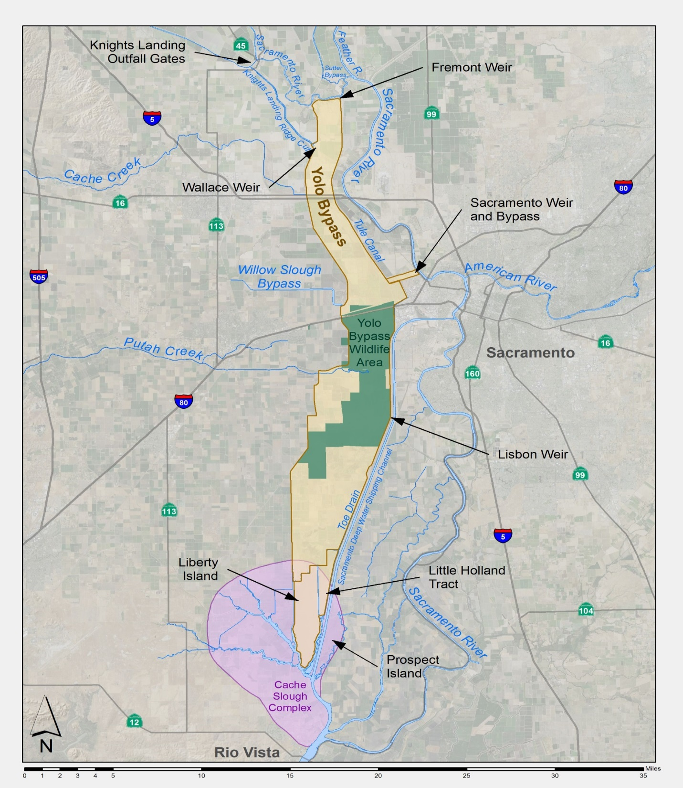

**Figure 1.** **Fremont Weir, Yolo Bypass and Yolo Bypass Wildlife Area.**

# Results

The White Sturgeon was in poor condition, likely due to exposure to elevated water temperatures and recent injuries including a nearly severed caudal fin (no ventral lobe and severely damaged dorsal lobe), multiple abrasions, and sunlight exposure to the dorsal surface. We also noted that the left pelvic fin was severed near the base, although the injury appeared to be completely healed. Due to the sturgeon’s poor condition, we did not measure it or tag it with an acoustic transmitter, although we estimated its fork length to be approximately 8-ft (243 com) and a weight of around 200 pounds (90 kg). The sturgeon was still extremely lethargic when removed from the sturgeon cradle for release into the Toe Drain and we spent 15-20 minutes reviving it by gently moving it back and forth to facilitate oxygen uptake. Once the sturgeon maintained dorsal orientation and began to exhibit increased caudal fin movement, it was released in the Toe Drain approximately 400 m upstream of Lisbon Weir.

**Figure 2.** Stranding and release locations for adult White Sturgeon stranded in the Yolo Bypass Wildlife Area, 14 April 2025.

**Figure 3.** Adult White Sturgeon rescued from the Yolo Bypass Wildlife Area, 14 April 2025. Note the recent injury to the caudal fin and historic injury to the pelvic fin.

# Discussion

This is the first instance of a sturgeon rescue conducted in the Yolo Bpass Wildlife Area. Matt Siepert mentioned that he has seen several desiccated sturgeon carcasses in past years once the Yolo Bypass Wildlife Area ponds and basins drained after Yolo Bypass flooding events. CDFW staff rescued 11 adult White Sturgeon from the Fremont Weir stilling basin which on 26 April 2025. Fremont Weir is located at the northern end of the Yolo Bypass and has been the site of numerous fish rescues following weir overtopping events (CDFW 2016). It is likely that most sturgeon that enter the Yolo Bpass from the Cach Slough Complex during weir overtopping events continue their upstream spawning migration and are able to pass over the stilling basin structures during high flows or end up stranded in the stilling basins as water levels recede. Sturgeon or other fish that enter the Yolo Bypass in the latter stages of overtopping events may end up stranded in the southern reaches of the Yolo Bypass including the Yolo Bypass Wildlife Area. Due to the vast area of the Yolo Bypass, typical “boots on the ground” reconnaissance surveys for stranded sturgeon and other fish species are for the most part impractical, however; the use of an aerial drone should be considered for surveying inundated areas that are remote from access roads or trails.

# References

California Department of Fish and Wildlife. 2016. Summary of Fish Rescues Conducted within the Yolo and Sutter Bypasses. Prepared for the U.S. Department of Reclamation.