Pismo State Beach and Oceano Dunes State Vehicular Recreation Area
Vegetation Mapping Report

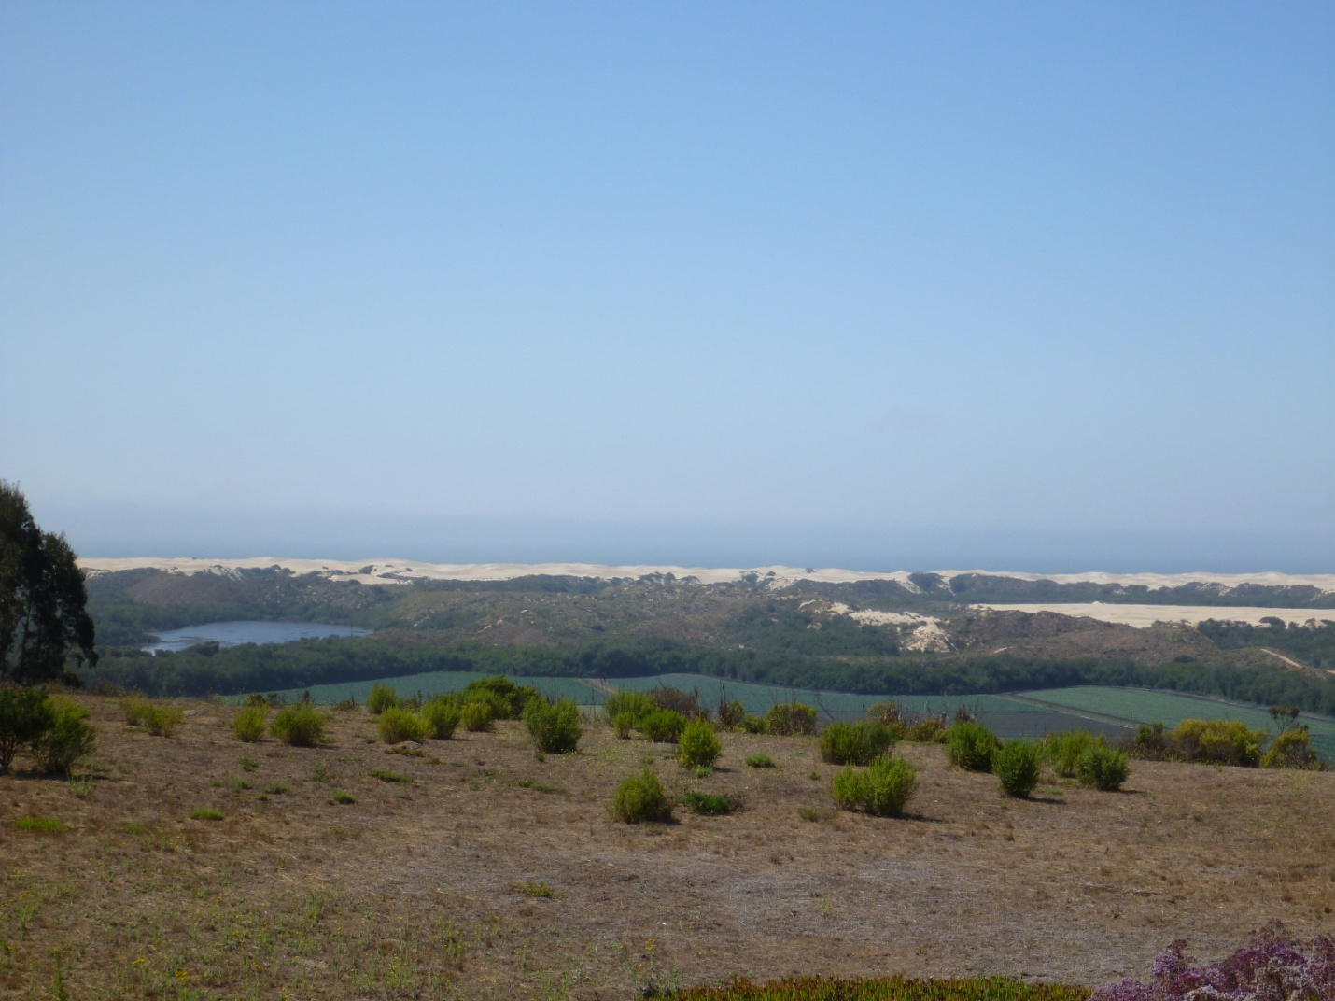

MIG|TRA Environmental Sciences, Inc.
February 2015

Pismo State Beach and Oceano Dunes State Vehicular Recreation Area (SVRA)
Vegetation Mapping Report

Prepared for:
California Department of Parks and Recreation
Off-highway Motor Vehicle Recreation Division
Oceano Dunes District

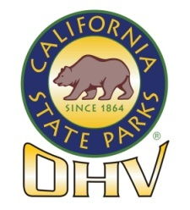

Prepared By:
MIG|TRA Environmental Sciences, Inc.
545 Middlefield Road, Suite 200
Menlo Park, CA 94025-3472
Tel.: (650) 327-0429
Fax: (650) 327-4024
www.traenviro.com

February 2015

PISMO STATE BEACH AND OCEANO DUNES SVRA
VEGETATION MAPPING REPORT

TABLE OF CONTENTS

1.0 INTRODUCTION 1
1.1 REPORT PURPOSE AND OUTLINE 1
1.2 LOCATION 1
1.3 OWNERSHIP, MANAGEMENT AND LAND USES 1
1.3.1 PISMO STATE BEACH 2
1.3.2 OCEANO DUNES SVRA 3
1.4 STUDY AREA SETTING 3
1.4.1 CLIMATE 3
1.4.2 GEOLOGY, TOPOGRAPHY AND SOILS 3
1.4.3 HYDROLOGY 4
1.4.4 Habitats 5
2.0 STUDY METHODS 8
2.1 VEGETATION ZONES 8
2.2 VEGETATION MAPPING 8
2.3 PLANT SPECIES NOMENCLATURE AND ALLIANCE CODES 10
2.4 SPECIAL-STATUS PLANT SPECIES DEFINITION AND SOURCES 10
3.0 VEGETATION ALLIANCES IN THE STUDY AREA 13
3.1 Overview 13
3.2 NATIVE UPLAND ALLIANCES 16
3.2.1 NATIVE UPLAND FOREST AND WOODLAND ALLIANCES 17
3.2.2 NATIVE UPLAND SHRUBLAND ALLIANCES 17
3.2.3 NATIVE UPLAND HERBACEOUS ALLIANCES 19
3.3 NATIVE WETLAND ALLIANCES 21
3.3.1 NATIVE WETLAND FOREST AND WOODLAND ALLIANCES 21
3.3.2 NATIVE WETLAND SHRUBLAND ALLIANCES 22
3.3.3 NATIVE WETLAND HERBACEOUS ALLIANCES 22
3.4 NON-NATIVE ALLIANCES 25
3.4.1 NON-NATIVE OR NATURALIZED FOREST OR WOODLAND ALLIANCES 27
3.4.2 NON-NATIVE SHRUBLAND ALLIANCE 28
3.4.3 NON-NATIVE HERBACEOUS ALLIANCES 29
4.0 VEGETATION ZONES IN THE STUDY AREA 32
4.1 PISMO ZONE 34
4.1.1 PISMO PIER 35
4.1.2 PISMO LAGOON 35
4.1.3 CARPENTER CREEK 35
4.1.4 GRAND AVENUE 35
4.1.5 SOUTH OF GRAND AVENUE 35
4.1.6 INTERPRETIVE TRAIL 36
4.1.7 PIER AVENUE 36
4.1.8 STRAND WAY 36
4.2 DUNES PRESERVE ZONE 36
4.3 VEGETATION ISLAND ZONE 37
4.3.1 ACACIA 38
4.3.2 BBQ FLATS 38
4.3.3 BBQ FLATS SOUTH 38
4.3.4 BELLYBUTTON 38
4.3.5 BIG MAC 39
4.3.6 BOYSCOUT NORTH 39
4.3.7 BOYSCOUT CAMP 39
4.3.8 CATERPILLAR HILL 39
4.3.9 COTTONWOOD 39
4.3.10 ELVIS 40
4.3.11 EUCALYPTUS NORTH 40
4.3.12 EUCALYPTUS SOUTH 40
4.3.13 EUCALYPTUS TREE 40
4.3.14 HEATHER 40
4.3.15 HUMPBACK 41
4.3.16 INDIAN MIDDEN 41
4.3.17 INDIAN MIDDEN SOUTH 41
4.3.18 MOYMELL 41
4.3.19 PAVILION HILL 41
4.3.20 PIPELINE 41
4.3.21 TABLETOP 42
4.3.22 WALLFLOWER 42
4.3.23 WORM VALLEY 42
4.3.24 7.5 REVEGETATION AREA 42
4.4 PHILLIPS 66 LEASEHOLD ZONE 42
4.5 NORTH OSO FLACO ZONE 43
4.6 MAIDENFORM ZONE 44
4.7 OSO FLACO LAKE AND CREEK ZONE 45
4.7.1 OSO FLACO CREEK 45
4.7.2 OSO FLACO LAKE 45
4.8 SOUTH OSO FLACO ZONE 46
4.8.1 FOREDUNES 46
4.8.2 BACKDUNES 46
5.0 SPECIAL-STATUS PLANTS IN THE STUDY AREA 56
5.1 SPECIAL-STATUS PLANTS KNOWN TO OCCUR IN THE STUDY AREA 56
5.1.1 MARSH SANDWORT 58
5.1.2 LA GRACIOSA THISTLE 58
5.1.3 GAMBEL’S WATER CRESS 59
5.1.4 BEACH SPECTACLEPOD 60
5.1.5 NIPOMO MESA LUPINE 60
5.1.6 SURF THISTLE 60
5.1.7 KELLOGG’S HORKELIA 61
5.1.8 SAND MESA MANZANITA 61
5.1.9 COASTAL GOOSEFOOT 61
5.1.10 DUNE LARKSPUR 62
5.1.11 BLOCHMAN’S LEAFY DAISY 62
5.1.12 CRISP MONARDELLA 62
5.1.13 SAN LUIS OBISPO MONARDELLA 62
5.1.14 RED SAND VERBENA 63
5.1.15 NUTTALL’S MILKVETCH 63
5.1.16 PANICULATE TARPLANT 63
5.1.17 SUFFRUTESCENT WALLFLOWER 63
5.1.18 SOUTHWESTERN SPINY RUSH 64
5.1.19 FUZZY PRICKLY PHLOX 64
5.1.20 CALIFORNIA SPINE FLOWER 64
5.1.21 SHORT-LOBED BROOMRAPE 64
5.1.22 HICKMAN’S POPCORN FLOWER 65
5.1.23 BLOCHMAN’S GROUNDSEL 65
5.1.24 MONTEREY COAST PAINTBRUSH 65
5.1.25 DOUGLAS’ SPINEFLOWER 66
5.1.26 DUNEDELION 66
5.1.27 SAND ALMOND 66
5.2 SPECIAL-STATUS PLANTS WITH THE POTENTIAL TO OCCUR IN THE STUDY AREA 66
5.2.1 CALIFORNIA SAWGRASS 67
5.2.2 BRANCHING BEACH ASTER 67
5.2.3 COAST WOOLLY-HEADS 67
5.2.4 SAN BERNARDINO ASTER 68
6.0 REPORT PREPARERS AND REFERENCES 69
6.1 REPORT PREPARERS 69
6.1.1 OCEANO DUNES DISTRICT STAFF 69
6.1.2 MIG|TRA ENVIRONMENTAL SCIENCES, INC. 69
6.1.3 WOOD BIOLOGICAL CONSULTING, INC. 69
6.1.4 INDEPENDENT CONSULTANT 69
6.2 REFERENCES 69
6.2.1 REFERENCES 69
6.2.2 PERSONAL COMMUNICATIONS 71
APPENDIX A. PLANT SPECIES RECORDED IN THE STUDY AREA 72
APPENDIX B. SPECIAL-STATUS PLANT TABLE 83

LIST OF FIGURES AND TABLES

FIGURES

Figure 1-1. Study Area Location and Boundary 6
Figure 1-2. Aerial Overview of the Study Area 7
Figure 2-1. Vegetation Zones in the Study Area 12
Figure 4-1. Pismo Zone Vegetation 48
Figure 4-2. Dunes Preserve Zone Vegetation 49
Figure 4-3. Vegetation Island Zone Vegetation 50
Figure 4-4. Phillips 66 Leasehold Zone Vegetation 51
Figure 4-5. North Oso Flaco Zone Vegetation 52
Figure 4-6. Maidenform Zone Vegetation 53
Figure 4-7. Oso Flaco Lake and Creek Zone Vegetation 54
Figure 4-8. South Oso Flaco Zone Vegetation 55

TABLES

Table 3-1 Summary of Vegetation Alliances in the Study Area 14
Table 4-1. Summary of the Vegetated Parts of the Study Area 32
Table 5-1. Special-status Plants Observed in the Study Area 56

ACRONYMS AND ABBREVIATIONS

Cal-IPC California Invasive Plant Council
CESA California Endangered Species Act
CDPR California Department of Parks and Recreation
CNDDB California Natural Diversity Database
CNPS California Native Plant Society
CRPR California Rare Plant Rank
District Oceano Dunes District
Dunes Preserve Pismo Dunes Natural Preserve
EIR Environmental Impact Report
FAC Facultative
FACW Facultative wetland
FESA Federal Endangered Species Act
HCP Habitat Conservation Plan
MCV2 A Manual of California Vegetation, Second Edition (Sawyer et al. 2009)
NOAA National Oceanic and Atmospheric Administration
OBL Obligate wetland
OHMVR Off-highway Motor Vehicle Recreation
OHV Off-highway vehicle
Post Marker Post
SB State Beach
SP State Parks
SVRA State Vehicle Recreation Area
U.S. United States
USACE U.S. Army Corps of Engineers
USFWS U.S. Fish and Wildlife Service
USGS U.S. Geological Survey

INTRODUCTION

REPORT PURPOSE AND OUTLINE

The purpose of this report is to characterize the vegetation in the study area, which includes Pismo State Beach (SB) and Oceano Dunes State Vehicle Recreation Area (SVRA) in coastal San Luis Obispo County, California. This report is intended for several applications, including the following:

- To inform the habitat monitoring program conducted by California Department of Parks and Recreation (CDPR), Off-highway Motor Vehicle Recreation (OHMVR) Division, and Oceano Dunes District (District);
- To provide background information for the proposed Oceano Dunes SVRA Habitat Conservation Plan (HCP) and the Environmental Impact Statement/Environmental Impact Report (EIR) for the HCP;
- To provide information for the biological resources chapter of the EIR for the Oceano Dunes SVRA Dust Control Project; and
- To inform implementation of the Particulate Matter Reduction Plan.

This report describes the study area setting (Chapter 1); the methods used to map the vegetation (Chapter 2); and the results, including the vegetation alliances (Chapter 3), the vegetation zones (Chapter 4), and the special-status plant species known to occur in the study area (Chapter 5).

LOCATION

The 5,020-acre study area includes Pismo SB and Oceano Dunes SVRA in San Luis Obispo County (Figure 1-1). It is bounded by Pismo Pier to the north, the Guadalupe-Nipomo Dunes National Wildlife Refuge to the south, urban and agricultural land to the east, and the Pacific Ocean to the west. Cities to the east of the study area include Pismo Beach, Grover Beach, Nipomo Mesa, and Oceano. Primary access to the area is via United States (U.S.) Highway 101 and California Highway 1.

OWNERSHIP, MANAGEMENT AND LAND USES

The majority of the study area lands are owned by CDPR. However, 34 acres are owned by Union Oil and 657 acres are owned by Phillips 66 Refinery (Phillips 66), formerly refererd to as Conoco Phillips Refinery or Tosco Corporation. The Union Oil and Phillips 66 lands are leased to CDPR.

Management of the study area lands is the responsibility of CDPR; however, activities over a small portion of Pismo SB are managed by the City of Pismo Beach under a lease agreement with CDPR. This area extends from the south end of the North Beach Campground to the northern Pismo SB boundary. This area has been leased by the City of Pismo Beach since 1951. Within this report, this area is included in the area that is referred to as the “Pismo Zone.”

The majority of the study area consists of undeveloped lands; however, some locations within the study area are developed. The developed lands include 136 acres that are under agricultural cultivation near Little Oso Flaco Lake, a 31-acre golf course, 67 acres that are designated campgrounds, 11 acres associated with the Pier Avenue parking lot and facilities, and 6 acres associated with the ranger station/maintenance yard and CDPR staff residences. The undeveloped lands in the study area include 1,490 acres of land used for off-highway vehicle (OHV) recreation and camping, 91 acres of land used for street legal vehicle recreation, and 3,118-acres managed for natural resource protection and non-motorized recreation (Figure 1-2). The 70-acre undeveloped Pismo Lake area was not mapped for this report. The areas open to OHV use include the Oceano Dunes SVRA and a portion of Pismo SB. The non-OHV areas include the Pismo Dunes Natural Preserve (Dunes Preserve) and other protected areas south of the Dunes Preserve. In this report, the leased Phillips 66 lands are referred to as the “Phillips 66 Leasehold Zone”.

The two park units that comprise the study area, Pismo SB and Oceano Dunes SVRA, are described in more detail below.

PISMO STATE BEACH

The 1,530-acre Pismo SB includes beach habitat, the Dunes Preserve, and a developed portion of the park that includes two designated campgrounds, a golf course, a ranger station/maintenance yard, and CDPR staff residences (Figures 1-1 and 1-2).

Recreational opportunities at Pismo SB include hiking, swimming, fishing, surfing, kite surfing and wildlife viewing. In addition to non-motorized recreation, Pismo SB provides access to Oceano Dunes SVRA via sand ramps at Grand Avenue in the City of Grover Beach and Pier Avenue in Oceano (Figure 1-2). Marker posts (Post) are placed along the beach at half-mile intervals beginning with Post 1 near the mouth of Arroyo Grande Creek. The area between the Grand Avenue access ramp and Post 2 is designated as a day use only area and is predominately used by people who want to drive their street-legal vehicles on the beach and enjoy day use beach activities such as picnicking, sunning, fishing, and wading. The open riding area south of Post 2 allows camping and OHV use and is predominately used by OHV enthusiasts (Figure 1-2).

The Dunes Preserve is a 694-acre subunit of Pismo SB consisting of undisturbed sand dunes, dune slack, and freshwater wetlands. The Dunes Preserve is bordered on the north by Arroyo Grande Creek and the community of Oceano; on the south by Oceano Dunes SVRA; on the east by private agricultural, recreational, and residential lands; and on the west by the seaward toe of a foredune system, which is stabilized with invasive exotic European beach grass (Ammophila arenaria), Russian wheat grass (Elymus farctus), and ice plant (Carpobrotus spp.). Recreational use of the Dunes Preserve is restricted to pedestrians and equestrians. Motorized vehicles of any type and bicycles are prohibited in the Dunes Preserve except in cases of emergency or approved resource management projects. Dogs are also prohibited. The Dunes Preserve is fenced and signs are posted to indicate that access is restricted.

OCEANO DUNES SVRA

The 3,490-acre Oceano Dunes SVRA is south of the City of Grover Beach and Oceano (Figure 1-2). Oceano Dunes SVRA is accessible via the sand ramps in Pismo SB at Grand Avenue and Pier Avenue as well as from a pedestrian entrance located at the end of Oso Flaco Lake Road.

Oceano Dunes SVRA provides vehicular and non-vehicular recreation opportunities. It contains an OHV recreation area, restrooms, a day use area, informational kiosks, and hiking trails. Non-vehicular recreation is permitted throughout the majority of the area but usually occurs within those areas closed to OHV recreation. These include the Pismo SB/Oceano Dunes SVRA day use area between the Grand Avenue access ramp and Post 2 and the Oso Flaco Lake area in the southern portion of Oceano Dunes SVRA. There are no designated campsites, but up to 1,000 registered camping vehicles per day are allowed to camp within the beach and dune areas (referred to as the open riding area on Figure 1-2).

STUDY AREA SETTING

CLIMATE

The study area has a Mediterranean climate characterized by year-round mild temperatures, moist winters, and warm dry summers. As a result of the marine influence, temperatures along the coast remain moderate during summer and winter. A band of low clouds is commonly present along the immediate coast during the summer months. This cloudy zone moves inland at night and during early morning hours and recedes offshore during the day. The wind direction is predominately from the west and northwest. Winds are light and variable at night and in the early morning. By mid-morning, wind speed increases with the addition of an onshore breeze, and averages 15-22 miles per hour by mid-afternoon through sunset (CDPR 2012).

From 2004 to 2010, average annual precipitation in the study area varied from 19.31 to 28.23 inches and average temperature varied from 57.65 and 58.58 degrees Fahrenheit (CDPR 2012).

GEOLOGY, TOPOGRAPHY AND SOILS

The study area is located within the Coast Range geomorphic province of California, at the intersection of the Pacific and North American tectonic plates. The geomorphic province is typified by northwest trending mountain ranges and valleys, almost parallel to the San Andreas Fault located about 40 miles east of the study area. Most of San Luis Obispo County sits atop a 180-million year old mix of consolidated igneous, metamorphic, and sedimentary rock.

The study area is dominated by sand dunes. It is located at a low elevation, ranging from about 0-192 feet above mean sea level (based on U.S. Geological Survey [USGS] National Elevation Dataset, 1/3 arcsecond Digital Elevation Model 2013). The topography of the study area is flat adjacent to the ocean, and undulates through the dunes east of the beach. Dune crests run north to south. On the western (windward) side of the dunes, slopes are gentle. On the eastern (leeward) side of the dunes, slopes are steep. Wave action, wind, and water erosion cause the dunes to move slowly over time. Lake, creek and wetland areas within or adjacent to the dunes are generally flat.

Beach sand is the dominant soil in the study area, much of which is barren of vegetation. Soil permeability is high and rapid, and wind and wave action erosion hazard is high. Beach sands originate from rivers and streams, are deposited onto the beach by ocean currents, and are shaped by prevailing ocean winds.

HYDROLOGY

The Pismo SB portion of the study area lies within the boundary of the Arroyo Grande Creek watershed. This watershed covers approximately 150 square miles of the southern portion of San Luis Obispo County. The lower one mile of Arroyo Grande Creek and the Arroyo Grande Creek Estuary are both located within Pismo SB (Figure 1-2). The lower portion of Arroyo Grande Creek and the estuary are influenced by upstream water uses. Lopez Dam impounds runoff from about 67 square miles of the watershed for use as the primary water supply for local municipalities and agricultural interests. Small domestic and agricultural water uses downstream of Lopez Dam also reduce the amount of surface water available for lower reaches of Arroyo Grande Creek. In dry or drought years, groundwater pumping and surface diversions may cause portions of lower Arroyo Grande Creek to completely dry up, resulting in dry creek beds and a much smaller lagoon (Reischbeiter 2008; 2009). The creek is impounded during summer months and does not reach the ocean. Arroyo Grande Creek downstream of Lopez Dam is listed on the Clean Water Act Section 303(d) Impaired Waters List for E. coli and fecal coliform from urban runoff, grazing, and agricultural activities (State Water Resources Control Board 2010).

The portion of the Arroyo Grande Creek watershed within the study area also includes the lower portion of Pismo Creek (Figure 1-2). The creek does not typically drift as far south as Meadow Creek, which runs along the southern border of North Beach Campground, although the two channels may connect. The Pismo Creek lagoon forms seasonally at the mouth of Pismo Creek and is surrounded by City of Pismo Beach property. Meadow Creek runs roughly parallel to the eastern boundary of Pismo SB and north of Arroyo Grande Creek (Figure 1-2). South of the North Beach Campground, Meadow Creek flows through a culvert underneath Grand Avenue and enters Arroyo Grande Creek via levee and flood control gates. A small outfall off Meadow Creek called Carpenter Creek may occasionally connect to the Pismo Lagoon south of the North Beach Campground.

The southern portion of the Oceano Dunes SVRA lies within the Oso Flaco Creek watershed. The Oso Flaco Creek watershed encompasses approximately 7,400 acres, nearly all of which consist of prime agricultural land. The western terminus of the watershed is Oso Flaco Lake, the largest of the freshwater lakes associated with the 18-mile-long Guadalupe-Nipomo Dune Complex. These freshwater lakes occupy a surface area of 82 acres and are classified as palustrine emergent wetlands. Water quality in the Oso Flaco watershed has been found by the Regional Water Quality Control Board to be impaired by several pollutants, including pesticides, nitrate, and excessive sediment (Coastal San Luis Resource Conservation District 2013). Oso Flaco Creek drains into Oso Flaco Lake and ultimately to the Pacific Ocean.

Those areas of Oceano Dunes SVRA that do not lie within the Oso Flaco Creek watershed drain directly to the Pacific Ocean.

Habitats
The portion of the study area open to OHV use includes habitats consisting of open sand and fenced vegetation islands. Other habitats in the study area include dune lakes, freshwater streams, coastal lagoons, wetlands, fore- and backdunes, dune scrub, and riparian areas.

The study area includes approximately 25 percent of the 18-mile stretch of the Guadalupe-Nipomo Dunes Complex (Figure 1-1). This complex is a relatively intact coastal dune and dune scrub ecosystem varying in width from two to five miles. The Guadalupe-Nipomo Dunes Complex extends from Pismo Beach to Point Sal, and roughly from California Highway 1 west to the Pacific Ocean in Santa Barbara and San Luis Obispo counties.

Beach dunes may be divided into two zones characterized by their location and dominant vegetation. The most seaward zone of the dunes is called the foredune. It is characterized as a low, wind deposited dune that is sparsely vegetated with the hardiest of dune stabilizing plants. Foredune plants must be able to tolerate periods of drought, saltwater spray, storm waves, and alternating periods of sand burial and erosion. In contrast, the backdune, also called coastal strand, is a more stabilized coastal dune that is vegetated with a dense thicket of salt-tolerant shrubs.

Figure 1-1. Study Area Location and Boundary
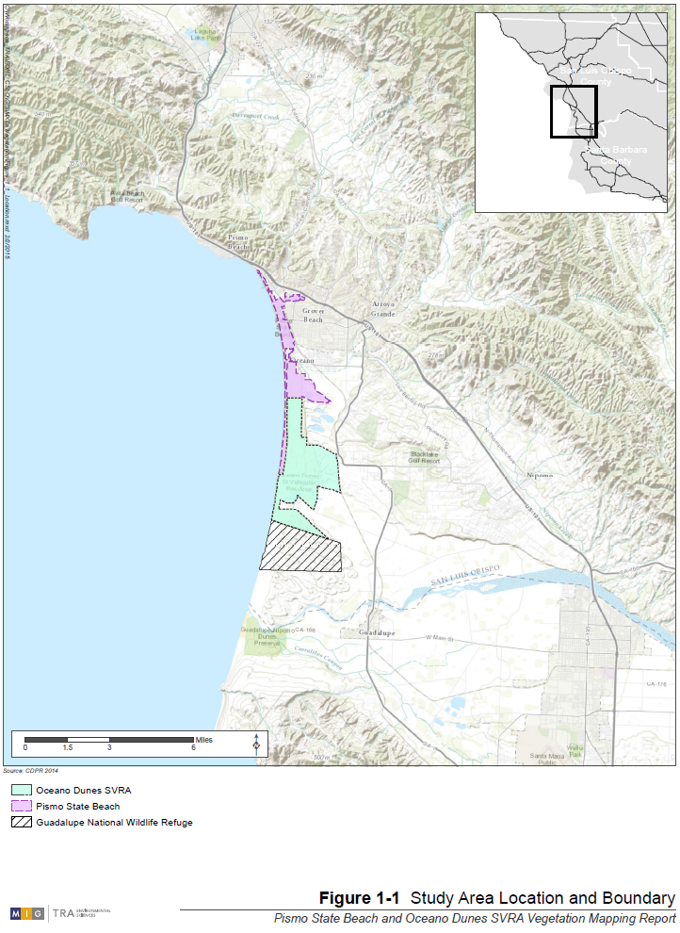
Figure 1-2. Aerial Overview of the Study Area
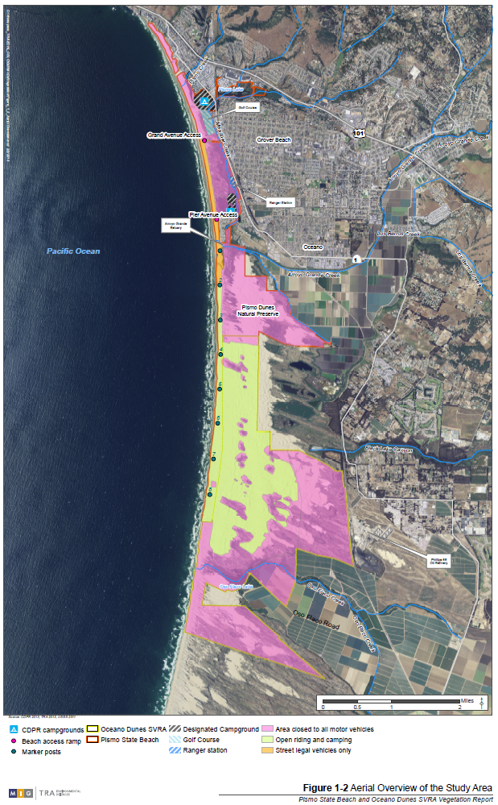

STUDY METHODS

VEGETATION ZONES

Vegetation “zones” were created in the study area to facilitate vegetation mapping. The eight zones do not represent or adhere to jurisdictional or land use boundaries (Figure 2-1):

- Pismo SB Zone: This includes the 558-acre portion of Pismo SB extends from near Pismo Pier in the north south to Arroyo Grande Creek.
- Dunes Natural Preserve Zone: This is a 773-acre area that includes the 674-acre Dunes Preserve and the 98-acre portion of Pismo SB bordering the Dunes Preserve to the west.
- Vegetation Island Zone: This includes the 1,646-acre portion of the open riding and camping area south of the Dunes Preserve, which is largely in the Oceano Dunes SVRA, although the westernmost portion is part of Pismo SB.
- Phillips 66 Leasehold Zone: This includes 892 acres east of the open riding and camping area, which is composed of CDPR land and land leased to CDPR by Phillips 66.
- North Oso Flaco Zone: This includes the 83-acre vegetated foredunes bordered by the open riding and camping area to the north and northeast, Oso Flaco Creek to the south, the Pacific Ocean to the west, and the Maidenform Zone to the southeast. A small portion of this zone overlaps the open riding and camping area where foredune vegetation extends past the boundary.
- Maidenform Zone: This 130-acre zone includes a vegetated “peninsula” bordered on three sides (north, east, and west) by the open riding and camping area, Oso Flaco Creek to the south, and the North Oso Flaco Zone to the southwest.
- Oso Flaco Lake and Creek Zone: This 200-acre zone includes Oso Flaco Lake, Oso Flaco Creek, and the surrounding area.
- South Oso Flaco Zone: This 593-acre zone includes all land in the Oceano Dunes SVRA south of the Oso Flaco Lake and Creek Zone, including both foredune and backdune areas.

The vegetation zones are described in detail in Chapter 4.

VEGETATION MAPPING

Vegetation types in the study area are classified as vegetation alliances defined by their dominant or co-dominant species, following the classification system in A Manual of California Vegetation, Second Edition (MCV2) (Sawyer et al. 2009). However, coastal dune vegetation types are under-represented in the MCV2 because these areas have not been well studied (Keeler-Wolf, pers. comm., to S. Little June, 2012). Therefore, portions of the study area also contain dominant plants that do not have an MCV2 corresponding alliance. As a result, District staff and their consultants created unique alliances to describe the alliances not classified by MCV2, and these are referred to as District alliances in this report.

Vegetation mapping was conducted during the week of September 10 through14, 2012 by a team of seven individuals representing biologists from the District, TRA Environmental Sciences, Inc. (TRA), and independent consultants. District biologists independently continued vegetation mapping in subsequent weeks and completed the effort in December 2012.

Mapping was conducted by teams of two biologists. Vegetation was mapped in the following areas: vegetation islands, Maidenform, Oso Flaco Lake and Creek, portions of the Phillips 66 leasehold, and North and South Oso Flaco. Aerial base maps, acquired from the National Oceanic and Atmospheric Administration (NOAA) Coastal Services Center (2011), were used for vegetation mapping. A checklist of common plant species in the study area, developed by District biologists, was also used to aid in documenting plants observed in the study area. The mapping methodology used was consistent with Sawyer et al. (2009). Each mapping unit was mapped as one vegetation alliance only (i.e., different vegetation layers were never mapped separately as different alliances in the same mapping unit). In areas dominated by shrubland species where dominant species of two or more shrubland alliances were present in the same mapping unit, the unit was mapped as the shrubland alliance corresponding with the dominant shrub species. Likewise, in areas dominated by herbaceous species where dominant species of two or more herbaceous alliances were present in the same unit, the unit was mapped as the herbaceous alliance corresponding to the most dominant herbaceous species. In addition, the following methods were used in those locations where dominant species from both shrubland and herbaceous alliances were present in the same mapping unit:

- In areas of higher than 20 percent total vegetative cover, the unit was mapped as the shrubland alliance if shrubs had at least 10 percent cover, even if total cover of herbs was higher than that of shrubs. If shrubs covered less than 10 percent and herbaceous vegetation was dominant, the unit was mapped as the herbaceous alliance.
- In areas of less than 20 percent total vegetative cover, the unit was mapped as the shrubland alliance even if shrubs were less than 10 percent cover if shrubs were evenly distributed across the area. If shrubs were less than 2-5 percent cover and unevenly distributed, the unit was mapped as the herbaceous alliance.

Vegetation alliance boundaries were sketched onto 11 x 17-inch base maps. All distinctive vegetation types were mapped in the field regardless of size. Plant species observed in each area mapped were checked off on the checklist of common plant species or added to the list, if necessary. Observations likely did not include every plant species present in the study area (e.g., fall annuals that were not present when mapping took place would not have been detected). During vegetation mapping one team member sketched the vegetation alliances while the other completed the species checklist. All species detected are listed in Appendix A.

Once on-site work was completed, field maps were georeferenced and digitized using ArcGIS 10.1. Vegetation alliance outlines were digitized to produce vector data representing hand-drawn polygons. Desktop mapping was performed at different scales appropriate to the variable scales of each field map. This process was started by CDPR staff and completed by TRA. Quality assurance and quality control were provided by CDPR biologists.

PLANT SPECIES NOMENCLATURE AND ALLIANCE CODES

Scientific names for plant species in this report follow MCV2 for dominant species that form the basis of an MCV2 alliance (Sawyer et al. 2009). For all other species independent of MCV2 alliances, naming conventions follow The Jepson Manual, Vascular Plants of California, Second Edition (Baldwin et al. 2012). In those instances where naming conflicts between an MCV2 alliance and Baldwin et al. (2012), the name used in Baldwin et al. 2012 is qualified with brackets and noted in the text. When a new species to the study area is first documented in this report, both the common name and scientific name (in parentheses) are presented. Subsequent references use only the common name.

SPECIAL-STATUS PLANT SPECIES DEFINITION AND SOURCES

For the purposes of this report, special-status plant species are defined as follows:

- Species listed as threatened or endangered under the federal Endangered Species Act (FESA), or proposed for listing under FESA;
- Species listed as threatened or endangered under the California Endangered Species Act (CESA), or candidate for listing under CESA;
- Species with a California Rare Plant Rank (CRPR), defined as follows:

Ranks:
CRPR 1B: Plants rare, threatened, or endangered in California and elsewhere;
CRPR 2: Plants rare, threatened, or endangered in California but common elsewhere;
CRPR 3: More information about this plant needed (Review List); and
CRPR 4: Limited distribution (Watch List).

CRPR Threat Code extensions and their meanings:
.1 – Seriously endangered in California (over 80 percent of occurrences threatened / high degree and immediacy of threat);
.2 – Fairly endangered in California (20-80 percent occurrences threatened); and
.3 – Not very endangered in California (< 20 percent of occurrences threatened or no current threats known).

Known or potential occurrences of special-status plants in the study area are derived from the following sources:

- Species lists compiled during vegetation mapping conducted by District staff and their consultants from September through December 2012;
- A focused survey for four federal and/or state listed plant species (surf thistle [Cirsium rhothophilum], La Graciosa thistle [Cirsium scariosum var. loncholepis], beach spectaclepod [Dithyria maritima], and Nipomo Mesa lupine [Lupinus nipomensis]) conducted by Oceano Dunes District staff in 2008;
- Annual population data for the Nipomo Mesa lupine from the San Luis Obispo County Land Conservancy;
- Vegetation transect surveys conducted by District staff from 2004 to 2009 as part of their ongoing habitat monitoring program (CDPR 2012);
- Records from the California Natural Diversity Database (CNDDB), including the Oceano USGS Quadrangle and eight surrounding Quads (CNDDB 2013); and
Species listed as occurring in the Oceano USGS Quadrangle and eight surrounding Quads by the California Native Plant Society (CNPS) Inventory of Rare and Endangered Plants (CNPS 2013).
Figure 2-1. Vegetation Zones in the Study Area
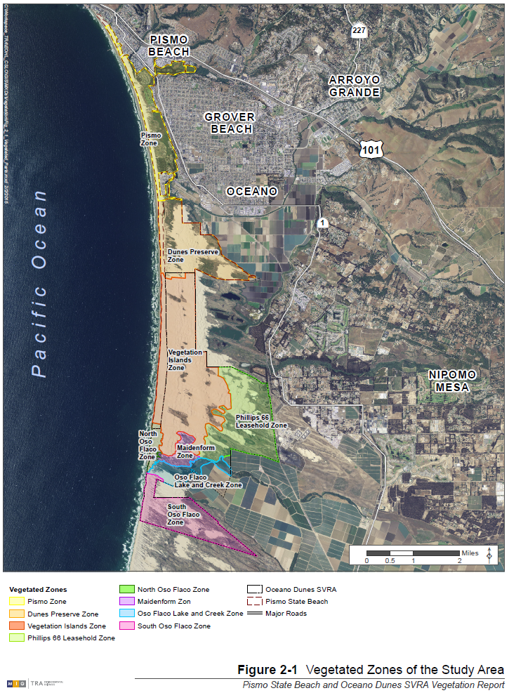

VEGETATION ALLIANCES IN THE STUDY AREA

Overview

There are forty-six vegetation alliances in the study area, including 35 MCV2 alliances and 11 District alliances. There are 8 forest and woodland alliances, 13 shrubland alliances, and 25 herbaceous alliances.

The vegetation alliances mapped in this survey are listed in Table 3-1, which includes the following information:
- Column 1 specifies the alliance name.
- Column 2 specifies whether the alliance is derived from the MCV2 or created by District staff.
- Column 3 specifies the area, in acres, for each alliance in descending order (largest area, which represents the dominant alliance, is listed first).
- Column 4 specifies whether the dominant plant in the alliance is native or non-native to the study area; the asterisk indicates alliances that are native to California but not to the study area (i.e., the study area is outside the natural range of the dominant species in the alliance).
- Column 5 specifies whether the alliance occurs in the foredunes, backdunes, or within both.
- Column 6 specifies whether the alliance occurs in an upland, a wetland, or is equally likely to occur in both, based on the 2012 U.S. Army Corps of Engineers (USACE) National Wetland Plant List (USACE 2012).

The dominant alliance in the study area is the silver dune lupine–mock heather scrub (Lupinus chamissonis-Ericameria ericoides Shrubland Alliance). It is an upland alliance that covers 1,079 acres of the backdunes and is native to the study area. The next most dominant alliance is the native arroyo willow thickets (Salix lasiolepis Shrubland Alliance), covering 359 acres in the backdunes. Arroyo willow thickets is considered a wetland alliance, however, standing water or other wetland species are not associated with every stand. European beach grass swards (Ammophila arenaria Semi-natural Herbaceous Stands Alliance) are the third most prevalent alliance, covering 194 acres of upland foredune habitat. This is a non-native, invasive species. Dune mat is a native herbaceous alliance (Abronia latifolia-Ambrosia chamissonis Herbaceous Alliance) that occurs in 140 acres of foredune upland habitat. Non-native perennial veldt grass stands (Erharta calycina Semi-natural Herbaceous Stands Alliance) cover about 90 acres of the backdunes in the study area. The remaining 40 alliances range in size from less than one acre to 45 acres, and mostly occur in the more heavily vegetated backdunes. The composition of alliances in the foredunes differed from those in the backdunes. European beach grass swards dominate the foredunes and the backdunes are dominated by the silver dune lupine–mock heather scrub.
Table 3-1 Summary of Vegetation Alliances in the Study Area
Alliance Name | MCV2/ District | Area (acres) | Native/ Non-native | Fore-/ backdunes | Upland/ wetland
Forest and Woodland Alliances
Eucalyptus groves  (Eucalyptus globulus Semi-Natural Woodland Stands Alliance) | MCV2 | 16 | Non-native | Backdunes | Upland
Black cottonwood forest  (Populus trichocarpa Forest Alliance) | MCV2 | 11 | Native | Backdunes | Both
Monterey pine forest  (Pinus radiata Forest Alliance) | MCV2 | 7 | Non-native | Backdunes | Upland
Torrey pine stands  (Pinus torreyana Woodland Special Stands Alliance) | MCV2 | 3 | Non-native | Backdunes | Upland
Monterey cypress stands  (Callitropsis [Hesperocyparis] macrocarpa Woodland Stands Alliance) | MCV2 | 1 | Non-native | Backdunes | Upland
Pepper tree or myoporum groves  (Schinus molle/terbinthifolius-Myoporum laetum Semi-Natural Woodland Stands Alliance) | MCV2 | 1 | Non-native | Backdunes | Upland
Coast live oak woodland  (Quercus agrifolia Woodland Alliance) | MCV2 | 0.6 | Native | Backdunes | Upland
Beach pine forest  (Pinus contorta ssp. contorta Forest Alliance) | MCV2 | 0.1 | Non-native | Backdunes | Both
Shrubland Alliances
Silver dune lupine–mock heather scrub  (Lupinus chamissonis-Ericameria ericoides Shrubland Alliance) | MCV2 | 1,089 | Native | Backdunes | Upland
Arroyo willow thickets  (Salix lasiolepis Shrubland Alliance) | MCV2 | 395 | Native | Backdunes | Wetland
Golden wattle stands  (Acacia longifolia Semi-Natural Shrubland Alliance) | District | 40 | Non-native | Backdunes | Upland
Coyote brush scrub  (Baccharis pilularis Shrubland Alliance) | MCV2 | 16 | Native | Backdunes | Upland
Wax myrtle scrub  (Morella californica Shrubland Alliance) | MCV2 | 10 | Native | Backdunes | Wetland
Blochman’s groundsel scrub  (Senecio blochmaniae Shrubland Alliance) | District | 7 | Native | Backdunes | Upland
Giant coreopsis scrub  (Coreopsis [Leptosyne] gigantea Shrubland Alliance) | MCV2 | 6 | Native | Backdunes | Upland
Coastal brambles  (Rubus ursinus Shrubland Alliance) | MCV2 | 3 | Native | Backdunes | Upland
Deer weed scrub  (Lotus scoparius [Acmispon glaber] Shrubland Alliance) | MCV2 | 1 | Native | Backdunes | Upland
California coffee berry scrub  (Frangula californica Shrubland Alliance) | MCV2 | 1 | Native | Backdunes | Upland
Poison oak scrub  (Toxicodendron diversilobum Shrubland Alliance) | MCV2 | 1 | Native | Backdunes | Upland
Blue elderberry stands (Sambucus nigra ssp. caerulea Shrubland alliance) | MCV2 | 0.4 | Native | Backdunes | Both
California sagebrush-black sagebrush scrub (Artemisia californica-Salvia mellifera Shrubland Alliance) | MCV2 | 0.02 | Native | Backdunes | Upland
Herbaceous Alliances
European beach grass swards  (Ammophila arenaria Semi-Natural Herbaceous Alliance) | MCV2 | 194 | Non-native | Foredunes | Upland
Dune mat  (Abronia latifolia-Ambrosia chamissonis Herbaceous Alliance) | MCV2 | 140 | Native | Foredunes | Upland
Perennial veldt grass stands  (Ehrharta calycina Semi-Natural Herbaceous Stands Alliance) | District | 90 | Non-native | Backdunes | Upland
California bulrush marsh  (Schoenoplectus californicus Herbaceous Alliance) | MCV2 | 45 | Native | Backdunes | Wetland
Iceplant mats  (Carpobrotus edulis or Other Ice Plants Semi-Natural Herbaceous Alliance) | MCV2 | 38 | Non-native | Both | Upland
Crisp monardella sands  (Monardella undulata ssp. crispa Herbaceous Alliance) | District | 17 | Native | Both | Upland
Salt rush (a.k.a. dune rush) swales  (Juncus lescurii Herbaceous Alliance) | MCV2 | 15 | Native | Backdunes | Wetland
Russian wheat grass stands  (Elymus farctus Semi-Natural Herbaceous Alliance) | District | 9 | Non-native | Foredunes | Upland
Searocket sands  (Cakile maritima Semi-Natural Provisional Herbaceous Alliance) | MCV2 | 6 | Non-native | Foredunes | Both
California sandaster mats  (Corethrogyne filaginifolia Herbaceous Alliance) | District | 24 | Native | Backdunes | Upland
Field sedge meadows  (Carex praegracilis Herbaceous Alliance) | District | 4 | Native | Both | Wetland
Tall stephanomeria meadows  (Stephanomeria virgata Herbaceous Alliance) | District | 3 | Native | Backdunes | Upland
Wedge-leaved horkelia–California spineflower meadows  (Horkelia cuneata–Mucronea californica Herbaceous Alliance) | District | 4 | Native | Backdunes | Upland
Cattail marshes  (Typha latifolia Herbaceous Alliance) | MCV2 | 3 | Native | Backdunes | Wetland
Mats of bur-reed leaves  (Sparganium eurycarpum Herbaceous Alliance) | MCV2 | 1 | Native | Backdunes | Wetland
Pickleweed mats  (Sarcocornia [Salicornia] pacifica Herbaceous Alliance) | MCV2 | 1 | Native | Backdunes | Wetland
Salt grass flats  (Distichlis spicata Herbaceous Alliance) | MCV2 | 1 | Native | Backdunes | Both
Annual brome grasslands  (Bromus diandrus-Brachpodium distachyon Semi-Natural Herbaceaus Alliance) | MCV2 | 1 | Non-native | Backdunes | Upland
Fields of fat hen and brass buttons  (Atriplex prostrata-Cotula coronopifolia Semi-Natural Herbaceous Alliance) | MCV2 | 0.5 | Non-native | Foredunes | Wetland
Pacific silverweed marshes  (Argentina egedii Herbaceous Alliance) | MCV2 | 0.4 | Native | Foredunes | Wetland
White sweetclover mats  (Melilotus albus Herbaceous Alliance) | District | 0.3 | Non-native | Foredunes | Upland
Jaumea mats  (Jaumea carnosa Herbaceous Alliance) | District | 0.1 | Native | Foredunes | Wetland
Giant wild rye grassland  (Leymus [Elymus] condensatus Herbaceous Alliance) | MCV2 | 0.1 | Native | Backdunes | Upland
American bulrush marsh  (Schoenoplectus americanus Herbaceous Alliance) | MCV2 | 0.2 | Native | Foredunes | Wetland
Duckweed blooms  [Lemna (minor) and Relatives Provisional Herbaceous Alliance] | MCV2 | Less than 0.01 acre | Native | Backdunes | Wetland

NATIVE UPLAND ALLIANCES

Native upland alliances are dominated by plants native to the study area that usually or always occur in uplands. These include one woodland alliance, ten shrubland alliances, and six herbaceous alliances. Native upland alliances occupying 10 or more acres in the study area include silver dune lupine–mock heather scrub, coyote brush scrub, dune mat, and crisp monardella sands. Silver dune lupine–mock heather scrub is widespread and covers more area than any other alliance in the study area. Although the dominant species in blue elderberry stands (Sambucus nigra ssp. caerulea), is listed by the USACE (2012) as facultative (FAC), or equally likely to occur in wetlands or uplands, this alliance is included here because it occurs within uplands in the study area. Both black cottonwood forest (Populus trichocarpa) and salt grass flats (Distichlis spicata) are FAC, but primarily occupy wetter areas in the study area so are included in the native wetland forest and native wetland herbaceous alliances, respectively. The native upland alliances and their location in the study area are described in detail below.

NATIVE UPLAND FOREST AND WOODLAND ALLIANCES

MCV2 Alliances

Coast live oak woodland (Quercus agrifolia Woodland Alliance); 0.6 acre
Coast live oak is dominant or co-dominant in the tree canopy in this alliance, exceeding 50 percent relative cover. In California, this alliance occurs on alluvial terraces, canyon bottoms, stream banks, slopes, and flats from 0-4,000 feet; soils are deep, sandy or loamy, with high organic matter (Sawyer et al. 2009). This alliance was documented as a single tree at five locations in the backdunes of the study area, including one near Pier Avenue in the Pismo SB Zone, one in the northeast corner of the Dunes Preserve Zone, one near the southern border of the Phillips 66 Leasehold Zone, and two in the South Oso Flaco Zone.

District Alliances

No unique native upland forest or woodland District alliances occur in the study area.

NATIVE UPLAND SHRUBLAND ALLIANCES

MCV2 Alliances

Silver dune lupine–mock heather scrub (Lupinus chamissonis–Ericameria ericoides Shrubland Alliance); 1,089 acres
This alliance occurs in California on stabilized dunes of coastal bars, river mouths, sand spits along coastlines, coastal bluffs, and terraces from 0-100 feet (Sawyer et al. 2009). Which of the two species (i.e., silver dune lupine or mock heather scrub) dominates varies, probably due to a combination of soil texture, aspect, hydrology, and stand age. Sometimes the species are co-dominant. Within the study area, other common native shrub and herbaceous species that occur in this alliance include lizard tail (Eriophyllum staechadifolium), California croton (Croton californicus), seacliff buckwheat (Eriogonum parvifolium), deerweed (Lotus scoparius [Acmispon glaber]), California sandaster (Corethrogyne filaginifolia), yarrow (Achillea millefolium), cudweed (Psuedognaphalium sp.), Monterey Coast paintbrush (Castilleja latifolia, a CRPR 4.3 plant), and Southern California dudleya (Dudleya lanceolata). Silver dune lupine–mock heather scrub is dominant in the backdunes of the study area. This alliance covers more area, and is more widespread than any other alliance in the study area and occurs in every vegetation zone of the study area.

Coyote brush scrub (Baccharis pilularis Shrubland Alliance); 16 acres
Coyote brush is dominant or co-dominant in the shrub canopy, exceeding 50 percent absolute cover in the shrub layer or exceeding 15 percent shrub cover over a grassy understory, with a relative cover exceeding 50 percent of other shrub species. In California, this alliance occurs from 0-5,000 feet elevation at river mouths, stream sides, terraces, stabilized dunes of coastal bars, coastline spits, coastal bluffs, open slopes, ridges on variable soils, and sandy to relatively heavy clay (Sawyer et al. 2009). Within the study area, this alliance occurs at a few locations in the backdunes, often near silver dune lupine–mock heather scrub, arroyo willow thickets, and/or salt rush swales (Juncus lescurii). It is relatively widespread but does not cover much of the study area. It occurs near Arroyo Grande Creek and at one other location in the Dunes Preserve Zone, at several of the vegetation islands in the Vegetation Island Zone, at one location in the Phillips 66 Leasehold Zone, in the southeastern part of the North Oso Flaco Zone, the southwestern part of the Maidenform Zone, near Oso Flaco Creek in the Oso Flaco Lake and Creek Zone, and at three locations in the South Oso Flaco Zone.

Giant coreopsis scrub (Coreopsis [Leptosyne] gigantea Shrubland Alliance); 6 acres
Giant coreopsis is dominant or co-dominant in the shrub canopy in this alliance, exceeding 30 percent relative cover. In California, this alliance occurs on the immediate coast within 1.2 miles of the ocean, usually on steep bluffs or stable slopes, from 0-1,300 feet (Sawyer et al. 2009). Within the study area, this alliance occurs at five locations in the backdunes, including a small patch in the south end of the Phillips 66 Leasehold Zone, in the middle part of the Maidenform Zone, and at three locations in the South Oso Flaco Zone. It is usually surrounded by silver dune lupine–mock heather scrub, but at one of the locations in the South Oso Flaco Zone it also occurs near European beach grass swards. Giant coreopsis also occurs extensively in one other area of the backdunes of the South Oso Flaco Zone, but that area is classified as silver dune lupine–mock heather scrub because silver dune lupine is dominant.

Coastal brambles (Rubus ursinus Shrubland Alliance); 3 acres
In this alliance, thimbleberry (Rubus parviflorus), salmonberry (R. spectabilis), and California blackberry (R. ursinus) are dominant or are co-dominant in the shrub canopy. In California, this alliance occurs in coastal bluffs, headlands, exposed slopes, and gaps in forest stands from 0-100 feet (Sawyer et al. 2009). Only California blackberry is present in the study area. Within the study area, this alliance occurs at a few locations in low-lying portions of the backdunes, often near areas dominated by rushes or other wetland vegetation. It occurs near Arroyo Grande Creek in the Dunes Preserve Zone, at one vegetation island (Heather Island) in the Vegetation Island Zone, at one location in the Phillips 66 Leasehold Zone, in the Oso Flaco Lake and Creek Zone, and in the southeast corner of the South Oso Flaco Zone.

Deerweed scrub (Lotus scoparius [Acmispon glaber] Shrubland Alliance); 1 acre
In this alliance, deerweed is dominant or co-dominant in the shrub canopy, exceeding 50 percent relative cover. In California, this alliance occurs in areas with recent disturbance, such as clearing, fire, or intermittent flooding, from 80-5,000 feet (Sawyer et al. 2009). Within the study area, this alliance is limited to three small patches, including one at the BBQ Flats vegetation island in the Vegetation Island Zone and two in the Maidenform Zone.

California coffeeberry scrub (Frangula californica Shrubland Alliance); 1 acre
In this alliance, California coffeeberry is dominant or co-dominant in the shrub canopy, exceeding 50 percent relative cover. In California, this alliance occurs on concave slopes, lower slopes, along drainages, and undulating moderate to steep slopes of sedimentary or serpentine substrates from 0-3,300 feet where soils retain moisture much of the year (Sawyer et al. 2009). Within the study area, this alliance is limited to several small patches in the Phillips 66 Leasehold Zone and one small patch in the mid-eastern part of the South Oso Flaco Zone. This alliance was usually observed surrounded by silver dune lupine–mock heather scrub, although one patch is located within a stand of invasive perennial veldt grass.

Poison oak scrub (Toxicodendron diversilobum Shrubland Alliance); 1 acre
In this alliance, poison oak is dominant in the shrub canopy, exceeding 50 percent relative cover. In California, this alliance occurs on the immediate coast in mesic hollows receiving salt-laden fog to interior sheltered mesic and disturbed dry slopes, from 0-2,400 feet (Sawyer et al. 2009). In the study area, this alliance occurs in the backdunes at a few locations with various moisture regimes (from dry to mesic). It occurs at five of the vegetation islands in the Vegetation Island Zone, at two locations in the Phillips 66 Leasehold Zone, at Oso Flaco Lake in the Oso Flaco Lake and Creek Zone, and at one location near the southeast part of the South Oso Flaco Zone. In some locations in the study area it co-occurs with the coastal brambles alliance.

Blue elderberry (Sambucus nigra ssp. caerulea Shrubland Alliance); 0.4 acre
In this alliance, blue elderberry is dominant in the shrub canopy, exceeding 50 percent relative cover. In California, blue elderberry occurs on stream terraces and in bottomlands from 0-1,000 feet where soils are typically alluvium and intermittently flooded (Sawyer et al. 2009). This alliance occurs at one location in the study area in the Phillips 66 Leasehold Zone.

California sagebrush-black sagebrush scrub (Artemisia californica-Salvia mellifera Shrubland Alliance); 0.02 acres.
In this alliance, California sagebrush and black sagebrush are co-dominant in the shrub canopy, with 30-60 percent relative cover. In California, this alliance occurs in colluvial soils on slopes that are steep and usually east to southwest facing from 800-2,450 feet (Sawyer et al. 2009). Within the study area, this alliance occurs at only one location at the south end of the Phillips 66 Leasehold Zone.

District Alliances

Blochman’s groundsel scrub (Senecio blochmaniae Shrubland Alliance); 7 acres
In this alliance, Blochman’s groundsel is dominant or co-dominant in the shrub layer. It is native to California and occurs in coastal strand habitats from 0-1,100 feet (Calflora 2013). Blochman’s groundsel is a CRPR 4.2 plant (CNPS 2013), but it is locally common within the study area. Blochman’s groundsel thrives in environments with an intermediate amount of disturbance. It sometimes co-occurs with yarrow and often occurs next to stands of crisp monardella (Monardella undulata ssp. crispa). This alliance transitions into silver dune lupine–mock heather scrub as soils become more stable. In the study area, this alliance occurs at the edges of the silver dune lupine–mock heather scrub in the backdunes, including at nine of the vegetation islands in the Vegetation Island Zone, in many locations within the Phillips 66 Leasehold Zone, at one location in the Maidenform Zone, and at a few locations in the South Oso Flaco Zone.

NATIVE UPLAND HERBACEOUS ALLIANCES

MCV2 Alliances

Dune mat (Abronia latifolia-Ambrosia chamissonis Herbaceous Alliance); 140 acres
In this alliance, yellow sand verbena (Abronia latifolia) and/or beach bur (Ambrosia chamissonis) mix with other perennial herbs, grasses and low shrubs to form a low canopy. In California, this alliance occurs on sand dunes of coastal bars, river mouths, and spits along the immediate coastline from 0-35 feet (Sawyer et al. 2009). In the study area, other common herbaceous plants in this alliance include red sand verbena (Abronia maritima, a CRPR 4.2 plant), pink sand verbena (Abronia umbellata), European searocket (Cakile maritima), beach evening primrose (Camissoniopsis cheiranthifolia var. cheiranthifolia) and Pacific silverweed (Potentilla anserina var. pacifica). This is the most common native vegetation type on the foredunes of the study area. It occurs intermittently along the foredunes from the Pismo Zone south to the western portion of the South Oso Flaco Zone (i.e., from the northern to the southern border of the study area).

Giant wild rye grassland (Leymus [Elymus] condensatus Herbaceous Alliance); 0.1 acre
In this alliance, giant wild rye is dominant or co-dominant in the herbaceous layer, exceeding 50 percent relative cover. In California, this alliance is found in somewhat steep, often northerly slopes at low elevations on loamy soils, from 0-4,900 feet elevation (Sawyer et al. 2009). Within the study area, this alliance only occurs at a single location in the backdunes of the South Oso Flaco Zone.

District Alliances

Crisp monardella sands (Monardella undulata ssp. crispa Herbaceous Alliance); 17 acres
In this alliance, crisp monardella is dominant or co-dominant, exceeding 50 percent relative cover in the herbaceous layer. In California, crisp monardella is a perennial endemic that is highly localized to unstable sand sheets and blowing sands located at the edge of established shrubland and tree alliances from 30-400 feet. It often co-occurs with beach bur. Crisp monardella is a CRPR 1B.2 plant (CNPS 2013), although it is locally common and widespread within the study area. The study area is covered with small pockets of crisp monardella in both the fore- and backdunes. It occurs near Arroyo Grande Creek and in several other pockets in the Dunes Preserve Zone, at the edges of eight of the vegetation islands in the Vegetation Island Zone, in the Phillips 66 Leasehold Zone, in the Maidenform Zone, in the Oso Flaco Lake and Creek Zone, and in several bare sand areas of the South Oso Flaco Zone.

California sandaster mats (Corethrogyne filaginifolia Herbaceous Alliance); 24 acres
In this alliance, the California sandaster is dominant or co-dominant, exceeding 50 percent relative cover in the herbaceous layer. California sandaster is a perennial herb native to California that occurs in coastal bluff scrub, maritime chaparral and coastal scrub from 0-7,000 feet (Calfora 2013). In the study area, this alliance occurs in the backdunes amongst silver dune lupine–mock heather scrub in areas where silver dune lupine seems to be dying back. It occurs in scattered patches usually surrounded by larger areas of the silver dune lupine–mock heather scrub at one location in the Dunes Preserve Zone, in eight of the vegetation islands in the Vegetation Islands Zone, at several locations in the Phillips 66 Leasehold Zone, in the Maidenform Zone, and in the Oso Flaco Lake and Creek Zone.

Tall stephanomeria meadows (Stephanomeria virgata Herbaceous Alliance); 3 acres
In this alliance, tall stephanomeria is dominant in the herbaceous layer, exceeding 50 percent relative cover. Emergent shrubs may also be present at low density in this alliance. In California, tall stephanomeria is a native annual herb characteristic of disturbed places in a variety of habitats, from 0-7,000 feet (Calflora 2013). In the study area, this alliance occurs in the south end of the Phillips 66 Leasehold Zone.

Wedge-leaved horkelia–California spineflower meadows (Horkelia cuneata–Mucronea californica Herbaceous Alliance); 4 acres
In this alliance, wedge-leaved horkelia and California spineflower are dominant or co-dominant in the herbaceous layer, exceeding 50 percent relative cover. Shrubs may also be present in this alliance. In California, wedge-leaved horkelia is a perennial herb that occurs in coastal habitats from 0-2,300 feet. (Calflora 2013) and California spineflower is a CRPR 4.2 plant that occurs in sandy habitats from 1-4,500 feet (CNPS 2013). The two species usually occur together, but which species is dominant varies. Within the study area, this alliance occurs in low lying meadows of the backdunes, often adjacent to shrubland alliances including silver dune lupine–mock heather scrub and/or coyote brush scrub. It occurs at six locations in the middle and southeast portions of the South Oso Flaco Zone and at one location above the southeast corner of the Phillips 66 Leasehold Zone. Wedge-leaved horkelia is the dominant species in the South Oso Flaco Zone locations, while California spineflower is the dominant species in the Phillips 66 Leasehold Zone.

NATIVE WETLAND ALLIANCES

Native wetland alliances are dominated by plants native to the study area that usually or always occur in wetlands. While dominant plants in the wax myrtle scrub (Morella californica), arroyo willow thickets, salt rush swale alliances are listed by the USACE (2012) as facultative wetland (FACW), or usually hydrophytes but occasionally found in uplands, these alliances are widespread in the study area and also commonly occur in uplands. Field sedge (Carex praegracilis), the dominant plant in field sedge meadows, is also listed as FACW and usually occurs in study area wetlands. Dominant plants in the remaining alliances described in this section are listed by the USACE (2012) as obligate wetland (OBL), or almost always hydrophytes and rarely occurring in uplands. These alliances only occur in wetlands within the study area.

There are fourteen native wetland alliances in the study area, including one forest alliance, two shrubland alliances, and eleven herbaceous alliances. Native wetland alliances occupying 10 or more acres in the study area include black cottonwood forest, arroyo willow thickets, California bulrush marsh, and salt rush swales. Native wetland alliances and their location in the study area are described in detail below.

NATIVE WETLAND FOREST AND WOODLAND ALLIANCES

MCV2 Alliances

Black cottonwood forest (Populus trichocarpa Forest Alliance); 11 acres
This alliance occurs where black cottonwood is dominant or co-dominant in the tree canopy, exceeding 5 percent absolute cover and 30 percent relative cover. In California, it is found in seasonally flooded and permanently saturated soils on streambanks and alluvial terraces between 0-9,000 feet (Sawyer et al. 2009). Within the study area, this alliance typically grows at scattered locations in the wetter areas of the backdunes, usually near larger arroyo willow thickets. It occurs near Arroyo Grande Creek and elsewhere in the eastern portion of the Dunes Preserve Zone, in the Cottonwood and Heather vegetation islands in the Vegetation Island Zone, in the Maidenform Zone, and in the eastern portion of the South Oso Flaco Zone. Although it is relatively widespread, the total area that this alliance occupies in the study area is small.

District Alliances

No unique native wetland forest or woodland District alliances occur in the study area.

NATIVE WETLAND SHRUBLAND ALLIANCES

MCV2 Alliances

Arroyo willow thickets (Salix lasiolepis Shrubland Alliance); 395 acres
In this alliance, arroyo willow is dominant or co-dominant in the shrub or tree canopy, exceeding 50 percent relative cover or 25 percent absolute cover. In California, it occurs along stream banks and benches, slope seeps, and along drainages from 0-7,120 feet (Sawyer et al. 2009). Within the study area, arroyo willow sometimes occurs with wax myrtle. This alliance occurs at scattered locations in the backdunes of all of the vegetation zones in the study area, often adjacent to or surrounded by silver dune lupine–mock heather scrub.

Wax myrtle scrub (Morella californica Shrubland Alliance); 10 acres
In this alliance, wax myrtle is dominant in the shrub canopy, exceeding 50 percent relative cover. In California, it occurs around brackish and freshwater lagoons, along small seeps, streams and on coastal dunes and bluffs from 0-1,000 feet (Sawyer et al. 2009). It prefers soils that are moist or wet and include moderately coarse sandy loams (Sawyer et al. 2009). This alliance often co-occurs with arroyo willow thickets. Within the study area, this alliance is relatively widespread but does not cover much area. Specifically, it occurs near the interpretive trail and Strand Way in the Pismo Zone, in the Dunes Preserve Zone, at 12 of the vegetation islands in the Vegetation Island Zone, in the Maidenform Zone, in the Oso Flaco Lake and Creek Zone, and at two locations in the South Oso Flaco Zone.

District Alliances

No unique wetland shrubland District alliances occur in the study area.

NATIVE WETLAND HERBACEOUS ALLIANCES

MCV2 Alliances

California bulrush marsh (Schoenoplectus californicus Herbaceous Alliance), 45 acres
In this alliance, California bulrush is dominant or co-dominant in the herbaceous layer, exceeding 10 percent absolute cover. In California, it occurs in brackish to freshwater marshes, shores, bars, and channels of river estuaries from 0-650 feet (Sawyer et al. 2009). It prefers soils that have a high organic content and are poorly aerated (Sawyer et al. 2009). This alliance is relatively widespread in the study area, occurring in wetter areas of the backdunes usually adjacent to or surrounded by arroyo willow thickets or near creeks and lakes. It is found near the interpretive trail and Strand Way in the eastern part of the Pismo Zone, at one location each in the Dunes Preserve Zone, at the southwestern edge of the Maidenform Zone, in the Oso Flaco Lake and Creek Zone, and in the southeast portion of the South Oso Flaco Zone.

Salt rush swales (Juncus lescurii Herbaceous Alliance); 15 acres
In this alliance, salt rush is dominant or co-dominant in the herbaceous layer, exceeding 50 percent relative cover. In California, it occurs in seasonally wet, slightly brackish marshes at the upper edges of salt marshes or behind dikes in former salt marsh at intermediate elevations, from 0-320 feet (Sawyer et al. 2009). Species diversity in this alliance type is low within the study area. Typically, salt rush, also known as dune rush, is usually the only species present in this alliance; however, it may be mixed with a few other species with low absolute and relative cover. This alliance is widespread and occurs in all of the vegetation zones in the study area. It is patchily distributed in the backdunes usually at the outer edges of arroyo willow thickets, silver dune lupine–mock heather scrub, wax myrtle scrub, or coyote brush scrub.

Cattail marshes (Typha latifolia Herbaceous Alliance); 3 acres
In this alliance, narrowleaf cattail (T. angustifolia), southern cattail (T. domingensis), or broadleaf cattail (T. latifolia) are dominant or co-dominant in the herbaceous layer, exceeding 50 percent relative cover (Sawyer et al. 2009). In California, this alliance occurs in semi-permanently flooded freshwater or brackish marshes with clayey or silty soils from 0-1,150 feet (Sawyer et al. 2009). Within the study area, this alliance occurs at a large wetland in the Phillips 66 Leasehold Zone and at one small wetland under an arroyo willow thicket in the southeastern corner of the South Oso Flaco Zone. Only southern cattail and broadleaf cattail are present in the study area.

Mats of bur-reed leaves (Sparganium eurycarpum Herbaceous Alliance); 1 acre
In this alliance, narrow leaved bur-reed (S. angustifolium) or other bur-reed species, are dominant on the water surface, exceeding 50 percent relative cover. In California, it occurs in ponds with shallow water or near the shoreline of deeper ponds or lakes with gravelly or muddy bottoms from 0-12,100 feet (Sawyer et al. 2009). Within the study area, this alliance occurs only at two locations near Oso Flaco Lake in the Oso Flaco Lake and Creek Zone and at one location in the southeast corner of the South Oso Flaco Zone where it is surrounded by willow thickets (i.e., arroyo willow thicket alliance). Broadfruit bur-reed (S. eurycarpum) is the only bur-reed species present in the study area.

Pickleweed mats (Sarcocornia [Salicornia] pacifica Herbaceous Alliance); 1 acres
In this alliance, pickleweed (S. pacifica) or Virginia glasswort (S. depressa) are dominant or co-dominant in the subshrub and herbaceous layers, exceeding 10 percent absolute cover, or exceeding 50 percent relative cover in the herbaceous layer; salt grass must be less than 30 percent relative cover (Sawyer et al. 2009). . In California, this alliance occurs in coastal salt marshes and alkaline flats from 0-10 feet (Sawyer et al. 2009). Within the study area, this alliance occurs only at a few locations in North Beach Campground in the Pismo Zone. Only pickleweed is present in the study area.

Salt grass flats (Distichlis spicata Herbaceous Alliance); 1 acre
In this alliance, salt grass is dominant or co-dominant in the herbaceous layer. It either exceeds 50 percent relative cover and has higher cover than any other single grass species or it exceeds 30 percent relative cover in the herbaceous layer and pickleweed is present with less than 30 percent relative cover. In California, this alliance occurs in coastal salt marshes and inland habitats including playas, swales, and terraces along washes that are typically intermittently flooded, from 0-5,000 feet (Sawyer et al. 2009). It prefers soils that are often deep, alkaline or saline, and often have an impermeable layer making them poorly drained. When the soil is dry, the surface usually has salt accumulations (Sawyer et al. 2009). Within the study area, other species that occur in this alliance include jaumea (Jaumea carnosa), Pacific silverweed (Potentilla anserina), field sedge, dune rush and rabbitsfoot grass (Polypogon monspeliensis). This alliance occurs at six low-lying wetland areas near arroyo willow thickets north of Oso Flaco Creek in the Maidenform Zone.

Pacific silverweed marshes (Argentina egedii [Potentilla anserina] Herbaceous Alliance; 0.4 acre
In this alliance, pacific silverweed is dominant or co-dominant in the herbaceous layer, exceeding 60 percent relative cover in the herbaceous canopy (Sawyer et al. 2009). In California, it occurs in seasonally flooded brackish marshes at intermediate tidal elevations from 0-500 feet (Sawyer et al. 2009). Within the study area, it occurs only at two locations near Oso Flaco Creek in the Oso Flaco Lake and Creek Zone.

American bulrush marsh (Schoenoplectus americanus Herbaceous Alliance); 0.2 acre
In this alliance, American bulrush is dominant or co-dominant in the herbaceous layer, exceeding 10 percent absolute cover or 50 percent relative cover. In California, it occurs along streams, around ponds and lakes, in sloughs, swamps and fresh and brackish marshes, and in roadside ditches from 150-5,000 feet (Sawyer et al. 2009). It prefers soils that have a high organic content and are poorly aerated (Sawyer et al. 2009). Within the study area, this alliance occurs only at two locations along the foredunes of the South Oso Flaco Zone.

Duckweed blooms [Lemna (minor) and Relatives Provisional Herbaceous Alliance], 36 acres (area of Oso Flaco Lake)
In this alliance, duckweed (Lemna spp.), duckmeat (Spirodela spp.), water meal (Wolffia spp.), or bogmat (Wolffiella spp.) are dominant herbs on the water surface or characteristically present in the herbaceous layer. In California, this alliance occurs in seasonal and perennial freshwater habitats with still water or on ground surfaces after water levels have dropped, from 0-7,550 feet (Sawyer et al. 2009). Within the study area, this alliance occurs only on the surface of Oso Flaco Lake in the Oso Flaco Lake and Creek Zone. Only Lemna minor is present in the study area.

District Alliances

Field sedge meadows (Carex praegracilis Herbaceous Alliance); 4 acres
In this alliance, field sedge is dominant or co-dominant in the herbaceous layer, exceeding 50 percent relative cover. In California, this alliance usually occurs in wetlands in a variety of coastal habitats between 0-9,000 feet (Calflora 2013). In the study area, this alliance occurs in both the fore- and backdunes in four small patches, including one in the mid-portion of the Dunes Preserve Zone surrounded by arroyo willow thickets, one in the midwest portion of the Phillips 66 Leasehold Zone at the edge of California sandaster mats and silver dune lupine–mock heather scrub, and two on the foredunes of the South Oso Flaco Zone near bare sand, silver dune lupine–mock heather scrub, and wax myrtle scrub.

Jaumea mats (Jaumea carnosa Herbaceous Alliance); 0.1 acres
In this alliance, jaumea is dominant in the herbaceous layer, exceeding 50 percent relative cover. In California, this alliance usually occurs in wetlands in coastal and salt marsh habitats, from 0-15 feet (Calflora 2013). Within the study area, it occurs only in three small patches in the northern foredunes of the South Oso Flaco Zone.

NON-NATIVE ALLIANCES

Non-native alliances are distinguished by dominant plants not native to California or those that are native to California but are not endemic to the study area. These alliances fall into three basic categories, including those that are not native to California and are invasive, those that are not native to California but are not invasive, and those that are native to California but are not native to the study area (i.e., the study area is outside of the natural range of these species). Non-native or naturalized alliances in the study area include six forest or woodland alliances, one shrubland alliance and eight herbaceous alliances.

The California Invasive Plant Council (Cal-IPC) defines non-native invasive plants as species that evolved in one region of the globe and are transported by humans to another region, where they flourish and crowd out native vegetation and wildlife that use native vegetation as a resource (Cal-IPC 2013a). Non-native invasive plants typically form monocultures that cover large areas. Non-native alliances in the study area with dominant plants listed as having a “Moderate” or “High” invasive potential by the Cal-IPC (Cal-IPC 2013b) include the following:

- Eucalyptus groves (Eucalyptus globulus Semi-Natural Woodland Stands Alliance) – blue gum eucalyptus is listed as moderate invasive potential;
- Pepper tree or myoporum groves (Schinus molle/terbinthifolius-Myoporum laetum Semi-Natural Woodland Stands Alliance) – myoporum is listed as moderate invasive potential;
- European beach grass swards Semi-Natural Herbaceous Alliance – European beach grass is listed as high invasive potential;
- Annual brome grasslands (Bromus diandrus-Brachpodium distachyon Semi-Natural Herbaceous Alliance) – ripgut brome (Bromus diandrus) is listed as moderate invasive potential;
- Iceplant mats (Carpobrotus edulis or other iceplants Semi-Natural Herbaceous Alliance) – freeway iceplant (Carpobrotus edulis) is listed as high invasive potential and sea fig (C. chilensis) is listed as moderate invasive potential; and
- Perennial veldt grass stands Semi-Natural Herbaceous Alliance – perennial veldt grass is listed as high invasive potential.

In addition, although Russian wheat grass (Elymus farctus) (i.e., the dominant plant in Russian wheat grass stands) is not listed on the Cal-IPC Inventory, this species behaves as an invasive species where it occurs in the study area and it is; therefore, considered an invasive species in the context of this study.

The study area contains a few non-native alliances that do not fit the description of invasive species. Not all species alien to California are invasive, and some have only a limited potential to be invasive (e.g., occurs only in limited areas, co-occurs with native species, and/or occurs at low densities). The dominant species in the golden wattle stands (Acacia longifolia Semi-Natural Shrubland Alliance) and white sweetclover mats (Melilotus albus Herbaceous Alliance) alliances – golden wattle and white sweetclover, respectively – are not listed on the Cal-IPC Inventory and are non-native, but not invasive. However, white sweetclover in the study area trends toward invasive behaviors (Skinner pers. comm. 2014). European searocket (Cakile maritime) in the searocket sands semi-natural provisional herbaceous alliance and brass buttons (Cotula coronopifolia) in the fields of fat hen (Atriplex prostrate) and brass buttons semi-natural herbaceous alliance are listed by the Cal-IPC as having “Limited” invasive potential (i.e., they are invasive but have minor ecological impact) (Cal-IPC 2013b). These species were observed to occur in few parts of the study area and/or co-occur with native species.

Alliances with dominant plants native to parts of California, but not endemic to the study area include Monterey cypress (Callitropsis [Hesperocyparis] macrocarpa) in the Monterey cypress woodland stands alliance, beach pine (Pinus contorta ssp. contorta) in the beach pine forest alliance, Monterey pine (Pinus radiata) in the Monterey pine forest alliance, and Torrey pine (Pinus torreyana) in the Torrey pine woodland special stands alliance. Monterey cypress, Monterey pine, and Torrey pine have a limited natural range and are CRPR 1B plants within their natural range. However, species rare in their natural range may be invasive elsewhere in the state. For example, Monterey cypress and Monterey pine are listed in Table 2: Species Native to Part of California, but Invasive in Other Parts of the State, of the 2006 Cal-IPC Inventory (Cal-IPC 2006). Torrey pine and beach pine are not native to the study area, but are also not invasive. Each of these alliances occurs in small areas of the study area, with each occurrence limited from one to a few trees. Although some of these occurrences are too small to be “groves,” “forests,” or “stands,” all trees were mapped in the study area since there are so few and many are not endemic to the study area. It is likely that these trees were planted in the study area, or escaped from nearby developed areas.

All of the non-native alliances occur primarily or exclusively in uplands except for fat hen and brass button fields, beach pine forests, and searocket sands. Brass buttons is an OBL plant (USACE 2012) occurring only in wetlands. Beach pine and European searocket are listed as FAC (USACE 2012) and they are equally likely to occur in either wetland or upland areas.

Non-native alliances occupying 10 or more acres in the study area include eucalyptus groves, golden wattle stands, European beach grass swards, perennial veldt grass stands, and iceplant mats. Non-native alliances and their location in the study area are described in detail below.

NON-NATIVE OR NATURALIZED FOREST OR WOODLAND ALLIANCES

MCV2 Alliances

Eucalyptus groves (Eucalyptus globulus Semi-Natural Woodland Stands); 16 acres
In this alliance, blue gum eucalyptus, red river gum (E. camaldulensis), or other gum are dominant in the tree canopy, exceeding 80 percent relative cover. In California, eucalyptus is a non-native species from Australia that was planted as trees, groves, and windbreaks and has naturalized on uplands and stream courses, from 0-1,000 feet (Sawyer et al. 2009). In the study area, this alliance occurs at several locations in the Pismo Zone, including several eucalyptus groves and individual trees at North Beach Campground, and two trees near the interpretive trail and one south of Arroyo Grande Creek. It also occurs at the Eucalyptus Tree vegetation island in the Vegetation Island Zone, and there are groves adjacent to Highway 1, developed areas, and farmland in the northeastern and southeastern corners of the Phillips 66 Leasehold Zone. Blue gum eucalyptus is the only eucalyptus species in the study area.

Monterey pine forest (Pinus radiata Forest Alliance); 7 acres
In this alliance, Monterey pine is dominant or co-dominant in the tree canopy, exceeding 25 percent cover. In California, this alliance occurs on maritime terraces and headlands on well-drained soils from 0-1,000 feet (Sawyer et al. 2009). Monterey pine plantations occur in California and worldwide, but natural stands of Monterey pine exist in only three disjunct areas in mainland California which are near Año Nuevo, on the Monterey Peninsula, and in Cambria (Sawyer et al. 2009). Although Monterey pine is considered a CRPR 1B.1 plant where it is naturally occurring (CNPS 2013), it is not endemic to the study area. Within the study area, it occurs at scattered locations in both the fore- and backdunes at low densities, often with only a single tree at any given location. Specifically, it occurs at a few locations in the Pismo Zone and the Dunes Preserve Zone within the European beach grass swards alliance. In addition, one single tree occurs in the south end of the Phillips 66 Leasehold Zone and one single tree occurs in the Maidenform Zone amongst the arroyo willow thickets.

Torrey pine stands Pinus torreyana (Woodland Special Stands); 3 acres
In this alliance, Torrey pine is dominant in the tree canopy or is emergent over a shrub canopy. In California, it occurs in sandstone or diatomaceous derived soils on coastal bluffs, maritime terraces and slopes, from 0-600 feet (Sawyer et al. 2009). Torrey pine is the rarest pine in North America, occurring naturally only in the vicinity of Del Mar and Torrey Pines State Reserve in San Diego County and on Santa Rosa Island in Santa Barbara County (Sawyer et al. 2009). Although both subspecies (P. torreyana ssp. torreyana and P. torreyana ssp. insularis) are CRPR 1B.2 plants (CNPS 2013), P. torreyana is not native to the study area. Within the study area, there are scattered Torrey pines in the Pismo Zone near the interpretive trail and Oceano Campground, and one individual tree in the western portion of the Dunes Preserve Zone.

Monterey cypress stands (Callitropsis [hesperocyparis] macrocarpa Woodland Alliance); 1 acres
In this alliance, Monterey cypress is dominant or co-dominant in the tree canopy (Sawyer et al. 2009). In California, it occurs in granitic derived soils in headlands and sheltered areas near the coast from 0-100 feet (Sawyer et al. 2009). This species is a CRPR 1B.2 species in its natural range, with only two native Monterey cypress groves on the Monterey Peninsula (Sawyer et al. 2009). Nevertheless, it has invasive tendencies in many places along the California coast (Sawyer et al. 2009). In the study area, this alliance occurs at only a few scattered locations near the interpretive trail and near Le Sage Riviera Golf Course in the Pismo Zone, often with only a single tree at any given location. This species is also a nursery plant and was likely planted where it occurs in the study area.

Pepper tree or myoporum groves (Schinus (molle, terbinthifolius)-Myoporum laetum Semi-Natural Woodland Stands); 1 acre
In this alliance, Peruvian pepper tree (S. molle), Brazilian pepper tree (S. terbinthifolius), or myoporum are dominant in the tree canopy, exceeding 80 percent Peruvian pepper tree cover or 60 percent Brazilian pepper tree or myoporum relative cover (Sawyer et al. 2009). In California, this alliance occurs in coastal canyons, washes, slopes, riparian areas, and roadsides (Sawyer et al. 2009), from 0-650 feet (Calflora 2013). In the study area, it is only present between the North Beach Campground and Highway 1 in the Pismo Zone, and was likely planted there. Only myoporum is present in the study area.

Beach pine forest (Pinus contorta ssp. contorta Forest Alliance); 0.1 acre
In this alliance, beach pine is dominant in the tree canopy, exceeding 50 percent relative cover. In California, it occurs in coastal dunes, seaside bluffs, and exposed rocky headlands with salt spray and winds, from 0-500 feet (Sawyer et al. 2009). It prefers soils that are skeletal, sandy, and may be excessively or poorly drained; some may be temporarily flooded (Sawyer et al. 2009). This species is native to the north coast of California (Sawyer et al. 2009), but is not endemic to the study area. Within the study area, this alliance is limited to three individual trees at three different locations, including one north of Pier Avenue and one near Strand Way in the Pismo Zone, and one at the BBQ Flats vegetation island in the Vegetation Island Zone.

District Alliances

No unique non-native forest or woodland District alliances occur in the study area.

NON-NATIVE SHRUBLAND ALLIANCE

MCV2 Alliances

No unique non-native shrubland MCV2 alliances occur in the study area.

District Alliances

Golden wattle stands (Acacia longifolia Semi-Natural Shrubland Alliance); 40 acres
In this alliance, golden wattle is dominant, exceeding 80 percent relative cover in the shrub or tree canopy. Golden wattle is a small tree introduced from Australia and naturalized in California (Calflora 2013). Within the study area, this alliance occurs in the backdunes, usually adjacent to arroyo willow thickets, silver dune lupine–mock heather scrub, or perennial veldt grass stands. More specifically, there is a large stand north of Pier Avenue as well as several other smaller stands in the Pismo Zone, a stand in the middle of the Acacia vegetation island in the Vegetation Island Zone, and several small stands scattered throughout the Phillips 66 Leasehold Zone.

NON-NATIVE HERBACEOUS ALLIANCES

MCV2 Alliances

European beach grass swards (Ammophila arenaria Semi-Natural Herbaceous Stands); 194 acres
In this alliance, European beach grass is dominant in the herbaceous layer, exceeding 80 percent relative cover. In California, it occurs on dunes of coastal bars, foredunes, river mouths, and spits along the immediate coastline, from 0-65 feet (Sawyer et al. 2009). This species, originally from Europe, was introduced across the Atlantic and Pacific coasts of North America to stabilize shifting sand dunes. It is now the predominant vegetation type in many Pacific coast dune systems (Sawyer et al. 2009). European beach grass is highly invasive, and significantly reduces the diversity of plant and wildlife species in native dune systems. Within the study area, the largest European beach grass swards occur over large areas of the foredunes of the Pismo Zone, the western half of the Dunes Preserve Zone, and in the South Oso Flaco Zone, although it occupies smaller areas in scattered locations elsewhere as well.

Iceplant mats (Carpobrotus edulis or Other Ice Plants Semi-Natural Herbaceous Stands); 38 acres
In this alliance, freeway ice plant, sea fig, and other ice plant taxa are dominant in the herbaceous canopy. In California, it occurs on bluffs, disturbed land, sand dunes of the immediate coastline, coastal and alkaline terraces, from 0-330 feet (Sawyer et al. 2009). Within the study area, this alliance is widespread in both the foredunes and backdunes, and occurs in homogenous patches at scattered locations in all of the vegetation zones of the study area. Freeway iceplant, sea fig, and narrow-leaved iceplant (Conicosia pugioniformis) are all present in the study area. All three of these iceplant species are non-native and invasive.

Searocket sands (Cakile maritima Semi-Natural Provisional Herbaceous Alliance); 6 acres
In this alliance, American searocket (Cakile edentula) or European searocket are dominant in the herbaceous layer (Sawyer et al. 2009). In California, this alliance occurs on bare sand at the leading edge of the beach, within reach of the storm tides and extreme lunar tides greater than 16 feet (Sawyer et al. 2009). European searocket is a non-native species introduced from Europe, but has limited invasive potential (Cal-IPC 2013b). It only occurs sparsely along the leading edge of beaches (Sawyer et al. 2009). Within the study area, this alliance occurs intermittently on the foredunes in the Pismo Zone from near Pismo Lagoon to near Arroyo Grande Creek. European searocket also commonly occurs in the dune mat alliance, but is not dominant in these areas. Only European searocket is present in the study area.

Annual brome grasslands (Bromus diandrus-Brachpodium distachyon Semi-Natural Herbaceous Stands); 1 acre
In this alliance, ripgut brome, soft chess (B. hordeaceus), or false brome (Brachpodium distachyon) are dominant or co-dominant with other non-natives in the herbaceous layer (Sawyer et al. 2009). In California, this alliance occurs in all topographic settings in foothills, waste places, rangelands and openings in woodlands, from 0-7,220 feet (Sawyer et al. 2009). Ripgut brome and soft chess are introduced from Europe and are now widespread in California. This alliance accounts for the largest acreage of grassland vegetation in cismontane California (Sawyer et al. 2009). This alliance is not widespread in the study area, occurring only in one small area in the backdunes of the South Oso Flaco Zone. Ripgut brome and soft chess are both present in the study area.

Fields of fat hen and brass buttons (Atriplex prostrata-Cotula coronopifolia Semi-Natural Herbaceous Stands); 0.5 acre
In this alliance, fat hen and/or brass buttons are dominant or co-dominant in the herbaceous layer, exceeding 60 percent relative cover (Sawyer et al. 2009). Although neither species in this alliance is native to California, they have limited invasive potential (Cal-IPC 2013b). In California, this alliance occurs in seasonally flooded saline mudflats and brackish marshes from 0-1000 feet (Sawyer et al. 2009). It prefers soils that are alluvium (Sawyer et al. 2009). Within the study area, this alliance only occurs near Oso Flaco Creek (Oso Flaco Lake and Creek Zone). Although both species occur in the study area, only brass buttons exceeds 60 percent relative cover in the herbaceous layer.

District Alliances

Perennial veldt grass stands (Ehrharta calycina Semi-Natural Herbaceous Stands), 90 acres
In this alliance, perennial veldt grass exceeds 50 percent relative cover in the herbaceous layer, and shrubs are sparse or absent. Perennial veldt grass is a non-native invasive perennial herb found in disturbed grasslands, roadsides, and coastal habitats in California’s south and central west regions. Perennial veldt grass is spreading very rapidly in the central California coast region, where it invades dunes and shrublands. It was originally imported to California for use as a pasture grass and for erosion control. Perennial veldt grass often displaces native vegetation and converts coastal scrub and chaparral communities to grasslands (Cal-IPC 2013c). Within the study area, this alliance occurs throughout the entire Phillips 66 Leasehold Zone and backdunes of the South Oso Flaco Zone, either with or without a silver dune lupine–mock heather over story. Only areas without a shrub over story are classified under this alliance.

Russian wheat grass stands (Elymus farctus Semi-Natural Herbaceous Stands); 9 acres
In this alliance, Russian wheat grass exceeds 50 percent relative cover in the herbaceous layer. Russian wheat grass is a perennial herb introduced from Eurasia and naturalized in California (Calflora 2013). Within the study area, this alliance is patchily distributed at scattered locations along the foredunes of the Pismo Zone, the Dunes Preserve Zone, and the 7.5 Revegetation Area in the Vegetation Island Zone.

White sweetclover mats (Melilotus albus Semi-Natural Herbaceous Alliance); 0.3 acre
In this alliance, white sweetclover is dominant exceeding 50 percent relative cover in the herbaceous layer. White sweetclover is an annual or biennial herb first introduced from Eurasia or soil reclamation and as a nectar source for honey bees. It was later used as livestock forage and to stabilize roadside cuts (Gucker 2009). In California, it occurs in a variety of disturbed habitats from 0-5,000 feet (Gucker 2009). Within the study area, this alliance occurs along the western edge of Pismo Lagoon in the Pismo Zone and in the Dunes Preserve Zone.

VEGETATION ZONES IN THE STUDY AREA

The eight vegetation zones in the study area contain many vegetation alliances (Table 4-1). Each vegetation zone is described further in this chapter.

Table 4-1. Summary of the Vegetated Parts of the Study Area
Vegetation Zone | Vegetation Alliances
Pismo Zone | Forest or Woodland: eucalyptus groves, Monterey cypress stands, pepper tree or myoporum groves, beach pine forests, Monterey pine forests, Torrey pine stands, coast live oak woodlands  Shrubland: golden wattle stands, silver dune lupine–mock heather scrub, wax myrtle scrub, arroyo willow thickets  Herbaceous: dune mats, European beach grass swards, iceplant mats, searocket sands, Russian wheat grass stands, salt rush swales, white sweetclover mats, pickleweed mats, California bulrush marsh
Dunes Preserve Zone | Forest or Woodland: eucalyptus groves, Monterey pine forests, Torrey pine stands, black cottonwood forests, coast live oak woodlands  Shrubland: coyote brush scrub, silver dune lupine–mock heather scrub, wax myrtle scrub, arroyo willow thickets, Blochman’s groundsel scrub  Herbaceous: dune mats, European beach grass swards, iceplant mats, field sedge meadows, California sandaster mats, Russian wheat grass stands, salt rush swales, crisp monardella sands, California bulrush marsh, searocket sands, white sweetclover mats
Vegetation Island Zone
Acacia | Shrubland: golden wattle stands, silver dune lupine–mock heather scrub, arroyo willow thickets  Herbaceous: iceplant mats, California sandaster mats
BBQ Flats | Forest or Woodland: beach pine forests  Shrubland: deer weed scrub, silver dune lupine–mock heather scrub, wax myrtle scrub, arroyo willow thickets  Herbaceous: salt rush swales, crisp monardella sands
BBQ Flats South | Shrubland: silver dune lupine–mock heather scrub, arroyo willow thickets, Blochman’s groundsel scrub, poison oak scrub  Herbaceous: dune mats, salt rush swales
Bellybutton | Shrubland: arroyo willow thickets
Big Mac | Shrubland: arroyo willow thickets
Boyscout North | Shrubland: silver dune lupine–mock heather scrub, wax myrtle scrub, arroyo willow thickets  Herbaceous: salt rush swales, crisp monardella sands
Boyscout Camp | Shrubland: coyote brush scrub, silver dune lupine–mock heather scrub, wax myrtle scrub, arroyo willow thickets  Herbaceous: iceplant mats, field sedge meadows, California sandaster mats, perennial veldt grass stands, salt rush swales, crisp monardella sands
Caterpillar Hill | Shrubland: arroyo willow thickets  Herbaceous: crisp monardella sands
Cottonwood | Forest or Woodland: black cottonwood forests  Shrubland: silver dune lupine–mock heather scrub, arroyo willow thickets, Blochman’s groundsel scrub  Herbaceous: dune mats
Elvis | Shrubland: arroyo willow thickets
Eucalyptus North | Shrubland: silver dune lupine–mock heather scrub, wax myrtle scrub, arroyo willow thickets, Blochman’s groundsel scrub  Herbaceous: salt rush swales
Eucalyptus South | Shrubland: silver dune lupine–mock heather scrub, wax myrtle scrub, arroyo willow thickets, Blochman’s groundsel scrub  Herbaceous: dune mats, California sandaster mats, salt rush swales
Eucalyptus Tree | Forest or Woodland: eucalyptus groves  Shrubland: coyote brush scrub, silver dune lupine–mock heather scrub, wax myrtle scrub, arroyo willow thickets, Blochman’s groundsel scrub  Herbaceous: iceplant mats, California sandaster mats
Heather | Forest or Woodland: black cottonwood forests  Shrubland: coyote brush scrub, wax myrtle scrub, arroyo willow thickets, Blochman’s groundsel scrub, poison oak scrub  Herbaceous: California sandaster mats, salt rush swales
Humpback | Shrubland: arroyo willow thickets
Indian Midden | Shrubland: silver dune lupine–mock heather scrub, wax myrtle scrub, arroyo willow thickets, Blochman’s groundsel scrub, poison oak scrub  Herbaceous: California sandaster mats, crisp monardella sands
Indian Midden South | Shrubland: silver dune lupine–mock heather scrub, wax myrtle scrub, arroyo willow thickets  Herbaceous: salt rush swales, crisp monardella sands
Moymell | Shrubland: silver dune lupine–mock heather scrub, arroyo willow thickets, Blochman’s groundsel scrub
Pavilion Hill | Forest or Woodland: black cottonwood forests  Shrubland: coyote brush scrub, silver dune lupine–mock heather scrub, arroyo willow thickets, Blochman’s groundsel scrub, poison oak scrub  Herbaceous: dune mats, European beach grass swards, iceplant mats
Pipeline | Shrubland: silver dune lupine–mock heather scrub, arroyo willow thickets, coyote brush scrub, poison oak scrub  Herbaceous: dune mats, iceplant mats, California sandaster mats, salt rush swales, crisp monardella sands
Tabletop | Shrubland: silver dune lupine–mock heather scrub, wax myrtle scrub, arroyo willow thickets  Herbaceous: salt rush swales, crisp monardella sands
Wallflower | Shrubland: arroyo willow thickets  Herbaceous: crisp monardella sands
Worm Valley | Shrubland: coyote brush scrub, silver dune lupine–mock heather scrub, wax myrtle scrub, arroyo willow thickets  Herbaceous: iceplant mats, salt rush swales
7.5 Revegetation Area | Herbaceous: dune mats, iceplant mats, Russian wheat grass stands
Phillips 66 Leasehold Zone | Forest or Woodland: eucalyptus groves, coast live oak woodlands, Monterey pine forests  Shrubland: golden wattle stands, coyote brush scrub, California coffee berry scrub, silver dune lupine–mock heather scrub, coastal brambles, arroyo willow thickets, wax myrtle scrub, Blochman’s groundsel scrub, poison oak scrub, California sagebrush-black sagebrush scrub, giant coreopsis scrub  Herbaceous: European beach grass swards, iceplant mats, field sedge meadows, California sandaster mats, perennial veldt grass stands, salt rush swales, crisp monardella sands, tall stephanomeria meadows, cattail marshes
North Oso Flaco Zone | Shrubland: coyote brush scrub, arroyo willow thickets  Herbaceous: dune mats, European beach grass swards, iceplant mats, Russian wheat grass stands, salt rush swales, California bulrush marshes, fields of fat hen and brass buttons
Maidenform Zone | Forest or Woodland: Monterey pine forests, black cottonwood forests  Shrubland: giant coreopsis scrub, deer weed scrub, silver dune lupine–mock heather scrub, wax myrtle scrub, arroyo willow thickets, Blochman’s groundsel scrub, coyote brush scrub  Herbaceous: Iceplant mats, California sandaster mats, salt rush swales, California bulrush marshes, crisp monardella sands
Oso Flaco Lake and Creek Zone | Forest or Woodland: Monterey pine forests, black cottonwood forests  Shrubland: coyote brush scrub, silver dune lupine–mock heather scrub, wax myrtle scrub, coastal brambles, arroyo willow thickets  Herbaceous: dune mats, European beach grass swards, iceplant mats, fields of fat hen and brass buttons, California sandaster mats, salt grass flats, salt rush swales, crisp monardella sands, field sedge meadows, Pacific silverweed marshes, American bulrush marshes, California bulrush marshes, mats of bur-reed leaves, cattail marshes
South Oso Flaco Zone | Forest or Woodland: black cottonwood forests, coast live oak woodlands  Shrubland: coyote brush scrub, giant coreopsis scrub, California coffee berry scrub, silver dune lupine–mock heather scrub, wax myrtle scrub, coastal brambles, arroyo willow thickets, Blochman’s groundsel scrub, poison oak scrub  Herbaceous: dune mats, European beach grass swards, annual brome grasslands, iceplant mats, perennial veldt grass stands, wedge-leaved horkelia–California spine flower meadows, jaumea mats, salt rush swales, giant wildrye grasslands, crisp monardella sands, American bulrush marshes, California bulrush marshes, mats of bur-reed leaves, cattail marshes

PISMO ZONE

The Pismo Zone is narrower than the vegetation zones located to the south, and is adjacent to more development than the other vegetation zones, with residences, campgrounds and R.V. parks, a golf course, and the Oceano County Airport adjacent to the beach to the east (Figure 4-1). As such, non-native vegetation types are more prominent in the Pismo Zone. In addition, an area of unvegetated beach stretches from the ocean to the foredunes. The foredune plant community consists primarily of the native dune mat alliance and non-native European beach grass swards, iceplant mats, searocket sands and Russian wheat grass stands. The backdune plant community is dominated by native silver dune lupine–mock heather scrub and arroyo willow thickets. There are a number of non-native trees scattered throughout backdunes in the Pismo Zone, including blue gum eucalyptus, Monterey cypress, myoporum, beach pine, Monterey pine, and Torrey pine. A few areas in the backdunes of the Pismo Zone support California bulrush marsh. Minor alliances occurring in the backdunes include wax myrtle scrub, salt rush swales, white sweetclover mats, and pickleweed mats. Special-status plants (see Chapter 5) observed in the Pismo Zone during 2012 surveys include red sand verbena (Abronia maritima), Monterey Coast paintbrush (Castilleja latifolia), Blochman’s leafy daisy (Erigeron blochmaniae), suffrutescent wall flower (Erysimum suffrutescens), crisp monardella (Monardella undulata ssp. crispa), and Blochman’s groundsel (Senecio blochmaniae) (Table 5-1). The vegetation in the Pismo Zone is described in more detail below, moving through the geography from north to south.

PISMO PIER

This area is centered on the Pismo Pier and consists primarily of unvegetated sand. Vegetated areas predominantly consist of large swaths of non-native iceplant mats at the eastern edges of the sand between the beach and developed areas adjacent to the beach (Figure 4-1).

PISMO LAGOON

The Pismo Lagoon is a body of water located at the mouth of Pismo Creek which is separated from the ocean by sand bars during low flow periods (Figure 4-1). The eastern side of the lagoon adjacent to developed areas is primarily dominated by iceplant mats, with a small area of silver dune lupine–mock heather scrub. The western side of the lagoon consists predominantly of areas dominated by beach bur (i.e., dune mat alliance) or non-native European searocket (i.e., searocket sands alliance). In addition, smaller areas of vegetation at the Pismo Lagoon consist of white sweetclover mats, salt rush swales, and non-native Russian wheat grass stands. There is a wide area of unvegetated sand bordering the ocean in this area.

CARPENTER CREEK

This area includes the North Beach Campground and the northern part of the Le Sage Riviera Golf Course, as well as beach areas to the west of these sites. There is a wide stretch of unvegetated sand bordering the ocean in this area which is bordered to the east by sandy areas dominated by non-native iceplant mats or European sea rocket (i.e., searocket sands alliance). To the east, there are several non-native eucalyptus groves and native pickleweed mats interspersed with trails and campsites. Listed as they occur from north to south, smaller areas of vegetation near Carpenter Creek are dominated by myoporum (i.e., pepper tree or myoporum groves alliance), arroyo willow thickets, silver dune lupine–mock heather scrub, and Monterey cypress trees.

GRAND AVENUE

This area is centered on Grand Avenue and runs parallel to the Le Sage Riviera Golf Course north of Grand Avenue (Figure 4-1). The western most portion of this area consists of unvegetated sand, while the eastern section is mostly dominated by non-native species including iceplant (i.e., iceplant mats alliance) European sea rocket (i.e., searocket sands alliance), Russian wheat grass stands, and European beach grass swards dominate smaller areas. Native silver dune lupine–mock heather scrub is patchily distributed near the golf course and around Grand Avenue, and there is an arroyo willow thicket south of the intersection of Grand Avenue and Highway 1.

SOUTH OF GRAND AVENUE

This area consists of three primary sections – an unvegetated strip of sand adjacent to the ocean, a foredune area dominated mostly by European beach grass swards, and a backdune area dominated by silver dune lupine–mock heather scrub and arroyo willow thickets. Minor components of the middle section dominated by European beach grass swards consist of other non-native elements including patches of iceplant mats, golden wattle stands, Russian wheat grass stands, and a single Monterey pine. In addition, there is a large California bulrush marsh in the backdunes amongst the willows.

INTERPRETIVE TRAIL

The interpretive trail area consists of three primary sections- an unvegetated strip of sand adjacent to the ocean, a wide area consisting primarily of silver dune lupine–mock heather scrub, and a large arroyo willow thicket bordering Highway 1 (Figure 4-1). Within the silver dune lupine–mock heather scrub, there are a few scattered Monterey pines, Torrey pines, and small arroyo willow thickets, sometimes with wax myrtle scrub. There are also a several scattered patches of non-native alliances including iceplant mats, Russian wheat grass stands, golden wattle stands, eucalyptus groves, and myoporum groves. There is also a California bulrush marsh amongst the willows in this area.

PIER AVENUE

The area north of Pier Avenue consists of an unvegetated strip of sand adjacent to the ocean, a narrow band of European beach grass swards, a wide golden wattle stand, and then a series of arroyo willow thickets bordering development in the eastern portion of the area (Figure 4-1). There are scattered Monterey pines, Torrey pines, Monterey cypress, and blue gum eucalyptus trees at the eastern edge of the golden wattle stand, as well as a single coast live oak. In addition, there are two small areas of silver dune lupine–mock heather scrub, including one at the northern side of the golden wattle stand and one south of Pier Avenue.

STRAND WAY

This area extends from south of Pier Avenue to just south of Strand Way, and is bisected by a developed area with streets and residences (Figure 4-1). The area west of the housing consists of an unvegetated strip of sand adjacent to the ocean, and a narrow band of vegetation dominated by beach bur (i.e., dune mat alliance) and silver dune lupine–mock heather scrub. The area east of the housing consists of European beach grass swards interspersed with arroyo willow thickets and wax myrtle scrub. There is also a large California bulrush marsh in this area. The area south of the housing is dominated by non-native alliances including iceplant mats, Russian wheat grass stands, and searocket sands. The area south of Strand Way (southeast of the housing) is vegetated primarily with arroyo willow thickets and California bulrush marshes.

DUNES PRESERVE ZONE

Vegetation in the Dunes Preserve Zone is concentrated along the western and eastern borders of the Dunes Preserve, with a large swath of unvegetated sand in the middle of the Dunes Preserve (Figure 4-2). The portion of Pismo SB adjacent to the Dunes Preserve is open to either street legal vehicles or OHV use, and is unvegetated. Special-status plants (see Chapter 5) observed in the Dunes Preserve Zone during 2012 surveys include red sand verbena, Nuttall’s milkvetch (Astragalus nuttallii var. nuttallii), Monterey Coast paintbrush, Blochman’s leafy daisy, suffrutescent wall flower, fuzzy prickly phlox (Linanthus californicus), crisp monardella, San Luis Obispo monardella (Monardella undulata ssp. undulata), California spine flower (Mucronea californica), and Blochman’s groundsel.

The northern portion of this zone near Arroyo Grande Creek consists of an unvegetated strip of sand adjacent to the ocean, patches of searocket sands. European beach grass swards interspersed with arroyo willow thickets are present throughout the northern portion and a largely unvegetated sand area is present in the easternmost portion of this section (Figure 4-2). In addition, there is a moderately sized area of silver dune lupine–mock heather scrub in the northeastern portion of this section, and several smaller patches of silver dune lupine–mock heather scrub interspersed throughout the willows. There is a California bulrush marsh just south of Strand Way, with a small area of California blackberry (i.e., coastal brambles alliance) and coyote brush scrub nearby. There is also one Monterey pine tree, one small eucalyptus grove, and one small black cottonwood forest in this section amongst the willows. Salt rush swales and crisp monardella sands occur on the eastern edge of the vegetated area.

In the western portion of the Dunes Preserve, the predominant vegetation types are non-native European beach grass swards closer to the ocean and native arroyo willow thickets bordering the European beach grass to the east. There are smaller patches of iceplant mats, Russian wheat grass stands, searocket sands, or dune mats amongst the European beach grass swards. In addition, areas of silver dune lupine–mock heather scrub, wax myrtle scrub, and black cottonwood forest occur amongst the willows. Salt rush swales occur mostly along the eastern edges of the willows, but in a few other scattered locations as well. There is also one Torrey pine and one Monterey pine growing amongst the willows.

The eastern portion of the Dunes Preserve borders farmland and developed land and is largely occupied by silver dune lupine–mock heather scrub and arroyo willow thickets. There are several small wetlands occupied by black cottonwood forest, California bulrush marsh, field sedge meadows, and salt rush swales amongst the willows. A few areas are occupied by minor shrubland alliances including coyote brush scrub and Blochman’s groundsel scrub. Non-native European beach grass swards occur at several locations amongst the silver dune lupine–mock heather scrub. Some sandy edges of the vegetation are colonized by crisp monardella. There is one coast live oak along the northeastern border of this portion of the Dunes Preserve.

VEGETATION ISLAND ZONE

This zone contains 24 “vegetation islands” ranging in size from 500 square feet to 50 acres (Figure 4-3). No vegetation exists in the open riding and camping area because any vegetation which is not fenced off is not protected from the effects of OHV use and; therefore, does not grow in these areas. Vegetation in this zone is restricted to the eastern side of the dunes, (i.e., the side sheltered from the wind on the leeward side). Species diversity on the vegetation islands varies dramatically according to the size of the islands, with smaller islands containing just a few species while larger islands may contain dozens of species. Restoration efforts have occurred at a number of vegetation islands to try to increase their size and habitat quality. Restoration consists of re-vegetating open dunes with native plants such as silver dune lupine and Blochman’s groundsel and control of invasive species such as jubata grass (Cortaderia jubata) (Stephanie Little, pers. comm., 2012). With the exception of the 7.5 Revegetation Area, all of the vegetation islands are located in the backdune area and are dominated by woody vegetation. The 7.5 Revegetation Area is in the foredunes and is dominated by herbaceous vegetation. Special-status plants (see Chapter 5) observed in the Vegetation Island Zone during 2012 surveys include red sand verbena, Monterey Coast paintbrush, Blochman’s leafy daisy, suffrutescent wall flower, southwestern spiny rush (Juncus acutus ssp. leopoldii), dunedelion (Malacothrix incana), crisp monardella, Hickman’s popcorn flower (Plagiobothrys chorisianus var. hickmanii), and Blochman’s groundsel. Each of the vegetation islands is described individually below, except for the three “Eucalyptus” islands, which are described as a group.

ACACIA

The vegetation at Acacia is on the east (leeward) side of an active dune approximately 40 feet high (Figure 4-3). There is actively drifting sand to the west, south, and north. Arroyo willow thickets dominate the western slope of the dune. As the name implies, the island supports an extensive stand of golden wattle, also known as acacia. Silver dune lupine–mock heather scrub occurs on the eastern half of the vegetation island. Small patches of native California sandaster mats are also present, along with non-native iceplant mats.

BBQ FLATS

The vegetation at BBQ Flats is on the east (leeward) side of an active dune approximately 40 feet high (Figure 4-3). Actively drifting sand lies to the west, south, and north. The slope of the dune is dominated by arroyo willow thickets. At the base of leeward side of dune, the willows spread east and wax myrtle scrub is present. An area of deer weed scrub occurs in between the willow thickets, and there is a restored area of silver dune lupine–mock heather scrub on the south side of the vegetation island. Level ground extends eastward on the north side of the restrooms that are located adjacent to this island, supporting a salt rush swale. Patches of ruderal habitat and a single beach pine are also present. Several small clumps of jubata grass are becoming established. Crisp monardella sands occur in several locations at the edges of this island.

BBQ FLATS SOUTH

The vegetation at BBQ Flats South is on the east (leeward) side of drifting dunes (Figure 4-3). These dunes are likely half as tall as those at BBQ Flats, being no more than 20 feet tall. Arroyo willow thickets dominate the face and base of the dune while the down-wind end of the crescent-shaped patch supports silver dune lupine–mock heather scrub. The central portion of the crescent is a flat characterized by silver dune lupine–mock heather scrub and some ruderal habitat. Also present are small patches of poison oak scrub, Blochman’s groundsel scrub, dune mat, and salt rush swale.

BELLYBUTTON

The vegetation at Bellybutton consists of a single round arroyo willow thicket (Figure 4-3). Blochman’s leafy daisy and lizard tail were the only other species recorded at this island.

BIG MAC

The vegetation at Big Mac consists of two very small arroyo willows thickets, perhaps consisting of only two individual plants (Figure 4-3).

BOYSCOUT NORTH

The vegetation at Boyscout North is on the east (leeward) side of an active dune that is approximately 60 feet tall (Figure 4-3). The eastern side of the island is dominated by silver dune lupine–mock heather scrub, while the western side of the island is dominated by arroyo willow thickets. There are smaller patches of wax myrtle scrub in the northeastern and southeastern parts of the vegetation island, and there is a salt rush swale along the eastern and northeastern borders of the island. Crisp monardella sands occur on the northeastern and southeastern edges of the island.

BOYSCOUT CAMP

This vegetation island is at the western (windward) end of an extensive system of backdunes leading into stabilized dune habitats (Figure 4-3). It includes the tops of high (80 feet or higher), drifting dunes and low stabilized dunes and dune slack. Extensive areas of dune habitats have been restored or partially restored, with varying levels of success. Actively drifting sand lies to the west, south, and north. Portions of the site were clearly subjected to historic disturbance by OHVs.

The top of the dune and eastern slope (leeward) of the dune supports silver dune lupine–mock heather scrub. The eastern slope of the dune is dominated by arroyo willow thickets, extending into the dune slack. It also contains areas of wax myrtle scrub. The dune slack also supports extensive areas dominated by field sedge meadows and the salt rush swales on slightly more elevated sites, often with a coyote brush scrub overstory. Other native alliances present include California sandaster mats and crisp monardella sands. Non-native alliances present include iceplant mats and perennial veldt grass stands; scattered jubata grass is also present. Other species observed include desert pholisma (Pholisma arenarium), and straggly gooseberry (Ribes divaricatum var. publiflorum).

CATERPILLAR HILL

The vegetation at Caterpillar Hill consists of three small arroyo willow thickets interspersed with crisp monardella sands (Figure 4-3).

COTTONWOOD

This medium sized vegetation island is dominated by woody vegetation alliances (Figure 4-3). Arroyo willow thickets and black cottonwood forests form a closed-canopy woodland that covers the majority of the island. The understory includes California blackberry, poison oak, and creek clematis (Clematis lingusticifolia). There are also patches of Blochman’s groundsel scrub and silver dune lupine–mock heather scrub at the south end of the island. There is notable dune movement in the upwind direction (northwest), such that some of the mature woodland is being buried in sand.

ELVIS

The vegetation on Elvis consists of five small arroyo willow thickets (Figure 4-3). Poison oak, yarrow, and Blochman’s leafy daisy were the only other species recorded at this island.

EUCALYPTUS NORTH

This medium-sized vegetation island is composed primarily of silver dune lupine–mock heather scrub and arroyo willow thickets, with two patches of wax myrtle scrub amongst the willows. Minor vegetation components include a small patch of Blochman’s groundsel scrub and a salt rush swale on the eastern side of the island.

EUCALYPTUS SOUTH

This medium-sized vegetation island is composed primarily of silver dune lupine–mock heather scrub and arroyo willow thickets, with two patches of wax myrtle scrub amongst the willows. Minor vegetation components include small patches of Blochman’s groundsel scrub and California sandaster mat at the southern edge of the island and a salt rush swale on the eastern side of the island.

EUCALYPTUS TREE

Eucalyptus tree is dominated by arroyo willow thickets with patches of wax myrtle scrub, and contains a small (approximately 3-10 trees) blue gum eucalyptus grove (Figure 4-3). The extensive arroyo willow thickets are bisected by silver dune lupine–mock heather scrub littered with decomposing silver dune lupine stems. The southwest portion of the island is protected from the wind and species found there include Heerman’s lotus (Acmispon heermannii var. heermannii), Nuttall’s milkvetch, and small established patches of deer weed. This island also has small patches of coyote brush scrub, Blochman’s groundsel scrub, California sandaster mats, iceplant mats.

HEATHER

This vegetation island is oriented northwest and is densely vegetated with a thick woodland canopy primarily composed of arroyo willow thickets with patches of wax myrtle scrub (Figure 4-3). There is a small area of black cottonwood forest in the northwest corner of the island. In addition, small areas are occupied by other native alliances including coyote brush scrub, poison oak scrub, Blochman’s groundsel scrub, and California sandaster mats. Salt rush swales occur at the outer edges of the island.

HUMPBACK

Humpback is a long and narrow, small vegetation island situated on the gradual slope of an active sand dune. It is dominated entirely by arroyo willow thickets.

INDIAN MIDDEN

Indian Midden is at a relatively low elevation and is protected from the wind by the surrounding sand dunes. The eastern side of the island contains silver dune lupine–mock heather scrub, while the western edge of the island contains arroyo willow thickets. There is a large patch of wax myrtle scrub on the western side of the island east of the willow thickets, and two smaller patches of wax myrtle scrub on the eastern side of the island within the silver dune lupine–mock heather scrub. There is also a salt rush swale and a California sandaster mat in the middle of the silver dune lupine-mock heather scrub. Crisp monardella sand is present on the north side of the island.

INDIAN MIDDEN SOUTH

Indian Midden South is a small vegetation island south of Indian Midden. The center portion of this island consists of a mix of arroyo willow thickets and wax myrtle scrub. There are two areas of silver dune lupine–mock heather scrub in the northwest and southeast parts of the island. There is a salt rush swale on the eastern edge of the island, and crisp monardella sand is present east of the swale.

MOYMELL

Moymell consists primarily of arroyo willow thickets and silver dune lupine–mock heather scrub, with a small patch of Blochman’s groundsel scrub in the middle. A sand sheet appears to be moving into the vegetated areas, covering established arroyo willow as well as recently planted silver dune lupine.

PAVILION HILL

This large northwest trending vegetation island has three fairly large areas of black cottonwood forest at its center, interspersed with arroyo willow thickets. The black cottonwood forest and arroyo willow thickets are surrounded by silver dune lupine–mock heather scrub in the southern portion of the island, and European beach grass swards in the northern portion of the island. Dune mat occurs at the outer edges of the island. Small areas of coyote brush scrub, Blochman’s groundsel scrub, crisp monardella sands, and iceplant mats also occur on this island.

PIPELINE

Pipeline is one of the larger islands and includes predominantly silver dune lupine–mock heather scrub and arroyo willow thickets. Minor alliances include coyote brush scrub, poison oak scrub, iceplant mats, crisp monardella sands, California sandaster mats, and salt rush swales. There is a small area of foredune vegetation on the western side of the island, including sand verbena and beach bur (i.e., dune mat alliance), with abundant European searocket. The eastern end of the island exhibits a high degree of die-back of mock heather. Southern California dudleya is fairly common in the northeast section of the island. Portions of this island have been restored, and vegetative cover is quite high, particularly in the southwestern portion of the island. Other species present include desert pholisma and fascicled broomrape (Orobanche fasciculata). A 1994 aerial image (Google Earth 2014) of this island shows much lower vegetative cover than is present today.

TABLETOP

Tabletop is located on the leeward side of an active sand dune. This vegetation island has areas dominated by arroyo willow thickets interspersed with silver dune lupine–mock heather scrub. There is a small patch of wax myrtle scrub and a small salt rush swale on the southeastern side of the island. There are two areas of crisp monardella sands north and northwest of the island.

WALLFLOWER

Wallflower is a small vegetation island to the south of Tabletop that contains arroyo willow thickets and crisp monardella sands (Figure 4-3).

WORM VALLEY

Worm Valley is a medium sized island located just east of Pavilion Hill (Figure 4-3). It is separated from Pavilion Hill by a 50-80 foot OHV road. Worm Valley features vegetation along a prominent drainage and windward hill that runs in a northwest-southeast direction. The predominant vegetation type is silver dune lupine–mock heather scrub, with small areas of arroyo willow thickets, wax myrtle scrub, and iceplant mats. Worm Valley contains a salt rush swale running from the northwestern end of the site into the middle of the island. Paintbrush (Castilleja sp.) and Southern California dudleya are well established along with early succession species like giant eriastrum (Eriastrum densifolium ssp. densifolium) and Blochman’s groundsel.

7.5 REVEGETATION AREA

The 7.5 Revegetation Area is a restored and area of foredune habitat dominated by beach bur and red sand verbena (i.e., dune mat alliance). The terrain consists of undulating dunes and draws. This alliance generally has low species diversity, but dunedelion, Blochman’s groundsel, European sea rocket, and beach evening primrose were also recorded. Scattered shrubs in this largely herbaceous vegetation type include mock heather and lizard tail. There are small areas dominated by iceplant mats and Russian wheat grass stands.

PHILLIPS 66 LEASEHOLD ZONE

The Phillips 66 Leasehold Zone is location in large backdune complex that is dominated by silver dune lupine–mock heather scrub (Figure 4-4). Small to medium sized arroyo willow thickets are also common in this area. Small pockets of other native shrubland include wax myrtle scrub, coyote brush scrub, California coffee berry scrub, California blackberry (i.e., coastal brambles alliance), Blochman’s groundsel scrub, poison oak scrub, California sagebrush–black sagebrush scrub, and giant coreopsis scrub. In addition, small areas of the silver dune lupine–mock heather scrub are interspersed with native herbaceous alliances including California sandaster mats and salt rush swales. There is a small meadow dominated by California spine flower (i.e., wedge-leaved horkelia–California spine flower meadows alliance) surrounded by perennial veldt grass in the eastern portion of this zone. Crisp monardella sands occur at the outer edges of the complex in sparsely vegetated areas. Special-status plants (see Chapter 5) observed in the Phillips 66 Leasehold Zone during 2012 surveys include Nuttall’s milkvetch, Monterey Coast paintbrush, coastal goosefoot (Chenopodium littoreum), paniculate tarplant (Deinandra paniculata), Blochman’s leafy daisy, suffrutescent wall flower, Kellogg’s horkelia (Horkelia cuneata var. sericea), fuzzy prickly phlox, Nipomo Mesa lupine, crisp monardella, San Luis Obispo monardella, California spine flower, Hickman’s popcorn flower, sand almond (Prunus fasciculata var. punctata), and Blochman’s groundsel.

Non-native and invasive species are common in the Phillips 66 Leasehold Zone. Almost the entire area is heavily invaded by perennial veldt grass in the understory. A large percentage (30-60 percent) of the spaces between the shrubs is occupied with veldt grass. The veldt grass is nearing 50 percent of the total cover in this area. There are several large stands of non-native golden wattle present in the Phillips 66 Leasehold Zone, particularly in the northeastern portion. Two small blue gum eucalyptus groves are present in the northeast and southeast corners of this zone. There is a single Monterey pine in the south end of this zone amongst the willows. Small European beach grass swards and iceplant mats also occur in scattered locations within the zone. There is also a single large coast live oak in the southern part of the zone, surrounded by a heavy perennial veldt grass understory.

There is a large cattail marsh in the southern portion of the Phillips 66 Leasehold Zone. This marsh is largely surrounded by arroyo willow thickets, with small pockets of California blackberry (i.e., coastal brambles alliance) and wax myrtle scrub. Field sedge meadows is another wetland vegetation alliance present in the midwestern portion of the zone.

The southern end of this large inland dune complex contains several areas where tall stephanomeria becomes dominant in the herbaceous layer, co-occurring with California sandaster. Although tall stephanomeria has been used in restoration plantings, the degree of dominance in localized areas indicates that it is becoming well-established. This alliance was mapped as tall stephanomeria meadows, and within the study area it only occurs in the southwestern portion of the Phillips 66 Leasehold Zone.

NORTH OSO FLACO ZONE

The North Oso Flaco Zone primarily consists of undulating dunes dominated by beach bur and sand verbena (i.e., dune mat alliance; Figure 4-5). Other common dune mat species at North Oso Flaco include Blochman’s leafy daisy, Blochman’s groundsel, European sea rocket, beach morning glory (Calystegia soldanella), beach evening primrose, seacliff buckwheat, and Pacific silverweed. Scattered shrubs in this largely herbaceous vegetation type include mock heather and lizard tail. There are a few scattered arroyo willow thickets and salt rush swales in the eastern part of this zone. There are also several small non-native iceplant mats scattered throughout and non-native Russian wheat grass stands in the southwest part of the North Oso Flaco Zone. There is at least one extant population of the state-threatened beach spectaclepod in the dune mat vegetation, which is currently threatened in the study area by competition with iceplant. Special-status plants (see Chapter 5) observed in the North Oso Flaco Zone during 2012 surveys include red sand verbena, Nuttall’s milkvetch, beach spectaclepod, Blochman’s leafy daisy, suffretescent wall flower, dunedelion, and Blochman’s groundsel.

A large European beach grass sward occurs south of the Oso Flaco Lake boardwalk in the North Oso Flaco Zone. There is a coyote brush scrub overstory in the area closest to the boardwalk. Small slivers of brass buttons (i.e., fields of fat hen and brass buttons alliance) and California bulrush marsh occur in the area bordering Oso Flaco Creek.

MAIDENFORM ZONE

Vegetation in this zone is dominated by a large complex of silver dune lupine–mock heather scrub (Figure 4-6). In the geographic center of the Maidenform Zone there is a large woody complex dominated by arroyo willow thickets, with wax myrtle scrub and black cottonwood forest interspersed among the willow. The woody complex is surrounded by salt rush swales as well as silver dune lupine–mock heather scrub.

A large band of silver dune lupine–mock heather scrub trends to the southeast of the woodland. Nearest the southern edge of this band, silver dune lupine dominates in unstable sand and small pockets of crisp monardella are present within the silver lupine. Mock heather dominates the band on the northern edge with California sandaster becoming co-dominant, forming patches of California sandaster mats with greater than 50 percent cover. Throughout this area, large areas of Southern California dudleya are present and appear to be competing with iceplant mats located in this area.

In the southern end of the Maidenform Zone, native alliances mapped include California sandaster mats, silver dune lupine–mock heather scrub, wax myrtle scrub, arroyo willow thickets, and field sedge meadows. Non-native alliances present include iceplant mats. A unique feature of this site, seen at two locations, is a dune slack in the stabilized dune dominated by field sedge with Blochman’s leafy daisy as a co-dominant plant. A 1994 aerial image (Google Earth 2014) shows this entire site nearly devoid of any vegetation.

Small areas within the larger silver dune lupine–mock heather scrub are occupied by other vegetation alliances. Blochman’s groundsel scrub occurs at two locations in the northern part of the Maidenform Zone. Deerweed scrub occurs in two less densely vegetated portions of the northern and middle parts of the Maidenform Zone. Giant coreopsis scrub occurs in the middle of the Maidenform Zone and is being invaded by iceplant. There is a single Monterey pine in the middle of the Maidenform Zone.

The southwest corner of Maidenform contains arroyo willow thickets interspersed with wetland. There is a small amount of wax myrtle scrub mixed in with the willows. There are some wetlands within the willows supporting salt grass flats, salt rush swales, and California bulrush marshes. Other wetland plants that occur in these wetlands included marsh pennywort (Hydrocotyle sp.), yerba mansa (Anemopsis californica), jaumea, southern goldenrod (Solidago confinis), field sedge, low bulrush (Isolepis cernua), and alkali bulrush (Bolboschoenus maritimus). There is a small area occupied by coyote brush scrub at the southwestern border of this zone.

OSO FLACO LAKE AND CREEK ZONE

OSO FLACO CREEK

The portion of Oso Flaco Creek in the study area extends from the mouth of the creek at the shoreline to approximately one mile upstream to the east (Figure 4-7). The area includes foredunes and backdunes, dune slacks, and stabilized dunes. Native alliances mapped include silver dune lupine–mock heather scrub, arroyo willow thickets, wax myrtle scrub, coastal brambles, deer weed scrub, coyote brush scrub, dune mat, California sandaster mats, crisp monardella sands, salt rush swales, salt grass flats, field sedge meadows, Pacific silverweed marshes, American bulrush marshes, and California bulrush marshes. Non-native alliances present include European beach grass swards (extensive areas with 100 percent cover are present) and iceplant mats. There is also an area dominated by non-native brass buttons near the western portion of the creek; this alliance occurs nowhere else in the study area.

OSO FLACO LAKE

North of the causeway, Oso Flaco Lake consists of a large wetland extending from the base of drifting dunes to actively cultivated agricultural lands (Figure 4-7). It supports extensive emergent freshwater marsh habitats including California bulrush marsh, cattail marsh, and duckweed blooms. Also present are extensive mats of broadfruit bur-reed leaves. This area supports a smaller body of open water than is found at the south portion of the lake. As it receives direct inflows from Oso Flaco Creek, a large area of the lake has filled with sediment, thereby decreasing the amount of open water present and creating suitable habitat for a much more extensive marshland. A sand blow-out on the western shore of the lake supports salt grass flats, which contain patches of jaumea, Pacific silverweed, and field sedge. Other wetland species detected here include saltmarsh baccharis (Baccharis glutinosa), low bulrush, and water parsnip (Berula erecta). Arroyo willow thickets extend up the adjacent dune slopes as upland habitat.

Oso Flaco Lake south and west of the causeway supports a much more extensive body of freshwater than the north portion of the lake, with emergent marsh vegetation restricted to the margins of the stabilized and non-stabilized dunes. Alliances along the marsh edges include arroyo willow thickets, black cottonwood forest, California bulrush marsh, cattail marsh, and duckweed blooms. The western end of this site includes a narrow outlet channel for Oso Flaco Creek with low-lying adjacent areas that are seasonally inundated or saturated, and wet meadows dominated by arroyo willow thickets, coastal brambles, California bulrush marsh, field sedge meadows, and salt rush swales.

Uplands bordering the northern edge of Oso Flaco Lake include stabilized dune habitat supporting such native alliances as silver dune lupine–mock heather scrub, arroyo willow thickets, wax myrtle scrub, California sandaster mats, salt rush swales, and crisp monardella sands. There is a single Monterey pine amongst the willows south portion of the lake. Scattered patches of Southern California dudleya and giant coreopsis scrub are also present. Non-native alliances present include European beach grass swards and iceplant mats.

Special-status plants (see Chapter 5) observed in the Oso Flaco Lake and Creek Zone during 2012 surveys include red sand verbena, marsh sandwort (Arenaria paludicola), Nuttall’s milkvetch, Monterey Coast paintbrush, surf thistle, Blochman’s leafy daisy, suffretescent wall flower, dunedelion, crisp monardella, Gambel’s water cress (Nasturtium gambelii), and Blochman’s groundsel (Table 5-1).

SOUTH OSO FLACO ZONE

FOREDUNES

This area includes the western portion of the South Oso Flaco Zone, from Oso Flaco Creek south to the southern border of the study area (Figure 4-8). These foredunes consist primarily of the dune mat alliance, dominated by sand verbena or beach bur. There is a large European beach grass sward in the middle foredunes of the South Oso Flaco Zone, and smaller European beach grass swards elsewhere in the foredunes. Small ice plant mats are also scattered throughout the foredunes. There are a few wetland alliances in the northern foredunes, including wax myrtle scrub, jaumea mats, salt rush swales, and American bulrush marsh. There are also small areas of the foredunes dominated by shrubs, including silver dune lupine–mock heather scrub, arroyo willow thickets, and California coffee berry scrub. Dune mat gives way to a larger shrubland area composed of silver dune lupine–mock heather scrub in the southeastern part of the foredunes.

BACKDUNES

The backdunes of the South Oso Flaco Zone include the southernmost triangular shaped wedge of the Oceano Dunes SVRA east of the coast and the foredunes (Figure 4-8). This extensive vegetated area is largely dominated by silver dune lupine–mock heather scrub. The hill tops of many of these inland ridges are colonized by giant coreopsis, although in most cases this taxon accounts for less than 5-10 percent cover. Within the silver dune lupine–mock heather scrub are smaller areas where other shrub species including California sagebrush (Artemisia californica), California spine flower, cardinal catchfly (Silene lacinata), sawtooth goldenbush (Hazardia squarrosa) or California coffee berry are prominent. Blochman’s groundsel scrub also occurs in a few patches in this area. Herbaceous species include wedge-leaved horkelia (as a co-dominant species in mesic valley bottoms), San Luis Obispo monardella, tall stephanomeria, California poppy (Eschscholzia californica), Monterey Indian paintbrush, and purple owl’s clover (Castilleja exserta var. exserta). Desert pholisma is a common parasite of mock heather and other woody shrubs in this area.

Large areas of the understory of the silver dune lupine–mock heather scrub are dominated by perennial veldt grass and some smaller areas consist entirely of this non-native invasive grass. There are other areas in the more western part of the backdunes that are dominated by non-native invasive European beach grass swards. There is also a small area of annual brome grassland in the northeastern portion of this zone.

There are arroyo willow thickets at two low-lying locations and under or in front of the willows are wetlands containing black cottonwood, coastal brambles, California bulrush marshes, cattail marshes, mats of bur-reed leaves, salt rush swales, or giant wild rye grassland. The willow thickets are encircled by coyote brush scrub with a dune rush and field sedge understory. There are two coast live oak trees growing at locations near the willows. There are also a few small wedge-leaved horkelia–California spine flower meadows in low lying areas of the backdunes.

There are some large areas of bare sand within the backdunes, many of which are colonized by crisp monardella. Beach bur and sand verbena (i.e., dune mat alliance) are also present in some bare areas.

Special-status plants (see Chapter 5) observed in the South Oso Flaco Zone during 2012 surveys include Nuttall’s milkvetch, Monterey Coast paintbrush, surf thistle, La Graciosa thistle, Blochman’s leafy daisy, suffretescent wall flower, fuzzy prickly phlox, crisp monardella, San Luis Obispo monardella, California spine flower, short-lobed broomrape (Orobanche parishii ssp. brachyloba) and Blochman’s groundsel (Table 5-1).

Figure 4-1. Pismo Zone Vegetation
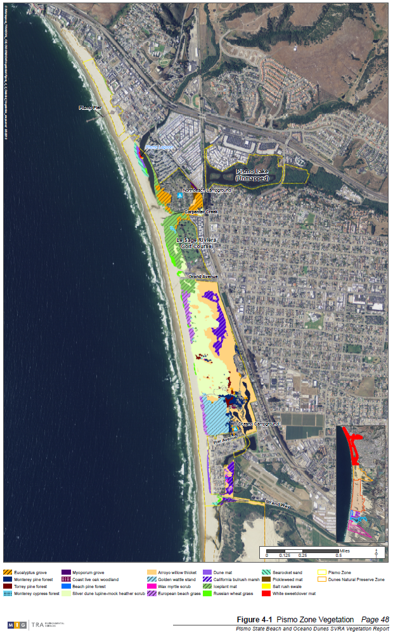
Figure 4-2. Dunes Preserve Zone Vegetation
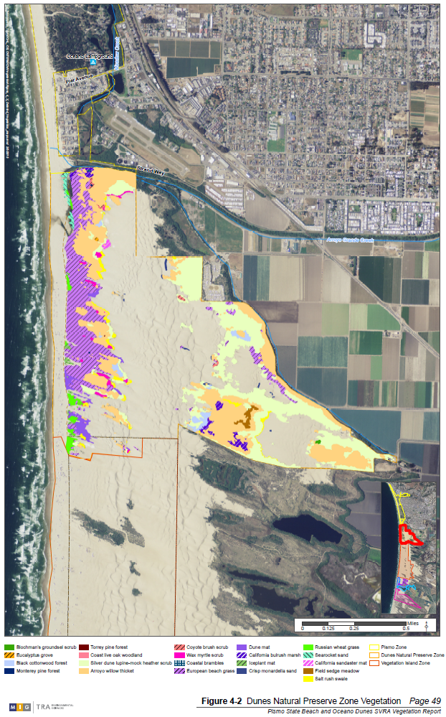
Figure 4-3. Vegetation Island Zone Vegetation
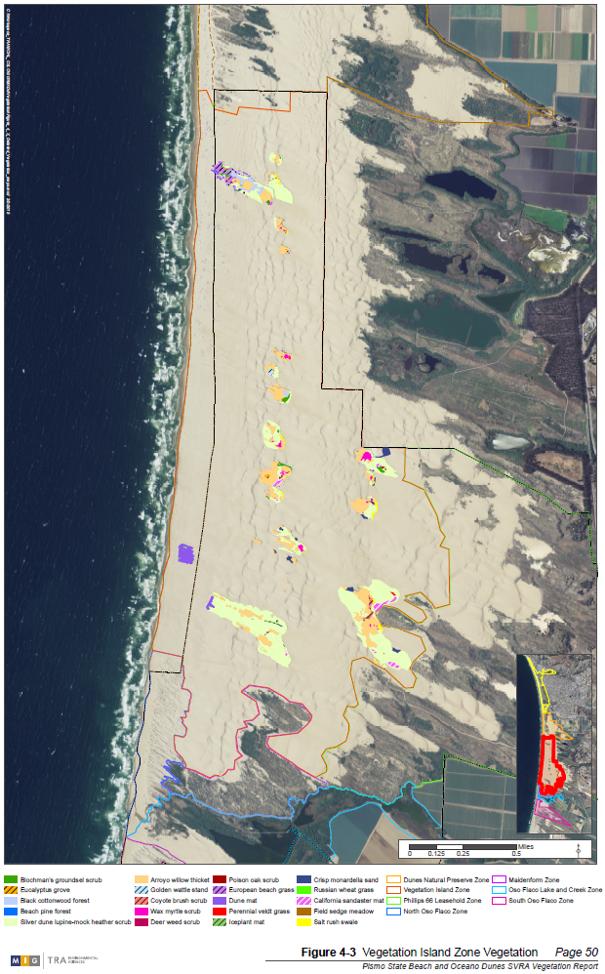
Figure 4-4. Phillips 66 Leasehold Zone Vegetation
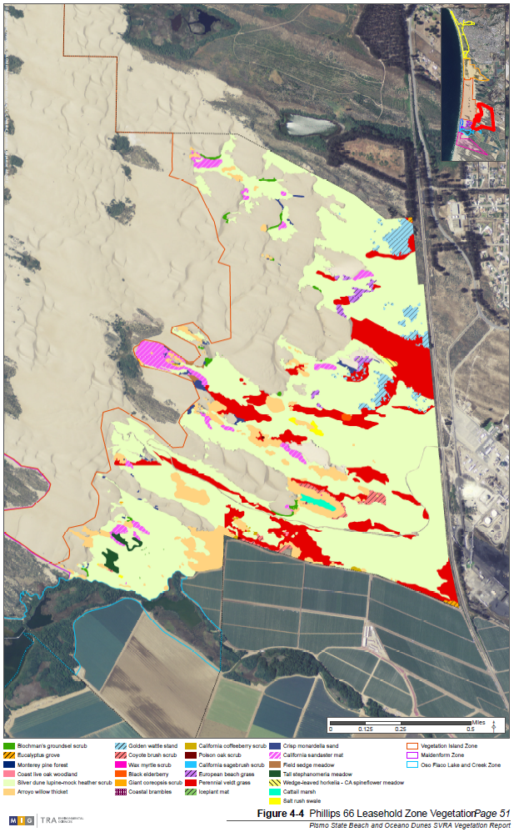
Figure 4-5. North Oso Flaco Zone Vegetation
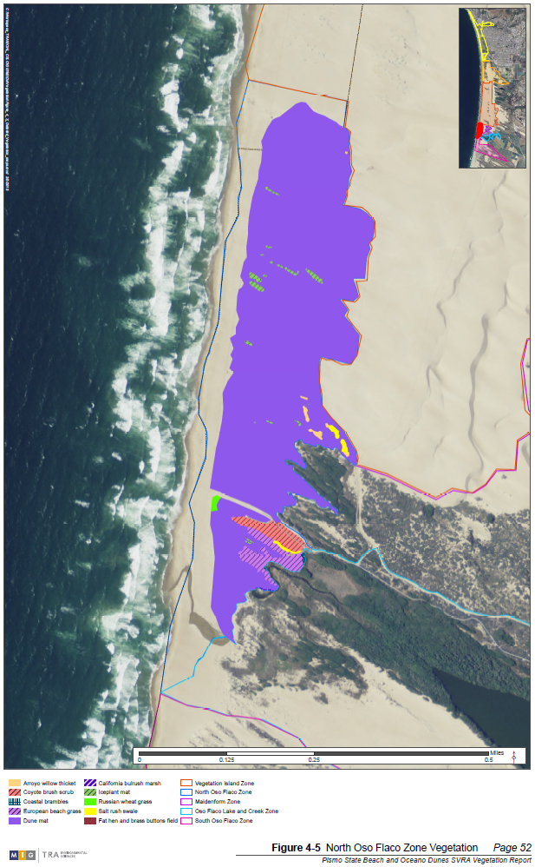
Figure 4-6. Maidenform Zone Vegetation
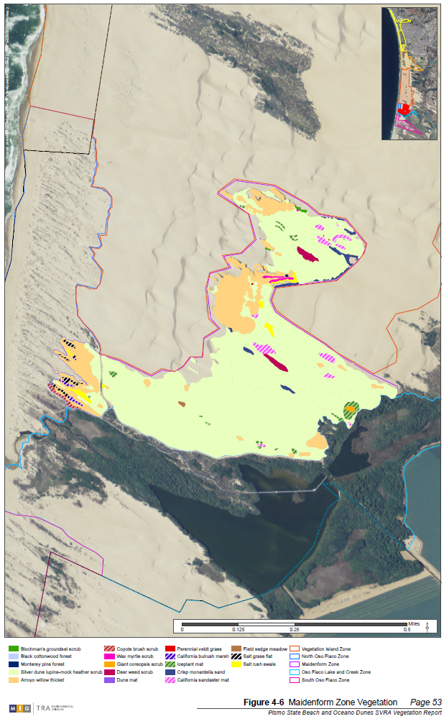
Figure 4-7. Oso Flaco Lake and Creek Zone Vegetation
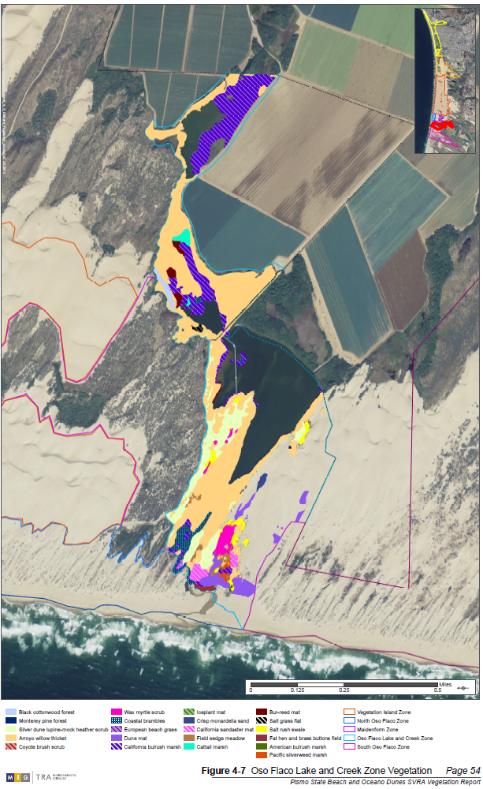
Figure 4-8. South Oso Flaco Zone Vegetation
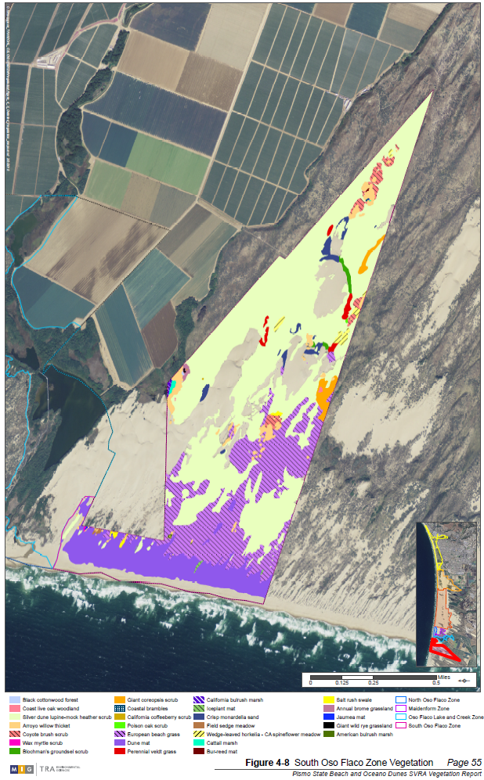

SPECIAL-STATUS PLANTS IN THE STUDY AREA

Twenty-seven special-status plant species are known to occur in the study area, and six more have a moderate to high potential to occur based on habitat present in the area and known occurrences nearby. Each of these species are described in the following sections. See Appendix B, Table B for a complete list of special-status plants with the potential to occur in the study area.

SPECIAL-STATUS PLANTS KNOWN TO OCCUR IN THE STUDY AREA

Twenty-seven special-status plants are known to occur in the study area (Table 5-1). Eighteen of these were observed during the vegetation mapping and two others may have been observed during the mapping (i.e., they were in same location as previously documented occurrences, but were not identified to species). The remaining seven species were not observed during the vegetation mapping, but are known to occur in the study area from past District surveys and/or CNDDB records. Additional rare plant mapping occurred in September 2013 and June 2014 and survey results are discussed below.

Three species observed in the study area, Monterey cypress (CRPR 1B.2), Monterey pine (CRPR 1B.1), and Torrey pine (CRPR 1B.2), are CRPR special-status plants where they naturally occur but are not native to the study area and, thus, are not described below.

Table 5-1. Special-status Plants Observed in the Study Area
Common Name | Scientific Name | Statusª | Pismo Zone | Dunes Preserve Zone | Vegetation Island Zone | Phillips 66 Zone | North Oso Flaco Zone | Maidenform Zone | Oso Flaco Lake & Creek Zone | South Oso Flaco Zone
Marsh sandwort | Arenaria paludicola | FE, SE, CRPR 1B.1 |  |  |  |  |  |  | X
La Graciosa thistle | Cirsium scariosum var. loncholepis | FE, ST, CRPR 1B.1 |  |  |  |  |  |  |  | X
Gambel’s watercress | Nasturtium gambelii | FE, ST, CRPR 1B.1 |  |  |  |  |  |  | X
Beach spectaclepod | Dithyria maritima | ST, CRPR 1B.1 |  |  |  |  | X
Nipomo Mesa lupine | Lupinus nipomensis | ST, CRPR 1B.1 |  |  |  | X
Surf thistle | Cirsium rhothophilum | ST, CRPR 1B.2 |  |  |  |  |  |  | X | X
Kellogg’s horkelia | Horkelia cuneata var. sericea | CRPR 1B.1 |  | X |  | X
Sand mesa manzanita | Arctostaphylos rudis | CRPR 1B.2 |  |  |  | X
Coastal goosefoot | Chenopodium littoreum | CRPR 1B.2 |  |  |  | X
Dune larkspur | Delphinium parryi ssp. Blochmaniae | CRPR 1B.2 |  |  |  |  |  |  |  | X
Blochman’s leafy daisy | Erigeron blochmaniae | CRPR 1B.2 | X | X | X | X | X | X | X | X
Crisp monardella | Monardella undulata ssp. crispa | CRPR 1B.2 | X | X | X | X |  | X | X | X
San Luis Obispo monardella | Monardella undulata ssp. undulata | CRPR 1B.2 |  | X |  | X |  |  |  | X
Red sand verbena | Abronia maritima | CRPR 4.2 | X | X | X |  | X |  | X
Nuttall’s milkvetch | Astragalus nuttallii var. nuttallii | CRPR 4.2 | X | X |  | X | X | X | X | X
Paniculate tarplant | Deinandra paniculata | CRPR 4.2 |  |  |  | X
Suffrutescent wall flower | Erysimum suffrutescens | CRPR 4.2 | X | X | X | X | X | X | X | X
Southwestern spiny rush | Juncus acutus ssp. leopoldii | CRPR 4.2 |  | X | X
Fuzzy prickly phlox | Linanthus californicus | CRPR 4.2 | X | X |  | X |  |  |  | X
California spineflower | Mucronea californica | CRPR 4.2 |  | X |  | X |  |  |  | X
Short-lobed broomrape | Orobanche parishii ssp. brachyloba | CRPR 4.2 |  |  |  |  |  |  |  | X
Hickman’s popcorn flower | Plagiobothrys chorisianus var. hickmanii | CRPR 4.2 |  |  | X | X |  | X
Blochman’s groundsel | Senecio blochmaniae | CRPR 4.2 | X | X | X | X | X | X | X | X
Monterey Coast paintbrush | Castilleja latifolia | CRPR 4.3 | X | X | X | X |  | X | X | X
Douglas’ spineflower | Chorizanthe douglasii | CRPR 4.3 |  |  | X
Dunedelion | Malacothrix incana | CRPR 4.3 |  |  | X |  | X |  | X
Sand almond | Prunus fasciculata var. punctata | CRPR 4.3 |  |  |  | X
ªStatus explanations:
Federal:
FE = Listed as endangered under the Federal Endangered Species Act.
FT = Listed as threatened under the Federal Endangered Species Act.
State:
SE = Listed as endangered under the California Endangered Species Act.
ST = Listed as threatened under the California Endangered Species Act.
California Rare Plant Rank:
1B = Plants Rare, Threatened, or Endangered in California and Elsewhere
2 = Plants Rare, Threatened, or Endangered in California, But More Common Elsewhere
4 = Watch List
0.1-Seriously threatened in California
0.2-Fairly threatened in California
0.3- Not very threatened in California

MARSH SANDWORT

Marsh sandwort is a perennial herb in the pink family (Caryophyllaceae). It has rooting, trailing stems and small white flowers which bloom from May through August. It can also reproduce asexually by producing adventitious roots on the trailing stems that establish new plants under suitable conditions. Historically, this species occurred in swamps, marshes, and other wet areas in widely disjunct localities in California and Washington. It occurred in four counties in the coastal region of Washington, as well as in San Francisco, Santa Cruz, San Luis Obispo, and San Bernardino counties in California (U.S. Fish and Wildlife Service [USFWS] 1998).

Since marsh sandwort was federally listed, a natural population was rediscovered at Oso Flaco Lake in 1998 (USFWS 1998). This site is now the only known extant, wild population. This population has been in decline with 85 individuals reported in 1998 and only 25 individuals reported in 2005 (USFWS 2008). There also was a recorded decline in habitat quantity and quality at this location since the population was discovered in 1998. The vegetation has become thicker, denser, and more overgrown, consistent with nutrient loading from agricultural operations upstream of the lake (USFWS 2008).

Marsh sandwort was not observed during the vegetation mapping, but was previously documented at Oso Flaco Lake as described above. A survey for this plant was attempted in 2013; however, presence of the plant could not be confirmed due to problems with accessibility. However, it was determined that habitat, including the Carex mat microhabitat used by this species, is still present in locations where marsh sandwort was observed to occur in the past.

LA GRACIOSA THISTLE

La Graciosa thistle is a bushy biennial or short-lived, perennial herb with large, smooth to slightly hairy leaves and clustered heads of white flowers. It is a spreading, mound-like or erect plant in the sunflower family (Asteraceae) that is well armored with spines on the leaves and flower heads. This species is known from coastal San Luis Obispo and Santa Barbara counties from Pismo Beach south to Los Alamos. La Graciosa thistle is associated with mesic areas on the margins of dune swales, dune lakes, marshes, estuaries, coastal meadows, seeps, springs, intermittent streams, creeks, and rivers. This species thrives on sandy soils and is pollinated by hummingbirds and insects (USFWS 2000).

The USFWS designated 41,089 acres as critical habitat for La Graciosa thistle in March 2004 (USFWS 2004). USFWS revised its designation of critical habitat for La Graciosa thistle in 2009 (USFWS 2012). The revised critical habitat designates approximately 24,103 acres of habitat in San Luis Obispo and Santa Barbara counties as critical habitat. The critical habitat is divided into six units. The Callender-Guadalupe Dunes unit is the second largest (9,696 acres) and includes the District. This unit extends along 8.5 miles of coast from Arroyo Grande Creek south to the Santa Maria River. Since federal listing in 2000, populations of this species have severely declined. At the time of listing there were eleven extant occurrences distributed among seven populations. Currently, La Graciosa thistle is considered to be extant at seven occurrences that are distributed among four populations (USFWS 2000).

An unidentified species of thistle (Cirsium sp.) was observed during the vegetation mapping in the South Oso Flaco Zone, at a location where La Graciosa thistle had been previously recorded. A subsequent visit in 2013 confirmed the presence of La Graciosa thistle in South Oso Flaco at Surprise Lake (Skinner pers. comm. 2014). This species had been previously recorded in the Phillips 66 Leasehold Zone and in the fore- and backdunes of the South Oso Flaco Zone (CNDDB 2013).

GAMBEL’S WATER CRESS

Gambel's water cress is an herbaceous perennial in the mustard family (Brassicaceae). This species characteristically roots from the stem, which bears scattered compound leaves and dense clusters of white flowers. Gambel's water cress is found in freshwater or brackish marsh habitats at the margins of lakes and along slow-flowing streams. It grows in or just above the water level and requires a permanent source of water (CNPS 2013).

Gambel’s water cress was listed as threatened by California in 1990 and endangered by the USFWS in 1993. At the time of federal listing, there were three known populations of Gambel’s water cress, all in San Luis Obispo County. Each of these three populations is now considered extirpated. Hybridization and subsequent genetic introgression with the closely related white or common water cress (Nasturtium officinale), habitat loss and degradation, biostimulation, sedimentation, encroachment of non-native eucalyptus trees, and drilling of water wells in the immediate watershed are serious threats to Gambel’s water cress (CNDDB 2013). All three populations that were discussed in the final listing rule in 1993 (Black Lake Canyon, Oso Flaco Lake, and Little Oso Flaco Lake), are now considered to be “possibly extirpated” (CNDDB 2013), as all individuals appear to show introgression with N. officinale (CNDDB 2013). However, it is important to note that while there has been a large change in the vegetation at Oso Flaco Lake due to eutrophication (i.e., artificial or natural addition of substances, such as nitrates and phosphates, to an aquatic system), some suitable habitat still appears to exist there, and it is possible that some pure Gambel’s water cress plants may still occur there.

An unknown water cress species was (Nasturtium sp.) was observed near Oso Flaco Creek during 2012 vegetation mapping; Gambel’s water cress was previously documented near Oso Flaco Creek with the most recent observation in 2005 (CNDDB 2013), although pure stands (not hybridized) may have been extirpated. Gambel’s water cress was confirmed to occur at Oso Flaco Lake in fall 2013 (J. Chestnut, pers. comm.), however it is still threatened by lake eutrophication and hybridization.

BEACH SPECTACLEPOD

Beach spectaclepod is a low growing, whitish-flowered perennial herb in the mustard (Brassicaceae) family. It is found in small transverse foredunes within approximately 10-170 feet from the surf. Beach spectaclepod is usually found in areas of these fragile dunes where the sand is relatively unstable. Historically occurring as far south as Los Angeles County and possibly Baja California Norte, Mexico, this species currently occurs in the dunes of San Luis Obispo and Santa Barbara counties and on San Nicholas and San Miguel islands. Several populations are found on Unocal’s property in the Guadalupe Dunes just north of the Santa Maria River (CDFG 2004 and CNPS 2013).

In the study area, beach spectaclepod was observed in the North Oso Flaco Zone in the 2012 vegetation survey and in the North Oso Flaco Zone and the South Oso Flaco Zone in the 2013 and 2014 rare plant surveys.

NIPOMO MESA LUPINE

Nipomo Mesa lupine is a low-growing, blue-flowered, annual herb in the pea family (Fabaceae). Nipomo Mesa lupine requires fine-grained, sandy soils of open sites or sparsely vegetated, stabilized dune communities close to the coast. Nipomo Mesa lupine is restricted to dry sandy flats of stabilized coastal dunes that lie west of Nipomo Mesa in San Luis Obispo County. There is no recovery plan or designated critical habitat for this species (USFWS 2000).

In the study area, Nipomo Mesa lupine was only observed in the eastern part of the Phillips 66 Leasehold Zone. It has been documented in the Phillips 66 Leasehold Zone in annual surveys conducted by the Land Conservancy of San Luis Obispo County (Daniel Bohlman, pers. comm. 2013).

SURF THISTLE

Surf thistle is a low-growing, short-lived perennial in the sunflower family (Asteraceae) with white flowers in dense heads. It is characterized by large rosettes of spiny, white-woolly, deeply lobed, and undulating leaves. The deep roots and white-woolly foliage are adaptations to the physical stresses of the dune habitat, such as high light intensity and sand movement and abrasion. Flowering occurs between April and June and occurs only in the narrow strip of coastal habitat between stabilized dunes and windblown beach. Surf thistle is endemic to the dunes of the central California coast, from the Nipomo Dunes of southern San Luis Obispo County to Point Conception in Santa Barbara County. It grows in coastal foredunes on the slopes of transverse ridges in areas of active sand accumulation. At the southern extreme of its range it is found in sand at the bases or tops of cliffs (CDFG 2004).

In the study area, surf thistle was observed near Oso Flaco Creek in the Oso Flaco Lake and Creek Zone and in the foredunes of the South Oso Flaco Zone during the 2012 vegetation survey and the 2013 and 2014 rare plant surveys. From previous surveys, it is also known to occur in the North Oso Flaco Zone (CDPR 2008).

KELLOGG’S HORKELIA

Kellogg’s horkelia is a perennial herb that blooms from April through September. It has white flowers and is in the rose family (Rosaceae). It occurs in closed-cone coniferous forest, maritime chaparral, coastal dunes, and coastal scrub on sandy or gravelly openings from 30-650 feet. It is endemic to California and is possibly threatened by coastal development (CNPS 2013).

Kellogg’s horkelia was not observed during the vegetation mapping, but has been documented in the Dunes Preserve Zone and in the Phillips 66 Leasehold Zone by previous District surveys (CDPR 2012), and in the Phillips 66 Leasehold Zone by CNDDB records with the most recent observation in 1998 (CNDDB 2013).

SAND MESA MANZANITA

Sand mesa manzanita (Arctostaphylos rudis) is a perennial evergreen shrub in the heath family (Ericaceae) that blooms from November through February. It occurs in maritime chaparral and coastal scrub on sandy soils from 80-1,050 feet. It is endemic to San Luis Obispo and Santa Barbara counties and is threatened by agriculture, road construction, road maintenance, and oil extraction. It has been severely reduced on Nipomo Mesa (CNPS 2013).

Sand mesa manzanita is not known in the study area from CNDDB records, but has been observed previously by District staff (Glick 2013). The closest CNDDB record to the study area is approximately 1.5 miles east at Nipomo Mesa (CNDDB 2013).

COASTAL GOOSEFOOT

Coastal goosefoot is an annual herb in the goosefoot family (Chenopodiaceae) that blooms from April through August. It occurs on sand dunes from 30-100 feet. It is endemic to Los Angeles, Santa Barbara, and San Luis Obispo counties and is known from fewer than 20 occurrences. It is possibly threatened by recreational activities, vehicles, and non-native plants (CNPS 2013).

In the study area, coastal goosefoot was only observed in the southern part of the Phillips 66 Leasehold Zone. It is also known from Oso Flaco Lake based on CNDDB records (CNDDB 2013).

DUNE LARKSPUR

Dune larkspur (Delphinium parryi ssp. Blochmaniae) is a perennial herb in the buttercup family (Ranunculaceae) that has purple and white or blue and white flowers and blooms from April through May. It occurs in maritime chaparral and on coastal dunes from 0-650 feet. It is endemic to California and is threatened by development (CNPS 2013).

Dune larkspur was not observed during vegetation mapping, but was previously documented in the Phillips 66 Leasehold Zone and at south Oso Flaco Lake in 1998 (CNDDB 2013). From 1998-2011, District staff has observed dune larkspur almost every year within the Phillips 66 Leasehold Zone property and at South Oso Flaco where it has been present near Beigle Road.

BLOCHMAN’S LEAFY DAISY

Blochman’s leafy daisy is a perennial rhizomatus herb that blooms from June through August. It is in the sunflower family (Asteraceae) and has light purple flowers. It occurs on coastal dunes and in coastal scrub from 10-150 feet. It is endemic to Santa Barbara and San Luis Obispo counties and is threatened by development, non-native plants, and vehicles (CNPS 2013).

Blochman’s leafy daisy is locally common and widespread in the study area, and occurs in all of the vegetation zones in the area. It was previously documented in the area by District surveys (CDPR 2012) and CNDDB records with the most recent observation in 2002 in the vicinity of Oso Flaco Lake (CNDDB 2013).

CRISP MONARDELLA

Crisp monardella is a perennial rhizomatus herb that blooms from April through August. It has purple flowers and is in the mint family (Lamiaceae). It occurs in coastal dunes and sandy scrub from 30-400 feet. It is endemic to Santa Barbara and San Luis Obispo counties and is threatened by vehicles (CNPS 2013).

Crisp monardella is locally common and widespread in the study area, and was observed at the sandy edges of other vegetation in all of the vegetation zones except North Oso Flaco. Crisp monardella is the dominant species in the crisp monardella sands herbaceous alliance. It has been documented in the study area during previous District surveys (CDPR 2012) and in CNDDB records with the most recent observation in 1998 (CNDDB 2013).

SAN LUIS OBISPO MONARDELLA

San Luis Obispo monardella is a perennial rhizomatus herb that blooms from May through September. It has purple flowers and is in the mint family (Lamiaceae). It occurs in coastal dunes and sandy coastal scrub from 30-650 feet. It is endemic to Santa Barbara and San Luis Obispo counties and is threatened by coastal development, vehicles, and potentially non-native plants (CNPS 2013).

In the study area, San Luis Obispo monardella was observed in the Dunes Preserve Zone, in the southern part of the Phillips 66 Leasehold Zone, and in the southern backdunes of the South Oso Flaco Zone. It has also been documented in the Dunes Preserve, near Oso Flaco Lake and the South Oso Flaco Zone with the most recent observation in 1998 (CNDDB 2013).

RED SAND VERBENA

Red sand verbena is a perennial herb in the four o’clock family (Nyctaginaceae) that blooms from February through November. It occurs on coastal dunes from 0-330 feet. It is nearly extirpated in southern California (CNPS 2013).

Red sand verbena was observed in the study area near Strand Way and the interpretive trail in the Pismo Zone, in the western portion of the Dunes Preserve Zone, on Pavilion Hill, Tabletop, and Worm Valley vegetation islands in the Vegetation Island Zone, in the North Oso Flaco Zone, and near Oso Flaco Creek in the Oso Flaco Lake and Creek Zone. It was previously known from the study area from District surveys (CDPR 2012).

NUTTALL’S MILKVETCH

Nuttall’s milkvetch is a perennial herb in the pea family (Fabaceae) that blooms from January through November. It occurs in coastal bluff scrub and coastal dunes from 10-400 feet. It is endemic to California and is possibly threatened by foot traffic (CNPS 2013).

Nuttall’s milkvetch was observed in the study area in the Dunes Preserve Zone, at Boyscout Camp, Worm Valley, Caterpillar Hill, and Eucalyptus Tree vegetation islands in the Vegetation Island Zone, in the south end of the Phillips 66 Leasehold Zone, in the North Oso Flaco Zone, in the northern part of the Maidenform Zone, in the Oso Flaco Lake and Creek Zone, and in the southwest of the South Oso Flaco Zone. It was previously known from the study area from District surveys (CDPR 2012).

PANICULATE TARPLANT

Paniculate tarplant is an annual herb in the sunflower family (Asteraceae) that blooms from April through November. It occurs in coastal scrub, valley and foothill grassland, and vernal pools, usually on vernally mesic and sometimes on sandy sites, from 80-3,080 feet. It is threatened by development and potentially by road widening. Some historical occurrences have been extirpated by urbanization (CNPS 2013).

In the study area, paniculate tarplant was only observed in the southern part of the Phillips 66 Leasehold Zone. There were no previous records of this species from the study area.

SUFFRUTESCENT WALLFLOWER

Suffrutescent wallflower is a perennial herb in the mustard family (Brassicaceae) that blooms from January through July. It occurs in coastal bluff scrub, maritime chaparral, coastal dunes, and coastal scrub from 0-500 feet. It is endemic to the southern California coast and is threatened by coastal development, vehicles, and non-native plants (CNPS 2013).

Suffrutescent wallflower is locally common and widespread in the study area, and occurs in all the vegetation zones in the area. It was documented in the area by previous District surveys (CDPR 2012).

SOUTHWESTERN SPINY RUSH

Southwestern spiny rush is a perennial rhizomatous herb in the rush family (Juncaceae) that blooms from March through June. It occurs in coastal dunes (mesic), meadows and seeps (alkaline seeps) and in marshes and swamps (coastal salt) from 10-3,000 feet. It is threatened by urbanization and flood control projects (CNPS 2013).

Southwestern spiny rush was not observed during the vegetation mapping, but has been documented in the Dunes Preserve Zone and at the Eucalyptus Tree vegetation island in the Vegetation Island Zone by previous District surveys (CDPR 2012).

FUZZY PRICKLY PHLOX

Fuzzy prickly phlox is a perennial deciduous shrub in the phlox family (Polemoniaceae) that blooms from March through August. It occurs on coastal dunes from 3-100 feet. It is endemic to Santa Barbara and San Luis Obispo counties (CNPS 2013).

In the study area, fuzzy prickly phlox was observed in the Dunes Preserve Zone, the southern part of the Phillips 66 Leasehold Zone, and in the backdunes of the South Oso Flaco Zone. It has been documented in the past in the Phillips 66 Leasehold Zone during District surveys (CDPR 2012).

CALIFORNIA SPINE FLOWER

California spine flower is an annual herb in the buckwheat family (Polygonaceae) that blooms from March through August. It occurs in chaparral, cismontane woodland, coastal dunes, coastal scrub, and valley and foothill grassland from 0-4,600 feet. It is endemic to California and is threatened by aggregate mining, vehicles, flood control modification, urbanization, water percolation projects, and possibly by non-native plants (CNPS 2013).

In the study area, California spine flower was observed in the Dunes Preserve Zone, in the Phillips 66 Leasehold Zone, and in the South Oso Flaco Zone. California spine flower is a co-dominant species in the wedge-leaved horkelia-California spine flower herbaceous alliance. It was not previously known to occur in the study area.

SHORT-LOBED BROOMRAPE

Short-lobed broomrape is a perennial parasitic herb in the broom-rape family (Orobanchaceae) that blooms from April through October. It occurs in coastal bluff scrub, coastal dunes and coastal scrub from 10-1,000 feet. It is parasitic to shrubs (CNPS 2013).

Short-lobed broomrape was not observed during the vegetation mapping, but was seen near in the South Oso Flaco Zone by Mark Skinner in 2013. It was also previously documented in the South Oso Flaco Zone in 1967 (CNDDB 2013).

HICKMAN’S POPCORN FLOWER

Hickman’s popcorn flower is an annual herb in the borage family (Boraginaceae) that blooms from April through June. It occurs in closed-cone coniferous forest, chaparral, coastal scrub, marshes and swamps, and vernal pools from 50-280 feet. It is endemic to California (CNPS 2013).

Hickman’s popcorn flower was not observed during the vegetation mapping, but was previously documented in four vegetation islands in the Vegetation Island Zone, in the Phillips 66 Leasehold Zone, and in the Maidenform Zone from previous District surveys (CDPR 2012).

BLOCHMAN’S GROUNDSEL

Blochman’s groundsel is a perennial herb in the sunflower family (Asteraceae) that blooms from May through October. It occurs on coastal dunes from 0-330 feet. It is endemic to Santa Barbara and San Luis Obispo counties and is threatened by non-native plants, development, and vehicles (CNPS 2013).

Blochman’s groundsel is locally common and widespread in the study area, and occurs in all of the vegetation zones. Blochman’s groundsel is the dominant species in the Blochman’s groundsel scrub herbaceous alliance. It has been documented to occur in the area in previous District surveys (CDPR 2012).

MONTEREY COAST PAINTBRUSH

Monterey Coast paintbrush is an annual herb in the broomrape family (Orobanchaceae) that blooms from March through May. It occurs in meadows and seeps and in valley and foothill grasslands, sometimes on serpentine soils, from 30-1,300 feet. It is endemic to California and is threatened by development and grazing (CNPS 2013).

Monterey Coast paintbrush is widespread in the study area. It was observed near the interpretive trail and Carpenter Creek in the Pismo Zone, in the Dunes Preserve Zone, throughout the Phillips 66 Leasehold Zone, at six of the vegetation islands in the Vegetation Island Zone, in the Maidenform Zone, near Oso Flaco Creek in the Oso Flaco Lake and Creek Zone, and in the eastern part of the South Oso Flaco Zone. This species is also known from previous District surveys (CDPR 2012).

DOUGLAS’ SPINEFLOWER

Douglas’ spine flower (Chorizanthe douglasii) is an annual herb in the buckwheat family (Polygonaceae) that blooms from April through July. It occurs in chaparral, cismontane woodland, coastal scrub and lower montane coniferous forest on sandy or gravelly soils from 180-5,250 feet. It is endemic to Monterey, San Benito, and San Luis Obispo counties (CNPS 2013).

Douglas’ spineflower was not observed in the study area during the vegetation mapping, but was previously documented at the Pavilion Hill vegetation island in the Vegetation Island Zone during a District survey (CDPR 2012).

DUNEDELION

Dunedelion is a perennial herb in the sunflower family (Asteraceae) that blooms from January through October. It occurs on coastal dunes and in coastal scrub from 10-115 feet. It is endemic to California (CNPS 2013).

In the study area, dunedelion was observed at the Pavilion Hill vegetation island and the 7.5 Revegetation Area in the Vegetation Island Zone, in the North Oso Flaco Zone, and near Oso Flaco Creek in the Oso Flaco Lake and Creek Zone. It has been documented near Oso Flaco Creek in previous District surveys (CDPR 2012).

SAND ALMOND

Sand almond is a perennial deciduous shrub in the rose family (Rosaceae) that blooms from March through April. It occurs in maritime chaparral, cismontane woodland, coastal dunes, and coastal scrub on sandy soils from 50-650 feet. It is endemic to Santa Barbara and San Luis Obispo counties (CNPS 2013).

In the study area, sand almond was only observed in the southern part of the Phillips 66 Leasehold Zone. It has been previously documented in the Phillips 66 Leasehold Zone during District surveys (CDPR 2012).

SPECIAL-STATUS PLANTS WITH THE POTENTIAL TO OCCUR IN THE STUDY AREA

This section describes the special-status plant species known to occur in the region but that have not been documented in the study area. These were assessed for their potential to occur in the study area, based on proximity and habitat availability. The assessment determined whether each species had a high, moderate, or low potential to occur in the study area based on the following criteria:

- High: The CNDDB or other reputable documents record the occurrence of the species off-site, but within a 5-mile radius of the study area and within the last 10 years. High-quality suitable habitat is present within the study area.
- Moderate: The CNDDB or other reputable documents may record the occurrence of the species near but beyond a 5-mile radius of the study area, or some of the components representing suitable habitat are present within or adjacent to the study area, but the habitat is substantially degraded or fragmented.
- Low: The CNDDB or other documents may or may not record the occurrence of the species within a 5-mile radius of the study area. However, few components of suitable habitat are present within or adjacent to the study area.

Based upon the criteria above, there are four special-status plant species with a moderate or high potential to occur in the study area. These species are described in more detail below. Those with a low potential to occur in the study area are included in Table B in Appendix B, but are not described further below. Special-status plant species in the region that have no potential to occur in the study area because the area is outside of the species’ geographic or elevation range or because there is no suitable habitat for the species in the area, were excluded from the Table B in Appendix B.

CALIFORNIA SAWGRASS

California sawgrass (Cladium californicum) is a perennial rhizomatus herb in the sedge family (Cyperaceae) that blooms from June through September. It occurs in meadows and seeps, or in alkaline or freshwater marshes and swamps, from 200-1,970 feet. It is known from fewer than 20 occurrences and is potentially threatened by land use management (CNPS 2013).

California saw-grass has a high potential to occur in the Oso Flaco Lake and Creek Zone in the study area based on the presence of suitable habitat and a nearby record from the 1990s (CNDDB 2013).

BRANCHING BEACH ASTER

Branching beach aster (Corethrogyne leucophylla) is a perennial herb in the sunflower family (Asteraceae) family that blooms from May through December. It occurs in closed-cone coniferous forest and coastal dunes from 10-200 feet. It is endemic to California (CNPS 2013).

Branching beach aster has a moderate potential to occur throughout the study area based on the presence of suitable habitat, although there are no records of this species in the vicinity of the study area (CNDDB 2013).

COAST WOOLLY-HEADS

Coast woolly-heads (Nemacaulis denudate var. denudate) is an annual herb in the buckwheat family (Polygonaceae) family that blooms from April through September. It occurs on coastal dunes from 0-330 feet. Populations have been much reduced by coastal development (CNPS 2013).

Coast woolly-heads has a moderate potential to occur throughout the study area based on the presence of suitable habitat, although there are no records of this species in the vicinity of the study area (CNDDB 2013).

SAN BERNARDINO ASTER

San Bernardino aster (Symphyotrichum defoliatum) is a perennial rhizomatus herb in the sunflower (Asteraceae) family that blooms from July through November. It occurs near ditches, streams and springs in cismontane woodland, coastal scrub, lower montane coniferous forest, meadows and seeps, marshes and swamps, and vernally mesic valley and foothill grassland from 10-6,700 feet. It is endemic to California (CNPS 2013).

San Bernardino aster has a moderate potential to occur in the study area based on limited suitable habitat and nearby records from 1993 (0.5 mile east of the Dunes Preserve, CNDDB 2013).

REPORT PREPARERS AND REFERENCES

REPORT PREPARERS

OCEANO DUNES DISTRICT STAFF

Stephanie Little, Environmental Scientist
Mark Skinner, Environmental Services Intern and Botanist
Ben Wagner, Environmental Services Intern and Botanist
Tamar Carmona, GIS Specialist

MIG|TRA ENVIRONMENTAL SCIENCES, INC.

Taylor Peterson, Senior Project Manager
Megan Kalyankar, Biologist/Analyst
Sarah Daniels, Biologist/GIS Analyst
Sara Jones, Senior Biologist/GIS Analyst
Susan Schwarz, Biologist/GIS Analyst

WOOD BIOLOGICAL CONSULTING, INC.

Michael Wood, Botanist

INDEPENDENT CONSULTANT

Lech Naumovich, Botanist

REFERENCES

REFERENCES

Baldwin, Bruce, G., Douglas H. Goldman, David J. Keil, Robert Patterson, Thomas J. Rosatti, and Dieter H. Wilken. 2012. The Jepson Manual, Vascular Plants of California, Second Edition. University of California Press, Berkeley, 1568 pages.
California Department of Fish and Game (CDFG). 2004. Species Accounts–Plants. Available at: http://www.dfg.ca.gov/wildlife/nongame/t_e_spp/docs/2004/t_eplants.pdf. Accessed May 2013.
California Department of Parks and Recreation (CDPR). 2012. Habitat Monitoring Report (In Progress). Oceano Dunes State Vehicular Recreation Area 2004-2011. Prepared by California Department of Parks and Recreation Off-highway Motor Vehicle Division, Oceano Dunes District. April.
________. 2008. Rare Plant Surveys for Covered Species under the proposed Oceano Dunes Habitat Conservation Plan (data only, no written report).
Calflora. 2013. Information on California plants for education, research and conservation, based on data contributed by dozens of public and private institutions and individuals, including the Consortium of Calif. Herbaria. Berkeley, California: The Calflora Database. Available: http://www.calflora.org/. Accessed May 2013.
California Invasive Plant Council (Cal-IPC). 2013a. Invasive Plant Definitions. http://www.cal-ipc.org/ip/definitions/index.php. Accessed May 8, 2013.
________. 2013b. California Invasive Plant Inventory Database. http://www.cal-ipc.org/paf/. Accessed May 8, 2013.
________. 2006. California Invasive Plant Inventory, Table 2: Species Native to Part of California, but Invasive in Other Parts of the State. http://www.cal-ipc.org/ip/inventory/pdf/Inventory2006.pdf. Accessed May 8, 2013.
California Native Plant Society (CNPS). 2013. Inventory of Rare and Endangered Plants (online edition, v8-01a). California Native Plant Society. Sacramento, CA. http://www.rareplants.cnps.org/. Accessed May 2013.
California Natural Diversity Database (CNDDB). 2013. California Department of Fish and Game, Biogeographic Data Branch. Last updated May, 2013.
Coastal San Luis Resource Conservation District (CSLRCD). 2013. Oso Flaco Lake Watershed. http://www.coastalrcd.org/watershed_osoflaco_lake.php. Accessed May 22, 2013.
Gucker, Corey L. 2009. Melilotus alba, M. officinalis. In: Fire Effects Information System. U.S. Department of Agriculture, Forest Service, Rocky Mountain Research Station, Fire Sciences Laboratory (Producer).http://www.fs.fed.us/database/feis/. Accessed May 7, 2013.
National Oceanic and Atmospheric Administration (NOAA) Coastal Services Center. 2011. Coastal California Digital Imagery. Retrieved August 2012 from NOAA Coastal Services Center’s Digital Coast Data Access Viewer.
Rischbieter, D. 2009. Lower Arroyo Grande Creek and Lagoon Fishery and Aquatic Resources Summary 2008 Monitoring Report. Oceano Dunes State Vehicular Recreation Area Pismo Dunes State Reserve. California Department of Parks and Recreation, Central Valley District, Columbia, CA.
________. 2008. Lower Arroyo Grande Creek and Lagoon Fishery and Aquatic Resources Summary 2007 Monitoring Report. Oceano Dunes State Vehicular Recreation Area Pismo Dunes State Reserve. California Department of Parks and Recreation, Central Valley District, Columbia, CA.
Sawyer, John O., Todd Keeler-Wolf, and Julie Evens. 2009. A Manual of California Vegetation, Second Edition. California Native Plant Society in collaboration with California Department of Fish and Game, Sacramento.
State Water Resources Control Board. 2010. 2010 Integrated Report (Clean Water Act Section 303(d) List / 305(b) Report. http://www.waterboards.ca.gov/water_issues/programs/tmdl/integrated2010.shtml. Accessed August 24, 2012.
U.S. Army Corps of Engineers (USACE). 2012. Arid West 2012 Final Regional Wetland Plant List. http://rsgisias.crrel.usace.army.mil/NWPL/doc/plant_lists/Regions/pdf/AW_2012v1.pdf. Accessed May 8, 2013.
U.S. Fish and Wildlife Service (USFWS). 2012. Critical Habitat Portal. Available online at http://criticalhabitat.fws.gov/crithab/.Accessed October, 2012.
________. 2008. Arenaria paludicola (Marsh Sandwort) 5-Year Review: Summary and Evaluation. Ventura Fish and Wildlife Office, Ventura, CA. June. http://ecos.fws.gov/docs/five_year_review/doc1932.pdf. Accessed May 2013.
________. 2004. Endangered and Threatened Wildlife and Plants; Final Designation of Critical Habitat for Cirsium loncholepis (La Graciosa thistle); Final Rule. 69 Fed. Reg. 12553.
________. 2000. Endangered and Threatened Wildlife and Plants; Final Rule for Endangered Status for Four Plants from South Central Coastal California. 65 Fed. Reg. 14888.
________. 1998. Recovery Plan for Marsh Sandwort and Gambel’s Water cress. September 28, 1998.

PERSONAL COMMUNICATIONS

Bohlman, Daniel, Conservation Director, San Luis Obispo County Land Conservancy, April 16, 2013
Chestnut, John, Botanist, Field meeting, September 2013
Little, Stephanie, Environmental Scientist, California Department of Parks and Recreation, Off-highway Motor Vehicle Recreation Division, Oceano Dunes District, September, 2012.
Skinner, Mark, Environmental Services Intern and Botanist, California Department of Parks and Recreation, Off-highway Motor Vehicle Recreation Division, Oceano Dunes District, February, 2014.

APPENDIX A. PLANT SPECIES RECORDED IN THE STUDY AREA

Table A. Plant Species Observed in the Study Area

Scientific Name | Common Name | Pismo Zone | Dunes Preserve Zone | Vegetation Island Zone | Phillips 66 Leasehold Zone | North Oso Flaco Zone | Maidenform Zone | Oso Flaco Lake & Creek Zone | South Oso Flaco Zone
FERNS
AZOLLACEAE | Mosquito Fern Family
Azolla filiculoides | mosquito fern | x |  | x
DENNSTAEDIACEAE | Bracken Family
Pteridium aquilinum | Western brackenfern |  |  |  |  |  |  |  | x
EQUISETACEAE | Horsetail Family
Equisetum hyemale var. affine | common scouring rush | x | x
GYMNOSPERMS
CUPRESSACEAE | Cypress Family
* Callitropsis [Hesperocyparis] macrocarpa | Monterey Cypress | x |  | x
*Juniperus chinensis | Chinese Juniper | x
PINACEAE | Pine Family
*Pinus contorta var. contorta | *shore pine | x |  | x
*Pinus radiata | *Monterey pine | x | x |  | x |  | x | x
*Pinus torreyana ssp. torreyana | *Torrey pine | x | x
MAGNOLIIDS
SAURURACEAE
Anemopsis californica | yerba mansa | x |  |  |  | x
EUDICOTS
ADOXACEAE | Muskroot Family
Sambucus nigra ssp. caerulea | blue elderberry | x |  |  | x |  |  |  | x
AIZOACEAE | Fig-Marigold Family
*Carpobrotus chilensis | sea fig | x | x | x | x | x | x | x | x
*Carpobrotus edulis | freeway iceplant | x | x | x |  | x | x | x | x
*Conicosia pugioniformis | narrow leaved iceplant | x | x | x | x | x | x | x | x
ANACARDIACEAE | Sumac or Cashew Family
Rhus integrifolia | lemonade berry |  |  |  | x
Rhus ovata | sugar bush | x
Toxicodendron diversilobum | poison oak | x | x | x | x | x | x | x | x
APIACEAE | Carrot Family
Apiastrum angustifolium | wild parsley |  |  | x
Berula erecta | water parsnip |  |  |  |  |  |  | x
*Conium maculatum | *poison hemlock |  |  |  | x |  |  | x | x
Daucus pusillus | rattlesnake weed |  |  | x
*Foeniculum vulgare | *fennel | x |  |  |  |  |  |  | x
ARALIACEAE
Hydrocotyle verticillata | whorled marshpennywort |  |  |  |  | x |  | x | x
*Hedera helix | English ivy | x
ASTERACEAE | Sunflower Family
Achillea millefolium | yarrow | x | x | x | x | x | x | x | x
Ambrosia chamissonis | beach bur | x | x | x | x | x | x | x | x
Ambrosia psilostachya | ragweed |  | x |  |  |  |  | x | x
Artemisia californica | California sagebrush | x |  |  | x |  |  | x | x
Artemisia douglasiana | mugwort | x |  |  |  |  |  | x
Artemisia dracunculus | tarragon | x | x |  | x |  |  |  | x
Baccharis glutinosa | saltmarsh baccharis | x |  |  |  |  |  |  | x
Baccharis pilularis | coyote brush | x | x | x | x | x | x | x | x
Baccharis salicifolia | mule fat | x
*Calendula officinalis | *pot marigold | x
*Carduus pycnocephalus | *Italian thistle | x |  |  |  |  |  |  | x
*Centaurea melitensis | *tocalote |  |  |  | x
Cirsium occidentale var. occidentale | cobweb thistle |  | x | x | x |  | x | x | x
Cirsium rhothophilum | surf thistle |  |  |  |  |  |  | x | x
*Cirsium vulgare | *bull thistle |  |  |  | x |  |  | x | x
Coreopsis [Leptosyne] gigantea | giant coreopsis | x |  |  | x |  | x | x | x
Corethrogyne filaginifolia | California sandaster | x | x | x | x | x | x | x | x
*Cotula coronopifolia | *brass buttons |  |  |  |  |  |  | x
Deinandra paniculata | paniculate tarplant |  |  |  | x
Ericameria ericoides | mock heather | x | x | x | x | x | x | x | x
Erigeron canadensis | horseweed | x |  | x |  |  |  |  | x
Erigeron blochmaniae | Blochman’s leafy daisy | x | x | x | x | x | x | x | x
Erigeron glaucus | seaside daisy | x
Eriophyllum staechadifolium | lizard tail | x |  | x | x | x | x | x | x
Gamochaeta purpurea | purple cudweed |  |  |  |  |  |  | x
Hazardia squarrosa | sawtooth goldenbush | x |  |  |  |  |  |  | x
Helenium puberulum | sneezeweed |  |  | x |  |  |  | x
*Helminthotheca echioides | *bristly ox-tongue | x |  |  |  |  |  | x
Heterotheca grandiflora | telegraph weed | x | x | x | x |  | x | x | x
Jaumea carnosa | marsh jaumea |  | x |  | x | x |  | x | x
*Lactuca serriola | *prickly lettuce |  |  | x
Layia hieracioides | tall layia |  |  | x | x
Lessingia pectinata var. pectinata | valley lessingia |  |  |  | x
Logfia filaginoides | California cottonrose |  |  |  |  |  |  |  | x
Malacothrix californica | California dandelion | x | x |  |  |  | x |  | x
Malacothrix incana | dunedelion |  |  | x |  | x |  | x
Pseudognaphalium bioletti | twocolor cudweed |  |  |  |  |  | x | x | x
Pseudognaphalium californicum | ladies' cudweed | x | x | x | x | x | x |  | x
Psuedognaphalium canescens | Wright's cudweed |  |  |  |  |  |  |  | x
*Pseudognaphalium luteoalbum | *Jersey cudweed | x |  | x | x |  | x
Pseudognaphalium ramosissimum | pink cudweed | x | x |  | x | x | x | x | x
Senecio blochmaniae | Blochman’s groundsel | x | x | x | x | x | x | x | x
*Senecio vulgaris | *common groundsel |  |  | x |  |  |  | x
Solidago confinis | Southern goldenrod | x | x | x |  | x | x | x | x
*Sonchus asper | *prickly sow thistle |  |  | x |  |  |  |  | x
*Sonchus oleraceus | *common sow thistle | x |  |  |  |  |  |  | x
Stephanomeria virgata | tall stephanomeria |  |  |  | x |  |  |  | x
Xanthium strumarium | cocklebur | x
BORAGINACEAE | Borage Family
Amsinckia spectabilis var. microcarpa | small fruit seaside fiddleneck |  |  | x | x |  |  |  | x
Cryptantha clevelandii | Cleveland's cryptantha |  |  |  | x |  | x | x | x
Heliotropium curassavicum | heliotrope |  |  |  |  |  |  | x
Phacelia ramosissima | branching phacelia | x | x | x | x | x | x | x | x
Pholisma arenarium | desert pholisma |  |  | x | x |  |  |  | x
Plagiobothrys sp. | popcorn flower |  |  |  | x
BRASSICACEAE | Mustard Family
*Alyssum sp. | *alyssum | x
*Brassica nigra | *black mustard | x |  | x | x |  |  |  | x
*Cakile maritima | *sea rocket | x | x | x |  | x |  | x | x
Descurainia pinnata | tansy mustard |  |  | x
Dithyrea maritima | beach spectaclepod |  |  |  |  | x
Erysimum suffrutescens | suffrutescent wallflower | x | x | x | x | x | x | x | x
Nasturtium sp. | unknown cress | x |  |  |  |  |  | x
*Raphanus sativus | *wild raddish | x
CACTACEAE | Cactus Family
Opuntia sp. | prickly pear |  |  |  |  |  |  |  | x
CAPRIFOLIACEAE | Honeysuckle Family
Lonicera involucrata var. ledebourii | twinberry honeysuckle | x |  |  | x |  |  | x | x
Symphoricarpos mollis | trailing snowberry | x
CARYOPHYLLACEAE | Pink Family
Cardionema ramosissimum | sand Mat |  |  |  | x |  |  |  | x
Silene laciniata var. laciniata | cardinal catchfly | x |  | x | x |  |  | x | x
Spergularia marina | saltmarsh sand spurrey |  |  |  |  |  |  | x
CASUARINACEAE | Sheoak Family
*Casuarina sp. | *unknown sheoak | x
CHENOPODIACEAE | Goosefoot Family
Atriplex leucophylla | beach saltbush |  |  |  |  |  |  |  | x
*Atriplex prostrata | *fat hen |  |  |  |  | x
Chenopodium californicum | California goosefoot |  |  | x | x | x | x | x
Chenopodium littoreum | coastal goosefoot |  |  |  | x
Chenopodium murale | nettleleaf goosefoot |  |  |  |  |  |  | x
Chenopodium sp. | unknown goosefoot | x |  |  |  |  |  |  | x
Sarcocornia [Salicornia] sp. | pickleweed | x
CONVOLVULACEAE | Morning Glory Family
Calystegia soldanella | beach morning glory | x |  |  |  | x |  | x | x
Cuscuta californica | California dodder | x
CORNACEAE | Dogwood Family
Cornus sericea | American dogwood | x
CRASSULACEAE | Stonecrop Family
*Crassula ovata | *jade plant | x
Dudleya lanceolata | Southern California dudleya | x | x | x | x | x | x | x | x
Dudleya pulverulenta | chalk dudleya |  | x
ERICACEAE | Heath Family
Arbutus meziesii | Pacific madrone | x
Arctostaphylos osoensis | oso manzanita | x
Arctostaphylos pilosula | Santa Margarita manzanita | x
Arctostaphylos rudis | sand mesa manzanita | x
EUPHORBIACEAE | Spurge Family
Croton californicus | California croton | x | x | x | x | x | x | x | x
*Ricinus communis | *castor bean | x
FABACEAE | Legume Family
*Acacia longifolia | *golden wattle | x |  | x | x
Acmispon heermannii var. heermannii | Heerman's lotus | x | x | x | x | x |  | x | x
Astragalus nuttallii var. nuttallii | Nuttall's milkvetch |  | x | x | x | x | x | x | x
Lotus scoparius [Acmispon glaber] | deerweed | x | x | x | x | x | x | x | x
Lupinus arboreus | yellow bush lupine | x | x |  | x
Lupinus chamissonis | silver dune lupine | x | x | x | x | x | x | x | x
Lupinus nipomensis | Nipomo Mesa lupine |  |  |  | x
*Melilotus albus | *white sweetclover | x
*Melilotus indicus | *yellow sweetclover |  |  |  |  |  |  | x
FAGACEAE | Oak Family
Notholithocarpus densiflorus var. densiflorus | tan oak | x
Quercus agrifolia | coast live oak | x |  |  | x |  |  |  | x
FRANKENIACEAE | Frankenia Family
Frankenia salina | alkali heath | x | x
GARRYACEAE | Silk Tassel Family
Garrya elliptica | coast silktassel | x
GERANIACEAE | Geranium Family
*Erodium cicutarium | *red stemmed filaree | x
Geranium sp. | unknown geranium | x
GROSSULARIACEAE | Gooseberry Family
Ribes divaricatum var. pubiflorum | straggly gooseberry | x |  | x | x |  | x | x | x
Ribes sanguineum | flowering currant | x
LAMIACEAE | Mint Family
Clinopodium douglasii | yerba buena | x
Monardella undulata ssp. crispa | crisp monardella | x | x | x | x |  | x | x | x
Monardella undulata ssp. undulata | San Luis Obispo monardella |  | x |  | x |  |  |  | x
Salvia apiana | white sage | x
Salvia leucophylla | San Luis purple sage | x
Salvia mellifera | black sage | x |  |  | x |  |  |  | x
Salvia spathacea | hummingbird sage | x
Salvia sp. | chia | x |  |  | x
Stachys bullata | California hedge nettle | x
LAURACEAE | Laurel Family
Umbellularia californica | California bay | x
MALVACEAE | Mallow Family
Fremontodendron californicum | California flannelbush | x
*Malva sp. | unknown mallow | x
MYRICACEAE | Wax Myrtle Family
Morella californica | wax myrtle | x | x | x | x | x | x
MYRTACEAE | Myrtle Family
*Eucalyptus globulus | *blue gum | x |  | x
*Melaleuca viminalis | *bottlebrush | x
*Unknown purple myrtaceae |  | x
NYCTAGINACEAE | Four-O'Clock Family
Abronia latifolia | yellow sand verbena | x | x | x | x | x | x | x | x
Abronia maritima | red sand verbena | x | x | x |  | x |  | x | x
Abronia umbellata | pink sand verbena | x | x | x | x |  |  | x | x
ONAGRACEAE | Evening Primrose Family
Camissoniopsis cheiranthifolia var. cheiranthifolia | beach evening primrose | x | x | x | x | x | x | x | x
Camissoniopsis micrantha | Spencer primrose | x
Camissonia strigulosa | contorted primrose |  |  | x | x |  | x |  | x
Epilobium canum | California fuchsia | x
Epilobium ciliatum var. watsonii | Watson's willowherb |  |  |  |  | x |  | x | x
Oenothera elata var. hookeri | common evening primrose | x | x | x |  | x |  | x
OROBANCHACEAE | Broomrape Family
Castilleja exserta var. exserta | purple owl's clover |  |  |  | x |  |  |  | x
Castilleja latifolia | Monterey Indian paintbrush | x | x | x | x |  | x | x | x
Orobanche fasciculata | fasicled broomrape |  |  | x
PAPAVERACEAE | Poppy Family
Eschscholzia californica | California poppy | x |  |  | x |  |  |  | x
PLANTAGINACEAE | Plantain Family
Penstemon sp. | penstemon |  |  |  | x | x
*Plantago major | *common plaintain | x | x |  |  |  |  | x
*Veronica anagallis-aquatica | water speedwell |  |  |  |  |  |  | x
PLATANACEAE | Sycamore Family
Platanus racemosa | Western Sycamore | x | x
POLEMONIACEAE | Phlox Family
Eriastrum densifolium ssp. densifolium | giant eriastrum |  |  | x |  | x | x
Linanthus californicus | fuzzy prickly phlox |  | x |  | x |  |  |  | x
POLYGONACEAE | Buckwheat Family
Chorizanthe angustifolia | narrow-leaf spineflower |  |  | x | x |  |  |  | x
Eriogonum gracile | slender buckwheat |  |  |  |  | x
Eriogonum parvifolium | seacliff buckwheat | x | x | x | x | x | x | x | x
Mucronea californica | California spineflower |  | x |  | x |  |  |  | x
Persicaria lapathifolia | common knotweed |  |  |  |  |  |  | x
*Polygonum arenastrum | *dooryard knotweed |  |  |  |  |  |  | x
Polygonum sp. | unknown knotweed | x
*Rumex conglomeratus | *clustered dock |  |  |  |  |  |  | x
Rumex salicifolius | willow dock |  |  |  |  |  |  | x
Rumex sp. | unknown dock | x |  |  |  | x
RANUNCULACEAE | Buttercup Family
Clematis ligusticifolia | creek clematis | x |  | x
RHAMNACEAE | Buckthorn Family
Ceanothus impressus var. nipomensis | Nipomo Mesa ceanothus | x
Ceanothus sp. | unknown ceanothus | x
Frangula californica ssp. californica | California coffeeberry | x | x | x | x |  |  | x | x
ROSACEAE | Rose Family
Adenostoma fasciculatum | chamise | x
Cercocarpus betuloides | mountain mahogany | x
Fragaria chiloensis | beach strawberry | x | x |  |  | x |  | x | x
Heteromeles arbutifolia | toyon | x |  |  |  |  |  |  | x
Horkelia cuneata var. cuneata | wedge-leaved horkelia |  |  |  | x |  | x |  | x
Potentilla anserina var. pacifica | Pacific silverweed | x | x |  |  | x |  | x | x
Prunus fasciculata var. punctata | sand almond |  |  |  | x
Prunus ilicifolia | hollyleaf cherry | x |  |  | x
Rosa californica | California wildrose | x
Rubus ursinus | California blackberry | x | x | x | x |  | x | x | x
RUBIACEAE | Coffee Family
Galium aparine | goose grass |  |  | x
Galium porrigens var. porrigens | climbing bedstraw |  |  | x
SALICACEAE | Willow Family
Populus trichocarpa | black cottonwood | x | x | x |  |  | x | x | x
Salix exigua | sandbar willow |  |  |  |  |  |  | x
Salix lasiolepis | arroyo willow | x | x | x | x | x | x | x | x
Salix sitchensis | Sitka willow |  |  | x
SAPINDACEAE | Soapberry Family
Acer negundo | box elder | x
SCROPHULARIACEAE | Figwort Family
Diplacus aurantiacus | orange bush monkeyflower |  | x
*Myoporum laetum | *lollypop tree | x
SOLANACEAE | Nightshade Family
Solanum douglasii | Douglas' nightshade | x | x | x | x |  |  | x | x
URTICACEAE | Nettle Family
Urtica dioica | stinging nettle | x | x | x | x |  |  | x | x
VERBENACEAE | Verbena Family
Verbena lasiostachys var. scabrida | robust vervain | x
MONOCOTS
AGAVACEAE | Agave Family
*Agave americana | *American century plant | x
ARACEAE | Arum Family
Lemna minor | duckweed |  |  |  |  |  |  | x
ARECACEAE | Palm Family
*Phoenix canariensis | *Canary Island date palm | x
*Washingtonia robusta | *Washington fan palm | x
ASPHODELACEAE | Aloe Family
*Aloe maculata | *soap aloe | x
CYPERACEAE | Sedge Family
Bolboschoenus maritimus | alkali bulrush |  |  |  |  | x
Carex pansa | sanddune sedge |  |  |  | x
Carex praegracilis | field sedge | x | x | x | x | x | x | x | x
Carex sp. | unknown sedge | x
Cyperus esculentus | yellow nutgrass | x
Isolepis cernua | low bulrush |  |  |  |  | x |  | x
Schoenoplectus americanus | American bulrush |  |  |  |  |  |  | x | x
Schoenoplectus californicus | California bulrush | x | x | x | x | x |  | x | x
Scirpus microcarpus | panicled bulrush | x
IRIDACEAE | Iris Family
Iris douglasiana | Douglas iris | x
JUNCACEAE | Rush Family
Juncus effusus var. brunneus | bog rush |  |  |  |  |  |  |  | x
Juncus lescurii | dune rush | x | x | x | x | x | x | x | x
Juncus sp. | unknown rush | x
LILIACEAE | Lily Family
*Agapanthus praecox | *African lily | x
POACEAE | Grass Family
*Ammophila arenaria | *European beachgrass | x | x | x | x | x |  | x | x
*Arundo donax | *giant reed | x
*Avena sp. | *wild oats | x
Bromus carinatus var. carinatus | California brome | x |  |  |  |  |  | x
*Bromus diandrus | *ripgut brome |  |  | x | x |  | x | x | x
*Bromus hordeaceus | *soft chess |  |  | x
*Bromus madritensis var. madritensis | *foxtail chess |  |  | x
*Bromus madritensis var. rubens | *red brome |  |  | x | x |  |  | x | x
*Cortaderia jubata | *jubata grass | x | x | x | x | x | x | x | x
*Cynodon dactylon | *Bermuda grass | x
Distichlis spicata | salt grass | x | x |  | x | x |  | x | x
*Ehrharta calycina | *perennial veldt grass | x | x | x | x |  |  | x | x
*Elymus farctus | *Russian wheatgrass | x | x | x
Elymus glaucus | blue wildrye |  |  |  |  |  |  |  | x
Elymus triticoides | beardless wild-Rye |  |  |  |  |  |  | x
Elymus sp. | unknown rye | x
*Festuca bromoides | *brome fescue |  |  |  |  |  |  |  | x
*Festuca myuros | *rattail sixweeks grass |  |  | x
Festuca octoflora | sixweeks grass |  |  | x
*Hordeum murinum | Mediterranean barley | x |  | x
Koeleria macrantha | June grass |  |  |  |  |  |  |  | x
Leymus [Elymus] condensatus | giant wild rye |  |  |  | x |  |  | x | x
Melica imperfecta | California melic |  |  | x | x |  |  |  | x
*Pennisetum clandestinum | *Kikuyu grass | x
*Polypogon monspeliensis | *rabbitsfoot grass |  |  | x |  | x |  | x | x
*Triticum aestivum | wheat |  |  | x
TYPHACEAE | Cattail Family
Sparganium eurycarpum var. eurycarpum | broadfruit bur-Reed |  |  |  |  |  |  | x | x
Typha domingensis | southern cattail |  |  | x
Typha latifolia | broadleaf cattail | x |  |  |  |  | x | x | x
* = Introduced Species
Bold= Special-status Species
 | Total Species
Total Species Documented = | 247 | 155 | 66 | 88 | 90 | 55 | 49 | 94 | 107
Total Non-Native Species = | 65 | 45 | 10 | 24 | 13 | 8 | 7 | 21 | 18
Total Special-status Species= | 21 | 9 | 9 | 7 | 10 | 4 | 5 | 9 | 9

APPENDIX B. SPECIAL-STATUS PLANT TABLE

Table B. Special-status Plant Species with the Potential to Occur in the Project Area

Species | Listing Statusª | Range in California | Habitat | Life Form/ Blooming Period | Potential to Occur in the Study Area^{b} | Sources
Pismo clarkia Clarkia speciosa ssp. immaculata | FE, CRPR 1B.1 | Endemic to SLO County. | Chaparral (margins, openings), cismontane woodland or valley and foothill grassland on sandy soils; 82-607 ft. (25-185 m.). | Annual herb, May-Jul. | Low - No native grasslands within project area. | 1, 2, 3
Indian Knob mountainbalm Eriodictyon altissimum | FE, SE, CRPR 1B.1 | Endemic to SLO County. | Chaparral (maritime), cismontane woodland or coastal scrub; 262-886 ft. (80-270 m.). | Perennial evergreen shrub, Mar.-Jun. | Low - Limited suitable habitat and no records from area. | 3
Marsh sandwort Arenaria paludicola | FE, SE, CRPR 1B.1 | Remaining extant occurrences are in SLO and Los Angeles counties. | Sandy openings in marshes and swamps (fresh water or brackish); 10-558 ft. (3-170 m.). | Perennial stoloniferous herb, May-Aug. | Present - Known to occur from CNDDB and District records. | 1, 2, 3
Nipomo Mesa lupine  Lupinus nipomensis | FE, SE, CRPR 1B.1 | Endemic to SLO County. | Coastal dunes; 33-164 ft. (10-50 m.). | Annual herb, Dec.-May | Present - Observed in the Phillips 66 Leasehold Zone during 2012 vegetation mapping; previously known from the Phillips 66 Leasehold Zone. | 1, 2, 3, 5
Chorro Creek bog thistle  Cirsium fontinale var. obispoense | FE, SE, CRPR 1B.2 | Endemic to SLO County. | Chaparral, cismontane woodland, coastal scrub or valley and foothill grassland in serpintinite seeps and drainages; 115-1,247 ft. (35-380 m.). | Perennial herb, Feb.-Sep. | Low - Limited suitable habitat and no records from area. | 2
Gambel's watercress Nasturtium gambelii | FE, ST, CRPR 1B.1 | Central and southern coast. | Marshes and swamps (freshwater or brackish) | Perennial rhizomatous herb, Apr.-Oct. | Present - Known from Oso Flaco Creek; although pure stands (non-hybridized) might be extirpated. | 1, 2, 3, 5
La Graciosa thistle  Cirsium scariosum var. loncholepis | FE, ST, CRPR 1B.1 | Endemic to SLO, Santa Barbara and Monterey counties. | Cismontane woodland, coastal dunes, coastal scrub, marshes and swamps (brackish) or valley and foothill grassland on mesic, sandy soils; 13-722 ft. (4-220 m.). | Perennial herb, May-Aug. | Present - Seen in the South Oso Flaco Zone during 2013 rare plant surveys, and in the Phillips 66 Leasehold Zone and South Oso Flaco Zone previously (CNDDB). | 1, 2, 3, 5
Morro manzanita Arctostaphylos morroensis | FT, CRPR 1B.1 | Endemic to SLO County. | Chaparral (maritime), cismontane woodland, coastal dunes (pre-Flandrian) or coastal scrub on Baywood fine sand; 16-673 ft. (5-205 m.). | Perennial evergreen shrub, Dec.-Mar. | Low - Limited suitable habitat and no records from area. | 2
Beach spectaclepod Dithyrea maritima | ST, CRPR 1B.1 | Southern coast and off-shore islands from San Luis Obispo to Los Angeles. | Coastal dunes, coastal scrub (sandy); 10-164 ft. (3-50 m.). | Perennial rhizomatous herb, Mar.-May | Present - Observed in the North Oso Flaco Zone during 2012 vegetation mapping, and in the North and South Oso Flaco Zones previously. | 2, 3, 5
Surf thistle Cirsium rhothophilum | ST, CRPR 1B.2 | Endemic to SLO and Santa Barbara counties. | Coastal bluff scrub or coastal dunes; 10-197 ft. (3-60 m.). | Perennial herb, Apr.-Jun. | Present - Observed in near Oso Flaco Creek during 2012 vegetation mapping, and in the North and South Oso Flaco Zones previously. | 2, 3, 5
Blochman’s dudleya  Dudleya blochmaniae ssp. blochmaniae | CRPR 1B.1 | Along coast from west of Paso Robles to Mexican border. | Coastal bluff scrub, chaparral, coastal scrub or valley and foothill grassland on rocky, often clay or serpintinite soils; 16-1,476 ft. (5-450 m.). | Perennial herb; Apr.-Jun. | Low - Limited suitable habitat and no records from area. | 2, 3
Hoover's button-celery  Eryngium aristulatum var. Hooveri | CRPR 1B.1 | Extant occurrences in Alameda, San Benito, San Diego and SLO counties. | Vernal pools, 10-148 ft. (3-45 m.). | Annual/perennial herb, Jul.-Aug. | Low - Limited suitable habitat and no records from area. | 2, 3
Kellogg’s horkelia  Horkelia cuneata var. sericea | CRPR 1B.1 | Endemic to coast from San Francisco Bay Area to vicinity of Lompoc. | Closed-cone coniferous forest, chaparral (maritime), coastal dunes or coastal scrub in sandy or gravelly openings; 33-656 ft. (10-200 m.). | Perennial herb, Apr.-Sep. | Present - occurs in the Dunes Preserve and in the Phillips 66 Leasehold Zone according to State Parks and CNDDB records | 2, 3, 4
Mesa horkelia Horkelia cuneata var. puberula | CRPR 1B.1 | Endemic to central and southern coast. | Chaparral (maritime), cismontane woodland, coastal scrub on sandy or gravelly soils; 230-2,657 ft. (70-810 m.). | Perennial herb, Feb.-Sep. | Low - Project area probably too low in elevation, closest occurrence is 2 miles north. | 2, 3
Aphanisma Aphanisma blitoides | CRPR 1B.2 | Southern California coast and offshore islands from Santa Maria to Mexican border. | Coastal bluff scrub, coastal dunes or coastal scrub on sandy soils; 3-1,001 ft. (1-305 m.). | Annual herb, Mar.-Jun. | Low - Suitable habitat but no records in the region. | 2, 3
Black-flowered figwort Scrophularia atrata | CRPR 1B.2 | Endemic to SLO and Santa Barbara counties | Closed-cone coniferous forest, chaparral, coastal dunes, coastal scrub or riparian scrub; 33-1,640 ft. (10-500 m.). | Perennial herb, Mar.-Jul. | Low - Mostly occurs on much older sand dunes than are present in the area. | 2, 3
Blochman's leafy daisy  Erigeron blochmaniae | CRPR 1B.2 | Endemic to SLO and Santa Barbara counties. | Coastal dunes, coastal scrub; 10-148 ft. (3-45 m.). | Perennial rhizomatous herb; Jun.-Aug. | Present - Observed in multiple locations during 2012 vegetation mapping, previously known from study area based on District surveys and CNDDB records. | 2, 3, 4, 5
Coast woolly-heads  Nemacaulis denudata var. denudata | CRPR 1B.2 | Central and southern coast. | Coastal dunes; 0-328 ft. (0-100 m.). | Annual herb, Apr.-Sep. | Moderate - Suitable habitat, but no records from area. | 2, 3
Coastal goosefoot Chenopodium littoreum | CRPR 1B.2 | Endemic to SLO, Santa Barbara and Los Angeles counties. | Coastal dunes; 33-98 ft. (10-30 m.) | Annual herb, Apr.-Aug. | Present - Observed in the Phillips 66 Leasehold Zone during 2012 vegetation mapping, and at Oso Flaco Lake previously. | 2, 3, v
Congdon’s tarplant Centromadia parryi ssp. congdonii | CRPR 1B.2 | Endemic to the San Francisco Bay Area, Monterey coast and SLO County. | Valley and foothill grassland (alkaline); 0-755 ft. (0-230 m.). | Annual herb, May-Nov. | Low - Limited suitable habitat and no records from area. | 2, 3
Crisp monardella Monardella undulata ssp. crispa | CRPR 1B.2 | Endemic to SLO and Santa Barbara counties. | Coastal dunes or coastal scrub; 33-394 ft. (10-120 m.). | Perennial rhizomatous herb, Apr.-Aug. | Present - Observed in multiple locations during 2012 vegetation mapping, previously known from study area. | 2, 3, 4, 5
Davidson’s saltscale  Atriplex serenana var. davidsonii | CRPR 1B.2 | Along coast from Santa Maria to San Diego. | Coastal bluff scrub or coastal scrub on alkaline soils; 33-656 ft. (10-200 m.). | Annual herb, April-Oct. | Low - Limited suitable habitat and no records from area. | 2, 3
dune larkspur Delphinium parryi ssp. Blochmaniae | CRPR 1B.2 | Endemic to SLO, Santa Barbara and Ventura counties. | Chaparral (maritime), coastal dunes; 0-656 ft. (0-200 m.). | Perennial herb, Apr.-May | Present - Observed in the Phillips 66 Leasehold Zone and known to occur south of Oso Flaco Lake from CNDDB records. | 2, 3
Hoover’s bent grass  Agrostis hooveri | CRPR 1B.2 | Endemic, coastal SLO and Santa Barbara counties. | Closed cone coniferous forest, chaparral, cismontane woodland or valley and foothill grassland usually on sandy soils; 20-689 ft. (6-610 m.). | Perennial herb, Apr.-Jul. | Low - Limited suitable habitat. | 2, 3
Jones’ layia Layia jonesii | CRPR 1B.2 | Endemic to SLO County. | Chaparral or valley and foothill grassland or clay or serpentinite soils; 16-1,312 ft. (5-400 m.). | Annual herb, Mar.-May | Low - Limited suitable habitat and no records from area. | 2
Mile’s milk-vetch Astragalus didymocarpus var. milesianus | CRPR 1B.2 | Endemic to SLO, Santa Barbara and Ventura counties. | Coastal scrub (clay); 66-295 ft. (20-90 m.). | Annual herb, Mar.-Jun. | Low - Limited suitable habitat and no records from area. | 2, 3
Oso manzanita Arctostaphylos osoensis | CRPR 1B.2 | Endemic to SLO County. | Chaparral or cismontane woodland on dacite porphyry buttes; 95-500 m. (312-1,640 m.). | Perennial evergreen shrub, Feb.-Mar. | Low- Limited suitable habitat and no records from area. | 5
Pecho manzanita Arctostaphylos pechoensis | CRPR 1B.2 | Endemic to SLO and Santa Barbara counties. | Closed-cone coniferous forest, chaparral or coastal scrub on siliceous shale; 410-2,789 ft. (125-850 m.). | Perennial evergreen shrub, Nov.-Mar. | Low - Limited suitable habitat and no records from area. | 2, 3
San Bernardino aster Symphyotrichum defoliatum | CRPR 1B.2 | Endemic to southwestern California. | Cismontane woodland, coastal scrub, lower montane coniferous forest, meadows and seeps, marshes and swamps or valley and foothill grassland (vernally mesic) near ditches, streams or springs; 7-6,693 ft. (2-2,040 m.). | Perennial rhizomatous herb, Jul.-Nov. | Moderate - Limited suitable habitat, occurs 0.5 mile east of Dunes Preserve. | 2, 3
San Luis Obispo County lupine Lupinus ludovicianus | CRPR 1B.2 | Endemic to SLO County. | Chaparral or cismontane woodland on sandstone or sandy soils; 164-1,722 ft. (50-525 m.). | Perennial shrub, Apr.-Jul | Low - Limited suitable habitat and no records from area. | 2, 3
San Luis Obispo mariposa lily Calochortus obispoensis | CRPR 1B.2 | Endemic to SLO County. | Chaparral, coastal scrub or valley and foothill grassland often on serpintinite soils; 164-2,395 ft. (50-730 m.). | Perennial bulbiferous herb, May-Jul. | Low - Limited suitable habitat and no records from area. | 2, 3
San Luis Obispo monardella Monardella undulata ssp. undulata | CRPR 1B.2 | Endemic to SLO and Santa Barbara counties. | Coastal dunes or coastal scrub (sandy); 33-656 ft. (10-200 m.). | Perennial rhizomatous herb, May-Sep. | Present - Observed in the Dunes Preserve, Phillips 66 Leasehold Zone and South Oso Flaco Zone during 2012 vegetation mapping; previously known from the Dunes Preserve, Phillips 66 and near Oso Flaco Lake. | 2, 3, 5
San Luis Obispo owl’s clover Castilleja densiflora spp. Obispoensis | CRPR 1B.2 | Endemic to SLO County. | Meadows and seeps or valley and foothill grassland sometimes on serpintinite soils; 33-1,312 ft. (10-400 m.). | Annual herb, Mar.-May | Low - Limited suitable habitat and no records from area. | 2, 3
Sand mesa manzanita Arctostaphylos rudis | CRPR 1B.2 | Endemic to SLO and Santa Barbara counties. | Chaparral (maritime) or coastal scrub on sandy soils; 82-1,056 ft. (25-322 m.). | Perennial evergreen shrub, Nov.-Feb. | Present - A single individual is present within the Phillips 66 Leasehold Zone. | 2, 3, 5
Santa Margarita manzanita Arctostaphylos pilosula | CRPR 1B.2 | Endemic, occurs in SLO, Santa Barbara and Monterey counties. | Broad-leaved upland forest, closed-cone coniferous forest, chaparral or cismontane woodland sometimes on sandstone; 577-3,609 ft. (170-1,100 m.). | Perennial evergreen shrub, Dec.-May | Low - Limited suitable habitat and no records from area. | 2, 3, 5
Brewer’s spineflower Chorizanthe breweri | CRPR 1B.3 | Endemic to SLO and Monterey counties. | Closed-cone coniferous forest, chaparral, cismontane woodland or coastal scrub on serpentinite, rocky or gravelly soils; 148-2,625 ft. (45-800 m.). | Annual herb, Apr.-Aug. | Low - Limited suitable habitat and no records from area. | 2, 3
Straight-awned spineflower Chorizanthe rectispina | CRPR 1B.3 | Endemic to SLO, Santa Barbara and Monterey counties. | Chaparral, cismontane woodland or coastal scrub; 278-3,395 ft. (85-1035 m.). | Annual herb, Apr.-Jul. | Low - Limited suitable habitat and no records from area. | 2, 3
California saw-grass  Cladium californicum | CRPR 2.2 | Eastern and southern California. | Alkaline or freshwater meadows and seeps; 197-2,838 ft. (60-865 m.). | Perennial rhizomatous herb, Jun.-Sep. | High - Occurs near project area at a bog near Highway 1. | 2, 3
Branching beach aster Corethrogyne leucophylla | CRPR 3.2 | Endemic to coast from Santa Cruz to Santa Maria. | Closed-cone coniferous forest or coastal dunes; 10-197 ft. (3-60 m.). | Perennial herb, May-Dec. | Moderate - Suitable habitat, but no records from area. | 3
Brewer’s calandrinia Calandrinia breweri | CRPR 4.2 | Coastal counties from Santa Rosa to the Mexican border. | Chaparral or coastal scrub on sandy or loamy disturbed sites or burns; 33-4,003 ft. (10-1,220 m.). | Annual herb, Mar.-Jun. | Low - Limited suitable habitat and no records from area. | 3
California spineflower Mucronea californica | CRPR 4.2 | Endemic to central and southern California. | Chaparral, cismontane woodland, coastal dunes, coastal scrub or valley and foothill grassland on sandy soils; 0-4,593 ft. (0-1,400 m.). | Annual herb, Mar.-Aug. | Present - Observed in the Dunes Preserve, Phillips 66 Leasehold Zone and South Oso Flaco Zone during 2012 vegetation mapping. | 3, 5
Cambria morning-glory Calystegia subacaulis subsp. Episcopalis | CRPR 4.2 | Endemic to SLO and Santa Barbara counties. | Chaparral, cismontane woodland, coastal prairie or valley and foothill grassland usually on clay soils; 98-1,640 ft. (30-500 m.). | Perennial rhizomatous herb, Mar.-May | Low - Limited suitable habitat and no records from area. | 2, 3
Douglas’ fiddleneck Amsinckia douglasiana | CRPR 4.2 | Endemic, west of the Sierras from Monterey County to Santa Barbara & in Tehachapi Ranges. | Cismontane woodland or valley and foothill grassland on Monterey shale; 0-6,398 ft. (0-1,950 m.). | Annual herb, Mar.-May | Low - No suitable habitat. | 3
Blochman’s groundsel Senecio blochmaniae | CRPR 4.2 | Endemic to SLO and Santa Barbara counties. | Coastal dunes, 0-328 ft. (0-100 m.). | Perennial herb, May-Oct. | Present - Observed in multiple locations during 2012 vegetation mapping, previously known from study area. | 3, 4, 5
Fuzzy prickly phlox  Linanthus californicus | CRPR 4.2 | Endemic to SLO and Santa Barbara counties. | Coastal dunes, 3-98 ft. (1-30 m.). | Perennial deciduous shrub, Mar.-Aug. | Present - Observed in the Dune Preserve, Phillips 66 Leasehold Zone and South Oso Flaco Zone during 2012 vegetation mapping; previously known from Phillips 66 Leasehold Zone. | 4, v
Hickman’s popcorn flower Plagiobothrys chorisianus var. hickmanii | CRPR 4.2 | Endemic to San Mateo, Santa Clara, Santa Cruz, San Benito, Monterey and SLO counties. | Closed-cone coniferous forest, chaparral, coastal scrub, marshes and swamps or vernal pools; 49-279 ft. (15-185 m.). | Annual herb, Apr.-Jun. | Present - Found in the Maidenform Zone and the Phillips 66 Leasehold Zone during past District surveys. | 4
Nuttall’s milkvetch Astragalus nuttallii var. nuttallii | CRPR 4.2 | Endemic to coast from San Francisco to SB County. | Coastal bluff scrub or coastal dunes; 10-394 ft. (3-120 m.). | Perennial herb, Jan.-Nov. | Present - Observed in multiple locations during 2012 vegetation mapping. | 3, 4, 5
Paniculate tarplant Deinandra paniculata | CRPR 4.2 | Several counties in southern California. | Coastal scrub, valley and foothill grassland, and vernal pools, usually on vernally mesic and sometimes on sandy sites; 82-3,084 ft. (25- 940 m.). | Annual herb, Apr.-Nov. | Present - Observed in the Phillips 66 Leasehold Zone during 2012 vegetation mapping. | 3, 5
Red sand verbena Abronia maritima | CRPR 4.2 | Along coast from SLO County to Mexican border. | Coastal dunes, 0-328 ft. (0-100 m.). | Perennial herb, Feb.-Nov. | Present - On-site surveys and CNDDB records. | 3, 4, 5
Short-lobed broomrape Orobanche parishii ssp. brachyloba | CRPR 4.2 | Central and southern coast and off-shore islands. | Coastal bluff scrub, coastal dunes or coastal scrub on sandy soils; 10-1,001 ft. (3-305 m.) | Perennial herb (parasitic), Apr.-Oct. | Present - Known to occur south of Oso Flaco Lake from CNDDB records and also seen in 2013 by the South Oso Flaco CXT. | 2, 3
Southwestern spiny rush  Juncus acutus ssp. leopoldii | CRPR 4.2 | Central and southern coast. | Coastal dunes (mesic), meadows and seeps (alkaline seeps) or marshes and swamps (coastal salt); 10-2,953 ft. (3-900 m.). | Perennial rhizomatous herb; Mar.-Jun. | Present - Species found during 2004-2010 plant surveys in the study area. | 4
Suffrutescent wallflower Erysimum suffrutescens | CRPR 4.2 | Endemic to and southern coast. | Coastal bluff scrub, chaparral (maritime), coastal dunes or coastal scrub; 0-492 (0-150 m.). | Perennial herb, Jan.-Jul. | Present - Observed in multiple locations during 2012 vegetation mapping, previously known from study area based on District surveys. | 3, 4, 5
Douglas's spineflower Chorizanthe douglasii | CRPR 4.3 | Endemic to SLO, San Benito and Monterey counties. | Chaparral, cismontane woodland, coastal scrub or lower montane coniferous forest on sandy or gravelly soils; 180-5,249 ft. (55-1600 m.). | Annual herb, Apr.-Jul. | Present - Found in 2009 District botanical survey. | 4
Dunedelion Malacothrix incana | CRPR 4.3 | Endemic to central and southern coast and off-shore islands. | Coastal dunes or coastal scrub; 7-115 ft. (2-35 m.). | Perennial herb, Jan.-Oct. | Present - Observed in the vegetation islands and near Oso Flaco Creek during 2012 vegetation mapping; previously known from near Oso Flaco Creek. | 4, 5
Hoffmann’s sanicle  Sanicula hoffmannii | CRPR 4.3 | Endemic to central coast and off-shore islands. | Broad-leafed upland forest, chaparral or coastal scrub often on serpentinite or clay soils; 98-984 ft. (30-300 m.). | Perennial herb, Mar.-May | Low - Limited suitable habitat and no records from area. | 3
Monterey Coast paintbrush Castilleja latifolia ssp. latifolia | CRPR 4.3 | Endemic to central coast. | Closed-cone coniferous forest, cismontane woodland (openings), coastal dunes or coastal scrub on sandy soils; 0-607 ft. (0-185 m.). | Perennial herb (hemiparasitic), Feb.-Sep. | Present - Observed in multiple locations during 2012 vegetation mapping. | 4, 5
Sand almond Prunus fasciculata var. punctata | CRPR 4.3 | Endemic to SLO and Santa Barbara counties. | Chaparral (maritime), cismontane woodland, coastal dunes or coastal scrub on sandy soils; 49-656 ft. (15-200 m.). | Perennial deciduous shrub, Mar.-Apr. | Present - Observed in the Phillips 66 Leasehold Zone during 2012 vegetation mapping; previously known from the Phillips 66 Leasehold Zone. | 3, 4, 5
ª Status explanations: |  |  | ^{b} Potential Occurrence explanations:
Federal:  FE = Listed as endangered under the Federal Endangered Species Act.  FT = Listed as threatened under the Federal Endangered Species Act.  State:  SE = Listed as endangered under the California Endangered Species Act.  ST = Listed as threatened under the California Endangered Species Act.  California Rare Plant Rank:  1B = Plants Rare, Threatened, or Endangered in California and Elsewhere  2 = Plants Rare, Threatened, or Endangered in California, But More Common Elsewhere  0.1-Seriously threatened in California  0.2-Fairly threatened in California |  |  | Present: Species was observed on the project site, or recent species records (within five years) from literature are known within the project area.  High: The CNDDB or other reputable documents record the occurrence of the species off-site, but within a 5-mile radius of the study area and within the last 10 years. High-quality suitable habitat is present within the study area.  Moderate: CNDDB or other reputable documents may record the occurrence of the species near but beyond a 5-mile radius of the study area, or some of the components representing suitable habitat are present within or adjacent to the study area, but the habitat is substantially degraded or fragmented.  Low: The CNDDB or other documents may or may not record the occurrence of the species within a 5-mile radius of the study area. However, few components of suitable habitat are present within or adjacent to the study area.

Sources

1. U.S. Fish and Wildlife Service, Sacramento Fish and Wildlife Office. 2012. Species Lists: Oceano (221D), Pismo Beach (221B), Arroyo Grande NE (221A), Tar Spring Ridge (220B), Nipomo (220C), Santa Maria (195B), Guadalupe (196A) and Point Sal (196B) Quads. Last updated July 27, 2012. http://www.fws.gov/sacramento/es_species/Lists/es_species_lists-form.cfm. Accessed August 7, 2012.
2. California Natural Diversity Database (CNDDB). 2012. California Department of Fish and Game, Biogeographic Data Branch. Last updated July, 2012.
- California Native Plant Society Inventory of Rare and Endangered Plants. 2012. Oceano and Point Sal Quads.http://www.rareplants.crpr.org/result.html?adv=t&quad=35120A5:1. Accessed August 15, 2012.
- California Department of Parks and Recreation. 2012. Habitat Monitoring Report (In Progress). Oceano Dunes State Vehicular Recreation Area 2004-2011. Prepared by California Department of Parks and Recreation Off-highway Motor Vehicle Division, Oceano Dunes District. March.
- California Department of Parks and Recreation OHMVR Division, Oceano Dunes District. 2012. Vegetation mapping. September 10-14.

Alliance derived from A Manual of California Vegetation, Second Edition (Sawyer et al., 2008; MCV2) or Oceano Dunes District staff (District)
Wetland alliances include those with a dominant plant species that is listed by the USACE (2012) as obligate (OBL) or facultative wetland (FACW) plants in the Arid West Region. OBL means almost always a hydrophyte, rarely in uplands; while FACW means usually a hydrophyte but occasionally found in uplands. Alliances listed as “both” have dominant plants that are facultative (FAC), meaning it commonly occurs as either a hydrophyte or non-hydrophyte.
Non-native= native to California, but not to the study area.
This species is known a Leptosyne gigantea in Baldwin et al. (2012).
This species is known as Acmispon glaber in Baldwin et al. (2012).
This species is known as Elymus condensatus in Baldwin et al. (2012).
This species is currently known as Salicornia pacifica in Baldwin et al. (2012).
This species is known as Potentilla anserina in Baldwin et al. (2012).
This species is known as Hesperocyparis macrocarpa in Blake et al. (2012).
Linear depressions close to sea level in coastal dune systems.
Roots growing from a location other than underground, such as from a leaf or a stem.
Infiltration of the genes of one species into the gene pool of another through repeated backcrossing of an interspecific hybrid with one of its parents.
A rhizome is a horizontal, usually underground stem that often sends out roots and shoots from its nodes.

