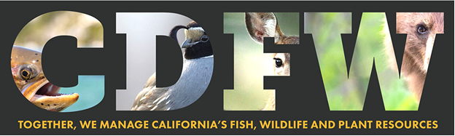

Nature Bowl 2024: Coach Registration Form
Welcome to the California Department of Fish and Wildlife’s Nature Bowl 2024! We are very excited to have you and your team participate this year in the Nature Bowl competition!
Please fill out this form completely, then email it to: genelle.treaster@wildlife.ca.gov
There is a $25 per team registration fee paid at and to your Semi-Final site. Thank you!
COACH NAME:
SCHOOL:
SCHOOL ADDRESS:
COACH EMAIL ADDRESS:
COACH PHONE NUMBER
TEAM GRADES (check one or both): 3/4 grade ____ 5/6 grade ____
PREFERRED SEMI-FINAL SITE AND DATE (please rank 1, 2, 3):
March
___ 20 Nimbus Fish Hatchery
___ 27 Placer Nature Center
April
___ 10 Yolo Basin Foundation
___ 17 Stone Lakes National Wildlife Refuge
___ 23 American River Conservancy
___ 25 Calaveras/Tuolumne
Other dates to remember: Jan. 24 Coach Workshop; Feb. 7 California Natural History Course for coaches; May 4 Finals
