FY2023-24 LAND ACQUISITION PRE-APPLICATION FORM
(Not for Planning and Implementation projects)

30x30 Grant Program

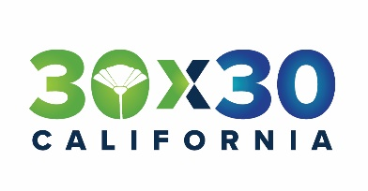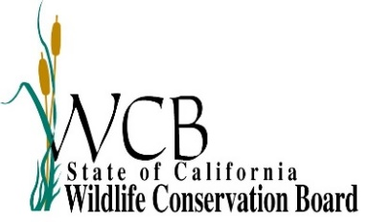

IMPORTANT

- For program guidelines, please refer to the Natural Community Conservation Planning 30X30 Grant Proposal Solicitation Package (PSP) available on-line at:
https://www.wildlife.ca.gov/Conservation/Planning/NCCP/Grants

- Please limit your responses. The Pre-Application should not exceed 10 pages (using a minimum of 11 point font), excluding any necessary maps or support letters (if applicable). Bullet points are encouraged.

- Please include all maps and photos in the same Word document. If you need to attach maps or photos as separate files, make sure they are in a .pdf file format only.
- This Pre-Application Form and all accompanying documents must be submitted electronically in Microsoft Word format to CDFW. Submit applications to: NCCP@wildlife.ca.gov. Please note that we are currently unable to accept ZIP files.

- Pre-Applications will be considered on a first come, first served basis during the ongoing solicitation until all funds are expended or December 31, 2024, whichever comes first.

Project
Project Name:
Name of Primary NCCP and/or HCP:
Year of Primary NCCP and/or HCP approval, if applicable:
Name of Secondary plan(s), if applicable:
Brief Summary (one paragraph): Click or tap here to enter text.
Total cost (round up to nearest $1,000):
Amount requested from 30x30 funding (round up to nearest $1,000):
Indicate whether partial funding of the project is practicable and, if so, what specific portion(s) of the project could be implemented with what level of funding.
Start date:
End date:
Work under an FY23-24 Land Acquisition award must be completed by March 31, 2027.
Project type: Land Acquisition
Primary Habitat Type (select one): Choose an item.
Total Acres:

Location
Primary County:
Specific location (each Assessor Parcel Number or address if available):
Nearest City (distance and direction):
Latitude (decimal degrees):
Longitude (decimal degrees):
Point represented by the Latitude and Longitude coordinates (e.g., center of project site):
Is the Project Area in a Disadvantaged Community; mapping tool https://gis.water.ca.gov/app/dacs/ (select one):

Applicant
Organization name:
Organization type:
Primary applicant’s contact name and title:
Phone:
E-mail address:
Mailing address:

Landowner
Landowner name:
Landowner type:

Project Overview
Describe the proposed project. Quantify the project’s goals and expected outcomes/benefits. Identify the major tasks involved in the project. Describe why the project is needed. Attach a map of the project location (and photos if helpful), and briefly describe the project location. Be specific about the portion of the project that would be funded by this request.
Click or tap here to enter text.

Environmental Review (CEQA)
The proposed project…. (Select the appropriate answer):
☐ Is not a project under CEQA. Briefly specify why in the box below.
☐ Is exempt under CEQA. Provide the CEQA exemption number and specify how the project meets the terms of the exemption in the box below.
☐ Requires Neg Dec, MND, or EIR. Specify the lead CEQA agency (the agency preparing the document) and the (expected) completion date in the box below. Please note that WCB will need to review and approve any CEQA document. For more information on CEQA, visit: http://ceres.ca.gov/topic/env_law/ceqa/flowchart/index.html.
Click or tap here to enter text.

Other Funding Sources
Please list all of the sources of cost share. Please indicate if other funding sources have been secured or are pending (applied for but not yet awarded).
Source | Amount ($) | Status - Secured / Applied for
e.g.: California Natural Resources – Prop 1 |  | Secured
e.g.: National Fish and Wildlife Foundation |  | Applied for
TOTAL | $
Add or delete rows as necessary.

Maps/Photographs
Attach location maps, designs, plans, engineering drawings, color photographs, etc., to help describe your proposal. Label photos with a one sentence description.

The primary NCCP and/or HCP is the plan that is most closely related to the proposed activities or that will benefit the most from the proposed activities.

